createBrowserRouter : This is a recommended router for all React Router web projects. It uses DOM History APi to update URL and manages history stack.

Syntax looks like below:

const appRouter = createBrowserRouter([

  {

    path: "/",

    element: <AppLayout />

  },

  {

    path: "/about",

    element: <About />,

  },

  {

    path: "/contact",

    element: <Contact />,

  },

]);

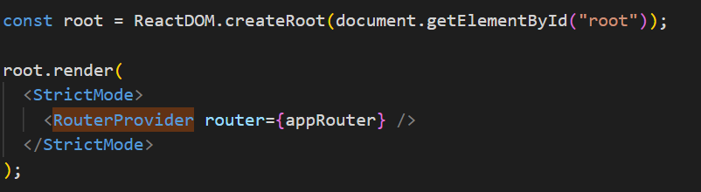

Outlet: Is component provided by React router dom which is used in parent route element to render their child routes. This allows nested UI to show up when child routes are rendered. If parent router matched exactly, it will render a child index route or nothing if there is no index route.

Using Link, we can navigate to different page without reloading the whole page.

2 types of Routing in web apps

**Client Side Routing**: There is no network call while navigating to any page

**Server Side Routing:**  If I click on any web link, it make a make call to network and reload the complete page.

   path: "/restaurant/:id",

: denotes that id is dynamic here

useEffect takes 2 arguments, 1 is callback and second is dependency array while second argument is optional. But if we will not pass second argument, this call will happen on every render

super(props) allows a component to inherit properties of its parent component and also pass additional properties as arguments to the components.

