Dean Alumni's Message

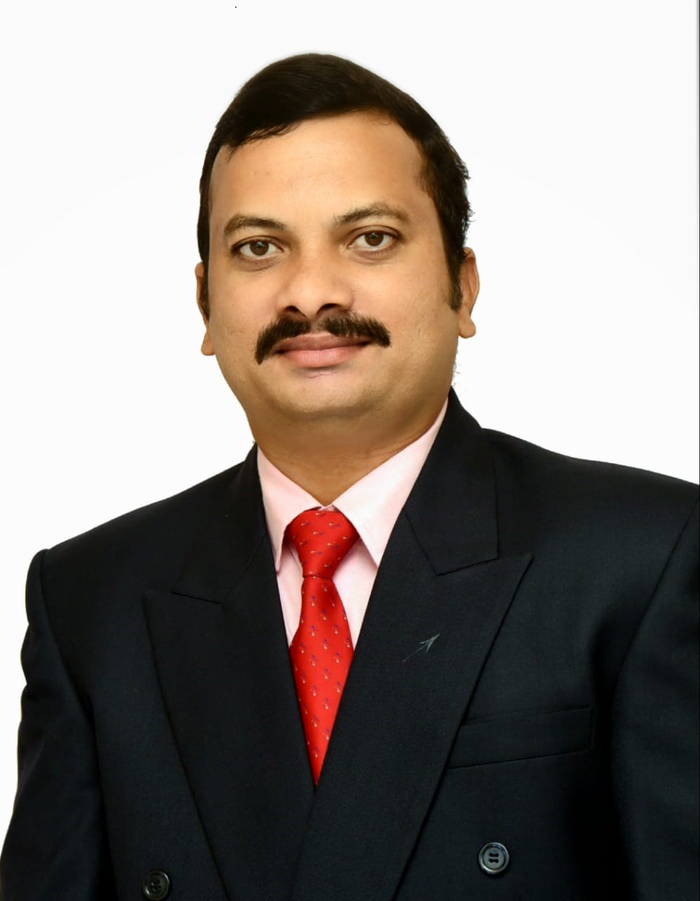

Bapuji Institute of Engineering and Technology has become an institution of iconic marvel in academics and research and accredited with "A" grade by NAAC.

Recognised by All India Council of Technical Education, New Delhi and affiliated to Visvesvaraya Technological University, Belagavi, Karnataka. The institution endeavours to provide broad based education and assistance for its students so that they may move towards the fulfilment of their dreams and aspirations. Since from the beginning, the University has produced graduates, post graduates and researchers in diverse disciplines, who went on to make their mark in their respective fields and are now a part of our Alumni Association. Alumni are spread across the world; the college alumni association remain connected with their alma mater as well as their friends/contemporaries through the Association activities. The institution cherishes its alumni, as not only they are role models for the coming generations but also ambassadors for promoting the Institute’s Vision and Mission. The association is committed to establish, foster and nurture a strong bond between the alumni and the institution for achieving excellence and reaching newer heights. The alumni association members are committed to develop a strong relationship between the alumni and the Institute and to develop different platforms for achieving excellence at the Institute.

In each department, a separate alumni coordinator has been identified and they are the key person for building association with the alumni. Some of the departments have organized the alumni meets at the department level and the last such meeting was held in 2019.

The Executive Council of the association has been formed consisting of President, Vice President, Treasurer, Secretary, Joint Secretary, Dean and Alumni Coordinators.

The Alumni Association ensures and facilitates interactions between alumni and the current students by providing forums and creating opportunities for interactions. An online registration facility has been provided on the alumni website for all the ex-students to re-connect to the alumni family.

The association also wishes to apprise, from time to time, the alumni with the academic and other activities of the institute.

The alumni can help the underprivileged students of the University by providing financial assistance in terms of scholarship/fellowships, distinguished lecture series, research projects and even for creating infrastructure. The Alumni Association strongly encourages its members to collaborate with the institution, stay in touch with its members and give valuable suggestions for the development and upliftment of their alma mater. The institute also welcomes suggestions from the alumni for its academic growth.

On behalf of the Institute and Alumni Association, I as Dean Alumni herewith to request alumni who have completed any academic degree from the institute to spare a minute to fill the Alumni registration Google form which will help us to construct centralized Alumni Database. The weblink for alumni registration form is:

[**https://forms.gle/K3S34yxtJN49r3bK9**](https://forms.gle/K3S34yxtJN49r3bK9)

Dr. Pradeep N

Dean Alumni,

Associate Professor,

CS and E department

Email: nmnpradeep@bietdvg.edu

nmnpradeep@gmail.com