***Mrs. Ramya Annigere***

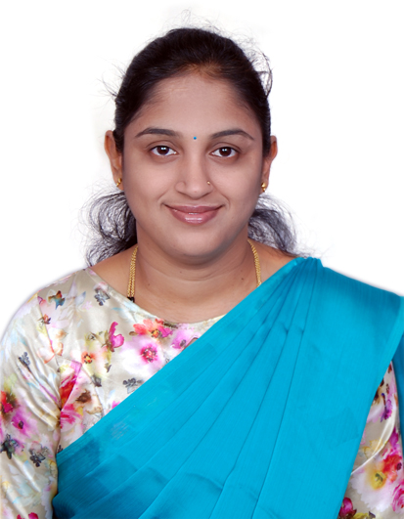

**Assistant Professor**

**Department of E&IE BIET, Davangere**

**[*annigere.ramya@gmail.com*]**

***Work Experience: 2.5 Years***

* Worked for Philips Electronics India Ltd. as a consultant software engineer from 1st August 2008 to 25th January 2009.
* Worked as a lecturer in BIET from 1st February 2009 to 30th April 2010.
* Currently Working as Assistant Professor in BIET Davangere from 2nd November 2020.

***Educational Qualification:***

* M.Tech [Digital Electronics] from G M Institute of Engineering and Technology, Davangere, 2016.
* B.E [Electronics and Instrumentation] from University BDT College of Engineering, Kuvempu University, 2008.

***Awards:***

* Awarded as University 1st Rank holder of Electronics and Instrumentation Engineering from Kuvempu University, 2008.

***Core Subjects Taught:***

Digital Logic Design, Lasers and Optical Instrumentation, Electronics Instrumentation and Measurements

***Publications:***

Presented the paper in National Conference on “Recent trends in Communication and Computing” (NCRTCC-16).

***Webinars/FDP’s Attended:***

1. Webinar on “Remote Lab Platform for Hardware Circuit Experiments”, organized by Dept. of E&CE, BIET, Davangere on 10 Nov 2020.
2. Attended Lecture Series conducted by R&D cell BIET, Davangere from 19-11-2020 to 26-11-2020.
3. Attended Online FDP on "Control Systems & Sensors Technology" from 2021-1-19 to 2021-1-23 at Manipal Institute of Technology.
4. Webinar on “Employability Skill for Women Empowerment in the Changing Environment”, organized by VTU, Women Cell on 5-02-2021.