***Ms. Vidya S***

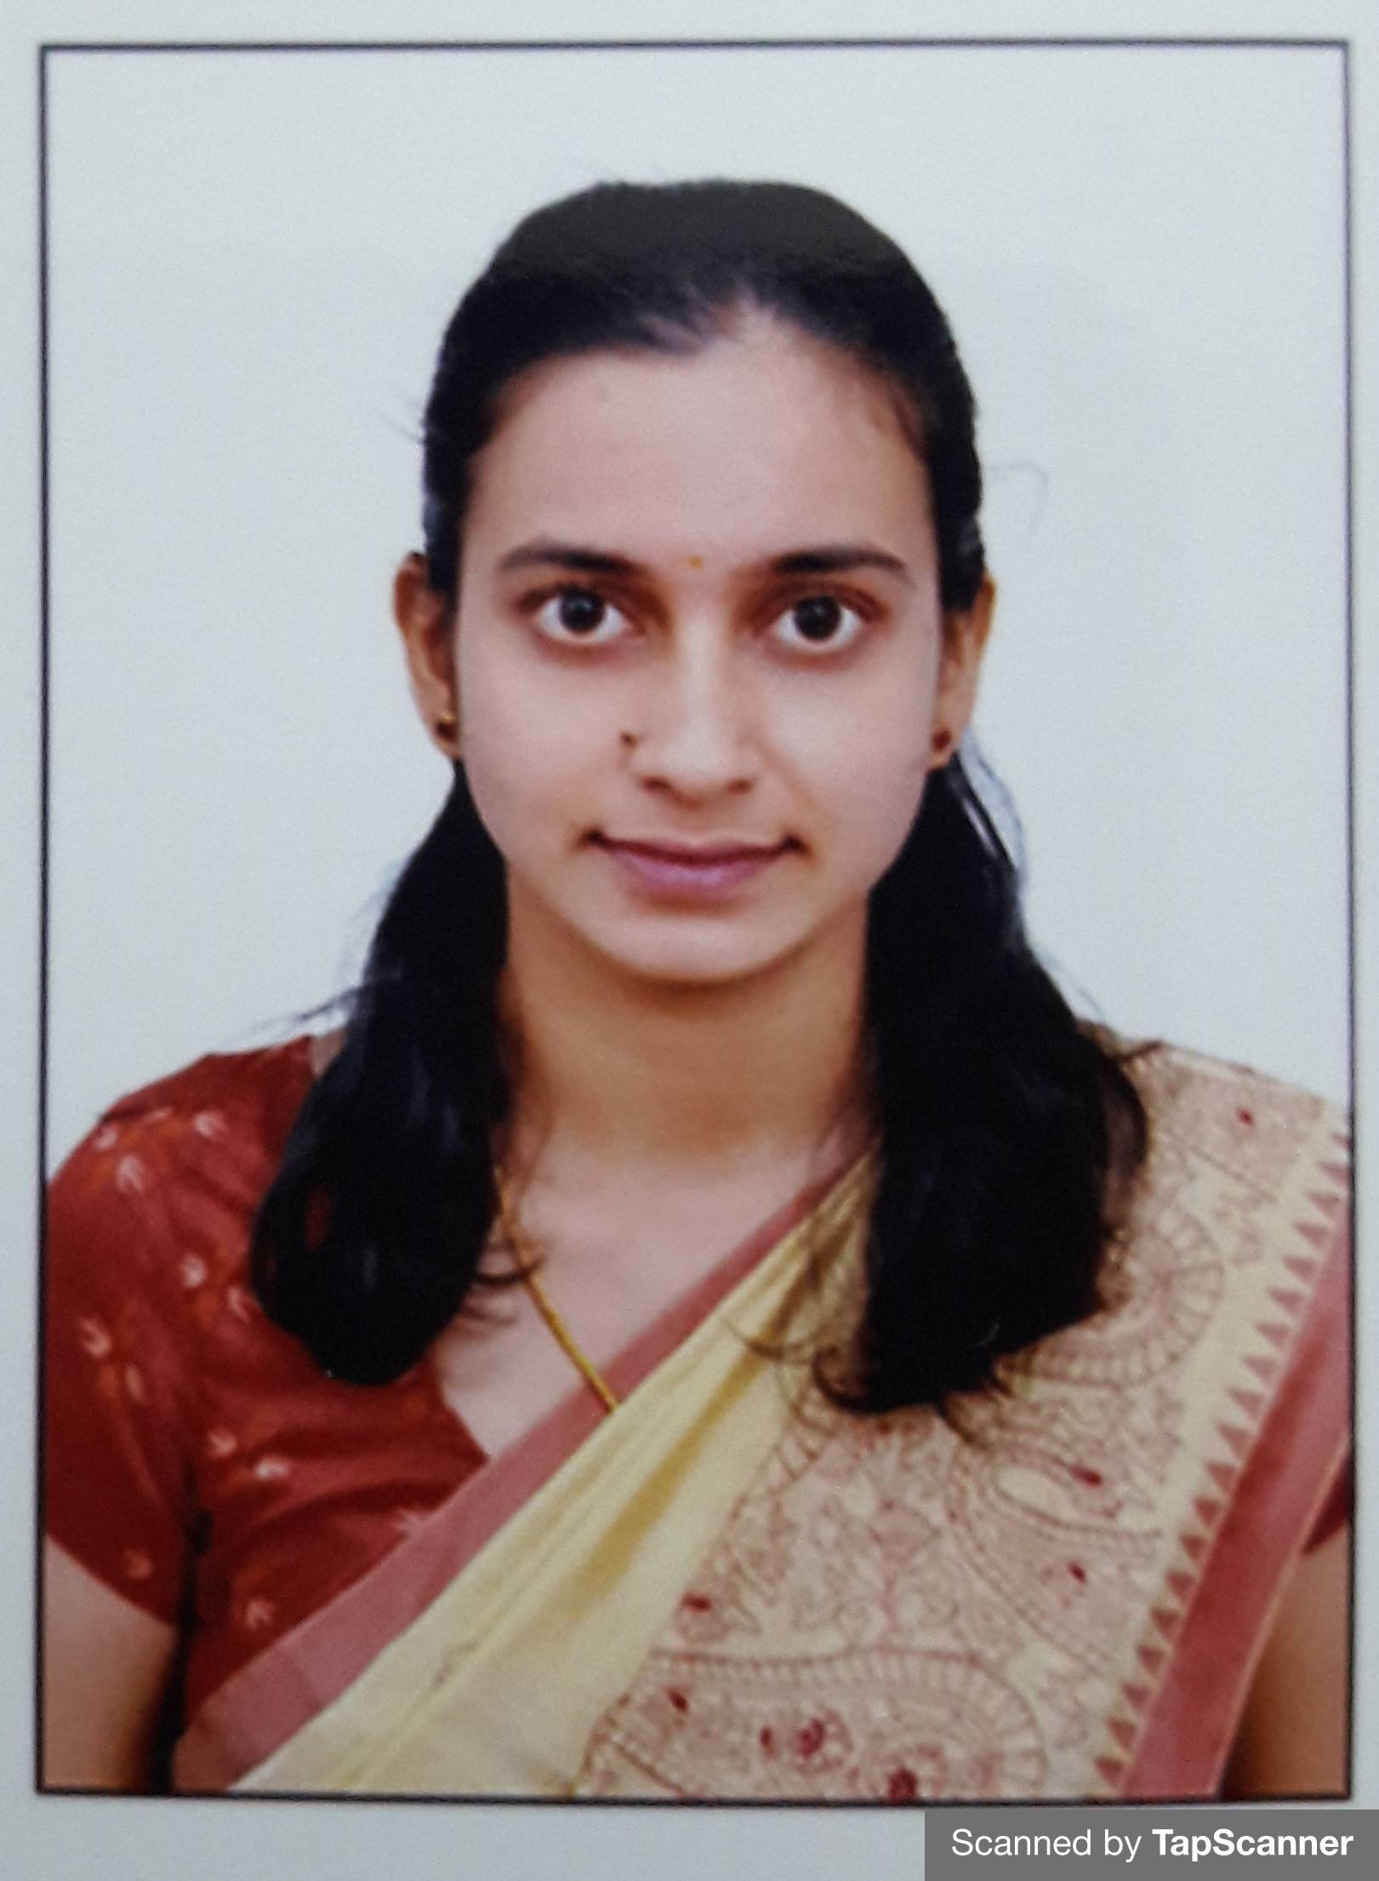

**Assistant Professor**

**Department of E&IE BIET, Davangere**

**[*vidya.s.jogada@gmail.com*]**

***Work Experience: 4 Months***

* Currently Working as Assistant Professor in BIET Davangere from 2nd November 2020.

***Educational Qualification:***

* M.Tech [VLSI Design and Embedded System] from Siddaganga Institute of Technology, Tumkuru, 2019.
* B.E [Electronics and Instrumentation Engineering] from University BDT college of Engineering, VTU, 2017.

***Core Subjects Taught:***

Fundamentals of signals and DSP, Technological Innovation and Entrepreneurship

***Publications:***

* Vidya S, Chaitra R and Deepa, Design and Analysis of Low Power Adder in 130nm Technology, National Conference on Recent Trends in Electrical Sciences 2018, page number: 104-107.

***Webinars/ FDP/ Workshops Attended****:*

* Webinar on “Remote Lab Platform for Hardware Circuit Experiments”, organized by Dept. of E&CE, BIET, Davangere on 10 Nov 2020.
* Attended Lecture Series conducted by R&D cell BIET, Davangere from 19-11-2020 to 26-11-2020.
* Attended Online FDP on "Control Systems & Sensors Technology" from 2021-1-19 to 2021-1-23 at Manipal Institute of Technology.
* Webinar on “Employability Skill for Women Empowerment in the Changing Environment”, organized by VTU, Women Cell on 5-02-2021.
* Participated in “Application of Open Source Hardware/Software in Electronics & Instrumentation” workshop on March 2016 organised by the Dept of Electronics & Instrumentation Engineering, UBDTCE, Davanagere with the collaboration of FOSSEE Lab, IIT Bombay.
* Participated in “Technical Writing and Publishing” workshop on January 2019 held at Siddaganga Institute of Technology, Tumkuru.
* Participated in “IOT in Agriculture: Karnataka Focus” workshop on August 2019 held at Dept of Electrical Communication Engineering, Indian Institute of Science campus, Bengaluru.