# **BAPUJI EDUCATIONAL ASSOCIATION (Regd)**

##### BAPUJI INSTITUSTE OF ENGINEERING AND TECHNOLOGY,DAVANGERE

# **DEPARTMENT OF SPORTS**

**Sports Information for the academic year 2019 – 2020**

Institute **cricket (Men) team** participated in the V.T.U. central Karnataka zone Inter Collegiate cricket Tournament held at **SIT, Tumkur** from 02 – 03 - 2019 & 10 – 03 –2019. Our team played very well but lost the match against SIT Tumkur.

Institute **Volley ball (Men)** teams participated in the VTU Central Karnataka Zone inter collegiate tournament held at **JNNCE, SHIMOGA** on 03 – 04 - 2019 & 04 – 04 – 2019. Our team played very well.

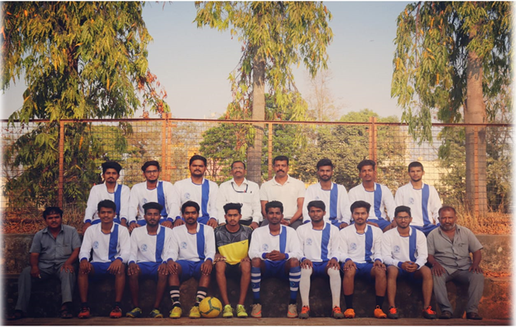

**College Football Team**

Institute **Basketball (Women)** team participated in VTU Rest of Bangalore held at **BLDCE, Bijapur** on 08 – 04 - 2019 & 09 – 04 – 2019.

Institute **Netball (Women)** player **Kum. Aishwarya M N** participated in the V.T.U. Inter Collegiate Net Ball selection competition held at **GIT, Bengalore** on 11 – 04 – 2019 & 12 – 04 – 2019.

We conducted annual **sports day 2018-2019**, prize distribution function on 25th April 2019

Institute **Kabaddi (Men)** team participate in the VTU Central Karnataka zone inter collegiate tournament held at **BCE, Shravanabelogola** on 29 – 04 - 2019 & 30 – 04 – 2019.

Institute **Chess (Men & Women)** teams participated in the VTU Central Karnataka Zone inter collegiate tournament held at **SJMIT, Chitradurga** on 18-08-2019 to 19-08-2019 our team played very well.

Institute **Basket Ball (Men)** teams participated in the VTU Central Karnataka Zone inter collegiate tournament held at **KIT, Tiptur** on 24-09-2019 to 25-09-2019 our team played very well. Our team qualified for Inter Zone level.

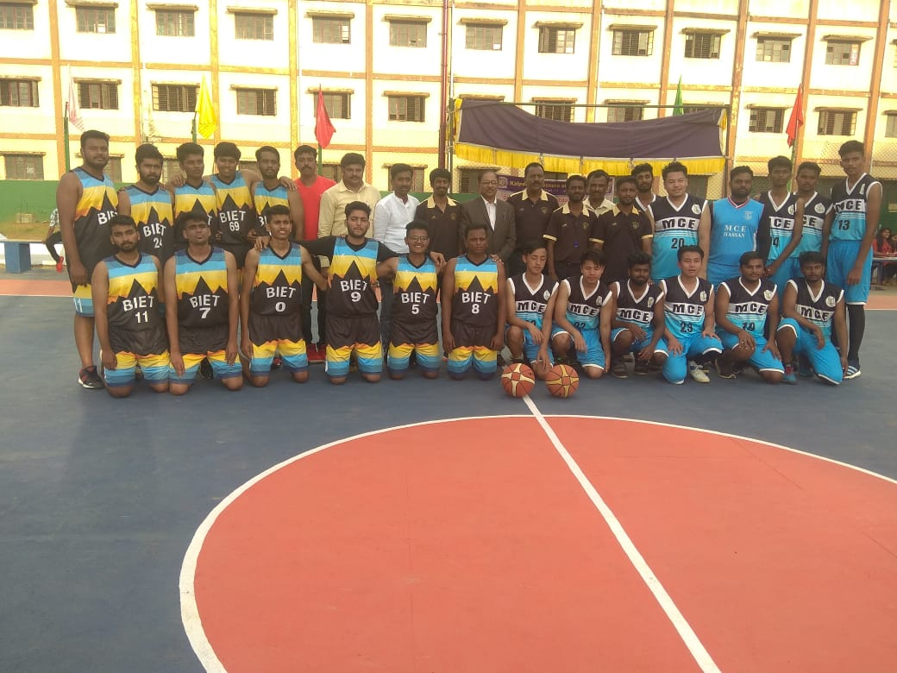

**College Basketball Team**

Institute **Badminton** (**Men & Women)** teams participated in the VTU Central Karnataka Zone inter collegiate tournament held at **SJMIT, Chitradurga** on 26 – 08 – 2019 & 27 – 08 – 2019 Our team played very well.

Institute **Basket Ball (Men)** teams participated in the VTU Inter Zone collegiate tournament held at **SIT, Tumkur** on 26-09-2019 to 28-09-2019 Our team played very well. Our team qualified for Inter Zone level.

Institute **Cricket (Women)** player Kum**. Pooja D R** participated in the V.T.U. Inter Collegiate Cricket selection competition held at **SJCIT, Chickballapura** on 17-10-2019.

Department of **Sports** Organized one day workshop on First Aid Awareness Program by **VMEDO, Bengaluru** on 09 – 11 – 2019, Jointly Organized by **NCC & NSS**.

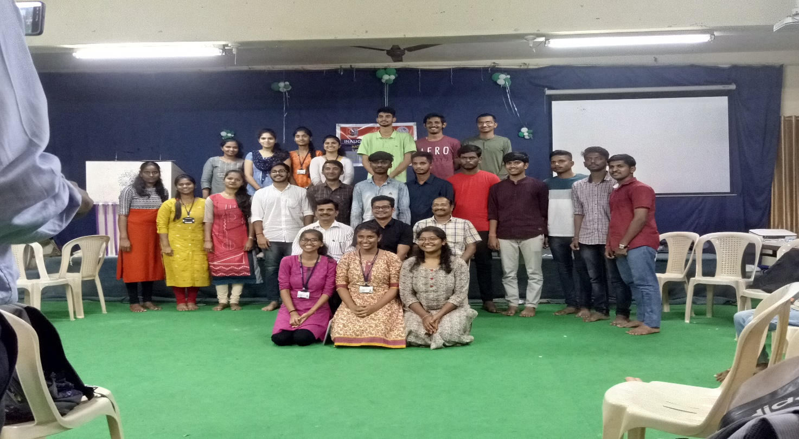

**First Aid Awareness Camp**

Institute Athletic **(Men and Women)** teams participated in the V.T.U. Inter Collegiate tournament held at **GNDEC, Bidar** on 22-10-2019 to 25-10-2019.

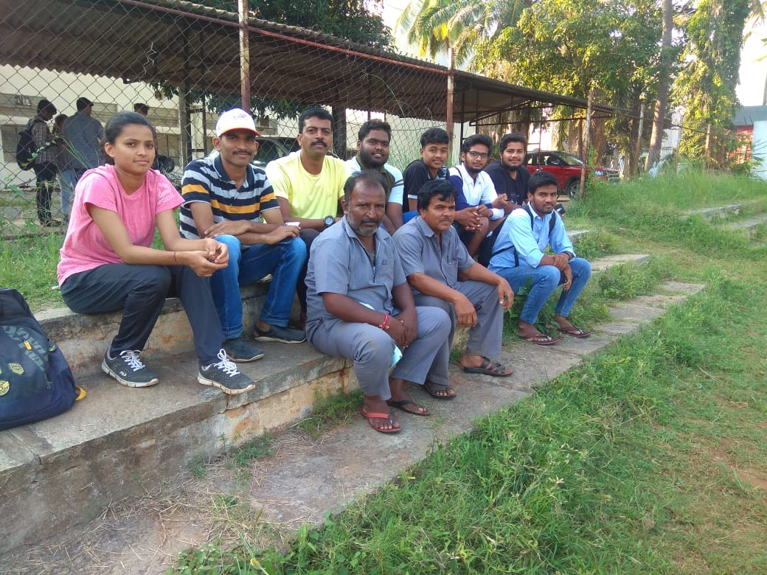

**College Athletic Team**

Institute **Throw Ball (Women)** teams participated in the VTU Central Karnataka Zone inter collegiate tournament held at **PESITM, Shivamogga** on 18-11-2019. Our team played very well.

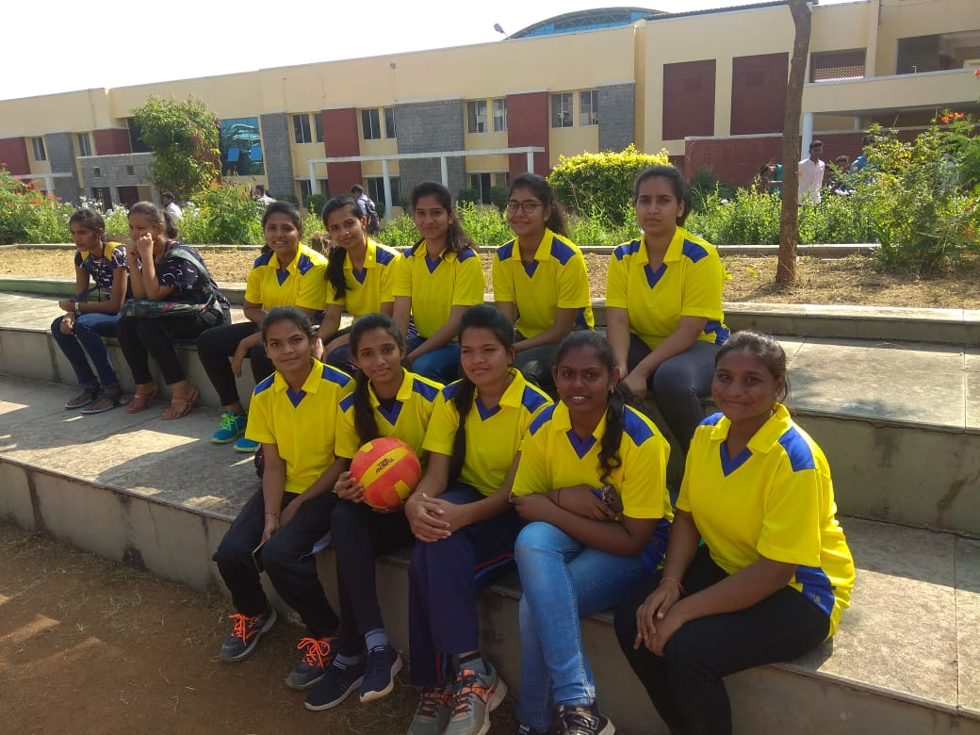

**College Throwball Team**

We conducted College **Annual Day Sports 2018 – 2019** from 09th March to 05th May 2019.

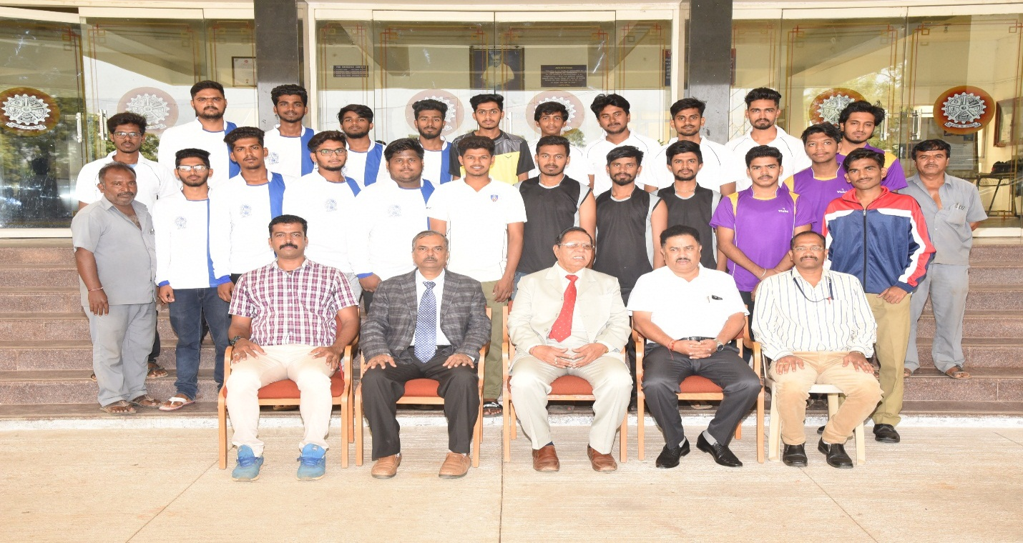

**College Sports Team**