Visvesvaraya Technological University, Belagavi



MANUAL FOR

RELAY AND HIGH VOLTAGE LABORATORY

[SEMESTER : 7TH SUBJECT CODE : 15EEL77]



Bapuji Institute of Engineering & Technology
Davanagere-577004
Department of Electrical & Electronics Engineering

Relay and High Voltage Laboratory

Subject Code: 15EEL77 IA Marks: 20
No. of Practical Hrs/ Week: 03 Exam Hours: 03
Total No. of Practical Hrs: 42 Exam Marks: 80

Sl.no | List of Experiments
 | NON- DIRECTIONAL IDMT OVER CURRENT RELAY
 | SPARK OVER CHARACTERISTICS OF AIR INSUATION TO HVAC
 | BREAKDOWN STRENGTH OF TRANSFORMER OIL
 | BREAKDOWN OF AIR IN HOMOGENEOUS AND NON HOMOGENEOUS ELECTRIC FIELDS
 | DEFINITE TIME OVER CURRENT RELAY
 | ELECTROLYTIC TANK
 | SINGLE PHASE UNDER VOLTAGE RELAY
 | SINGLE PHASE OVER VOLTAGE RELAY
 | MICROPROCESSOR BASED OVER CURRENT RELAY
 | IMPULSE GENERATOR

Experiment no 1:
NON- DIRECTIONAL IDMT OVER CURRENT RELAY

AIM: To study operating characteristics of Non-directional IDMT over current relay.

APPARATUS REQUIRED:

Sl. No | Particulars | Range | Quantity
1.  2.  3.  4.  5.  6.  7  8.  9. | Over current Relay type  Timer  Ammeter  Current Transformer  DPST switch  Lamp load  Patch cords | TMAS101a  0-20A, 0-5A(MI)  10/5 A | 1  1  1  1  1  1  12

THEORY:

PROCEDURE:
- Circuit connections are made as shown in figure.
- Adjust the timer multiplier setting (TMS).
- Adjust the relay current setting to desired value say for example 0.5A.
- Auxiliary supply 220VDC is switched ON and supply is given to timer.
- Keep some of switches of lamp load ON.
- Short the CT secondary and close DPST switch and switch ON lamps.
- Open the DPST switch and remove the short circuited link across CT secondary.
- Close the DPST switch.
- Relay trips and time of operation is recorded by timer is noted.
- The experiment is repeated for different current and time setting.
- Plot the graph Time v/s Load Current.

CIRCUIT DIAGRAM:
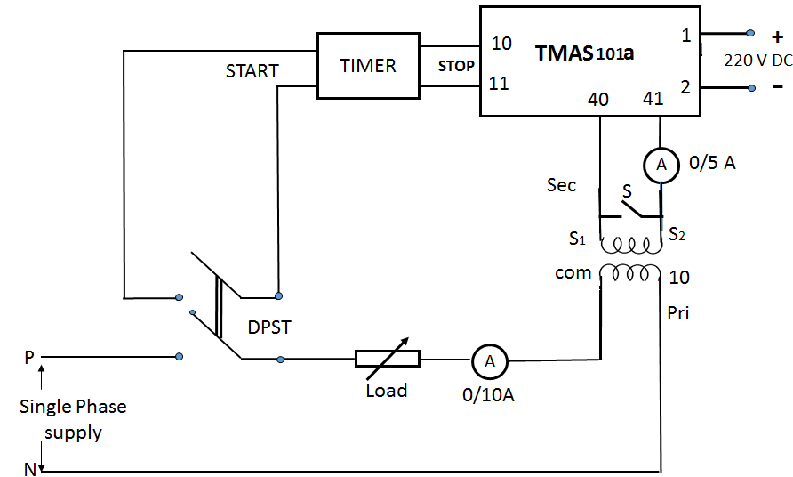

TABULAR COLUMN:
Current setting of the relay = …………V Time Setting = ……..secs

Sl.No | Load current  (in amps) | Time of operation  (in Seconds)
1
2
3
4
5
6

IDEAL GRAPH:
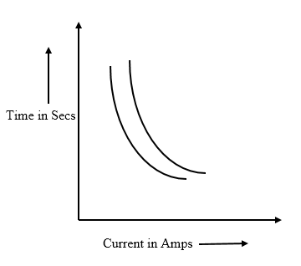
Experiment no 2:
SPARK OVER CHARACTERISTICS OF AIR INSUATION TO HVAC

AIM: Spark Over characteristics of Air insulated to HVAC using Sphere Gap and Spark over Connected to STP

APPARATUS REQUIRED:

Sl. No. | Particulars | Range | Quantity
1  2  3  4  5 | HV transformer  HV resistor  Insulating stand  Measuring scale  Sphere Gaps | 10kVA, 0-400/0- 100 kV  150 mm (Diameter) | 1  1  1  1  1

THEORY:

PROCEDURE:
- The connections are made as shown in the figure
- Ensure proper grounding of the device used
- Adjust the gap spacing S to desired value( say 10mm)
- Input to the control panel is provided by 3-phase supply
- Switch on the key provided on the control panel
- HT on switch is pressed in the control panel
- Increase the input voltage to the HV transformer gradually by operating ‘MANUAL or AUTO’ knobs
- The voltage of the secondary of HV transformer is increased until the gap sparks over
- Note down the voltage as indicated by the voltmeter mounted on the control panel
- De-energize the system and change the gap spacing and repeat the steps 4 to 9
- Tabulate the readings as shown in the tabular column
- Plot the graph of breakdown voltage V/s gap

CIRCUIT DIAGRAM:
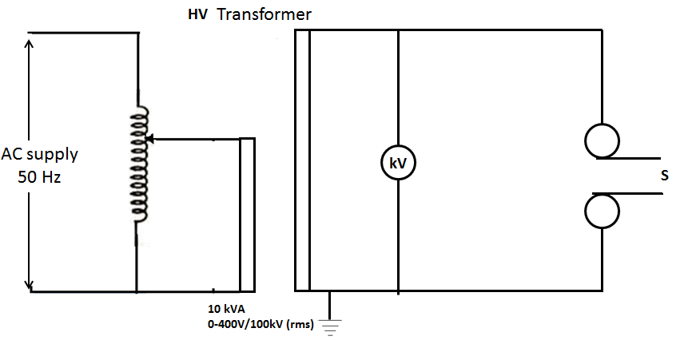
TABULAR COLUMN:

Gap  Spacing ‘S’ in mm | Primary  Voltage V(rms) in volts | kV (rms) panel reading | Average Primary  Voltage V(rms) in volts | Average kV (rms) | IS value for NTP (peak) in kV | Corrected  IS value for NTP (peak) in  kV | Peak  value of  SG  method in  kV
10 | 1  2  3 | 1  2  3

IDEAL GRAPH:
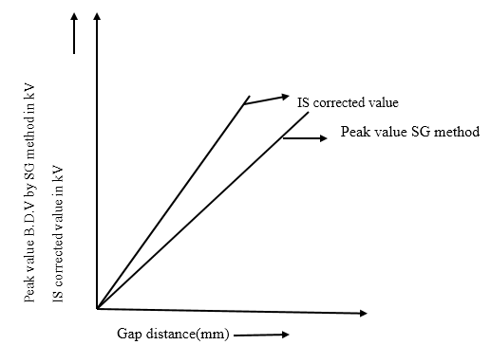

Experiment no 3:
BREAKDOWN STENGTH OF TRANSFORMER OIL

AIM: To determine the dielectric strength of transformer oil.

APPARATUS REQUIRED:

Sl. No | Particulars | Range | Quantity
1.  2.  3. | Oil test kit Ammeter  Transformer oil  Measuring gauge. | 2.5kVA,0-230v/0-60kv(rms)  ------  ------ | 1  1  1

THEORY:

PROCEDURE:
1. Connections are made as shown in circuit diagram.
2. Ensure the proper grounding of the devices used.
3. Adjust the gap to 2.5mm between the electrodes.
4. Pour the oil in to the test vessel to about 3/4th level.
5. Place the test vessel in the place provided.
6. Switch on the supply to the set and switch on the toggle switch provided in the control pannel
7. Apply the voltage to the test setup gradually by varying the autotransformer gradually(at the rate of 2kV per sec).
8. Note the reading of the kV meter after the trip indication is given.
9. Repeat the procedure for 8 times and tabulate the result.
10. Average of 8 readings gives the breakdown strength of the oil used.
11. de-energies the system and adjust the gap to 4mm.
12. Repeat the procedure from 5-10.
NOTE: 1. Allow at least 1 min gap between the successive operations.
2. Clean the distance between the electrodes for every 2-3 operation (if there is any carbon formation)
TEST CONDITION:
TEMP (dry)-Td=---------deg.celsius.
TEMP (wet)-Tw=--------deg.celsius.
Pressure p=---------mbar.
STANDARD: IS 335-1993
ELECTODES USED: Spherical surfaced stainless steel.
CIRCUIT DIAGRAM:

TABULAR COLUMN
Gap=2.5mm Gap=4.0mm

Sl.NO. | Breakdown voltage in kV | Sl.NO | Breakdown voltage in kV
1
2

Experiment no 4:
BREAKDOWN OF AIR IN HOMOGENEOUS AND NON HOMOGENEOUS ELECTRIC FIELDS

AIM: To study breakdown of air in homogeneous and non-homogeneous fields

APPARATUS REQUIRED:

Sl. No. | Particulars | Range | Quantity
1  2  3  4  5 | HV transformer  HV resistor  Insulating stand  Measuring scale  Different electrodes  Point- Point  Point – Plane  Plane – Plane  Rod – Rod | 10kVA, 0-400/0- 100 kV | 1  1  1  1  1  1 set  1 set  1 set  1 set

THEORY:

PROCEDURE:
- The connections are made as shown in the figure
- Ensure proper grounding of the device used
- Place the plane- plane across the terminals X₁ & X₂
- Adjust the gap spacing S to desired value say 10mm
- Input to the control panel is provided by 3-phase supply
- Switch on the key provided on the control panel
- HT on switch is pressed in the control panel
- Increase the input voltage to the HV transformer gradually by operating ‘MANUAL or AUTO’ knobs
- The voltage of the secondary of HV transformer is increased until the gap sparks over
- Note down the voltage as indicated by the voltmeter mounted on the control panel
- De-energize the system and change the gap spacing and repeat the steps 5 to 10
- Tabulate the readings as shown in the tabular column
- The above procedure is repeated for the following electrode configurations like point-point, point-plane, plane-plane and Rod-Rod connecting across the terminals X1 and X2
- Plot the graph of breakdown voltage V/s gap for all configurations.

CIRCUIT DIAGRAM:
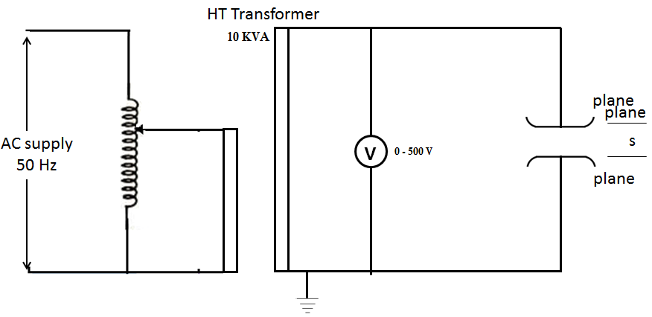

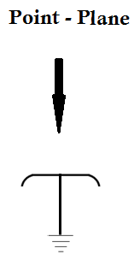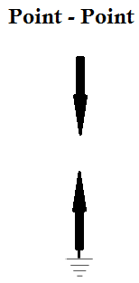

TABULAR COLUMN:
Electrode configuration: …………….

Gap spacing ‘S’in mm | Primary Voltage in Volts (RMS) | Breakdown Voltage in KV(RMS)
10

20

30

40

Average Breakdown Voltage(kV)

IDEAL GRAPH:

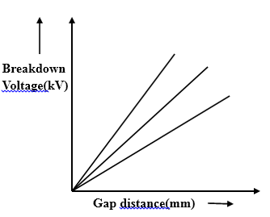

Experiment no 5:
DEFINITE TIME OVER CURRENT RELAY

AIM: To study operating characteristics of definite time over current relay.

APPARATUS REQUIRED:

Sl. No | Particulars | Range | Quantity
1.  2.  3.  4.  5.  6.  7. | Over current Relay type  Timer  Ammeter  Current Transformer  DPST switch  Lamp load  Patch cords | TMAS111a  0-20A, 0-5A(MI)  10/5 A | 1  1  1  1  1  1  12

THEORY:

PROCEDURE:
- Circuit connections are made as shown in figure.
- Adjust the timer multiplier setting (TMS).
- Adjust the relay current setting to desired value say for example 0.5A.
- Auxiliary supply 220VDC is switched ON and supply is given to timer.
- Keep some of switches of lamp load ON.
- Short the CT secondary and close DPST switch and switch ON lamps.
- Open the DPST switch and remove the short circuited link across CT secondary.
- Close the DPST switch.
- Relay trips and time of operation is recorded by timer is noted.
- The experiment is repeated for different current and time setting.
- Plot the graph Time v/s Load Current.
CIRCUIT DIAGRAM:
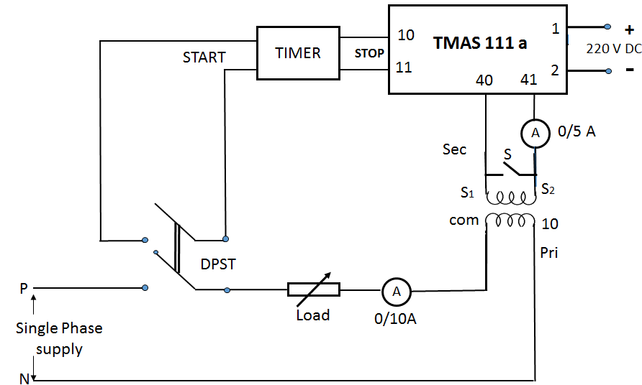

TABULAR COLUMN:
Current setting of the relay = …………V Time Setting = ……..secs

Sl.No | Load current  (in amps) | Time of operation  (in Seconds)
1
2
3
4
5
6

IDEAL GRAPH:
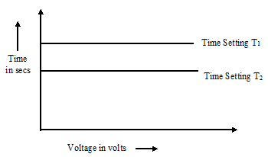
Experiment no 6:
ELECTROLYTIC TANK

AIM: To plot the equipotential lines for the given electrode configuration and to calculate
the capacitance.

APPARATUS REQUIRED:

Sl. No | Particulars | Range | Quantity
1.  2.  3.  4. | Electrolytic tank  Electrodes – coaxial cable model  Power supply  voltmeter | -  -  0-10 V rms  - | 1  1  1  1

THEORY:

PROCEDURE:
- Setup the electrolytic tank assembly on a flat table, level the top of glass sheet, if necessary by means of leveling screws.
- Keep the model whose field has to be plotted in the center of tank. Fix a drawing sheet on the glass sheet above the model.
- Pour tap water into the tank until it submerges apparatus approximately half the height of model.
- Connect the two electrodes of the model to the output terminals (at the back) of the power supply as shown. Connect the ground terminal of model and power supply to the laboratory ground.
- Connect the leads of probe (needle point) of electrolytic tank to the input terminals of a high impedance voltmeter.
- Switch on the power supply unit. Touch the probe to the line terminal of model and adjust the pot on front panel of power supply till the voltmeter reads 10V.
- Proceed the plot of equipotential lines in steps 1V or 2V by moving the probe in space between electrodes.
- Reduce the voltage to zero and switch of the supply.

CIRCUIT ARRANGEMENT:

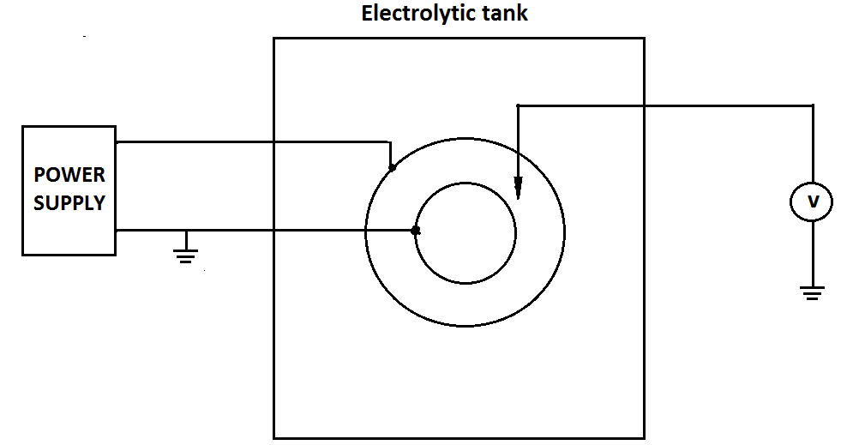

Electrode configuration:
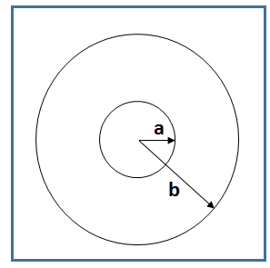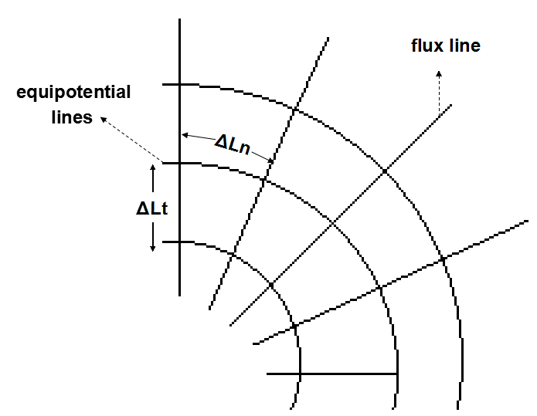
a = radius of inner circle = 2.5 cm
b = radius of outer circle = 10.3 cm

CALCULATIONS:

Theoretical calculation:
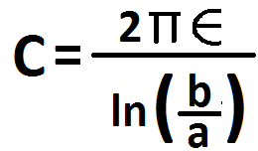
pF/m

Practical calculation:
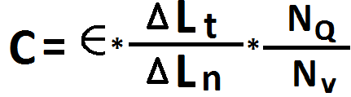
pF/m
Where
N_{Q} → number of flux tubes
N_{V} → number of potential increments

Experiment no 7:
SINGLE PHASE UNDER VOLTAGE RELAY

AIM: To study operating characteristics of single phase under voltage relay.

APPARATUS REQUIRED:

Sl. No | Particulars | Range | Quantity
1  2  3  4  5  6  7 | Under voltage relay  Timer  Voltmeter  DPST switch  Auto transformer(single phase)  Rheostat  Patch cords | TMV 111M  -  (0-300V) MI  -  0-230V  750/1.2 A  - | 1  1  1  1  1  1  13

THEORY:

PROCEDURE:
- Connections are made as shown in diagram.
- Set the relay setting to desired values.
- Close the auxiliary DC supply switch - relay trips.
- Close the DPST and apply the voltage slightly more than the set value.
- Open the DPST and adjust the voltage to a value less than the set value.
- Close the DPST to reset the relay and timer.
- Open the DPST, relay trips, note down the time.
- Adjust the next voltage and repeat the steps 5 to 7.
- Plot the graph, Voltage v/s Time

CIRCUIT DIAGRAM:
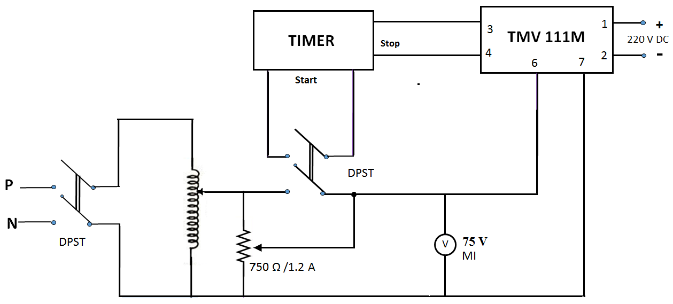

TABULAR COLUMN:
Voltage setting of the relay (V₁+ V₂) = …………V Time Setting = ……..secs

Sl.No | Operating voltage  (Volts) | Time of operation  (in Seconds)
1
2
3
4
5
6

IDEAL GRAPH:

Experiment no 8:
SINGLE PHASE OVER VOLTAGE RELAY

AIM: To study operating characteristics of single phase over voltage relay.

APPARATUS REQUIRED:

Sl. No | Particulars | Range | Quantity
1.  2.  3.  4.  5.  6. | Over voltage relay  Timer  Voltmeter  DPST switch  Auto transformer(single phase)  Patch cords | TMV 111  -  (0-300V), MI  -  0 to 230V  - | 1  1  1  1  1  12

THEORY:

PROCEDURE:
- Circuit connections are made as shown in figure.
- Relay operating time and voltage (V1+V2) is adjusted to desired value.
- Auxiliary supply 220V DC is switched ON and supply is given to timer.
- Auto transformer voltage is adjusted to a value which is greater than the set value.
- DPST switch is closed.
- Relay trips and time of operation is recorded by timer is noted.
- The experiment is repeated for different voltage setting and different time setting.
- Plot graph Time v/s Voltage

CIRCUIT DIAGRAM:
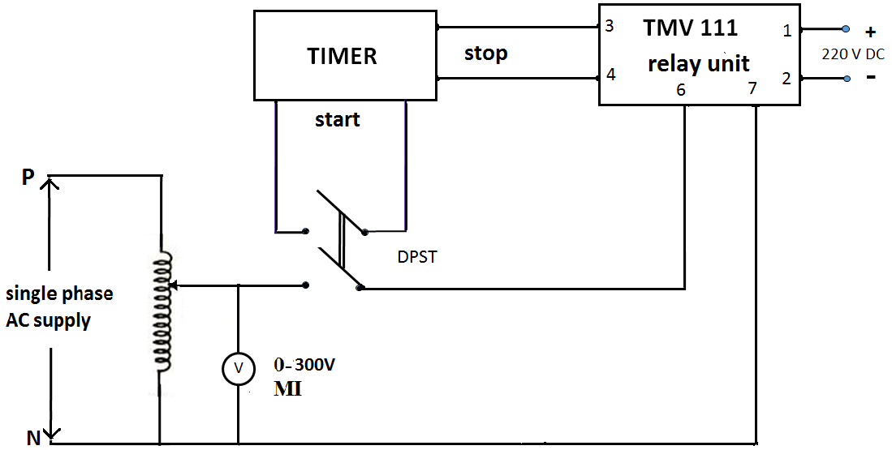

TABULAR COLUMN:
Voltage setting of the relay (V₁+ V₂) = …………V Time Setting = ……..secs

Sl.No | Operating voltage  (Volts) | Time of operation  (in Seconds)
1
2
3
4
5
6

IDEAL GRAPH:
Experiment no 9:
MICROPROCESSOR BASED OVER CURRENT RELAY

AIM: To draw current v/s time characteristics curve for the given microprocessor based over
current relay.

APPARATUS REQUIRED:

Sl. No | Particulars | Quantity
1.  2. | Numerical over current relay setup  Patch cords | 1  8

THEORY:

PROCEDURE:
- Connections are made as shown in the circuit diagram.
- The relay unit is powered suitably.
- Ensure that it displays
Prok dv’s
PNA 442 1A

- Press and hold the and simultaneously, now release the
START
SET F-RST
key first and after one second release the key. Now LCD
START
SET F-RST
displays select No.
Password change?
[Yes (>) / No (<)].
Current setting
[1> = 1.000 (0.5-2)
- The LCD displays the ‘set parameter’, phase current user can select phase low set current the (1>) any value between the range 0.5-2A which also mean 50% to 200% the step of 0.005 that is 5% press
SET F-RST
- LCD displays next parameter, to select the curve and press
Curve 1

SET F-RST

- LCD displays next parameter time multiplier and select time of operation press.
Time multiplier
TMS = 1.000 (0.25-1.6)
SET F-RST
High set disable?
[<] YES / NO[>]
- Now LCD displays since high set disable is not required select YES then press
SET F-RST
- Adjust current more than the set value by varying auto transformer provided on the control panel then the relay trips.
- Reset relay by button and press button to proceed next readings.
START
- Repeat for different current and tabulate time.
- Plot the graph of current v/s time
- Repeat the experiment for different curves.

CIRCUIT DIAGRAM:
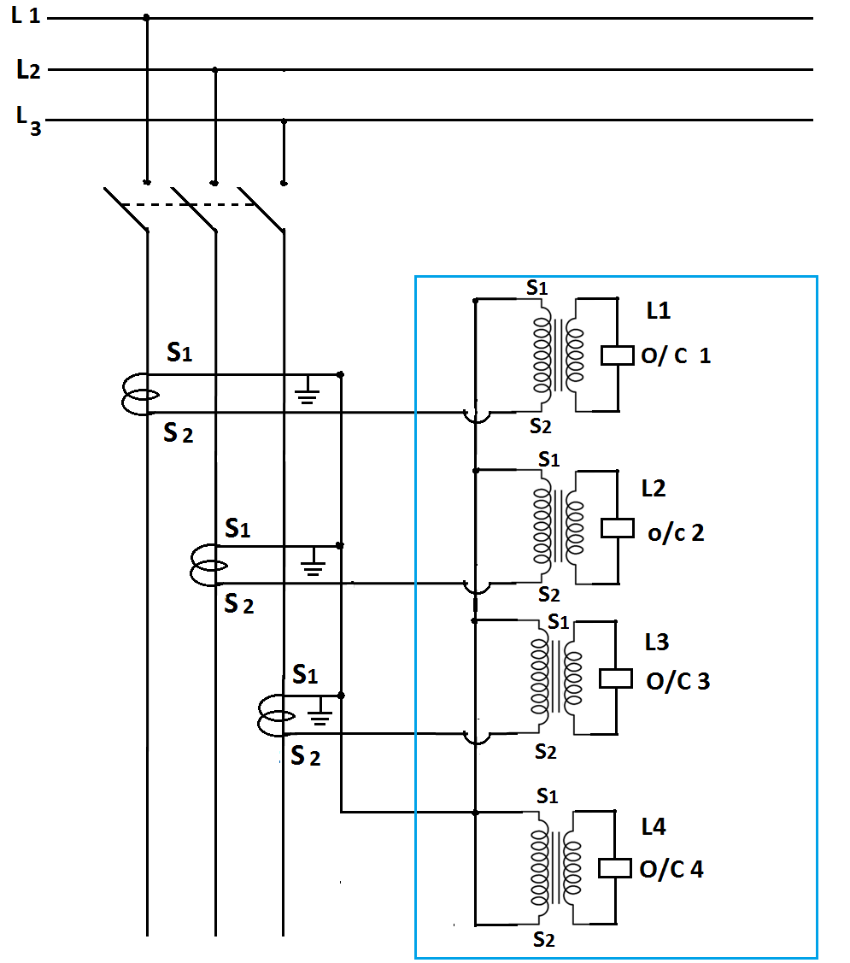
TABULAR COLUMN:
Type of curve: …………………….
Current setting: …………..
TMS: …………
Sl. No | Current  (A) | Time  (Sec) | Calculated time (Sec)
1
2
3
4
5
6

CALCULATIONS:
- For restricted inverse
K= TMS
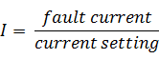


- For very inverse
K= TMS

Time 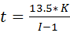 sec

Experiment no 10:
IMPULSE GENERATOR

