CHAPTER 1
INTRODUCTION
Audio waveforms have complex structure at drastically varying timescales. Local structure is captured to produce high-fidelity audio, while long-range dependencies spanning tens of thousands of timesteps is captured to generate audio which is globally consistent. A generative model for audio which captures longer-range dependencies than existing end-to-end models.
This is achieved by modelling 2D time-frequency representations using spectrograms. The temporal axis of a spectrogram is in orders of magnitude more compact than that of a waveform, meaning dependencies that span tens of thousands of timesteps in waveforms only span hundreds of timesteps in spectrograms. In practice, this enables our spectrogram models to generate unconditional speech and music samples with consistency over multiple seconds whereas time-domain models must be conditioned on intermediate features to capture structure at similar timescales. To reduce information loss and capture local characteristics, we model high-resolution spectrograms which have the same dimensionality as their corresponding time-domain signals. To limit over smoothing of spectrograms, we use a highly expressive autoregressive model which factorizes the distribution over both the time and frequency dimensions. Modelling both fine-grained details and high-level structure in high-dimensional distributions and to capture both local and global structure in spectrograms with hundreds of thousands of dimensions, a multiscale approach is employed which generates spectrograms in a coarse-to-fine manner. A low-resolution, subsampled spectrogram that captures high-level structure is generated initially, followed by an iterative upsampling procedure that adds high-resolution details. Combining these representational and modelling techniques yields a highly expressive, broadly applicable, and fully end-to-end generative model of audio.

1.1 Role of Deep learning in current world
Deep learning is all around us. It’s used to determine which online ads to display in real time, identify and tags friends in photos, translate your voice to text, translate text into different languages on a Web page, and drive autonomous vehicles.
Deep learning is also found in less visible places. Credit card companies use deep learning for fraud detection; businesses use it to predict whether you will cancel a subscription and provide personalized customer recommendations; banks use it to predict bankruptcy and loan risk; hospitals use it for detection, diagnosis, and treatment of diseases.
The range of applications is almost limitless. Other options include text analysis, image captioning, image colorization, x-ray analysis, weather forecasts, finance predictions, and more.
Deep learning is already being widely used to automate processes, improve performance, detect patterns, and solve problems.
Deep learning is being used to improve natural language processing tools to consistently comprehend the meaning of a sentence, not just the individual words. It will translate the expression into a corresponding expression in the other language.
Facial recognition software is already operating at a high level. Scientists are now training deep learning algorithms to differentiate between similar objects, such as teacups and bowls, houses and cabins, shoes and boots.

1.2 Recurrent Neural Network (RNN)
Recurrent Neural Network (RNN) are a type of Neural Network where the output from previous step are fed as input to the current step. RNNs are designed to recognize a data's sequential characteristics and use patterns to predict the next likely scenario.
They are composed of layers of artificial neurons (network nodes) that have the capability to process input and forward output to other nodes in the network. The nodes are connected by edges or weights that influence a signal's strength and the network's ultimate output.
RNNs are used in deep learning and in the development of models that simulate the activity of neurons in the human brain. They are especially powerful in use cases in which context is critical to predicting an outcome and are distinct from other types of artificial neural networks because they use feedback loops to process a sequence of data that informs the final output, which can also be a sequence of data. These feedback loops allow information to persist; the effect is often described as memory.
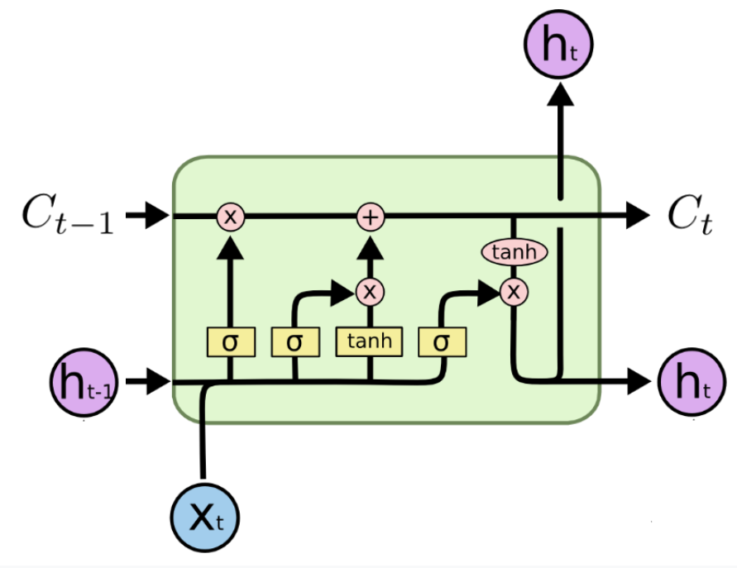
Figure 1.1: RNN: Single LSTM

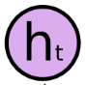 | Current LSTM output
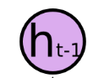 | Previous LSTM output
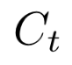 | Current candidate value
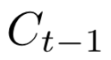 | Previous candidate value
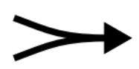 | Concatenate
 | Copy
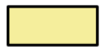 | Neural Network Layer
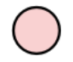 | Pointwise Operation
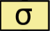 | Sigmoid layer
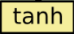 | tanh layer to create a vector of new candidate values
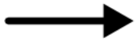 | Vector Transfer

1.3 Spectrogram
A spectrogram is a visual representation of the spectrum of frequencies of a signal as it varies with time. A spectrogram is a visual way of representing the signal strength, or “loudness”, of a signal over time at various frequencies present in a particular waveform.

1.4 Waveform
Waveform means a graphical representation of the shape and form of a signal moving in a gaseous, liquid, or solid medium. For sound, the term describes a depiction of the pattern of sound pressure variation (or amplitude) in the time domain.

1.5 Time Series
Time series is a sequence of numerical data points in successive order. In investing, a time series tracks the movement of the chosen data points, such as a security’s price, over a specified period of time with data points recorded at regular intervals. There is no minimum or maximum amount of time that must be included, allowing the data to be gathered in a way that provides the information being sought by the investor or analyst examining the activity.

1.6 Autoregression Model
Autoregression is a time series model that uses observations from previous time steps as input to a regression equation to predict the value at the next time step. It is a very simple idea that can result in accurate forecasts on a range of time series problems.The autoregressive model specifies that the output variable depends linearly on its own previous values and on a stochastic term (an imperfectly predictable term).The autoregression model is widely used in economic analysis to predict an output of an index based on the previous outputs.This can predict future stock market prices.

1.7 Speech to Text
Google Cloud Speech-to-Text enables developers to convert audio to text by applying powerful neural network models in an easy-to-use API. The API recognizes 120 languages and variants to support your global user base. It can enable voice command-and-control, transcribe audio from call centers, and more. It can process real-time streaming or prerecorded audio, using Google’s machine learning technology.

  - Existing System
WaveNet is a deep neural network for generating raw audio waveforms. The model is fully probabilistic and autoregressive, with the predictive distribution for each audio sample conditioned on all previous ones; nonetheless we show that it can be efficiently trained on data with tens of thousands of samples per second of audio. When applied to text-to-speech, it yields state-of-the-art performance, with human listeners rating it as significantly more natural sounding than the best parametric and concatenative systems for both English and Mandarin. A single WaveNet can capture the characteristics of many different speakers with equal fidelity, and can switch between them by conditioning on the speaker identity. When trained to model music, we find that it generates novel and often highly realistic musical fragments. We also show that it can be employed as a discriminative model, returning promising results for phoneme recognition.
WaveNet is a deep generative model of audio data that operates directly at the waveform level. WaveNets are autoregressive and combine causal filters with dilated convolutions to allow their receptive fields to grow exponentially with depth, which is important to model the long-range temporal dependencies in audio signals. WaveNets can be conditioned on other inputs in a global (e.g. speaker identity) or local way (e.g. linguistic features). When applied to TTS, WaveNets produced samples that outperform the current best TTS systems in subjective naturalness. Finally, WaveNets showed very promising results when applied to music audio modeling and speech recognition.

1.8.1 Disadvantages
The following gaps were identified in the present system:
- The model does not capture the sentiment of the user.
- Usage of Convolutional Neural Network (CNN) instead of Recurrent Neural Network (RNN) for sequence prediction problems.
- We require tens of thousands of timestamps for the waveform representation of sound waves.

CHAPTER 2
LITERATURE SURVEY
[1] Sercan O Arik, et al. “Deep voice: Real-time neural text-to-speech” explained that Deep Voice, a production-quality text-to-speech system constructed entirely from deep neural networks. The system comprises five major building blocks: a segmentation model for locating phoneme boundaries, a grapheme-to-phoneme conversion model, a phoneme duration prediction model, a fundamental frequency prediction model, and an audio synthesis model.
[2] Xi Chen, Nikhil Mishra, Mostafa Rohaninejad, and Pieter Abbeel. “Pixelsnail: An improved autoregressive generative model” proposed that autoregressive generative models consistently achieve the best results in density estimation tasks involving high dimensional data, such as images or audio. They pose density estimation as a sequence modelling task, where a recurrent neural network (RNN) models the conditional distribution over the next element conditioned on all previous elements. A recurrent neural network (RNN) is trained to model p(x_{i} |x_{1:i−1}).
[3] R´emi Decorsi`ere, Peter L Søndergaard, Ewen N Mac-Donald, and Torsten Dau. “Inversion of auditory spectrograms, traditional spectrograms, and other envelope representations” proposed that the two-stage approach on time-domain metrics are applied to traditional spectrograms based on the magnitude of the short-time Fourier transform. STFT and inverse STFT to project the signal back and forth between time domain and time-frequency domain in an iterative fashion. At each iteration, the STFT magnitude is constrained to equal the target spectrogram from which the signal is being reconstructed.
[4] Alex Graves. “Generating sequences with recurrent neural networks” identified that Long Short-term Memory (LSTM) recurrent neural networks can be used to generate complex sequences with long-range structure, simply by predicting one data point at a time. RNNs can be trained for sequence generation by processing real data sequences one step at a time and predicting what comes next. RNNs synthesize and reconstitute the training data in a complex way, and rarely generate the same thing twice. A large enough RNN should be sufficient to generate sequences of arbitrary complexity. RNNs are unable to store information about past inputs for very long. LSTM is an RNN architecture designed to be better at storing and accessing information than standard RNNs. It can use its memory to generate complex, realistic sequences containing long-range structure.
[5] Diederik P Kingma and Max Welling. “Auto-encoding variational bayes” proposed the SGVB (Stochastic Gradient Variational Bayes) algorithm can be applied in learning almost any generative model with continuous latent variables. When we use a neural network for the posterior approximation, we arrive at a variational auto-encoder. The SGVB objective contains a regularization term dictated by the variational bound, and a stochastic data reconstruction term.
[6] Soroush Mehri, et. al. “Samplernn: An unconditional end-to-end neural audio generation model” proposed a novel model for unconditional audio generation based on generating one audio sample at a time. It shows that the model, which profits from combining memory-less modules, namely autoregressive multilayer perceptrons, and stateful recurrent neural networks in a hierarchical structure is able to capture underlying sources of variations in the temporal sequences over very long time spans, on three datasets of different nature.
[7] Wei Ping, Kainan Peng, and Jitong Chen. “Clarinet: Parallel wave generation in end-to-end text-to-speech” proposed a new solution for parallel wave generation by WaveNet. A Gaussian inverse autoregressive flow from the autoregressive WaveNet by minimizing a regularized KL divergence between their highly-peaked output distributions. This method computes the KL divergence in closed-form, which simplifies the training algorithm and provides very efficient distillation.
[8] Aaron van den Oord, et. al. “Wavenet: A generative model for raw audio” explained WaveNet, a deep neural network for generating raw audio waveforms. The model is probabilistic and autoregressive, with the predictive distribution for each audio sample conditioned on all previous ones. A single WaveNet can capture the characteristics of many different speakers with equal fidelity, and can switch between them by conditioning on the speaker identity.
  - Summary of Literature Survey
A production-quality text-to-speech system can be constructed entirely from deep neural networks. STFT and inverse STFT can be used to project the audio signal back and forth between time domain and time-frequency domain in an iterative fashion. When applied autoregressive generative models, they consistently achieve the best results in tasks involving high dimensional data. Long Short-term Memory (LSTM) recurrent neural networks can be used to generate complex sequences with long-range structure. LSTM is an RNN architecture designed to be better at storing and accessing information than standard RNNs. It can use its memory to generate complex, realistic sequences containing long-range structure.

  - Problem Statement
Humans generate sound by their vocal cord is unique, generation of human voice and keeping its original sound condition using machines is very difficult. Adaptation of speech in different languages in real-time and reading a text, keeping realistic voice essence of human is difficult and is not been seen till now.

  - Proposed Solution
The proposed solution generates a model for audio in the frequency domain. The long-range dependencies in the audio are modelled in two-dimensional time-frequency representations such as spectrograms. It also uses a highly expressive probabilistic model and a multiscale generation procedure. A model will be capable of generating high-fidelity audio samples which capture structure at timescale. We apply our model for text-to-speech synthesis in multiple languages. The model learns to procedure diverse vocalizations for the given sample text and also infers speaking characteristics from text and perform text-to-speech on unseen text while preserving speaking style of primary sequence. The model gives a unique voice to your personal assistant. The model can be applied as a audiobook: narrate your books, with celebrity voices, author voices or the voice of one of your relatives. It can get rid of your robotic hotline and provide an ultra-realistic voice with emotion control. It also allows you to read the articles of your favourite website with the voices of your choice.

  - Objectives
- To build a generative model for spectrograms which couples a fine-grained autoregressive model and a multiscale generation procedure to jointly capture local and global structure.
- To model longer-range dependencies than existing time-domain models.
- To build model that is broadly applicable to a variety of audio generation tasks—capable of unconditional speech generation, music generation, and text-to-speech synthesis, entirely end-to-end.

CHAPTER 3
METHODOLOGY
3.1 Flow Diagram
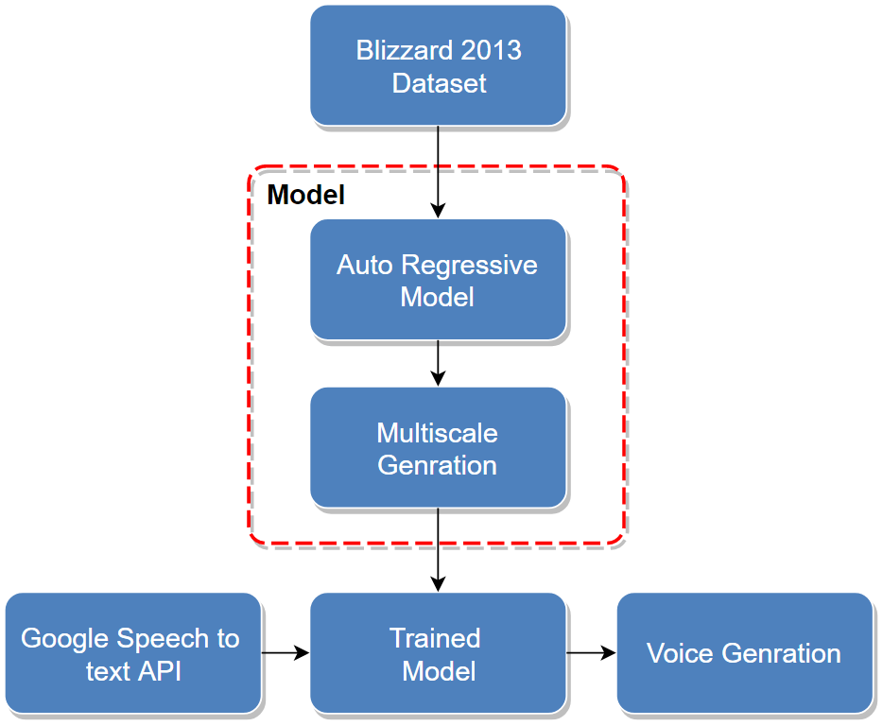
Figure 3.1: Flow Diagram
The dataset contains the synthetic speech submitted by participants in the challenge along with listeners' scores for the subset synthetic speech used in the listening test. The dataset is in WAV file format which is a raw audio format created by Microsoft and IBM. The synthetic speech contains all possible sound syllable which can be generated by human vocal cord.
A highly expressive autoregressive model factorizes the distribution over both the time and frequency dimensions. This model also prevents over smoothing of spectrogram.
A multiscale approach which effectively permutes the autoregressive ordering so that a spectrogram is generated in a coarse-to-fine order
The user’s voice is converted to text using Google’s speech to text API and is given as input to trained model. The model outputs speech which could not be differentiable from targeted original person's speech.
3.2 Network Architecture
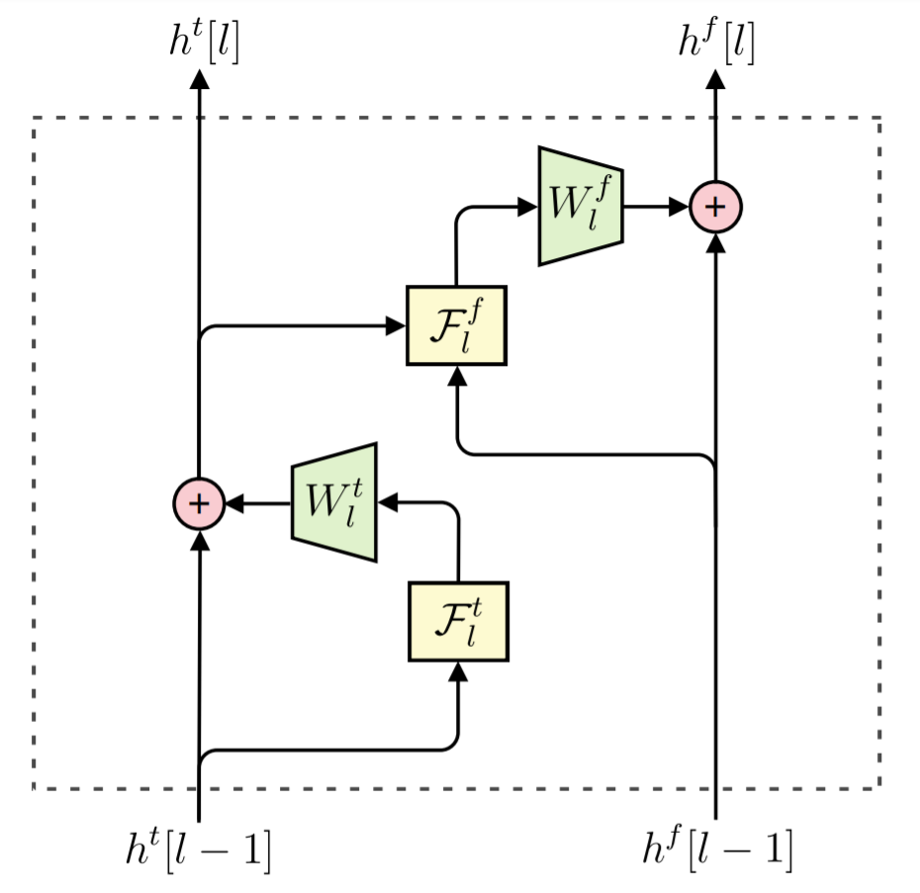
Figure 3.2: Computation graph for a single layer of the network.
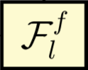 | function computed at layer l of the time delayed stack (three RNNs followed by concatenation)
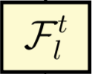 | function computed at layer l by the frequency-delayed stack
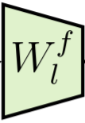 | output of function F_{l}^{f} projected in the form of matrices.
 | output of function F_{l}^{t} projected in the form of matrices.

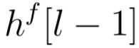 | the previous-layer output of the frequency-delayed stack.
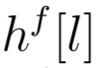 | the output from the frequency-delayed stack
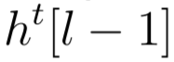 | the previous-layer output of the time-delayed stack,
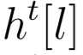 | the output from the time-delayed stack

The network has multiple stacks of computation. They are time-delayed stack and frequency delayed stack. These stacks extract features from different segments of the input to collectively summarize the full context x_{<ij}:
• The time-delayed stack computes features which aggregate information from all previous frames x_{<i,∗}.
• The frequency-delayed stack utilizes all preceding elements within a frame, x_{i,<j} , as well as the outputs of the time-delayed stack, to compute features which
summarize the full context _{x<ij} .

The stacks are connected at each layer of the network, meaning that the features generated by layer l of the time delayed stack are used as input to layer l of the frequency delayed stack. The outputs of the final layer of the frequency-delayed stack are used to compute the unconstrained parameters θ.

3.2.1 Time Delayed Stack
The time-delayed stack utilizes multiple layers of multidimensional RNNs to extract features. Each multidimensional RNN is composed of three one dimensional RNNs: one which runs forwards along the frequency axis, one which runs backwards along the frequency axis, and one which runs forwards along the time axis. Each RNN runs along each slice of a given axis, as shown in Figure 3.1. The output of each layer of the time-delayed stack is the concatenation of the three RNN hidden states.

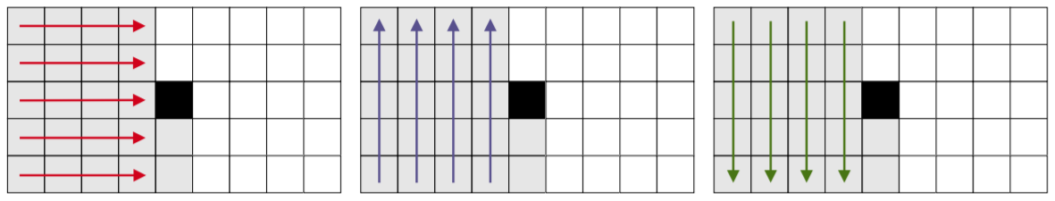
Fig 3.2: Time-delayed stack

At each layer, the time-delayed stack uses the feature map from the previous layer, h^{t}[l-1] to compute the subsequent feature map F_{l}^{t} h^{t}[l-1] which consists of the three concatenated RNN hidden states. When using residual connections, the computation of h^{t}[l] from h^{t}[l-1] becomes
h^{t}_{ij}[l] = W_{l}^{t}F_{l}^{t} (h^{t}[l-1])_{ij +} h^{t}_{ij}[l+1]

To ensure the output h^{t}_{ij}[l] is only a function of frames which lie in the context x_{<ij} , the inputs to the time delayed stack are shifted backwards one step in time:
h^{t}_{ij}[0] = W₀ ^{t}x_{i-1,j}

3.2.2. Frequency-Delayed Stack
The frequency-delayed stack is a one-dimensional RNN which runs forward along the frequency axis. Much like existing one-dimensional autoregressive models (language models, waveform models, etc.), the frequency-delayed stack operates on a one-dimensional sequence (a single frame) and estimates the distribution for each element conditioned on all preceding elements. The primary difference is that it is also conditioned on the outputs of the time delayed stack, allowing it to use the full two-dimensional context x_{<ij}.
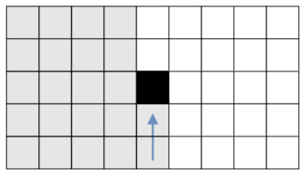
Figure 3.3: Frequency-delayed stack
We denote the function computed by the frequency-delayed stack as F_{l} ^{f}. At each layer, the frequency-delayed stack takes two inputs: the the previous-layer outputs of the frequency-delayed stack, h ^{f}[l-1], and the current-layer outputs of the time-delayed stack h^{t}[l]. These inputs are summed and used as input to a one-dimensional RNN to produce the output feature map F_{l}^{t} (h^{t}[l-1]), h^{t}[l] which consists of the RNN hidden state:
h^{f}_{ij}[l] = W_{l}^{t}F_{l}^{t} (h^{f}[l-1], h^{t}[l]) ₊ h^{f}_{ij}[l+1]

To ensure that h^{f}_{ij}[l] is computed using only elements in the context x_{<ij} , the inputs to the frequency-delayed stack are shifted backwards one step along the frequency axis:
h^{f}_{ij}[0] = W₀ ^{t}x_{i,j-1}

At the final layer, layer L, a linear map is applied to the output of the frequency-delayed stack to produce the unconstrained parameters:
θ_{ij}= W_{θ}h^{f}_{ij}[L]
3.3 Description of Each Phase
The development of the project consists of following five SDLC (Software Development Life Cycle) phases:
- Planning Phase
The first step is making a research in finding the best project to propose. After get information about the project, proposal is submitted. The proposal consists of the project background, problem area, objectives and project requirements. This is the most important thing to do in phase planning.

- Analysis Phase
First of all, the analysis has to done to know the view of whole system to develop. The content of the proposal is the result from the analysis.
In this chapter, the important thing needed is to make more research to capture key functionality, system process and tolls needed. This finding and research can be done via internet, journal, books and article. The finding should be described and elaborated in diagram, chart and table to make the system easier to understand in process of development.
Many analyses must be done to know the business process of the as-is system and to-be system. Analysis about requirements and functionality of the system is very important to process and develop the system.

- Design Phase
Based on the analysis phase, the design will be done. The design phase consists of 3 activities. These activities are:
- Logical design: This activity involves class diagram and interaction diagram
- Interface design: The activity includes navigation design, output design and input design.
- Database design: This activity defines logical data model, detail explanation for each entity, description of the association, cardinality and relationship.
- Testing phase
In this phase, all functionality systems are tested and confirms that there are no errors.

- Implementation Phase
After all phases have been perfectly done, the system will be implemented to the server and the system can be used.

CHAPTER 4
TOOLS AND TECHNOLOGIES IDENTIFIED
4.1 Tools and Techniques
Software:
- Python
- Pytorch

Hardware:
- Proccesor: Intel Core i5 8th gen
- Ram: 8 GB
- Graphics Card: GeForce GTX 1060

API:
- Google Speech API
- Speech Recognition
- pyaudio

IDE: VS code

Backend: Django

4.2 Technologies
1. Python: Python is an interpreted, high-level, general-purpose programming language.Python allows mandatory and optional arguments, keyword arguments, and even arbitrary argument lists.

2. Pandas: Pandas is a software library written for the Python programming language for data manipulation and analysis. In particular, it offers data structures and operations for manipulating numerical tables and time series

3. Matplotlib: Matplotlib is a plotting library for the Python programming language and its numerical mathematics extension NumPy. It provides an object-oriented API for embedding plots into applications using general-purpose GUI

4. Numpy: NumPy is a library for the Python programming language, adding support for large, multi-dimensional arrays and matrices, along with a large collection of high-level mathematical functions

5. Pytorch: PyTorch is an open source machine learning library based on the Torch library, used for applications such as computer vision and natural language processing. It is primarily developed by Facebook's artificial intelligence research group

6. Speech Recognition: Library for performing speech recognition, with support for several engines and APIs, online and offline.

7. pyaudio: Bindings for PortAudio v19, the cross-platform audio input/output stream library.

8. RNN (Recurrent Neural Network): Type of Neural Network where the output from previous step are fed as input to the current step. RNN came into existence, which solved this issue with the help of a Hidden Layer. The main and most important feature of RNN is Hidden state, which remembers some information about a sequence. RNN have a “memory” which remembers all information about what has been calculated

9. Django: Django is a Python-based free and open-source web framework, which follows the model-template-view architectural pattern.

10. React: React is a JavaScript library for building user interfaces.React can be used as a base in the development of single-page or mobile applications, as it is optimal for fetching rapidly changing data that needs to be recorded.

11. Google Speech to text API: Google Cloud Speech-to-Text enables developers to convert audio to text by applying powerful neural network models in an easy-to-use API. The API recognizes 120 languages and variants to support your global user base. You can enable voice command-and-control, transcribe audio from call centers, and more.

