Maintenance Documentation

Android Ticket System

### Database Diagram

### Untitled.png

### Table Details

* Login
  + Username: holds username data
  + password : original project specified that the password had to be 8 char exactly and had to have at least 1 capital, 1 special char, and one number
  + Access level: indicates the difference between admin and technician. Access level of 2 indicates admin 1 technician.
* Notes
  + Noteid: Auto incremented primary key unique identifier for note data
  + Ticketid: Foreign key referencing ticket table
  + Note: text area data of relevant information to a particular ticket
* Tickets
  + Ticketid: Auto incremented primary key unique identifier for tickets
  + Firstname: First name of ticket submitter
  + Lastname: Last name of ticket submitter
  + Urgency: Submitters perceived importance of submitted ticket
  + Catagories: Believed cause or problem of ticket for sorting purposes
  + Description: Details of ticket submission
  + Domain: Status of submitter (Student, Instructor, Admin)
  + Date_submitted: Date and time of ticket submittion, yyyy-mm-dd hh:mm:ss
  + Email: Email of ticket submitter
  + Active: current status of ticket (0 = open, 1 = closed)
  + lastUpdate: Date and time of last update to ticket, yyyy-mm-dd hh:mm:ss
  + Closed: Time of ticket being closed.
  + Pcid: ID of the pc ticket relates to
  + Stateid: state ID ticket relates to
  + Assignedtech: the technician currently assigned to ticket resolution.

### Database Create Table Scripts

CREATE TABLE `login` (  
 `username` varchar(20) COLLATE utf8_unicode_ci NOT NULL,  
 `password` varchar(8) COLLATE utf8_unicode_ci DEFAULT NULL,  
 `accesslevel` int(1) NOT NULL  
)

CREATE TABLE `notes` (  
 `noteid` int(11) NOT NULL AUTO_INCREMENT,  
 `ticketid` int(11) NOT NULL,  
 `note` varchar(1000) COLLATE utf8_unicode_ci DEFAULT NULL,  
 PRIMARY KEY (`noteid`),  
 KEY `ticketid` (`ticketid`)  
)  
   
CREATE TABLE `Tickets` (  
 `ticketid` int(11) unsigned zerofill NOT NULL AUTO_INCREMENT,  
 `firstname` varchar(20) COLLATE utf8_unicode_ci DEFAULT NULL,  
 `lastname` varchar(20) COLLATE utf8_unicode_ci DEFAULT NULL,  
 `urgency` varchar(11) COLLATE utf8_unicode_ci DEFAULT NULL,  
 `catagories` int(11) DEFAULT NULL,  
 `description` varchar(500) COLLATE utf8_unicode_ci DEFAULT NULL,  
 `domain` varchar(10) COLLATE utf8_unicode_ci DEFAULT NULL,  
 `date submitted` timestamp NOT NULL DEFAULT CURRENT_TIMESTAMP ON UPDATE CURRENT_TIMESTAMP,  
 `email` varchar(40) COLLATE utf8_unicode_ci DEFAULT NULL,  
 `active` tinyint(1) NOT NULL,  
 `lastUpdated` timestamp NOT NULL DEFAULT '0000-00-00 00:00:00',  
 `closed` timestamp NOT NULL DEFAULT '0000-00-00 00:00:00',  
 `pcid` varchar(25) COLLATE utf8_unicode_ci DEFAULT NULL,  
 `stateid` varchar(8) COLLATE utf8_unicode_ci DEFAULT NULL,  
 `assignedtech` varchar(20) COLLATE utf8_unicode_ci DEFAULT NULL,  
 PRIMARY KEY (`ticketid`),  
 UNIQUE KEY `ticketid` (`ticketid`),  
 KEY `ticketid_2` (`ticketid`),  
 KEY `ticketid_3` (`ticketid`)  
)

Page Flow Diagram

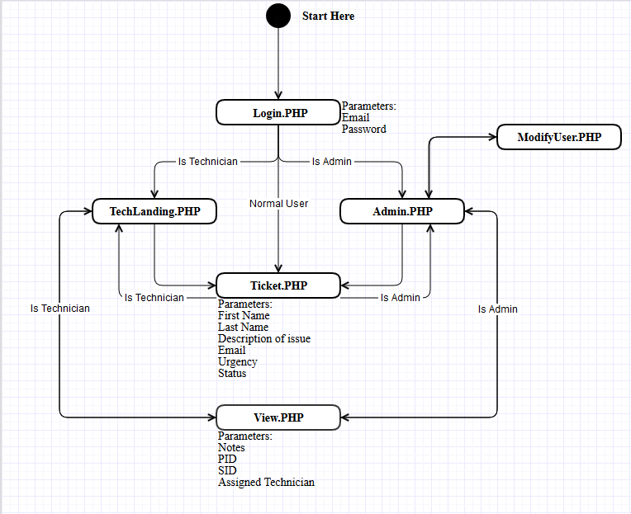

File Descriptions

**Android files**

AppLanding.java: First activity. Holds Login functionality. Communicates with loginAndroid.php.

MyApplication.java: Enusres that the context provided to the volley request que is always the correct context.

SingleTicketActivity.java: Unfinished. Intended to display specific information relating to a single ticket selected on TicketTableActivity.java. Is supposed to hold functionality to update the information about the single ticket.

SubmitTicketActivity.java: This activity hold functionality to submit a new ticket to the database via AndroidSubmitTicket.php.

TicketTableActivity.java: This activity displays a list of the open tickets in database. Communicates with AndroidTicketTable.php.

VolleySinglton.java: This class is used to prevent multiple request que’s from being created. Funnels all volley requests through one que.

AndroidManifest.xml: This file is mostly auto-generated. But had to add internet and network permissions.

**Php files**

AndroidTicketTable.php: Holds php scripts to receive a JSONArray request and return all open tickets in the database.

loginAndroid.php: Holds php scripts to semi-securely login. The file checks for the 1 match in the database of username and password. If true returns “true” and username. If false return “false”.

AndroidSubmitTicket.php: Holds php scripts to add a new ticket to the database. If no errors returns “success”.