Simulating DOS attack from Kali vm to another Kali vm

Install virtual box and kali linux

Launch one kali instance and then go to settings->storage->empty disk->kali-linux.iso(default)

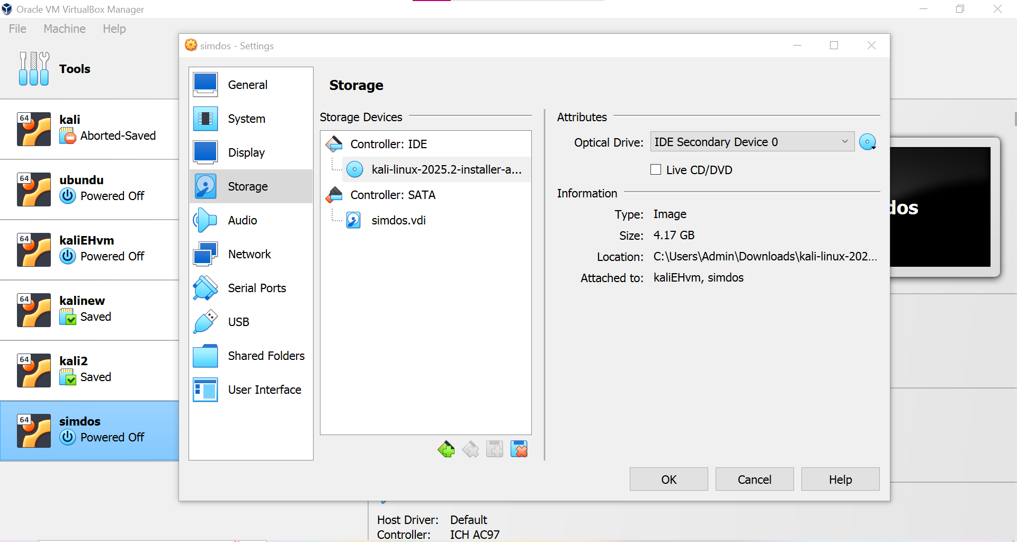

Then choose clone, name it attacker then click next,choose full clone and then finish.

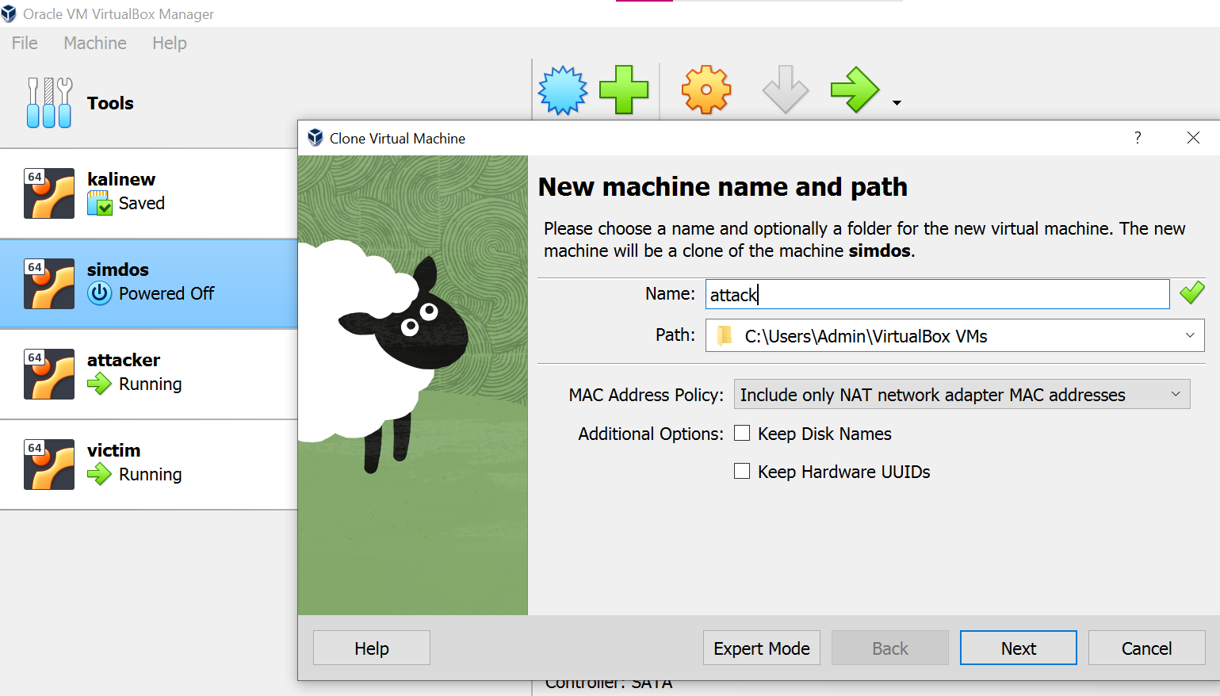

Same for another clone that is named victim

If using WiFi, go to settings of both attacker and victim,

In network->adapter1 ->enable->choose NAT.

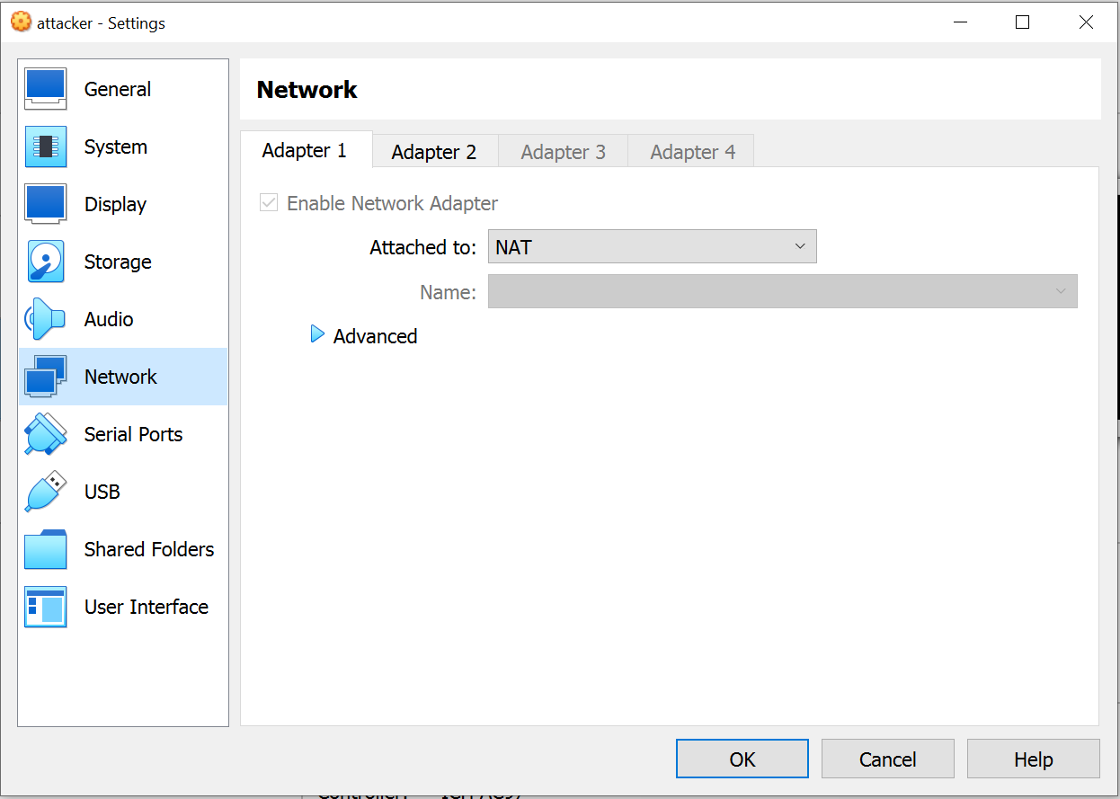

adapter2->enable->choose host only adapter,virtualbox host only Ethernet adapter.

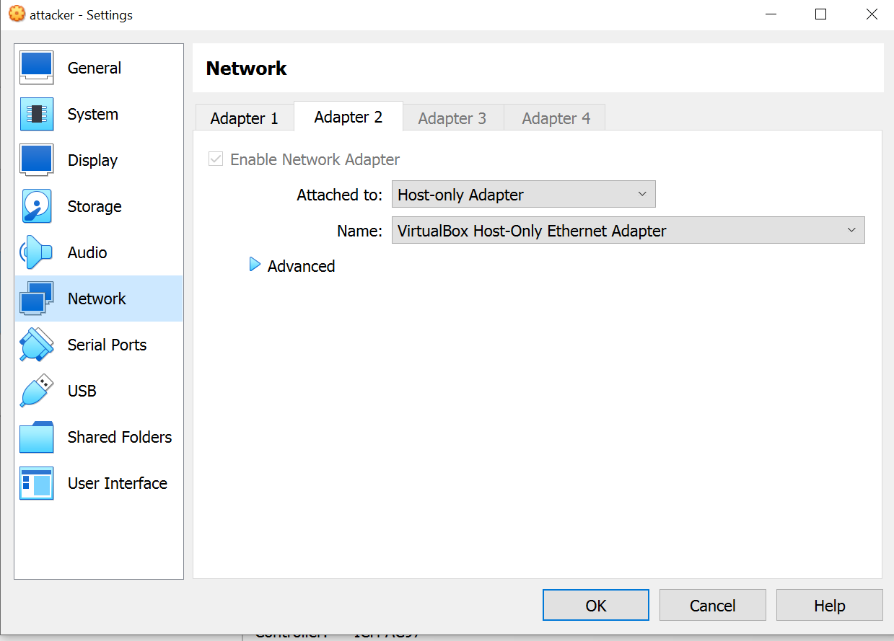

Then start both vm(attacker,victim).

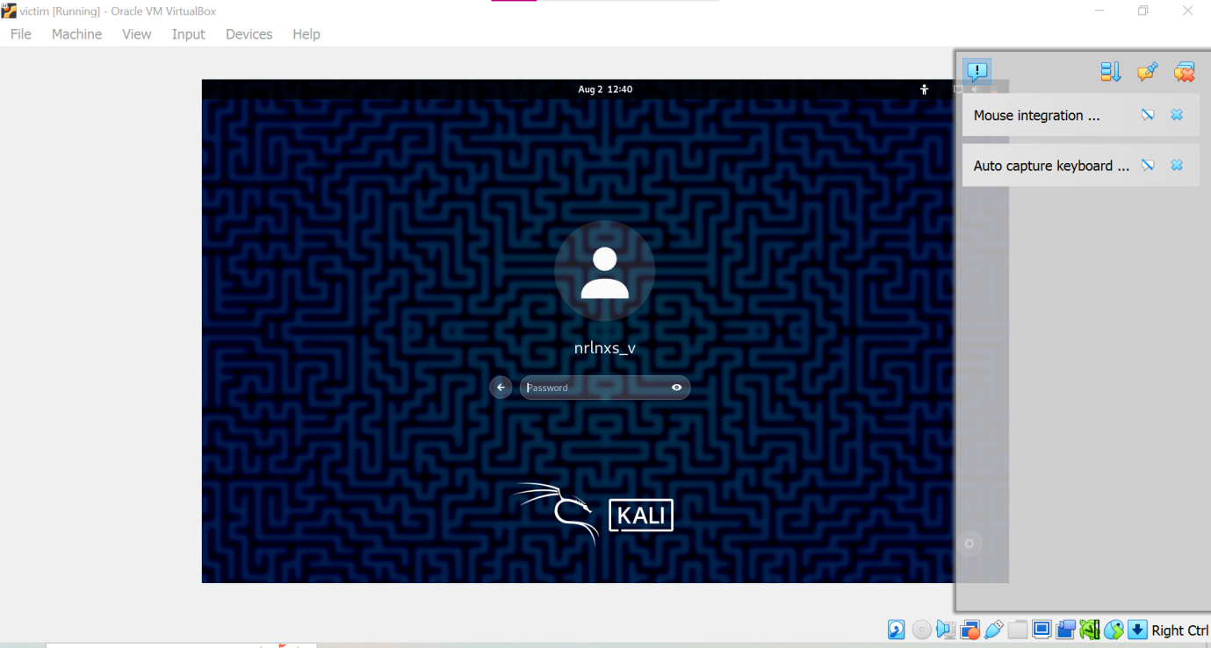

Then check IP of both attacker and victim using ifconfig. Both must have different ip.

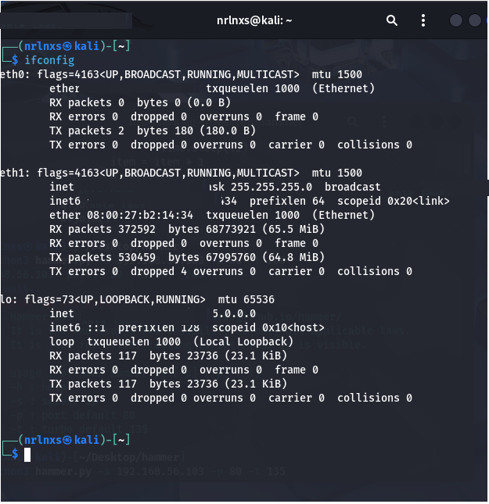

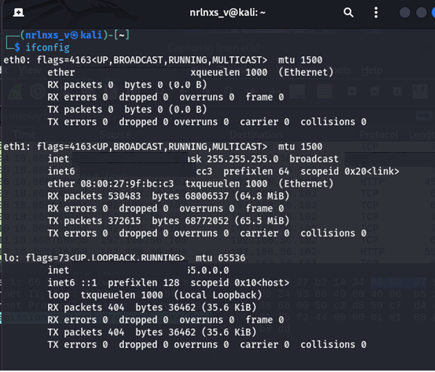

In attacker, ping victim using ping command.

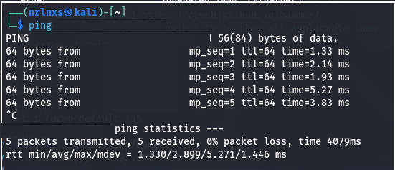

In attacker, install python3

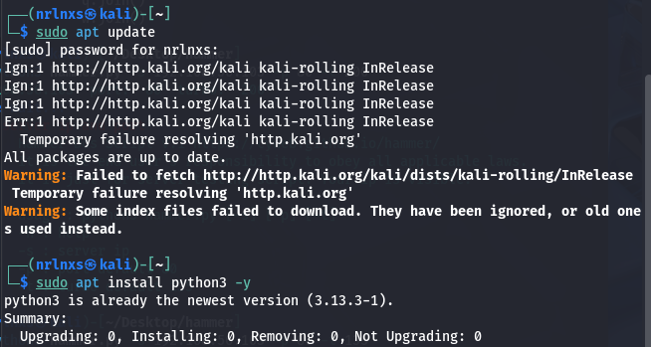

in attacker

Then move to directory Desktop,

cd Desktop

and get git repository hammer,

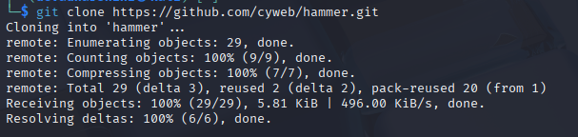

Move to directory hammer

cd hammer

check tcp port 80 of victim is free

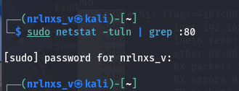

Install apache2 on victim

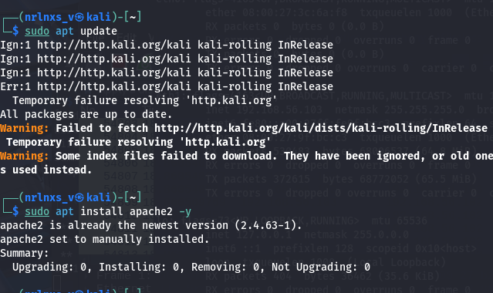

Then start apache server and check its status in victim.

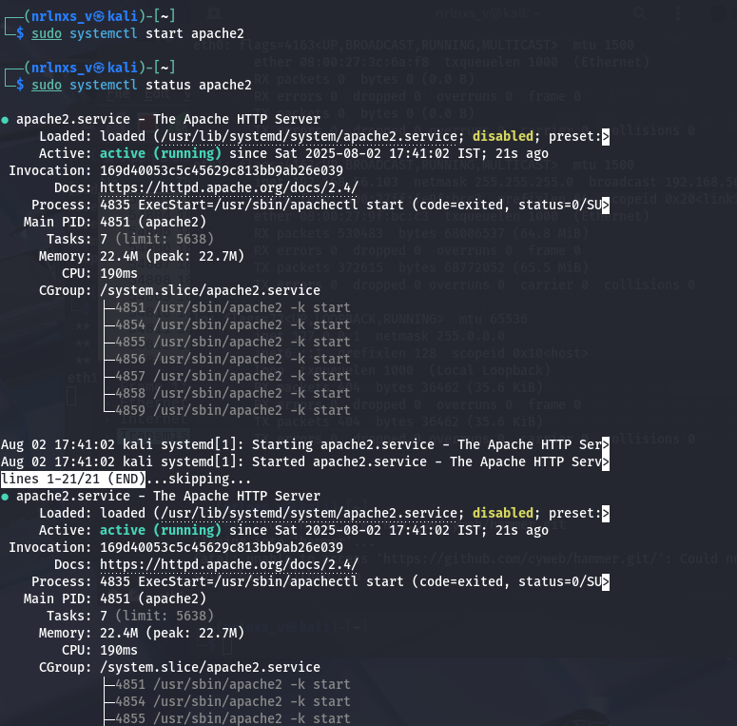

Active:active(running)->represents apache2 server is running.

use sudo ufw status to check firewall is active. If it is active we can’t perform dos.

In attacker,

curl http://<ip of victim>

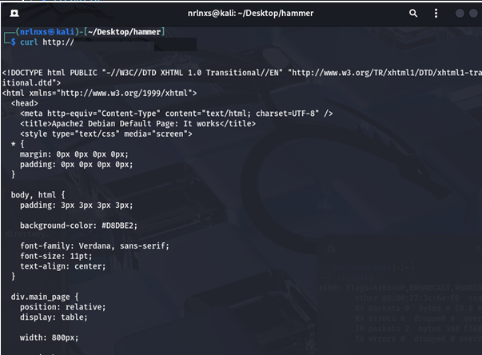

Shows some html code that means we can that victim machine is accessible and we can simulate dos on it.

Use command,

Python3 hammer.py –s <ip of victim> -p 80 –t 135

-p ->tcp port

-t->threads

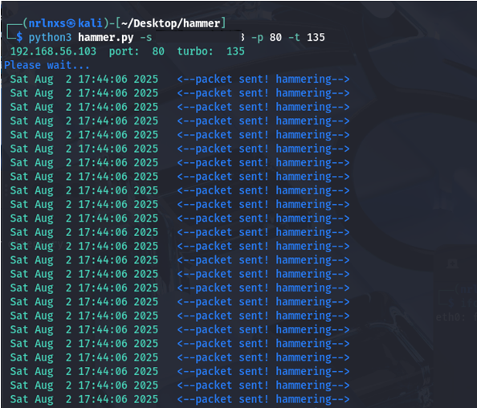

This continuously send http requests to victim machine. And make it slowdown, may cause failure.

From time 17:44:06 to 17:48:36, it generates 56595 packets.

In victim machine, use

sudo tail -f /var/log/apache2/access.log

to check the requests arrive.

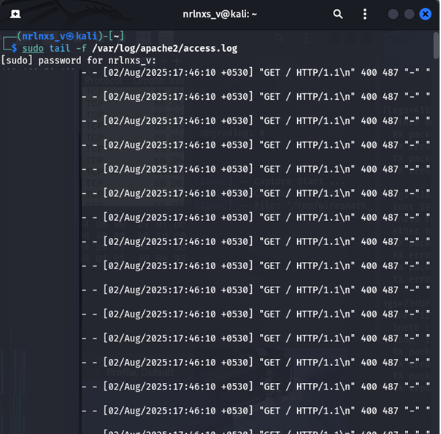

If Want to visualize the packets received use wireshark,

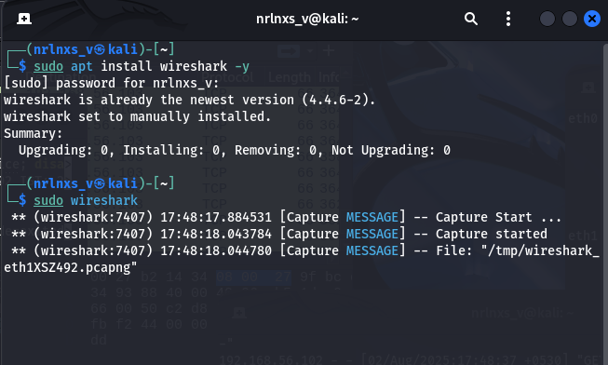

Packets captured:

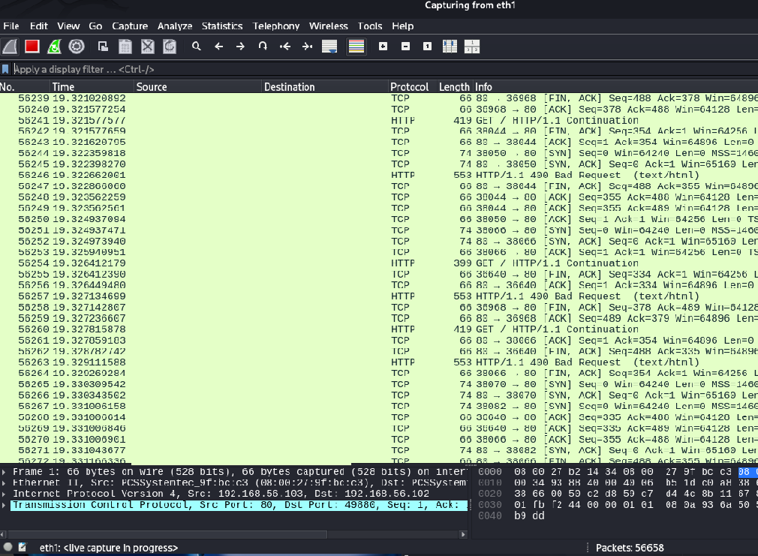

Finally we simulate dos attack from one kali vm to another kali vm that uses apache2 server.

**Disclaimer:**  
This document contains detailed information about Denial of Service (DoS) attacks, including methods, techniques, and potential vulnerabilities. It is intended solely for educational, research, and cybersecurity awareness purposes. Unauthorized use or exploitation of the information provided in this document for malicious or illegal activities is strictly prohibited and may result in legal consequences. The author and distributor of this document do not endorse or condone any form of cyberattack or unauthorized network intrusion. Readers are urged to use this information responsibly and within the boundaries of applicable laws and regulations.