**Pathways towards risk-informed sustainable development and trade: Integrating disaster risk reduction and prevention into global trade and trade policy**

**Pathways towards risk-informed sustainable development and trade: Integrating disaster risk reduction and prevention into global trade and trade policy**

1. **Introduction**

The COVID-19 pandemic is a global shock that continues to wreak havoc across the world. In addition, we witness an onslaught of natural and man-made disasters, of previously unseen strength, frequency and location. Many of these disasters can be linked to widespread, rapid, and intensifying climate change set in motion.[1] Conflict, trade wars, complex humanitarian crises and mass displacement complicate the global political landscape. As a result, calls for rethinking of our approach to development start to reverberate across the globe, calls nothing short of a reset of our global systems, in economic, financial and social terms.

The calls reflect the recognition of political and business leaders that, without urgent action, a future punctuated by shocks and crises of growing intensity and frequency lies ahead. A future increasingly defined by the interactions between climate change, ecosystem fragility, biodiversity loss, disease outbreaks, unplanned urbanization, mass displacement and geo-political instability. A future in which the interconnectivity of communications, economies and politics accentuates the risks of contagion and provides the foundation for collective action.

**BOX:** “If I had to select one sentence to describe the state of the world, I would say we are in a world in which global challenges are more and more integrated, and the responses are more and more fragmented, and if this is not reversed, it’s a recipe for disaster.” UN Secretary-General Antonio Guterres

In this rapidly changing and increasingly uncertain risk landscape, accelerating the integration of comprehensive resilience and disaster (including climate) risk reduction into social and economic development is essential if our global systems are to be sustainable for the future.[2] Within this, it is increasingly recognized that rising temperatures and extreme weather events also has implications for production and trade in all countries.[3] Similarly, the SDGs put significant emphasis on the role that trade plays in promoting sustainable development and recognize the contribution that the WTO can make to the 2030 Agenda.[4] In both cases, we need better understanding of the role trade can play in enabling resilient, sustainable development. This included how trade is affected by the changing climate and risk landscape and how to ensure that trade does not amplify disaster risks, thereby undermining development gains, both present and future. Incorporating risk reduction into global trade and trade policy through closer engagement and exchange between the risk reduction and trade communities is one way to address this.

**Box:** “I have said that to remain relevant, the WTO needs to deliver results. And looking to the future, we have to see how we can harness the power of trade to help us have a healthy environment….Trade policies can help unlock the green investment and innovation needed to decarbonize our economies and create the jobs of the future.” WTO Director General Dr Ngozi Okonjo-Iweala

In this paper, we explore how trade and trade policy can support a greener, more sustainable and resilient economic system through the lens of disaster risk reduction aligned with the Sendai Framework for Disaster Risk Reduction.[5] We start by identifying challenges, progress and opportunities on risk, prevention and resilience and their current integration into the economic and financial systems. Building on that foundation, we explore progress and opportunities for global trade and trade policy to help strengthen resilience through disaster risk reduction (DRR). We close with a set of recommendations for the trade, economic and risk reduction communities to consider in support of risk-informed trade and sustainable development.

1. **The interrelation between disaster risk reduction and sustainable economic development**

The interrelation between DRR and sustainable economic development is not a new concept. First articulated in the 1994 Yokohama Strategy and Plan of Action for a Safer World[6], risk reduction was integrated in all main global development agreements (e.g. 2000 Millennium Development Goals, 2002 Johannesburg Plan of Implementation, Hyogo Framework for Action 2005-2015 and 2012 Rio Declaration on “Future We Want”). Governments took another step in 2015. The commitments contained in the 2030 Agenda for Sustainable Development, Addis Ababa Action Agenda, Paris Agreement and Sendai Framework for Disaster Risk Reduction present a collective call to action to go beyond short-term thinking to achieve climate-smart, risk-informed sustainable development and economic growth.This was driven by rapidly rising economic impact caused by disasters and related recognition that the long-term costs of prevention and risk reduction are ‘but a tiny fraction of the astronomic costs of episodic, often chaotic responses to sudden, emergent crises driven by unforeseen shocks.’ [7]

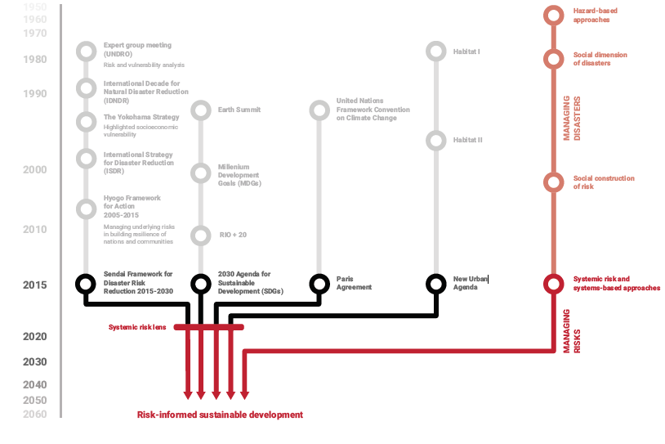

UNDRR GAR 2019[8]

Within the 2030 agenda agreements, the Sendai Framework is the global blueprint for disaster risk reduction, prevention and resilience. It aims at ‘the prevention of new and reduction of existing disaster riskthrough the implementation of integrated and inclusive economic, structural, legal, social, health, cultural, educational, environmental, technological, political and institutional measures that prevent and reduce hazard exposure and vulnerability to disaster, increase preparedness for response and recovery and thus build resilience.’

Though the word ‘trade’ does not appear in the Sendai Framework, the word ‘economic’ is mentioned 23 times. The substantial reduction of economic losses and damage to critical infrastructure and making economic assets more resilient are key underlying concepts of the agreement (see Box below). The discrepancy may be related to the fact that, prior to 2015, there is little evidence from the progress reports of the Hyogo Framework for Action 2005-2015, the predecessor of the Sendai Framework, of the engagement of investment boards, trade ministries and private sector in national disaster risk governance frameworks.[9]

**Box: A global framework for a resilient, risk-informed future**

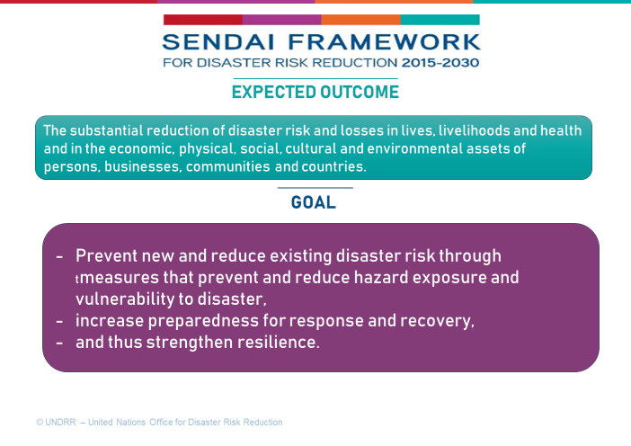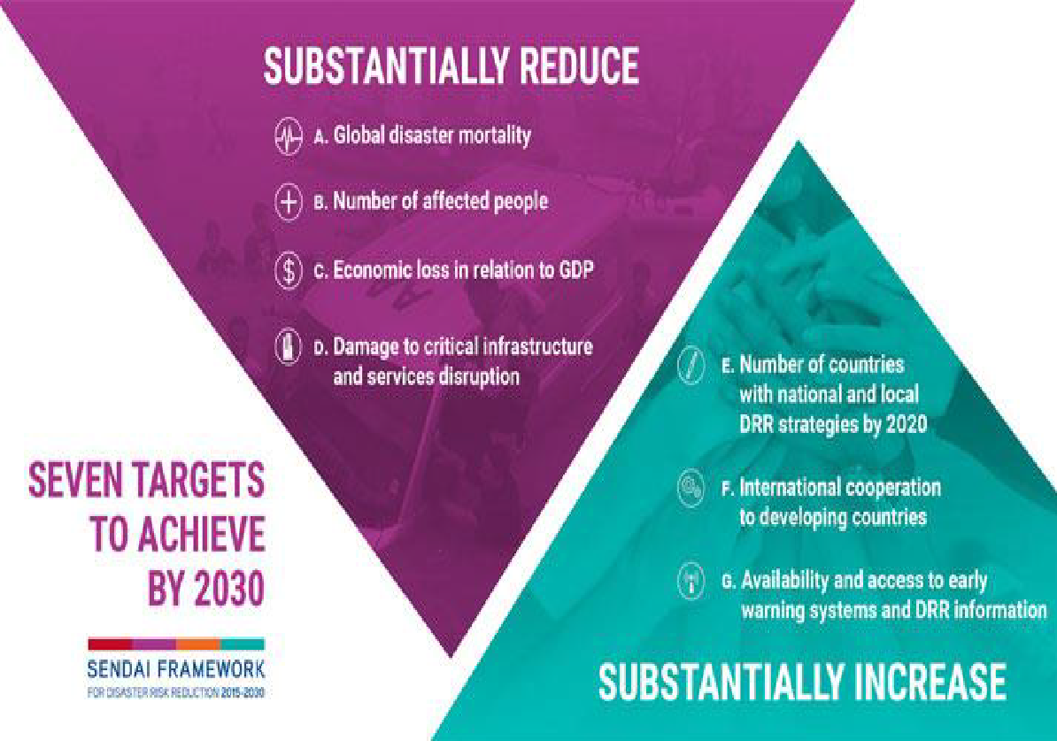

Source: UNDRR

Another key development in 2015 was the expansion of the scope of disaster risk reduction to cover risks caused by natural and man-made hazards, including related biological, environmental and technological hazards and risks. A recent effort by the science community identified over 300 hazards comprised in this scope (see Box below).[10] Importantly, Member States also reflected on the increasingly interconnected risk landscape and its cascading and ‘systemic’ impact, enshrining a shift from response to prevention, from short- to long-term thinking, from risk-blind to risk- informed decision-making into the Sendai Framework.

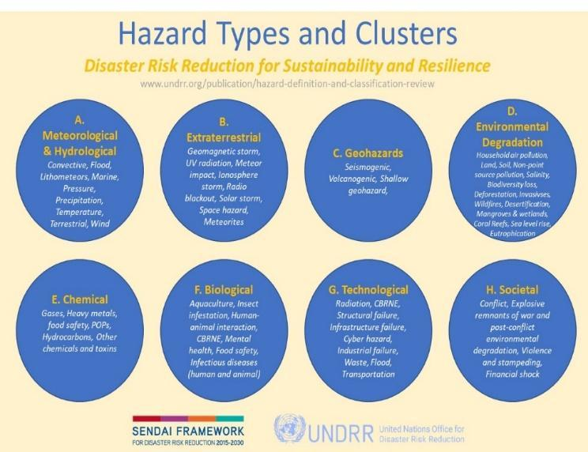

Source: UNDRR 2021

**Box: A Word on Definitions**

In this paper, we focus on risk prevention and risk reduction (rather than preparedness for response) as key elements of resilience and sustainable economic development. As the discussion on risk and resilience is picked up by different sectors, fields and stakeholder groups, the lack of common definitions and understanding of related terms has (again) become very clear. We use the risk terminologies agreed by the UN Member States in 2009 and 2017 (UN General Assembly Resolution A/RES/76/276). [11] Therein:

* **Risk** is the combination of the probability of an event and its negative consequences, and generally understood as the combination of natural or man-made hazards, exposure and vulnerability.
* **Resilience** is defined as the ability of a system, community or society exposed to hazards to resist, absorb, accommodate, adapt to, transform and recover from the effects of a hazard in a timely and efficient manner, including through the preservation and restoration of its essential basic structures and functions through risk management. Importantly, resilience thereby encompasses economic, social, health and environmental resilience.
* **Disaster risk reduction (DRR)** is aimed at preventing new and reducing existing disaster risk and managing residual risk, all of which contribute to strengthening resilience and therefore to the achievement of sustainable development.
* **(Disaster) Prevention** is defined as activities and measures to avoid existing and new disaster risks. Prevention expresses the concept and intention to completely avoid potential adverse impacts of hazardous events. While certain disaster risks cannot be eliminated, prevention aims at reducing vulnerability and exposure in such contexts where, as a result, the risk of disaster is removed. Examples include dams or embankments that eliminate flood risks, land-use regulations that do not permit any settlement in high-risk zones, seismic engineering designs that ensure the survival and function of a critical building in any likely earthquake and immunization against vaccine-preventable diseases. Prevention measures can also be taken during or after a hazardous event or disaster to prevent secondary hazards or their consequences, such as measures to prevent the contamination of water.
* **Multi-hazard approaches** and risk analysis involves the selection of multiple major hazards that [the entity] faces; and the assessment of the specific contexts where hazardous events may cascade, occur simultaneously or cumulatively over time, taking into account the potential interrelated effects.
* **Risk-informed investment:** Investments that incorporate an understanding of multiple and concurrent sources of risk, which may interact in complex and cascading ways.
* **Systemic risk** in financial terms is the risk of a breakdown of an entire financial system (e.g., in one country, one region, or globally) rather than simply the failure of individual parts (e.g., one bank or one firm). This definition of systemic risk captures the risk of a cascading failure, caused by interlinkages within the financial system, resulting potentially in a severe economic downturn.[12] In the DRR community, systemic risk has been understood as risk that is endogenous to, or embedded in, a system that is not itself considered to be a risk and is therefore not generally tracked or managed, but which is understood through systems analysis to have a latent or cumulative risk potential to negatively impact overall system performance when some characteristics of the system change.[13]

1. **Why the trade community should care about risk reduction, prevention and resilience**

Despite the global recognition of the economic value of prevention versus response, until now the focus of policy and practice remained mainly on preparedness and response to disasters and less on risk reduction as a means for preventing disasters from happening in the first place.

COVID-19 is changing this dynamic. Since January 2020, we have seen more momentum and concrete action towards ex ante risk reduction and prevention in the COVID-19 recovery, sustainable development, climate change and related financing processes. New policies, laws and regulation on carbon emissions, climate risk disclosures, integration of environmental, social, governance (ESG) and a circular economy in support of the transition to more sustainable, green and healthy systems beginning to catalyze change within the economic and finance sectors. If implemented, the changes will impact the way business is done and with this also how goods and services are traded.

**BOX:** If lessons from this crisis only inform decision-makers how to better prepare for the next pandemic—rather than enhancing risk processes, capabilities and culture—the world will be again planning for the last crisis rather than anticipating the next. 2021 Global Risk Report, World Economic Forum (WEF)

The need for urgent change is supported by a suite of economic evidence: Between 2000 to 2019, 7,348 major disaster events were recorded that claimed 1.23 million lives, affected 4.2 billion people (many on more than one occasion) and resulted in approximately US$2.97 trillion in global economic losses.[14]

In only 20 months, COVID-19 has surpassed these records. As of July 2021, the pandemic had caused over 4 million deaths and severe socio-economic impact, including rising inequalities, violence against women, child labor, loss of education progress, jobs and livelihoods. For many economists, the overall costs of this is incalculable;[15] the Economist put forward an estimate of USD10 trillion in forgone GDP.[16] In July 2021, the IMF calculated that the ‘final bill’ for the pandemic would total USD28 trillion in lost output,[17]  with GDP loss in 2020 of 3,5 percent, a 7 percent loss relative to the 3.4 percent growth forecast back in October 2019. [18]

With changing virus variants and uncertainties related to the vaccine rollout it seems likely that these estimates need further revisions. Though fiscal support prevented more severe economic contractions and larger job losses, it also meant that, as per July 2021, average deficits as a share of GDP in 2020 reached 11.7 percent for advanced economies, 9.8 percent for emerging market economies, and 5.5 percent for low-income developing countries.[19] Within this picture, the IMF foresees significant scarring in economic performance and income distribution through 2025, associated with an increase in poverty of about 75 million people.[20]

**GDP growth rate of the world's seven largest economies as of 3rd quarter of 2020, by country**

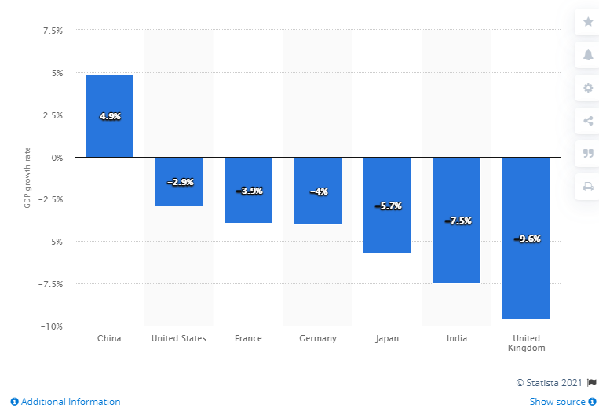

Statista 2021 Accessed 14 May 2021 https://www.statista.com/statistics/1207780/gdp-growth-rate-of-the-world-s-seven-largest-economies-by-country/[21]

At the same time, the pandemic is not the only disaster that should raise alarm bells in the trade sector. Though often overlooked in the ‘pandemic storm’, other disasters caused by natural and man-made hazards did not relent. With the jury is still out on 2021, 2020 was the fifth costliest year on record in terms of global insured losses from so called ‘natural disasters.’[22] And this was just a ‘lucky escape’[23] as a record-breaking Atlantic hurricane season in 2020 only hit areas of low population density, economic activity and/or low insurance penetration. In the same year, conflict and disaster displacement triggered immediate and direct costs of $20.5 billion globally.[24] In light of this, insurance experts warn that the accumulation of socio-economic value and other dynamics such as changing weather conditions in the intervening years could lead to large scale losses in the future, with potential annual insured losses (only!) as high as USD 250-300 billion.[25] With some risks and regions becoming uninsurable,[26] these changes will have a severe impact on business and trade as usual.

Within the range of systemic risk, climate change is possibly the biggest economic, social, and environmental threat to the planet and humanity today. In the US, the total costs of 298 major weather and climate disasters since 1980 exceed $1.975 trillion[27]. Climate change could cut world economy by $23 trillion in 2050.[28] Estimates of disaster response spending needs of $1 trillion, or 0.75% of global GDP, in a 1 °C global temperature rise[29] seem not only a daring prospect in light of overstretched humanitarian budgets and tightening fiscal space, but outdated in light of dire warnings by the IPCC that, without urgent global and coordinated action to reduce emissions and climate risks, even 1.5 or 2.0 °C scenarios may be out of reach. The IPCC also highlighted that impacts other than temperature caused by climate change are already driving unpredictable changes and tipping points globally which must be addressed by accelerated action on adaptation and risk reduction.[30] Drought as a driver of desertification and land degradation, increasing fragility of ecosystems and social instability has become a major systemic risk threatening peace, wellbeing, and resilience of communities worldwide.[31]

Though currently undervalued in most official disaster statistics, the impact of man-made disasters and their systemic impact on economies and trade is also rising. Examples include the Brumadinho dam collapse in 2019 which spooked investors (see below) as well as financial losses due to cybercrime estimated to reach USD 10.5 trillion annually by 2025.[32] According to the World Bank, the Beirut explosion in 2020, highlighted as a key example of interconnected risk,[33] cost Lebanon $3.8-4.6 billion in material damage; combined with the economic impact of COVID-19 GDP plummeted from close to US$55 billion in 2018 to an estimated US$33 billion in 2020.[34]

**BOX** ‘The impacts of the COVID-19 on people's health and daily life, stock markets, and businesses illustrate the increasingly dynamic, interconnected and complex nature of the challenges facing governments around the world. Integrating new economic approaches (including systemic thinking, resilience, neuro-economics, econophysics, non-linear dynamics, nonequilibrium social science, integrative economics) will be essential to address these issues in an era of rapid and disruptive change. William Hynes, Senior Advisor to the Secretary General and Coordinator of New Approaches to Economic Challenges (NAEC), OECD[35]

Yet, at the same time, as stock markets roared since May 2020 and global economic growth projected at 6.0 % in 2021 and 4.9% in 2022[36], some experts laude the global economic, finance and trade systems as inherently resilient.[37] In the trade world, after a ‘short-lived but deep dive’[38] in 2020, global trade is expected to grow up to 8.0% in 2021[39] and 6.0% in 2022.[40] Trade in goods recovered more quickly than trade in services, in parts due to the nature of the pandemic as well as due to what some experts see as ‘considerable resilience’ of global value chains to transitory disruptions in the first semester of 2020.[41] Global Foreign Direct Investment (FDI) flows dropped by 35% in 2020 but are expected to bottom out and rise by 10-15% in 2021.[42]

So, why be concerned? In fact, the picture is not that simple. Kristalina Georgieva, Managing Director of the IMF, highlighted the intensifying divergence across economies. ‘Essentially, the world is facing a two-track recovery’, she said at the G20 Finance Ministers meeting in July 2021.[43] Or, as Dr Ngozi Okonjo-Iweala, Director General of the WTO, phrased it, reality is ‘looking like the tale of two pandemics.’[44] Whilst forecasts for advanced economies rose over the course of 2021, including due to anticipated fiscal support and vaccine access, prospects for emerging market and developing economies have been marked down.[45] And as the pandemic and other disasters continue to exact a heavy socio-economic toll on trade and aid dependent developing and emerging economies with already tight fiscal space it feeds into the vicious cycle between poverty and disasters. As Steve Hallegatte, Senior Economist at the World Bank, noted, the main policy implication is that poverty reduction can be considered as disaster risk management, and disaster risk management can be considered as poverty reduction.[46]

**Graph: Effects of COVID-19 on the wellbeing of the poor**

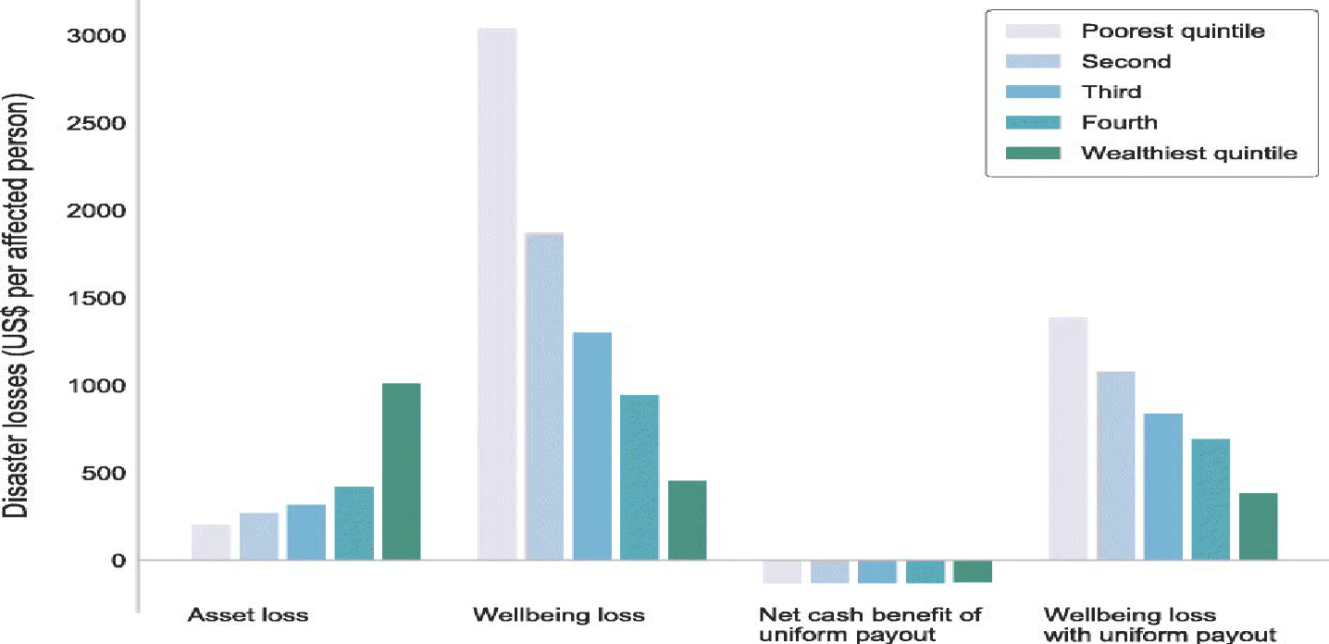

Source: World Bank 2020[47]

In light of the uneven recovery, UNCTAD has warned of the temptation to ‘double down on pre-pandemic trade policies’, highlighting that for a quick recovery and lasting resilience, ‘industrial and trade policies will have to complement macroeconomic efforts, simultaneously targeting employment generation, wage growth, strengthened public services and decarbonization’. UNCTAD also calls for action to ‘reduce vulnerability with more inclusivity, solidarity and building regional resilience with greater diversification of production processes.’[48]

“Economic losses from natural disasters totaled $92 billion in 2015.” Such statements, all too commonplace, assess the severity of disasters by no other measure than the damage inflicted on buildings, infrastructure, and agricultural production. But $1 in losses does not mean the same thing to a rich person that it does to a poor person; the gravity of a $92 billion loss depends on who experiences it. By focusing on aggregate losses—the traditional approach to disaster risk—we restrict our consideration to how disasters affect those wealthy enough to have assets to lose in the first place, and largely ignore the plight of poor people. Steve Hallegatte et al, 2017[49]

In a globalized and interconnected world, risks and disasters do no longer occur in isolation. What happens in one country can and frequently will affect other countries. It is just a question of time and scale. Already in 2013, the Global Assessment Report highlighted that ‘[I]ncreased hazard exposure therefore not only poses a threat to the competitiveness of cities and ports but increasingly to global trade flows and supply chains. … At every step of the chain, transport and associated infrastructure can be at risk of direct damage from hazard events, meaning that interruptions at critical points or nodes can ripple through the supply chain. Those investing in agricultural production, processing and trade, therefore, have a vested interest in the uninterrupted functioning of this infrastructure and in reducing damage owing to disasters…. The balance of supply and demand, however, does not directly translate into prices in the agricultural commodity market. National food security policies, such as export restrictions and hoarding, can prevent produced commodities from being traded in the global market. Price volatility and international price spikes are further catalyzed by factors such as the concentration of production in a few hazard-exposed regions, declining stocks, the role of commodity markets and weather and climate related disasters.[50]

Recognizing the link between trade, economics and disaster risk the 2020 World Economic Forum (WEF) Global Risk Report rated climate change, conflict and cyber risk as top threats to trade.[51]

‘“Climate change impacts trade by distorting prices and disrupting supply chains, with most companies still operating risk-blind and thus likely to be underestimating significantly climate risks.” 2021 WEF Global Risk Report [52]

1. **Progress and barriers in the integration of risk reduction in economics and financing**

While the COVID-19 pandemic underscores that we urgently need to embed risk and resilience into our economic, financial and social system, a growing body of research suggests it also makes good economic sense. Global annual investments of only US$6billion in appropriate disaster risk management strategies could generate benefits of US$360 billion or an equivalent of more than 20 per cent reduction in new and additional expected annual losses.[53] Benefits of multipurpose dams for flood risk management over a period of 40 years were estimated to bring approximately US$ 6 million in Angola, US$ 5 million in Tanzania, and US$ 7.2 million in Zambia.[54] Including co-benefits in the form of enhanced savings and investment, hence economic growth, additional power production, and better access to water when combined total growth effects of investment were estimated at 8.5% of GDP for Angola, 8.8% of GDP for Tanzania, and 7.6% of GDP for Zambia respectively.[55]

Yet, building truly resilient systems will not be easy. Key obstacles include:

1. Our global economic system is risk-blind, even rewarding the creation of risk, as it was built on a prioritization of profit and returns as discounted cashflow analysis allows large risks to be ignored respectively generated and responsibility pushed to future generations. [56] As Steve Waygood from AVIVA investors points out “[H]ad you been privy to the conversations at Bretton Woods and the meetings thereafter, you would not have heard mention of climate change. It simply wasn’t on people’s radar…. Bar some minor tinkering, the current international order was essentially created before general awareness of the climate crisis and was, instead, set up to help sustain world peace, economic growth and poverty alleviation.”[57]To address this gap, AVIVA and an increasing number of other influential figures such Mark Carney, Special Envoy of the UN Secretary-General for Climate Action and Finance and former Governor of the Bank of England, are calling for the economic and financial sector to internalize externalities, such as environmental and socio-economic consequences of economic activities, into pricing, financing and investment decisions.
2. The short-term outlook which our economic and financial systems are built upon is another major barrier to risk-informed development, trade and investment. Business is driven by short-term decision and reward cycles; business cycles, political cycles, monetary policies, technocratic posts, and many financial bonuses all occur within a 2-5-year time frame. [58] On average investment portfolio holding periods of even long term investors such as pension funds are just 21 months[59] and, as listed companies, stock exchanges are incentivized to increase trading volumes to improve their own share price.[60] On the other hand, high liquidity of public markets means equities are traded frequently, limiting the amount of time an investor is exposed to risks.[61] Fiduciary duty is interpreted as a duty to maximize short-term returns for shareholders, not as a duty to consider long-term investment value drivers, including environmental, social and governance issues (ESG) in investment research and processes towards shareholders, stakeholders and the public good.[62]
3. Even when we want to change, we do not necessarily have the full understanding of what we are facing. Current risk models look to the past, relying on historic data and multi-decadal averages[63], or, in case of climate change, aiming to predict impacts in the far future. In a risk landscape that is evolving very dynamically with interconnected, cascading effects in the here and now, this approach can no longer suffice. For example, despite the increasing evidence worldwide, global market projections for crops, livestock and fisheries products often still presume “normal weather conditions” as part of a plausible view on the evolution of the global agricultural markets over the next decade, and continue to discount for disaster risk in growth projections.[64] A new analysis of ten interconnected disasters in 2020/2021 identified three root causes that affected most of the events in the analysis: human-induced greenhouse gas emissions, insufficient disaster risk management and undervaluing environmental costs and benefits in decision-making.[65] Scientists warn about the increasing risks of multiple breadbasket failure caused by increasingly interconnected and unmanaged systemic risk.[66] Better understanding of these interconnections, including focus on what we can learn from events of the past few years about the risks we are facing right now and in the next few years[67] will be critical.
4. We live in a world of (often artificial) siloes. As mentioned earlier, the Sendai Framework does not refer to the role or interconnections between trade and DRR. Vice versa, as per the WTO, ‘the issue of climate change, per se, is not part of the WTO's ongoing work programme and there are no WTO rules specific to climate change’ (or, for that matter, environmental protection or disaster risk reduction).[68] As a result, coordination between economic promotion and growth policies, on the one hand, and disaster risk management strategies, on the other hand, is largely absent.[69] In the same vein, disaster resilience and economic resilience are still far too often treated as separate issues. Yet, reducing hazard risks or boosting coping capacity – without also addressing economic resilience – do not do enough to lessen disaster impacts on their own. [70]

Over the past 20 years, we’ve been steadily removing man-made and natural buffers, redundancies, regulations and norms that provide resilience and protection when big systems — be they ecological, geopolitical or financial — get stressed. We’ve been recklessly removing

these buffers out of an obsession with short-term efficiency and growth, or without thinking at all. (New York times opinion 2020)[71]

However, if only because of COVID-19 and a series of previously unseen disaster scenarios across the globe, the policy space for risk reduction and resilience is opening. As Mami Mizutori, Special Representative of the Secretary-General for Disaster Risk Reduction (SRSG) said, ‘[P]oliticians have never been more acutely aware of the consequences of ignoring or downplaying disaster risk.’[72]

‘COVID-19 pandemic has laid bare and exacerbated our world’s vulnerabilities and inequalities within and among countries, accentuated systemic weaknesses, challenges and risks and threatens to halt or damage progress made in realizing the Sustainable Development Goals’.[73] Faced with an increasingly tight fiscal space and existential dilemmas over whether to allocate scarce public resources to immediate relief or to invest in a more inclusive sustainable recovery, political leaders have recognized the value of investing in ex-ante disaster risk reduction to bridge the short term with the long term, whilst addressing climate change and ensuring environmental sustainability.

As a result, disaster risk reduction features increasingly prominently in the 2020 Menu of Options for the Consideration of Heads of States and Governments Financing for Development in the Era of COVID-19 and Beyond,[74] recommendations of the 2021 ECOSOC Forum on Financing for Development[75] and 2021 High-Level Political Forum.[76] The outcome statement of the 2021 Financing for Development Forum is particularly clear as is recognizes that ‘COVID-19, climate change and environmental degradation have demonstrated the importance of understanding risk across all sectors and at all levels of planning – global, regional, national, subnational and local. Disasters are becoming more frequent, complex and systemic. There is an urgent need to shift the balance from investing in response, to investing in prevention and in disaster risk reduction. Risk-sensitive public investment planning and risk financing policy can be supported through integrated national financing frameworks for sustainable development (INFFs).’ [77]  DRR is an integral part of the guidance developed in support of the development of INFFs on risk assessment and financial strategies that help recovery from the COVID-19 pandemic and its economic fallout. [78]

You know, and our nations must — all of our nations must stand together in shifting policies and on public investment as well, you know, to invest in breakthrough technologies; to finally end fossil fuel subsidies; to help the world’s most vulnerable nations and those bearing the least responsibility for the climate crisis cope with the devastating impacts of the climate crisis; you know, to help developing economies leapfrog to a clean technologies of tomorrow; to mobilize the trillions of dollars needed to make the most of the opportunity to build a clean-energy, job-rich path to meet our goals; to make sure that our climate response is about more than just building and developing new sectors, but also about international security, regional stability, food security, and gender and racial equity as well. Remarks by President Biden at the Virtual Leaders’ Summit on Climate Session 2: Investing in Climate Solutions[79]

Similarly, climate change and DRR are increasingly connected at the policy and practice levels. The inclusion of DRR into Nationally Determined Contributions (NDCs), National Adaptation Plans (NAPs) and related climate finance to ensure greater coherence in national goals and targets, strengthened policy frameworks and institutional arrangements and enhanced technical expertise, knowledge, data and information are just some of the Government commitments that acknowledge the need for comprehensive risk reduction which addresses climate risks and its links to other environmental, biological and man-made hazards in a systemic manner.[80] Next to net zero as a key measure of risk prevention, adaptation and resilience have become key priorities in the 26th UNFCCC Conference of the Parties (COP 26).[81]

Policy is are increasingly translated into practice. As of July 2021, 118 countries had adopted national and local disaster risk reduction strategies aligned with the Sendai Framework and inclusive of core development aspects such as climate change, biological hazards and sustainable development. This is a clear acceleration since 2017.[82]

Momentum is also seen from within the economic and financial sector. Initiated in 2015 by then Governor of the Bank of England, Mark Carney, the Task Force on Climate-related Financial Disclosures (TCFD) has led the way on mainstreaming climate risk reporting and raising awareness of the many benefits to incorporate systemic climate risk into corporate strategy, capital allocation and risk assessment processes. [83] The integration of ESG issues into business strategy has become the new buzzword in the business sector. ESG-related financial market instruments are booming. Regulators and standard-setters are following suite in efforts towards the adoption of global sustainability and climate disclosure standards led by the International Financial Reporting Standards (IFRS) foundation and the Sustainable Accounting Standards Board (SASB). This includes the proposal of an International Sustainability Standards Board (ISSB) to better reflect the realities of a post-COVID and multi-hazard world in the corporate sector and related policy and regulatory frameworks. [84]

**Box: ESG, DRR and resilience**

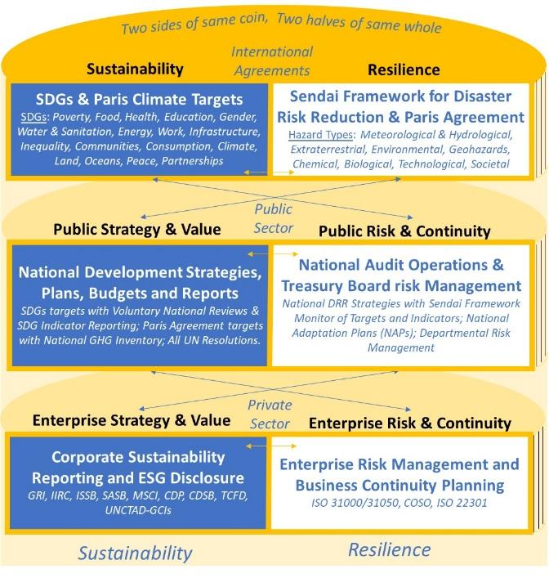

Source: Authors

Strengthened oversight for risk-informed investment is also picked up by central banks and financial supervisors through the integration of physical climate or environmental risk elements into stress tests for banks and insurers. The global Network for Greening the Financial System (NGFS), comprising of over 70 central banks and supervisors, seeks to increase understanding of the materiality of climate and other environmental risks and the transmission channels of climate impacts from the economy to the financial sector. [85]

**Box: Sustainable finance**: The term refers to the process of taking environmental, social and governance (ESG) considerations into account when making investment decisions in the financial sector, leading to more long-term investments in sustainable economic activities and projects. Environmental considerations might include climate change mitigation and adaptation, as well as the environment more broadly, for instance the preservation of biodiversity, pollution prevention and the circular economy. Social considerations could refer to issues of inequality, inclusiveness, labour relations, investment in human capital and communities, as well as human rights issues. The governance of public and private institutions – including management structures, employee relations and executive remuneration – plays a fundamental role in ensuring the inclusion of social and environmental considerations in the decision-making process. European Commission, 2021[86]

Regionally, the European Union has been pushing action towards greater climate and broader disaster resilience. In reaction to the economic fallout caused by the COVID-19 pandemic the European Council agreed in July 2020 on a so-called Recovery and Resilience Facility (RRF)[87] as its economic stimulus package to revive and upskill EU economies in the spirit of ‘Building Back Better’. The RRF is part of Next Generation EU (NGEU)[88] which allocates 30 per cent to tackling climate change and deliver transformational investments needed for a more resilient future. The total amount of EU spending for NGEU and the EU multi-annual budget earmarked for climate-related goals will amount to €1.8 trillion in the next seven years.[89] Within the framework of the European Green Deal[90], which aims to see the EU carbon neutral by 2050, progress has been made to make investments more disaster resilient. These include:

* The entry into force of the EU Sustainable Finance Disclosure Regulation (SFDR) in March 2021[91], which requires certain financial market participants and other companies to follow mandatory environmental, social, and governance (ESG) criteria, and disclose how and to what extent their activities align with those considered environmentally sustainable.
* Entry into force of delegated acts on climate change mitigation and adaptation under the EU Taxonomy[92] in April 2021, which set out technical screening criteria for determining whether an economic activity contributes substantially to mitigation or adaptation. Like the SFDR, the acts include the ‘do no significant harm’ principle to the other environmental objectives of the taxonomy.[93] Making the connection between different hazards and risks, this will help drive a more systemic risk approach into the economic system. Regulation and guidance on the remaining taxonomy objectives are expected over the course of 2022.
* The adoption of the Strategy for Financing the Transition to a Sustainable Economy in July 2021, which comprises an ambitious and comprehensive package of measures to help improve the flow of money towards financing the transition to a sustainable economy.[94] The strategy points to increasing the resilience of the financial system to shocks that requires the identification, measurement and management of risks at the system level .
* Adoption of delegated acts and guidelines specifying the information companies subject to the non-financial reporting directive (NFRD),[95] including in support of Sendai Framework, is expected in 2021.[96] This connects to a Commission proposal in April 2021 for a Corporate Sustainability Reporting Directive (CSRD), which aims to revise and strengthen the existing rules introduced by the NFRD and over time bring sustainability reporting on a par with financial reporting.[97]
* The development of EU Green Bond Standard (GBS) will help standardize design, implementation and reporting of activities in support of the anticipated transitional shift.[98]

It is noteworthy that national courts are also taking a position on Government action on climate change. For example, in April 2021, Germany’s Federal Constitutional Court declared Germany’s climate-change law partly unconstitutional.[99] Similarly, in February 2021, four environmental groups succeeded against France in what some commentators described as the “case of the century;” the claimants accused the French government of failing to fulfil its obligations to decrease greenhouse gas emissions in line with the Paris Climate Agreement and related French laws. In 2018, the Government of Nepal was ordered by the Supreme Court to, inter alia, enact a new climate change law to mitigate and adapt to the effects of climate change. This was after a claimant petitioned that the existing Environmental Protection Act was inadequate because it did not address climate change.[100] In all three cases, the respective Government was forced to reconsider its approach.[101]

Change is also visible in the case of companies being increasingly held responsible for environmental damage, despite difficulties regarding economic valuation of environmental damage in some cases.[102] For example, a complaint filed by the United States against BP Exploration & Production and several other defendants in the Horizon Oil Spill led to the ‘the largest environmental damage settlement’ in U.S. history of $20.8 billion in 2016.[103] Whilst questions have arisen over a review of the initial damages of USD 3.8 billion agreed by Vale SA and BHP related to the 2015 Fundão dam disaster,[104] Vale SA agreed to pay USD 7 billion socioeconomic and environmental damage in the 2019 Brumadinho dam failure.[105] Even more importantly, the Brumadinho disaster sparked action by a group of investors, controlling $14 trillion in assets, which started to demand public disclosure of trailings dam failure risk by mining companies. Collaboration between investors, companies, United Nations Environment Programme (UNEP), Principles for Responsible Investment (PRI) and International Council on Mining and Metals (ICMM), a Global Industry Standard on Tailings Management was released in August 2020 to prevent future disasters.[106]

Progress and suggested recommendations on delivering risk-informed investment were summarized in a new report developed by UNDRR with financial sector partners (see box below).

Box: Recommendations for greater inclusion and incorporation of disaster risk reduction into financial sector decision-making and investment

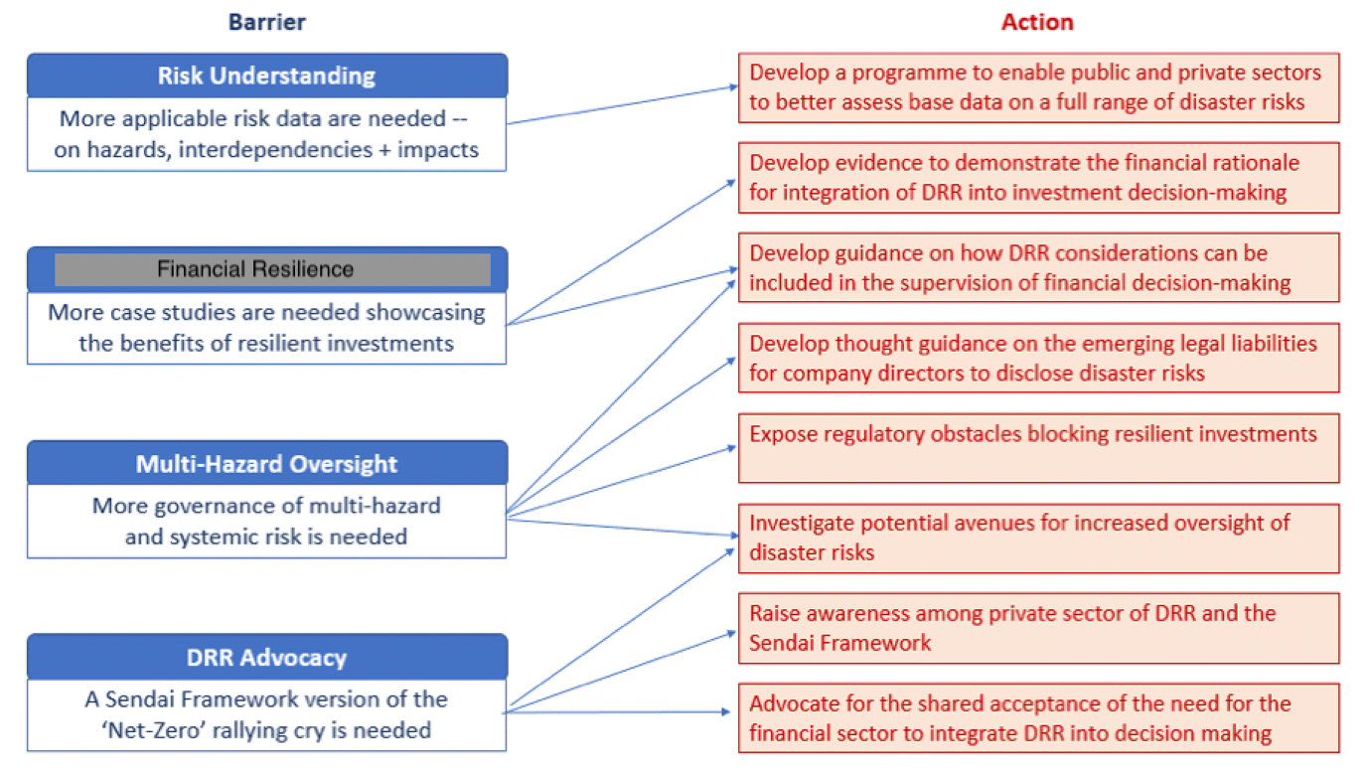

UNDRR, 2021

In summary, more than 300 hazards have the potential to significantly impact the world’s economic and financial system in which the majority of decisions, including capital allocation, are still made ‘risk-blind’, thereby increasing the potential for systemic shocks. Political and business leaders are increasingly recognizing the threats of large scale, dynamic, non-linear risks. As a result, action to incorporate disaster risk, related to climate change but also other natural and man-made hazards, into economic and finance policy, law and regulation is accelerating at all levels.

Trade and trade policy are also part of this picture. It is therefore imperative that the global trade community is aware and understands hazards and risks, their interconnections and probable impacts on trade. Building on the above review of progress in risk reduction and economic fields, a range of potential actions for the WTO and its Members emerge and will be outlined in the final section of this report.

1. **Developments at WTO on trade, resilience and sustainable development**

The [Marrakesh Agreement](https://www.wto.org/english/docs_e/legal_e/04-wto_e.htm) establishing the World Trade Organization[107] and 2001 [Doha Ministerial Declaration](https://www.wto.org/english/thewto_e/minist_e/min01_e/mindecl_e.htm)[108] highlight sustainable development as a central objective of international trade. In the Preamble of the WTO Agreement, WTO Members recognize that “their relations in the field of trade and economic endeavor should be conducted with a view to raising standards of living, ensuring full employment and a large and steadily growing volume of real income and effective demand, and expanding the production of and trade in goods and services, while allowing for the optimal use of the world’s resources in accordance with the objective of sustainable development, seeking both to protect and preserve the environment and to enhance the means for doing so in a manner consistent with their respective needs and concerns at different levels of economic development.”

Though often thorny and hotly debated, the link between trade and environment is a well-established element of WTO's work. Indeed, consideration of this topic dates back to the 1970s and the General Agreement on Tariffs and Trade – the WTO's predecessor arrangement.[109]  In broad terms, work on trade and environment has sought to build on the role that trade can play in bridging relative differences in resource endowments across countries, relieving resource scarcities in some regions and allowing for a more economically and environmentally efficient allocation of resources globally. The role that trade can play in promoting resource efficiency is a role that may grow in importance due to the increasing impacts of climate change and resource scarcity. In light of the pandemic and climate emergency the topic is gaining further attention, including linked to the global discussions on climate change and sustainable development.

In broad terms, work at WTO on trade and environment has sought to consider how:

* Trade rules can grow the global market for environmental goods and services and help the diffusion of related technologies.
* To promote a mutually supportive relationship between Multilateral Environment Agreements and WTO rules.
* Ensuring that trade measures taken for environmental purposes are not used as the basis for arbitrary or unjustified discrimination between local and foreign suppliers or between trade partners (i.e. green protectionism).

Latterly, trade officials have also considered how trade can address response and recovery from disasters, initially in the context of specific disasters, and more recently in the context of the growing burden of such events on the trading system and Members' development, in particular that of small economies. The latter may in the future provide a foundation for systematic consideration of disaster risk reduction and prevention.

On trade and disasters, the policy focus has been on how to use trade preference schemes provided for under the 1979 Enabling Clause to promote recovery from such events. Reference here can be made to the General Council decision of 2012 authorizing the European Union to waive from MFN obligations under Articles I and XIII of the GATT 1994 and apply a two-year period duty-free and other preferential tariff treatments on imports of textiles and apparel originating in Pakistan.[110] Similarly, a 2016 General Council decision granted the US a 10-year waiver to provide duty-free treatment on some imports from Nepal.[111] In both cases, the dramatic social and economic situation of the two beneficiary countries in the aftermath of disasters caused by natural hazards (the 2010 floods in Pakistan and the dramatic earthquake that occurred in Nepal in 2015) was considered as a legitimate “exceptional circumstance” according to Article IX:3 of the Marrakesh Agreement, justifying the adoption of the waiver.[112] Also of note is that the 2010 earthquake in Haiti was also referenced by the US at the General Council to support its request to extend and expand the scope of the Caribbean Basic Recovery Act (CBERA) waiver – a measure approved by the Council in 1995.

In the above-mentioned cases, the disaster-affected countries were already beneficiaries of tariff preferences according either to the 1979 Enabling Clause (as in the case of Pakistan and Nepal) or to an already existing waiver approved under Article IX:3 of the Marrakesh Agreement (Haiti). The further decisions by the WTO in favor of Pakistan and Nepal is explained by the (positive) discrimination features of the EU and US programmes, aiming at according additional further preferences to the beneficiaries in view of the impact of massive (natural) disasters on their economies. In both cases, the waivers were viewed as ways to hasten the pace of recovery by extending market access benefits provided for by existing preferential schemes.

The destruction and dislocation caused by the passage of two Category 5 Atlantic hurricanes (Irma and Maria) in September 2017 prompted further attention to the economic and trade effects of disasters. At the WTO's Eleventh Ministerial Conference, six WTO Members of the Organisation of Eastern Caribbean States (WT/MIN(17)/37), issued a proposal calling for "Recognition of the need for flexibilities for Caribbean and Small and Vulnerable Economies recovering from natural disasters". More specifically, the proposal argues that "WTO rules and disciplines must not stand in the way of reconstruction" and argued that the" full flexibility of the multilateral trading system should be deployed so that reconstruction measures taken by the affected Members will be considered compatible with the WTO Agreements"*. [113]*

In April 2018, WTO members approved a research project to look at the impact of disasters on trade. The first study undertaken as part of the project examined the economic and trade impact of natural disasters, with a particular focus on six disaster-affected countries: Dominica, Fiji, Nepal, Saint Lucia, Tonga and Vanuatu. A second study looked at the measures that governments can take under the ambit of WTO agreements to support disaster recovery and to improve resilience to future disasters. The research was funded by the Permanent Mission of Australia to the WTO.

The studies sought to extend the focus beyond the narrow focus of how additional preferential trade measures could be used to support (natural) disaster recovery, and to examine in a more holistic sense how trade rules could also support preparedness and resilience. [114] A series of symposia were organized to discuss the research and feed in expert perspectives.

It is important to note that the majority of findings focused on preparedness, response and recovery, not risk prevention and risk reduction, thus falling short of connecting DRR, resilience and sustainable development. In the following, we are nevertheless summarizing all findings, whilst highlighting those relevant for the engagement of the trade community in long-term risk reduction and resilience building.

Key messages coming out of the symposiums and associated research included the prominent role of trade in helping economies respond to and recover from natural disasters and in building resilience against future events. Well-functioning and open markets were cited as crucial. The role of WTO agreements and decisions in helping members take the necessary measures featured prominently in the discussions.[115] In her legal mapping exercise, Professor Giovanna Adinolfi found that "a wide range of actions can be taken across a broad cross-section of WTO Agreements dealing with trade in goods, trade in services and, where germane, trade-related aspects of intellectual property rights."[116]

Looking at the results in more detail, the research has borne out the role of trade as a “shock absorber” for disasters through helping disaster preparedness, response and recovery (i.e. for when a disaster strikes). A good example of this role is Nepal’s housing reconstruction programme in the wake of the 2015 earthquake that required usage of earthquake-proof building techniques and materials. Many of these materials had to be imported due to supply constraints in Nepal in the face of the damage caused by the earthquake.

From the macroeconomic perspective, a disaster generates economic damage and delivers a shock to the aggregate supply curve, resulting in a decline in real output and employment. Impacts may be more or less severe depending on the nature of the disaster, the sectors impacted and the varying duration of the event (e.g. floods and droughts). For example, in the wake of a hurricane, it may take a lot longer for exports of tree crops to return to pre-hurricane levels than for exports of other agricultural produce, e.g. root crops. Furthermore, the initial surge in economic activity associated with economic recovery in disaster-affected states may mask important distributional impacts on the poor and between different sectors of economic activity.[117]

Evidence of both short-term economic output contraction and medium to long-term difficulties (both at an economy-wide level and in specific sectors) is growing more robust, particularly in situations where the fiscal space is unavailable to engage in fiscal stimulus or funds are insufficient to achieve reconstruction. The deleterious effect of recurrent, multiple disasters on the same economy is also accumulating.

Another factor diverting attention and complicating the measurement of natural disaster effects is that a disaster-affected state may face several challenges at the same time. For example, several countries have experienced compound disasters, i.e. when two or more threats happen simultaneously with potential collective impact greater than the sum of its parts[118], during the COVID-19 pandemic. The eruptions of the La Soufrière volcano on the island of Saint Vincent between December 2020 to April 2021 are a case in point. Sanitary controls to limit the spread of the SARS-COVID-2 virus added further complications to humanitarian relief and evacuation measures. Super cyclone Amphan in the border region of India and Bangladesh in turn worsened the conditions for pandemic response in its aftermath, as health centers were destroyed and COVID-19 cases spiked in some areas. Amphan caused over 100 fatalities, damages in excess of 13 billion USD and displaced 4.9 million people.[119]

Fiscal space, institutional capacity, and ex-ante preparedness can help mitigate the cost of disasters. However, building such preparedness takes time. One argument made by the governments of small economies is that a lack of access to concessional finance further constraints the fiscal space that they have to carry out stimulus policies. Their argument is that recurrent disasters lock their economies in a vicious circle of debt accumulation and restructuring.

A further complication for many disaster-affected Members is that a fall in output is likely to reduce revenue from taxes and duties. Amongst the reasons reported for output declines in the research are damages to export-oriented firms and trade-related infrastructure, such as ports, airports, roads, and customs.

Disaster events in one Member may also affect the trade of others. Various Trade Policy Reviews (TPRs) note how disaster events have had impacts on others. Examples here include the disruption to global automotive supply chains caused by the floods in Thailand in 2011 as well as Uganda’s 2012 TPR that references problems in coffee exports as a result of air transport disruption following the 2010 eruption of the Eyjafjallajökull volcano in Iceland. These initial findings may give room for further research in how systemic risk can be systematically addressed. Here lessons learned could be taken from the increasing integration of disaster risk (in this case so far mainly climate risk) into the financial stability assessment program (FSAP) by the IMF.[120]

In this sense, supply chains can transmit shocks. The magnitude of this impact will depend on the level of input specificity (i.e. whether companies can find substitutable inputs from alternative sources) and how integrated the affected supplier is in global supply networks. Diversified networks with suppliers and clients, enhanced multi-sectoral cooperation, better information sharing, development and adoption of international standards on resilience and greater use of risk assessment tools were mentioned as a potential prevention measure. It is noteworthy that guidance developed by UNDRR in 2021 on enhancing the resilience of SMEs took this further, outlining a range of activities for policymakers, financiers and the business community in support long-term resilience of SMEs (see box below).

**Box: Recommendations to policymakers, financiers and the broader business community on enhancing the uptake of risk reduction by SMEs**



Source: UNDRR, 2021 forthcoming

On the application of international trade agreements in support of resilience, the findings give some examples. For example, the TBT Agreement offers broad latitude to promote a “Build Back Better” approach using both domestic regulations and regulatory co-operation internationally. Flexibilities are also available under the Agreement on Agriculture for the implementation of government-financed support schemes aiming at strengthening resilience to disasters. Indeed, the burden of these events (particularly hydro-meteorological events) tends to fall disproportionately heavily on the agricultural sector.

In the same vein, discussion in Dominica on how to ensure that building material imports meet local building codes (e.g. for corrugated sheet roofing) is indicative of a broader debate on the role of standards for resilience. Other risk management challenges and measures included how government procurement can support resilience, renewable electricity sources, risk management plans to mitigate the risk of droughts and the use of agricultural weather-index insurance products, mandatory legal requirements for buildings insurance and infrastructure investment to protect against natural hazards.

In the services sectors, the improvement of disaster resilience is highly dependent upon the availability of some services (e.g. environmental services, health services, engineering services, telecommunication, and weather-related services). Liberalization in these sectors could have a positive impact, encouraging the growth of the private sector and, overall, enhancing the domestic capacity to supply services crucial for reducing vulnerability to disasters.

Trade and development financing partners can play a useful role in providing technical assistance to disaster-prone countries, to improve their preparedness for natural hazards as well as enhance engagement in prevention and risk reduction. This assistance could support, for example, the participation in international standard-setting bodies, that would give vulnerable countries the opportunity to actively contribute to the elaboration of international standards (e.g. on building materials, coherent with a “Build Back Better” approach), or focus on the elaboration of domestic regulatory frameworks on critical services for resilience purposes (e.g. telecommunication services, data storage and data management services). Trade measures that would help bridge the insurance protection gap, promote the global weather enterprise as well as strengthen the role of insurance for enhanced DRR[121] also merit consideration, including as part of discussions on environmental goods and services.

The COVID-19 pandemic has put the issue of trade and resilience firmly at the center of policy-makers attention and raised the question of how resilient economies are to such shocks. The topic was the focus of a series of WTO webinars in early 2021, including in support of research for the 2021 edition of the World Trade Report which focuses on Trade and Economic Resilience. The 2021 WTR explores on the impact, challenges and opportunities for international trade related to the response and recovery from COVID-19, and also integrates a broader disaster risk reduction and prevention lens, including links between trade, DRR and climate action in support of risk-informed trade and sustainable development and international cooperation.

Though so far addressed separately, the discussions on trade and disasters are a further dimension to the well-established work at WTO on trade and environment. Work on the nexus between sustainable development and trade has been given new impetus by the increasingly dire predictions of the impacts of climate change on economic growth and trade, and also as part of the response to the COVID-19 pandemic. Various WTO Members indicated that recovery from COVID-19 should be seen in the broader context of the transition to green growth and sustainable development more generally during a special meeting of the General Council on 15 May 2020 on trade responses to the COVID-19 pandemic. [122]

The 1994 Ministerial Decision on Trade and Environment created the WTO’s Committee on Trade and Environment (CTE), which is open to the entire WTO membership, with some international organizations as observers. The committee’s mandate is broad, and it has contributed to identifying and understanding the relationship between trade and the environment in order to promote sustainable development. As part of the Doha Development Agenda, the following were mandated for negotiation:

* The relationship between existing WTO rules and specific trade obligations set out in Multilateral Environmental Agreements (MEAs).
* Procedures for regular information exchange between MEAs Secretariats and the relevant WTO committees, and the criteria for the granting of observer status.
* The reduction or, as appropriate, elimination of tariff and non-tariff barriers to environmental goods and services.
* The effect of environmental measures on market access, especially in relation to developing countries, in particular the least-developed among them, and those situations in which the elimination or reduction of trade restrictions and distortions would benefit trade, the environment and development.
* The relevant provisions of the Agreement on Trade-Related Aspects of Intellectual Property Rights; and
* Labelling requirements for environmental purposes.

The Doha Round of trade negotiations, launched in 2001, introduced the first environment-specific negotiation elements, including the issue of disciplining certain fisheries subsidies that contribute to overcapacity and overfishing. Successful conclusion of the WTO fisheries subsidies negotiations would also deliver on SDG 14.6 and some groups of Members have sought other paths to advance consideration of the relationship between trade and the environment. Intense negotiations are currently underway, in line with the call made by ministers at their [15 July virtual meeting](https://www.wto.org/english/news_e/news21_e/fish_15jul21_e.htm) to conclude the negotiations soon and before MC12 in late November 2021. Negotiators have the task of securing agreement on disciplines to eliminate subsidies for illegal, unreported and unregulated fishing and to prohibit certain forms of fisheries subsidies that contribute to overcapacity and overfishing. Special and differential treatment is an integral part of the negotiations, with one of the issues being how to treat subsidies given to fishers when their livelihoods are impacted by natural disasters.

On 17 November 2020, a group of WTO Members issued a "Communication on Trade and Environmental Sustainability" in which they indicated their intent to "organise structured discussions for interested WTO Members as well as a dialogue with external stakeholders".[123] This work is intended to complement and support the work of the CTE and other relevant WTO Committees and Bodies. Plenary sessions have been held to advance the Trade and Environmental Sustainability Structured Discussions (TESSD).

On 5 July 2021, the TESSD coordinators issued a first iteration of draft elements for a TESSD declaration at WTO's 12th Ministerial Conference. [124] Among the points proposed for consideration in the draft text, and that are of interest from a disaster risk reduction perspective, include:

* Launching dedicated discussions on how WTO members could reach long-term climate targets (including net-zero emissions) and how to foster the transition to low-carbon economies in an effective, least-trade restrictive and non-discriminatory manner, with a view to ensure that any climate-related trade measures and policies that WTO members may adopt, including border carbon adjustment mechanisms, follows WTO rules and principles;
* Develop a model framework of best practices and voluntary actions and partnerships that Members could take to promote the transition to a green economy as well as sustainable supply chains that takes into consideration: (i) a more resource efficient circular economy, including in relation to plastics (ii) addressing challenges and opportunities for developing countries, as well as those arising from the use of sustainability standards and regulatory and domestic measures; The and (iii) promoting access to environmentally-sustainable goods and services.[125]

How to arrive at climate targets is not without controversy, in particular whether or not carbon border adjustment measures should be part of the trade policy toolbox. The primary purpose of carbon border adjustments is to prevent so-called "carbon leakage". As Gary Clyde Hubauer from the Peterson Institute for International Economics explains this is shorthand "for the risk that high-carbon imported goods, paying little or no carbon fees, will take market share from low-carbon fee paying domestic firms, thereby defeating the effort to reduce global emissions while harming the domestic industry. But border tax proposals are controversial for two reasons: First, trading partners fear disguised protection that violated WTO rules; second, many observers believe that the proposals, if implemented, will provoke opposition and obstruct cooperative action to reduce emissions"[126]

The communication also references other initiatives being taken forward by other grouping of Members on issues related to trade and environmental sustainability:

* **Fossil Fuel Subsidy Reform**: In 2017, at the WTO eleventh Ministerial Conference a group of WTO members released a Ministerial Statement seeking to ‘phase out inefficient fossil fuel subsidies that encourage wasteful consumption’ and the need for reform taking into account the needs of developing countries as well as minimization of adverse effects on development in pursuant of the commitment to fossil fuel subsidy reform under the Sustainable Development Goal 12 (c) of the 2030 Agenda.[127] The proponents argued that fossil fuel subsidies, which accounted for 20% of the value of internationally traded fuels in 2015, negatively impacted renewable energy and investment in energy efficiency. Since the 2017 statement, thus emphasizes the need for global action at the WTO, and calls for reforming such fossil fuel subsidies. The statement has led to the creation of a ‘Friends of Fossil Fuel Subsidy Reform’ at WTO. One action that the groups is recommending is to use the post COVID-19 economic recovery phase to take urgent action to phase out fossil fuel subsidies.
* **Plastic Pollution and Environmentally Sustainable Plastics Trade**: A group of WTO Members have also launched an open-ended informal dialogue that seeks to address the rising environmental, health and economic cost of plastics pollution. It currently has 14 participants and is open to all WTO Members.

In addition to these different initiatives to update the WTO rule book, WTO Members are also taking an ever-greater number of trade measures for a variety of environmental purposes. The WTO’s Environmental Database shows that from 2009 to 2018 WTO members notified more than 11,000 environmental measures to the WTO. In 1995, less than one in 12 notifications of trade measures had an environmental component; today, it is one in six. Presently, more than 15 per cent of all notifications made to the WTO include environmental objectives. In fact, many more measures of this nature are probably in place, as not all trade-related environmental measures need to be notified to the WTO.[128] Covering a range of the hazards identified as critical in the context of DRR and resilience building, these measures include establishing minimum energy efficiency requirements for household goods, addressing air pollution, introducing licensing schemes to limit trade in endangered species of wildlife, creating taxes applicable to hazardous chemicals, enhanced waste management, and supporting policies for the development of low-carbon technologies. [129]

For example, 2020 notifications include new draft measures for hazardous waste submitted by Bangladesh (G/TBT/N/BGD/3) for the information of trading partners. Mexico submitted a draft Mexican Official Standard with specifications for transporting certain classes of hazardous substances or materials packaged/packed in excepted quantities and specifications for transporting products including to the final consumer (G/TBT/N/MEX/481) and the Republic of Korea submitted a draft partial amendment of the Public Notice on Corporate Average Energy Efficiency Standards, Greenhouse Gas Emission Standards for Motor Vehicles and Application and Management of the Standards (Ministry of Environment Notice No. 2019-34, January 30, 2019) setting CO2 emissions performance standards for new passenger cars and for new light commercial vehicles (G/TBT/N/KOR/920).

As previously noted, however, at WTO the interface between trade and environment has proven thorny and contested . In 2014, a group of 14 countries committed to pursue global free trade in environmental goods. They agreed that this plurilateral agreement would take effect “once a critical mass of WTO members participates.” In spite of a promising beginning, the negotiations on an Environmental Goods Agreement failed in 2016.[130]

The WTO cooperates with several international partners to help developing and least-developed countries (LDCs) improve their capacity to participate more fully in international trade and promote sustainable development. The Aid for Trade initiative, the Enhanced Integrated Framework and the Standards and Trade Development Facility are examples of WTO-led partnerships working to achieve this objective. All three illustrate how the WTO is putting into practice Sustainable Development Goal (SDG) 17, which calls on the international community to revitalize global partnerships for sustainable development.

1. **Conclusions: Towards a risk-informed and resilient trade system: Recommendations for action**

The COVID-19 pandemic is a stark reminder that, in a connected and globalized world, risk is multi-dimensional: what was initially a health disaster quickly became a socioeconomic one with long-term impact on our social, economic and financial systems, highlighting the urgent need for a whole-of-society approach towards prevention and risk-informed recovery and development.

As a recent report of the UNDRR Stakeholder Engagement Mechanism put it: Systemic risk requires systemic solutions. Global trade must be part of this.[131]

Sustainable development, environmental protection and preservation and social wellbeing are fundamental goals of the world trade system. The comprehensive consideration of risk reduction, risk prevention and resilience in trade and trade policy and related laws, regulation and standards is integral to achieve this objective.  While COVID-19 is focusing attention on trade and health issues, trade policy reviews are also cataloguing a growing number of other (mostly smaller) events that are negatively impinging on the trade and development prospects of WTO Members at all levels of development.

Building on work already ongoing in the trade and broader development policy space, the WTO and its Members have an opportunity to take an active role, supporting a framework of rules and an enabling environment for the systemic change needed to promote sustainable development and a more resilient and green global economy. Opportunities for the WTO Members and broader trade community to engage in DRR and resilience include:

1. Use the WTO's twelfth Ministerial Conference COP26 and the G7 and G20 summits to push green recovery and **garner political support and commitment to systemic change** towards sustainable development and the integration of disaster risk reduction, prevention and resilience into trade policymaking.
2. Recognize the **urgency of committing to concrete actions on trade and resilience** as key elements for a future sustainable and resilient global trade system.
3. Consider DRR and **resilience in within Members’ proposals on WTO reform**

Concrete initiatives could include:

* **Promote a systemic approach** to risk reduction, prevention and resilience within the full range of WTO functions (rulemaking, transparency, monitoring, information exchange, policy dialogue, capacity building, technical assistance and training).
* **Link trade policy with DRR, climate, environment and development policies** through among other integration of risk reduction and resilience in the work of the CTE and related processes; explore opportunities of using trade policy and measures to promote action on comprehensive risk reduction through the Sendai Framework, SDGs, Paris Agreement and Addis Ababa Action Agenda
* **Break down silos between the trade, economic and disaster risk community** to effectively addressing the complexity of today’s risk landscape and intersection with trade. This may include trade actors reaching out and engaging with organizations, partners and processes in the field of risk and resilience And on the other hand the use of existing mechanisms, such as national and regional platforms for DRR, for **consultation and dialogue between trade and non-trade ministries,** including on national risk registers and potential trade dimensions
* Encourage further **systematic assessment of how trade can contribute to disaster risk reduction and systemic resilience**, identifying concrete trade-related actions that can be taken by Members, in particular small economies and least-developed countries
* Consider the development of **a ‘think-resilience-tool or checklist** , and encourage its application in the negotiations of global and regional trade treaties and trade policy reviews
* **Develop regular monitoring, research and a multi-stakeholder dialogues** on trade and resilience; specifically,
  + Support the development of **comprehensive risk assessment tools** and methodologies, including through the sharing of trade and economic information
  + Explore ways of trade and trade policy to support **ongoing discussions on a greener and more resilient economic sector through risk-informed business and finance**
  + Review how **trade rules can strengthen the resilience of MSMEs** for example by including standardized risk reduction and resilience requirements and promote the application of climate and disaster disclosure rules to the full value chain
* **Make risk reduction, prevention and resilience an integral part of support through Aid for Trade**, including the development of projects and initiatives to link trade and risk-related policies, development of comprehensive DRR laws, regulations and standards, resilient global value chains, exports and infrastructure,

References

1. IPCC Working Group I report, Climate Change 2021: the Physical Science Basis, IPCC’s Sixth Assessment Report (AR6)https://www.ipcc.ch/2021/08/09/ar6-wg1-20210809-pr/
2. https://sustainabledevelopment.un.org/topics/disasterriskreduction
3. For example, in a 2021 webinar series, the World Bank and a group of experts aim to deepen the understanding of the complex dynamics between trade and climate change and identify solutions for its work with Governments. The findings from the first phase of this work program have been encapsulated in a soon to be released summary report “The Trade and Climate Change Nexus: The Urgency and Opportunities for Developing Countries”. This report explores the different ways in which trade and climate change intersect and confronts a number of myths concerning the two phenomena. The report focuses on the impacts of, and adjustments to, climate change in developing countries and on how future trade opportunities will be affected by both the changing climate and the policy responses to address it. It also discusses how trade provides the goods and services that can drive mitigation and adaptation, and the new opportunities for promoting trade diversification in the transition to a low-carbon world. Suitable trade and environmental policies can offer the right economic incentives for attaining both sustainable growth and poverty reduction through trade.

   https://www.worldbank.org/en/topic/trade/brief/trade-and-climate-change#1
4. https://www.wto.org/english/thewto_e/coher_e/sdgs_e/sdgs_e.htm
5. https://www.preventionweb.net/files/43291_sendaiframeworkfordrren.pdf
6. https://www.preventionweb.net/files/8241_doc6841contenido1.pdf
7. Development Cooperation Forum, Risk-informed development cooperation and its implications for ODA use and allocation. Lessons for the Decade of Action to Deliver the SDGs; https://www.un.org/development/desa/financing/sites/www.un.org.development.desa.financing/files/2021-03/ODA%20Study%20-%20Finalized%20Version%20%281%29.pdf
8. Global Assessment Report on Disaster Risk Reduction, UNDRR, 2019; https://gar.undrr.org/report-2019
9. For example: Hyogo Framework Midterm Review, UNISDR, 2011; <https://www.preventionweb.net/publication/hyogo-framework-action-2005-2015-mid-term-review>; Global Assessment Report, UNISDR, 2015; https://www.preventionweb.net/english/hyogo/gar/2015/en/home/
10. UNDRR/ISC: Hazard Definitions and Classification Review, Technical Report, 2020; https://www.undrr.org/publication/hazard-definition-and-classification-review#:~:text=The%20UNDRR%2FISC%20Sendai%20Hazard,mechanisms%20and%20renewed%20global%20partnerships%E2%80%9D.
11. Terminology ‘Disaster Risk Reduction’, UN GA A/RES/76/276, 2017; <https://www.undrr.org/terminology/disaster-risk-reduction>; UNISDR Terminology on Disaster Risk Reduction, United Nations Office for Disaster Risk Reduction (UNISDR), 2009; <https://www.undrr.org/publication/2009-unisdr-terminology-disaster-risk-reduction>;
12. <https://www.imf.org/en/Publications/WP/Issues/2018/01/24/A-Comprehensive-Multi-Sector-Tool-for-Analysis-of-Systemic-Risk-and-Interconnectedness-SyRIN-45580>; Systemic Risk Centre. (2020). Systemic Risk. https://www.systemicrisk.ac.uk/systemic-risk
13. UNDRR. (2019). GAR Report. https://gar.undrr.org/sites/default/files/reports/2019-05/full_gar_report.pdf
14. The Human Cost of Disasters 2000-2019, UNDRR 2020; https://www.undrr.org/publication/human-cost-disasters-2000-2019
15. E.g Statista Global Cost of COVID-19; <https://www.statista.com/topics/6139/covid-19-impact-on-the-global-economy/>; accessed 5 September 2021
16. The Economist, 7th January 2021: What is the Economic Costs of Covid-19? https://www.economist.com/finance-and-economics/2021/01/09/what-is-the-economic-cost-of-covid-19
17. World Economic Output, October 2020, https://www.imf.org/en/Publications/WEO/Issues/2020/06/24/WEOUpdateJune2020
18. World Economic Outlook, April 2021: Managing Divergent Recoveries; https://www.imf.org/en/Publications/WEO/Issues/2021/03/23/world-economic-outlook-april-2021
19. IMF Fiscal Monitor: A fair shot. April 2021. https://www.imf.org/en/Publications/FM/Issues/2021/01/20/fiscal-monitor-update-january-2021
20. IMF Working Paper: Will the Economic Impact of COVID-19 Persist? Prognosis from 21st Century Pandemics

    Author/Editor:Johannes Emmerling ; Davide Furceri ; Francisco Líbano Monteiro ; Prakash Loungani ; Jonathan David Ostry ; Pietro Pizzuto ; Massimo Tavoni; April 30, 2021 https://www.imf.org/en/Publications/WP/Issues/2021/04/30/Will-the-Economic-Impact-of-COVID-19-Persist-Prognosis-from-21st-Century-Pandemics-50288
21. Accessed 14 May 2021 https://www.statista.com/statistics/1207780/gdp-growth-rate-of-the-world-s-seven-largest-economies-by-country/
22. Swiss Re Institute estimated USD 81 billion global insured catastrophe losses and USD 190 billion global economic losses from natural catastrophe events in 2020; man-made disasters resulted in USD 8 billion insured losses; <https://www.swissre.com/institute/research/sigma-research/sigma-2021-01.html>

    Note: The Sendai Framework stepped away from the language of ‘natural disasters’, recognizing that disasters are not natural but caused by natural or man-made hazards which become disasters due to human action. However, the authors recognize that the term ‘natural disaster’ is still widely used in other fora and have kept the term where used in official documents.
23. Unbreakable: Building the Resilience of the Poor in the Face of Natural Disasters, World Bank 2016 https://www.worldbank.org/en/news/press-release/2016/11/14/natural-disasters-force-26-million-people-into-poverty-and-cost-520bn-in-losses-every-year-new-world-bank-analysis-finds
24. 2021 Global Report on Internal Displacement, International Displacement Monitoring Center (IDMC), 2021; https://www.internal-displacement.org/global-report/grid2021/ In 2020, conflict and disasters triggered 40.5 million new internal displacements across 149 countries and territories, triggering immediate direct costs of 20.5 billion. Of this, more than 23 million people under the age of 18 were internally displaced worldwide, with significant impacts on their education, with potential negative long-term impact.
25. For 2021, the US National Oceanic and Atmospheric Administration is predicting a likely range of 13 to 20 named storms (winds of 39 mph or higher), of which 6 to 10 could become hurricanes (winds of 74 mph or higher), including 3 to 5 major hurricanes (category 3, 4 or 5; with winds of 111 mph or higher).
26. <https://www.theguardian.com/australia-news/2021/apr/02/fire-and-flood-whole-areas-of-australia-will-be-uninsurable>; https://www.lemonde.fr/economie/article/2021/09/02/climat-les-compagnies-d-assurance-tirent-la-sonnette-d-alarme-et-commencent-a-refuser-certains-risques_6093133_3234.html
27. This is disasters where overall damages reached or exceeded $1 billion damages including CPI adjustment to 2021; Oceanic and Atmospheric Administration (NOAA), National Centers for Environmental Information (NCEI), July 2021;https://www.ncdc.noaa.gov/billions/
28. The economics of climate change: no action not an option, Swiss Re Institute, 2021; https://www.swissre.com/institute/research/topics-and-risk-dialogues/climate-and-natural-catastrophe-risk/expertise-publication-economics-of-climate-change.html
29. [John H. Patterson](https://www.thenewhumanitarian.org/authors/john-h-patterson), Topher L. McDougal, The global financial burden of humanitarian disasters: Leveraging GDP variation in the age of climate change; Elsevier, International Journal of Disaster Risk Reduction, Volume 55, March 2021, 102073; https://www.sciencedirect.com/science/article/abs/pii/S221242092100039X?dgcid=author
30. IPCC Working Group I report, Climate Change 2021: the Physical Science Basis, IPCC’s Sixth Assessment Report (AR6)https://www.ipcc.ch/2021/08/09/ar6-wg1-20210809-pr/
31. Global Assessment Report, Special Report on Drought, UNDRR, 2021; https://www.undrr.org/publication/gar-special-report-drought-2021
32. https://cybersecurityventures.com/cybercrime-damages-6-trillion-by-2021/
33. Interconnected Risks, UN University, 2021
34. <https://www.worldbank.org/en/news/press-release/2021/05/01/lebanon-sinking-into-one-of-the-most-severe-global-crises-episodes>; https://www.hrw.org/report/2021/08/03/they-killed-us-inside/investigation-august-4-beirut-blast
35. William Hynes, Senior Advisor to the Secretary General and Coordinator of New Approaches to Economic Challenges (NAEC), OECD, Presentation at WTO webinar on “The Role of International Cooperation in Economic Resilience”, April 2021; https://www.wto.org/english/res_e/reser_e/hynes_290421.pdf
36. World Economic Outlook, IMF, July 2021; https://www.imf.org/en/Publications/WEO/Issues/2021/07/27/world-economic-outlook-update-july-2021
37. Eg. Lessons Learnt from the COVID-19 Pandemic from a Financial Stability Perspective, Interim Report, Financial Stability Board, July 2021; https://www.fsb.org/wp-content/uploads/P130721.pdf
38. https://www.brookings.edu/wp-content/uploads/2021/06/Social-and-economic-impact-COVID.pdf
39. Global Economic Effects of COVID-19, Congressional Research Service, Updated 9 July 2021; <https://fas.org/sgp/crs/row/R46270.pdf>
40. Atradius Economic Research, August 2021; <https://group.atradius.com/publications/economic-research/global-economic-outlook-august-2021.html>
41. The World Bank. 2021. Global Economic Prospects, January 2021: Subdued Global Economic Recovery. January. Washington, DC.
42. World Investment Report, UNCTAD, June 2021; <https://unctad.org/webflyer/world-investment-report-2021>; Note: Within this, FDI in developed economies fell by 58%, in part due to corporate restructuring and intrafirm financial flows, whereas FDI in developing economies was relatively resilient, declining by 8%, mainly because of robust flows in Asia.
43. https://www.imf.org/en/News/Articles/2021/07/10/pr21211-g20-md-statement
44. Speaking at a joint WHO-WTO dialogue on 21 July https://www.wto.org/english/news_e/spno_e/spno12_e.htm
45. World Economic Outlook, IMF, July 2021; https://www.imf.org/en/Publications/WEO/Issues/2021/07/27/world-economic-outlook-update-july-2021
46. Hallegatte, S., Vogt-Schilb, A., Rozenberg, J. et al. From Poverty to Disaster and Back: a Review of the Literature. EconDisCliCha 4, 223–247 (2020). https://doi.org/10.1007/s41885-020-00060-5
47. https://www.wto.org/english/res_e/reser_e/stephane_hallegatte_040321.pdf
48. Reforming the International Trading System for Recovery, Resilience and Inclusive Development, Richard Kozul Wright, Rashmi Banga, Jeronim Capaldo, Katie Gallogly Swan, Division on Globalization and Development Strategies, UNCTAD Research Paper No. 65 UNCTAD/SER.RP/2021/8, April 2021, https://unctad.org/system/files/official-document/ser-rp-2021d8_en.pdf
49. Hallegatte, Stephane; Vogt-Schilb, Adrien; Bangalore, Mook; Rozenberg, Julie. 2017. Unbreakable : Building the Resilience of the Poor in the Face of Natural Disasters. Climate Change and Development;. Washington, DC: World Bank. World Bank. https://openknowledge.worldbank.org/handle/10986/25335
50. Global Assessment Report on Disaster Risk Reduction 2013: From Shared Risk to Shared Value: the Business Case for Disaster Risk Reduction, UNDRR, 2013; https://www.preventionweb.net/english/hyogo/gar/2013/en/home/index.html
51. Global Risks Report 2020, World Economic Forum; See also: ‘Conflict, cyberattacks and climate change top threats to trade’ GLOBAL, BY GTR; January 2020,
52. Global Risk Report 2021, WEF; https://www.weforum.org/reports/the-global-risks-report-2021
53. Global Assessment Report on Disaster Risk Reduction, UNISDR, 2015
54. Assuming a dam’s lifetime to be 40 years, and operation and maintenance costs equal 5% of the capital cost
55. Disaster Risk Reduction in Africa: A Summary of Findings from 16 Risk-sensitive Budget Reviews Disaster Risk Reduction in Africa, UNDRR, 2020
56. Delivering Risk Informed Investment, UNDRR 2021, forthcoming
57. Harnessing the international financial architecture to deliver a smooth and just transition: Sustainable finance proposals for the G7 & G20, White Paper, Aviva Investors, April 2021; https://www.avivainvestors.com/en-gb/about/responsible-investment/climate-finance-challenge/sustainable-finance-proposals-g7-g20/
58. Mark Carney (2015), “Breaking the Tragedy of the Horizon: climate change and financial stability”. https://www.bankofengland.co.uk/-/media/boe/files/speech/2015/breaking-the-tragedy-of-the-horizon-climate-change-and-financial-stability.pdf?la=en&hash=7C67E785651862457D99511147C7424FF5EA0C1A
59. 2Dii, & The Generation Foundation. (2017). All swans are black in the dark: How the short term focus of financial analysis does not shed light on long term risks. https://www.genfound.org/media/1383/all-swans-are-black-in-the-dark.pdf
60. EAC. (2018). Greening Finance: embedding sustainability in financial decision making. London. https://publications.parliament.uk/pa/cm201719/cmselect/cmenvaud/1063/1063.pdf
61. The Generation Foundation, Mercer, & 2Dii. (2017). The long and winding road: How long-only equity managers turn over their portfolios every 1.7 years. http://www.tragedyofthehorizon.com/The-Long-And-Winding-Road.pdf
62. Rory Sullivan, Will Martindale, Elodie Feller and Anna Bordon: Fiduciary Duty in the 21st Century, UNEP-FI, PRI, UN Global Compact, 2021; https://www.unepfi.org/fileadmin/documents/fiduciary_duty_21st_century.pdf
63. Swiss Re, 2021
64. Global Assessment Report on Disaster Risk Reduction 2013: From Shared Risk to Shared Value: the Business Case for Disaster Risk Reduction, UNDRR, 2013; https://www.preventionweb.net/english/hyogo/gar/2013/en/home/index.html
65. Interconnected Disaster Risk, United Nations University, 2021; https://s3.eu-central-1.amazonaws.com/interconnectedrisks/reports/UNU_Interconnected_Disaster_Risks_Report_210908.pdf

    Note: The ten disasters covered in the report are: 1) Amazon wildfires – Wildfires fueled by global appetite; 2) Arctic heatwave – Spiraling into a climate disaster; 3) Beirut explosion – When the global community abandons a ship; 4) Central Viet Nam floods – When being prepared is no longer enough; 5) Chinese Paddlefish extinction – The fish that survived the dinosaur extinctionbut not humankind; 6) COVID-19 pandemic – How a pandemic is showing us the value of biodiversity; 7) Cyclone Amphan – When a cyclone and a pandemic combine, 8) Desert locust outbreak – How manageable risks spin out of control, 9) Great Barrier Reef bleaching – Losing more than a natural wonder, 10) Texas cold wave – A preventable catastrophe?
66. Franziska Gaupp, Jim Hall, Dann Mitchell, Simon Dadson, Increasing risks of multiple breadbasket failure under 1.5 and 2 °C global warming, Agricultural Systems, Volume 175, 2019, Pages 34-45, ISSN 0308-521X, <https://doi.org/10.1016/j.agsy.2019.05.010>. (<https://www.sciencedirect.com/science/article/pii/S0308521X18307674>); see also UNDRR Global Assessment Report 2019; <https://gar.undrr.org/report-2019>; Anthony Janetos, The Frederick S. Pardee Center for the Study of the Longer-Range Future, Boston University, Christopher Justice, University of Maryland College Park, Molly Jahn, University of Wisconsin-Madison; Oak Ridge National Laboratory

    Michael Obersteiner, International Institute for Applied Systems Analysis, Joseph Glauber, International Food Policy Research Institute, William Mulhern, University of Wisconsin-Madison: The Risks of Multiple

    Breadbasket Failures in the 21st Century: A Science Research Agenda, The Frederick S. Pardee Center for the Study of the Longer-Range Future, Pardee Center Research Report, March 2017; <https://www.bu.edu/pardee/files/2017/03/Multiple-Breadbasket-Failures-Pardee-Report.pdf> and
67. Swiss Re, 2021
68. WTO website, accessed last July 2021 <https://www.wto.org/english/tratop_e/envir_e/climate_intro_e.htm#:~:text=The%20issue%20of%20climate%20change,a%20number%20of%20different%20ways>
69. GAR 2013
70. Topher L. McDougal, John H. Patterson, Environment and Disasters Opinion’ 18 March 2021: Revenge of the nerds: Disaster risk reduction and climate change; https://www.thenewhumanitarian.org/opinion/2021/3/18/revenge-of-the-nerds-disaster-risk-reduction-and-climate-change
71. https://www.nytimes.com/2020/05/30/opinion/sunday/coronavirusglobalization.html
72. Remarks by SRSG Mizutori, IDF Development Impact of Risk Analytics webinar, November 2020; https://www.undrr.org/news/remarks-srsg-mizutori-idf-development-impact-risk-analytics-webinar
73. HLPF 2021 outcome document; https://undocs.org/en/E/2021/L.26
74. E.g. Thematic Session on Protecting the planet and building resilience;

    https://sustainabledevelopment.un.org/index.php?page=view&type=20000&nr=7130&menu=2993
75. https://www.un.org/development/desa/financing/events/2021-ecosoc-forum-financing-development
76. https://sustainabledevelopment.un.org/hlpf/2021
77. Outcome document of the Financing for Development Forum, Para 17, 2021; https://www.un.org/development/desa/financing/sites/www.un.org.development.desa.financing/files/2021-04/E-FFDF-2021-L1_0.pdf
78. E.g Integrated National Financing Frameworks (INFFs) Overview Brochure; https://www.un.org/development/desa/financing/sites/www.un.org.development.desa.financing/files/2021-05/INFF%20Overview%20Brochure.pdf; see also guidance materials developed under the INFF process: https://www.un.org/development/desa/financing/what-we-do/other/integrated-national-financing-frameworks/inff-guidance-materials
79. https://www.whitehouse.gov/briefing-room/speeches-remarks/2021/04/22/remarks-by-president-biden-at-the-virtual-leaders-summit-on-climate-session-2-investing-in-climate-solutions/
80. For example: <https://unfccc.int/resource/docs/2017/tp/03.pdf>; https://gar.undrr.org/sites/default/files/chapter/2019-06/chapter_13.pdf; http://www.oecd.org/env/climate-change-adaptation-and-disaster-riskreduction-

    3edc8d09-en.htm); Common Ground Between the Paris Agreement and the Sendai Framework:

    Climate Change Adaptation and Disaster Risk Reduction, OECD, 2020
81. https://unfccc.int/process-and-meetings/conferences/glasgow-climate-change-conference
82. Status Report on Target E implementation, UNDRR, 2020; https://www.undrr.org/publication/status-report-target-e-implementation-2020
83. https://www.fsb-tcfd.org/
84.
85. Network for Greening the Financial System (NGFS).
86. https://ec.europa.eu/info/business-economy-euro/banking-and-finance/sustainable-finance/overview-sustainable-finance_en#what
87. https://ec.europa.eu/info/business-economy-euro/recovery-coronavirus/recovery-and-resilience-facility_en
88. The NGEU comprises of an expenditure program of €750 billion based on grants (€390 billion) and capital markets raised loans (€360 billion), which is the front-loaded (2021-2023) recovery package and is structurally embedded into the EU multi-annual budget for 2021-2027 (€1,074 billion).
89. Speech, Ursula von der Leyen, Global Leaders Summit 2021; <https://ec.europa.eu/commission/presscorner/detail/pt/speech_21_1882>; Note OECD has highlighted that current actual allocation is only 17%, or 2% of total COVID-19 spending, causing doubts about the transitional impact this may have.
90. https://ec.europa.eu/info/strategy/priorities-2019-2024/european-green-deal_en
91. <https://ec.europa.eu/info/business-economy-euro/banking-and-finance/sustainable-finance/sustainability-related-disclosure-financial-services-sector_en>
92. <https://ec.europa.eu/info/publications/210421-sustainable-finance-communication_en#taxonomy>
93. Sustainable use and protection of water and marine resources; transition to a circular economy; pollution prevention and control and protection and restoration of biodiversity and ecosystems
94. <https://ec.europa.eu/info/publications/210706-sustainable-finance-strategy_en>
95. NB: The NFRD (EU Directive 2014/95) requires large firms with over 500 employees (listed companies, banks, and insurance companies) to publish regular reports on the social and environmental impacts of their activities. Specifically, the NFRD requires companies to disclose information on environmental, social and employee matters, respect for human rights, and bribery and corruption, to the extent that such information is necessary for an understanding of the company’s development, performance, position and impact of its activities.
96. https://ec.europa.eu/info/publications/210421-sustainable-finance-communication_en#taxonomy
97. https://ec.europa.eu/info/business-economy-euro/company-reporting-and-auditing/company-reporting/corporate-sustainability-reporting_en
98. For more information on the TEG recommendations on a green Bond Standard, see: <https://ec.europa.eu/info/files/190618-sustainable-finance-teg-report-green-bond-standard_en>
99. A court ruling triggers a big change in Germany’s climate policy; The Economist. 2021. https://www.economist.com/europe/2021/05/08/a-court-ruling-triggers-a-big-change-in-germanys-climate-policy
100. https://www.climate-laws.org/geographies/nepal/litigation_cases/shrestha-v-office-of-the-prime-minister-et-al
101. Climate change litigation risk growing in UK. Pinsentmasons; 2021; https://www.pinsentmasons.com/out-law/analysis/climate-change-litigation-risk-growing-in-uk;
102. Mauro Mendonça MaglianoHumberto Angelo, The Lack of Economic Environmental Damage Valuation- A critical review of Fundao Disaster, in: CERNE, jan-March 2020; https://doi.org/10.1590/01047760202026012640
103. https://www.weitzlux.com/environmental-pollution/gulf-oil-spill/
104. https://www.reuters.com/business/energy/miner-vale-says-value-samarco-settlement-not-open-renegotiation-2021-07-12/
105. Vale dam disaster: $7bn compensation for disaster victims; BBC News, Published 4 February; https://www.bbc.com/news/business-55924743
106. Global Tailings Review. (2020). Global Industry Standard on Tailings Management. <https://globaltailingsreview.org/global-industry-standard/>
107. https://www.wto.org/english/docs_e/legal_e/04-wto_e.htm
108. https://www.wto.org/english/thewto_e/minist_e/min01_e/mindecl_e.htm
109. For more information see: "Early years: emerging environment debate in GATT/WTO" on WTO website available at: https://www.wto.org/english/tratop_e/envir_e/hist1_e.htm
110. WT/L/851 of 22 February 2012
111. WT/L/1001 of 12 December 2016
112. WT/L/950 of 5 May 2015
113. WT/MIN(17)/37 of 10 December 2017
114. [WTO | Research on natural disasters and trade](https://www.wto.org/english/tratop_e/devel_e/a4t_e/researchnaturdisaster_e.htm) See https://www.wto.org/english/tratop_e/devel_e/a4t_e/researchnaturdisaster_e.htm
115. https://www.wto.org/english/news_e/news19_e/devel_29nov19_e.htm
116. Natural Disasters and Trade Research, Study 2, A Legal Mapping" Giovanna Adninolfi, 2019 Available at: [study2_exec_summary_sympnaturaldisaster29112019_e.pdf (wto.org)](https://www.wto.org/english/tratop_e/devel_e/study2_exec_summary_sympnaturaldisaster29112019_e.pdf)
117. Unbreakable, World Bank, 2017
118. https://gho.unocha.org/delivering-better/compound-risk-monitor
119. Interconnected Disasters, UN University, 2021;
120. International Monetary Fund, 2021 Financial Sector Assessment Program Review—Background Paper On Quantitative Analysis, Monetary and Capital Markets Department, Volume/Issue: Volume 2021: Issue 041, Publisher: International Monetary Fund, ISBN: 9781513584126, ISSN: 2663-3493, https://doi.org/10.5089/9781513584126.0072021
121. See for example the first-of-its-kind joint report, From protection to prevention: The role of cooperative and mutual insurance in disaster risk reduction, 2021, in which the International Cooperative and Mutual Insurance Federation (ICMIF) and UNDRR identify seven practical mechanisms for how the cooperative and mutual insurance sector can help drive prevention and disaster risk reduction; https://www.icmif.org/undrr-icmif-report/
122. Members discuss trade responses to COVID-19 pandemic. See: <https://www.wto.org/english/news_e/news20_e/gc_18may20_e.htm>
123. Communication on Trade and Environmental Sustainability, W/CTE/W/249, 17 November 2020 and W/CTE/W/249/Rev.1 on 11 December 2020.
124. INF/TE/SSD/W/14
125. Trade and Environmental Sustainability Structured Discussions Draft Elements for a TESSD Ministerial Declaration, I[NF/TE/SSD/W/14](https://docs.wto.org/dol2fe/Pages/FE_Search/FE_S_S006.aspx?Language=English&SourcePage=FE_B_009&Context=Script&DataSource=Cat&Query=%40Symbol%3dINF%2fTE%2fSSD%2f*&languageUIChanged=true), 5 July 2021
126. "Divergent climate change policies among countries could spark a trade war. The WTO should step in", 30 August 2021, Gary Clyde Hubauer, Peterson Institute for International Economics,
127. Fossil Fuel Subsidies Reform Ministerial Statement, issued by the delegations of Chile; Costa Rica; Iceland; Liechtenstein; Mexico; the Republic of Moldova; New Zealand; Norway; Samoa; Switzerland; the Separate Customs Territory of Taiwan, Penghu, Kinmen and Matsu; and Uruguay. WT/MIN(17)54 
128. Short answers to big questions on the WTO and the Environments" , 2020, WTO Secretariat, https://www.wto.org/english/res_e/booksp_e/envirqapublication_e.pdf
129. https://edb.wto.org/search?search_api_fulltext=&field_keywords%5B%5D=13580
130. Reviving the Environmental Goods Agreement: Why it Matters, Why It Is Stalled, and How to Move Forward1 Jaime de Melo, Jean-Marc Solleder University of Geneva Available at: https://envirocenter.yale.edu/sites/default/files/files/CoolHeads_deMelo(1).pdf
131. Building Resilience During COVID-19: Lessons Learned from Disaster Risk Reduction Programming, UNDRR Stakeholder Engagement Mechanism, 2021; https://www.undrr.org/publication/building-resilience-during-covid-19-lessons-learned-disaster-risk-reduction-programming