**UTTARAKHAND BOARD OF TECHNICAL EDUCATION, ROORKEE(HARIDWAR)**

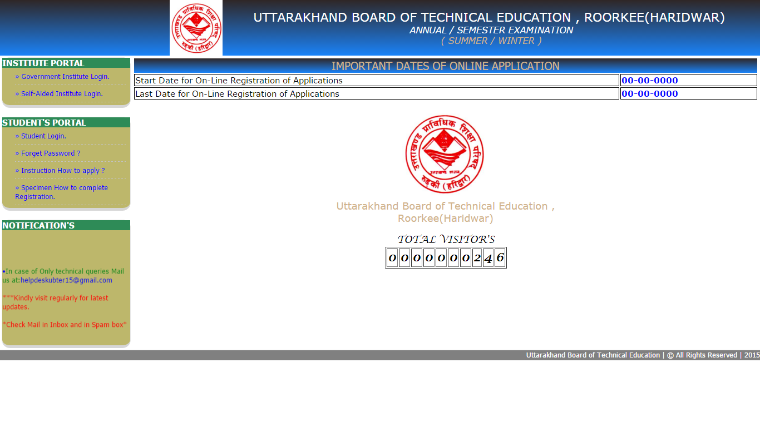

**INSTITUTE / BRANCH LOGIN**

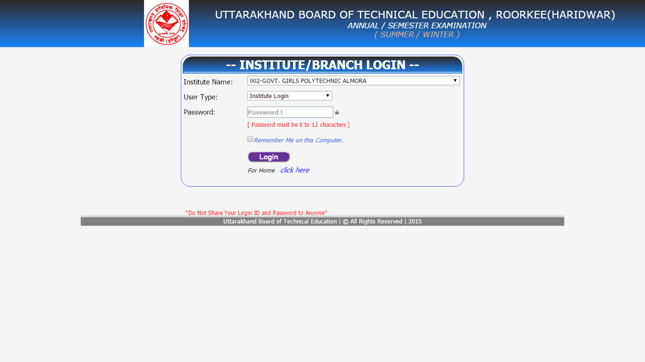

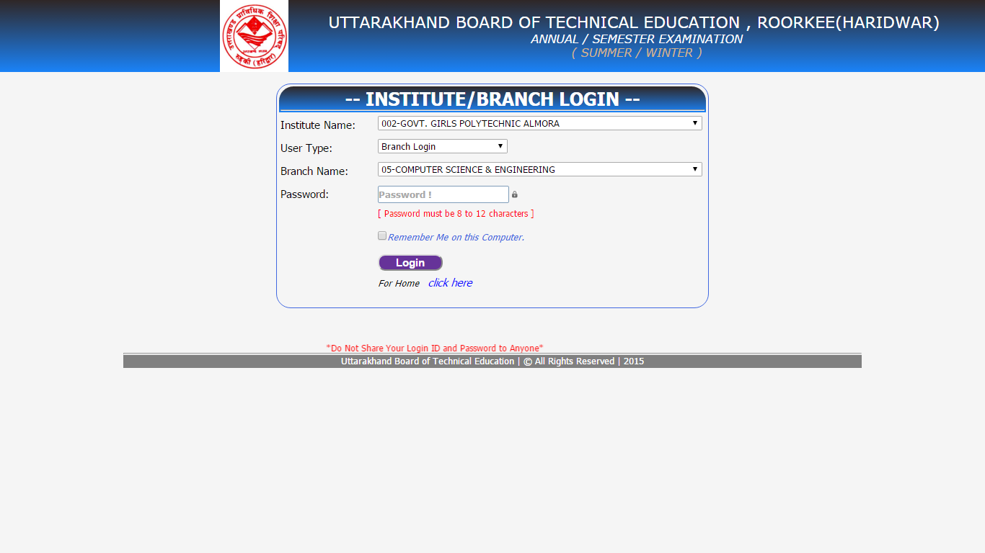

**AFTER INSTITUTE LOGIN**

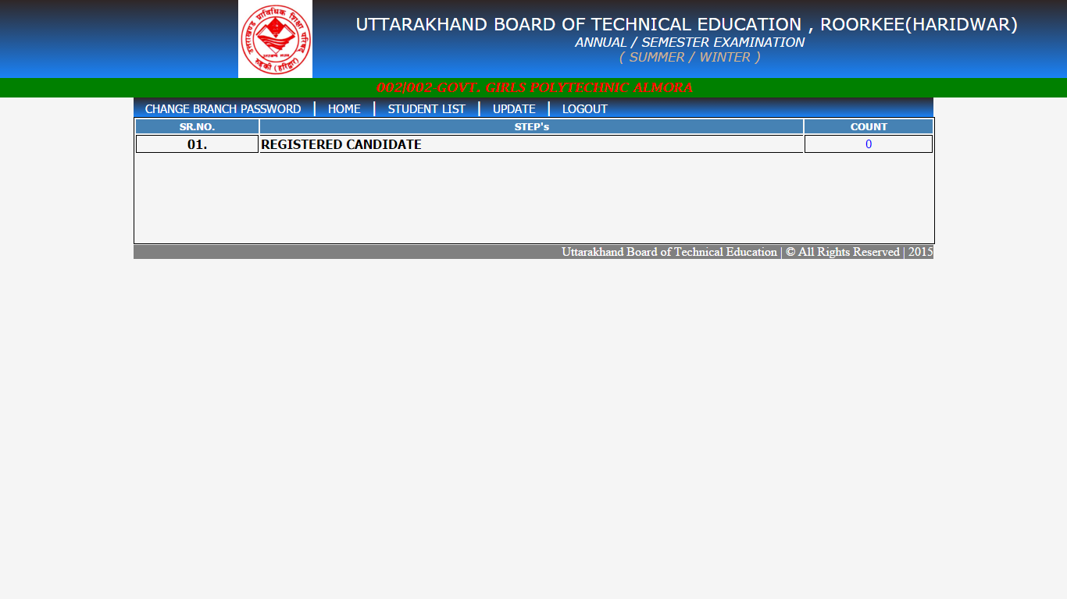

**AFTER BRANCH LOGIN**

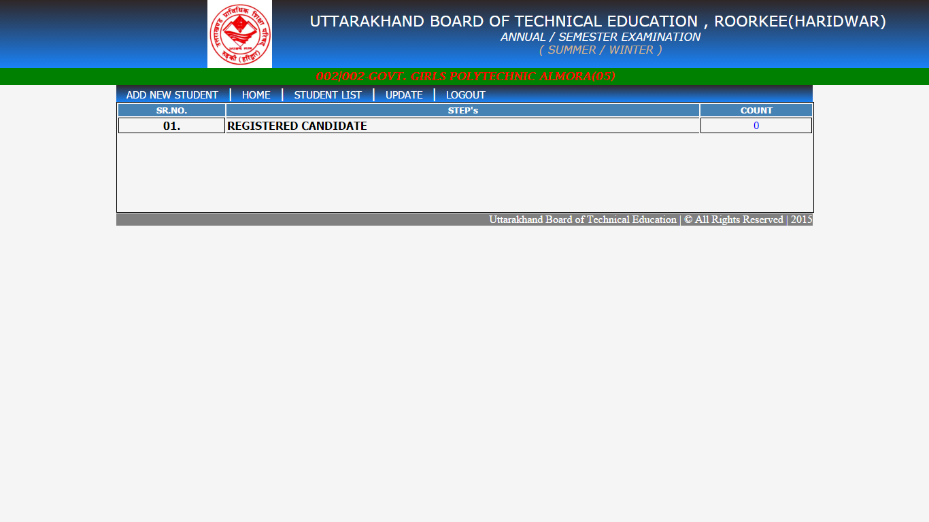

**STUDENT LOGIN**

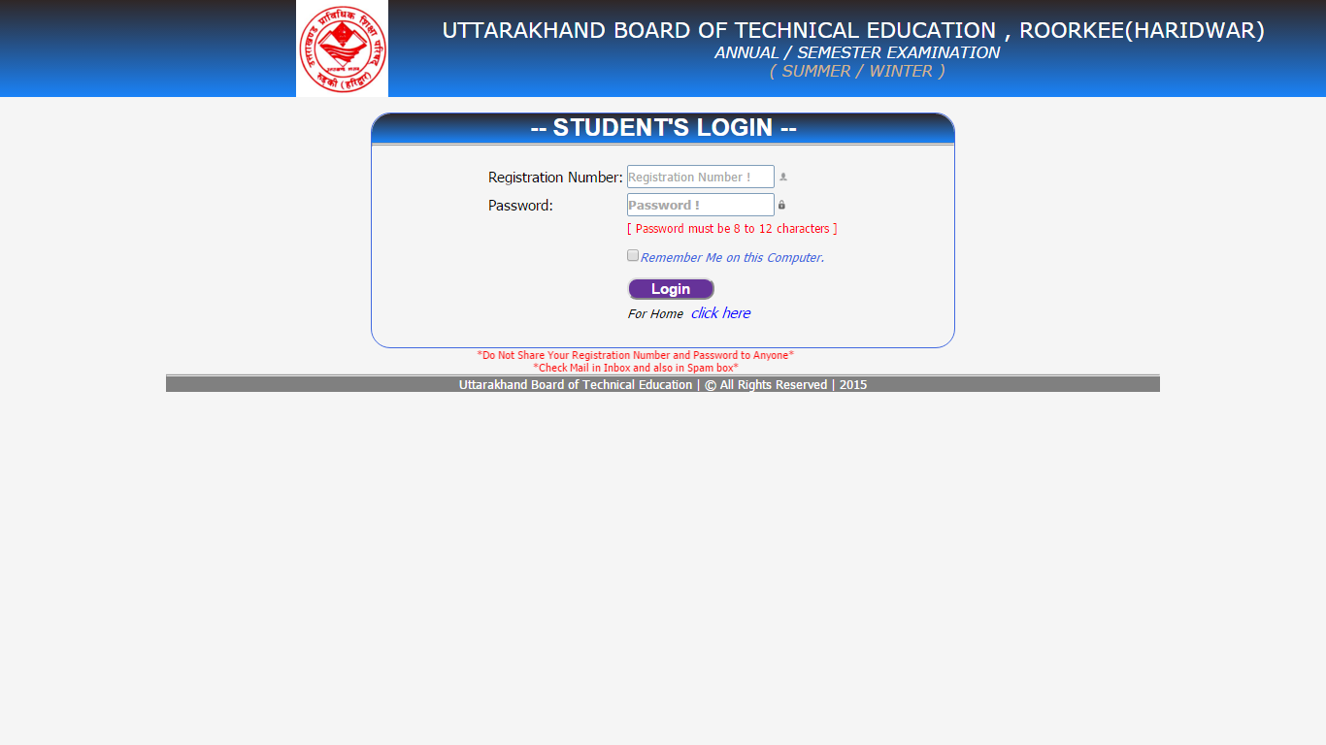

After Login Below page will be Display-

**REGISTRATION FORM**

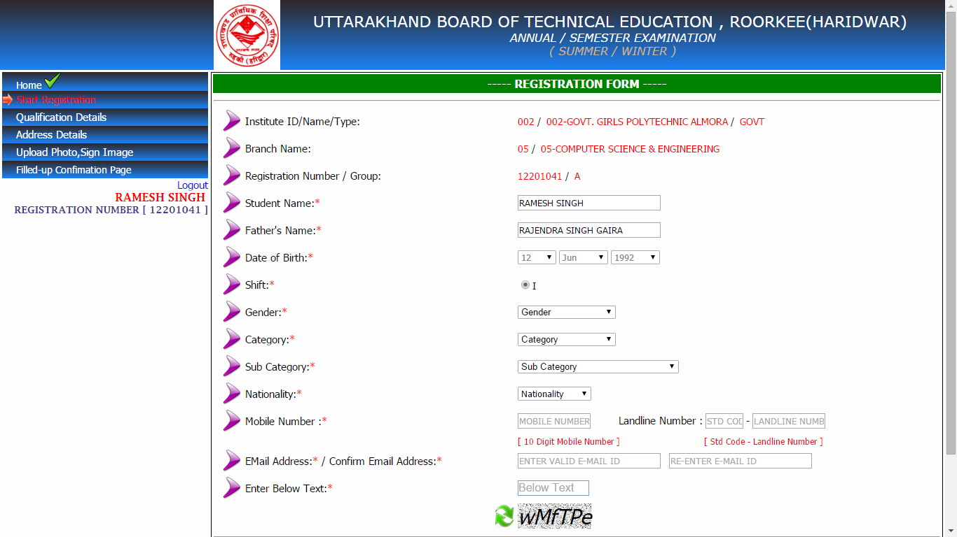

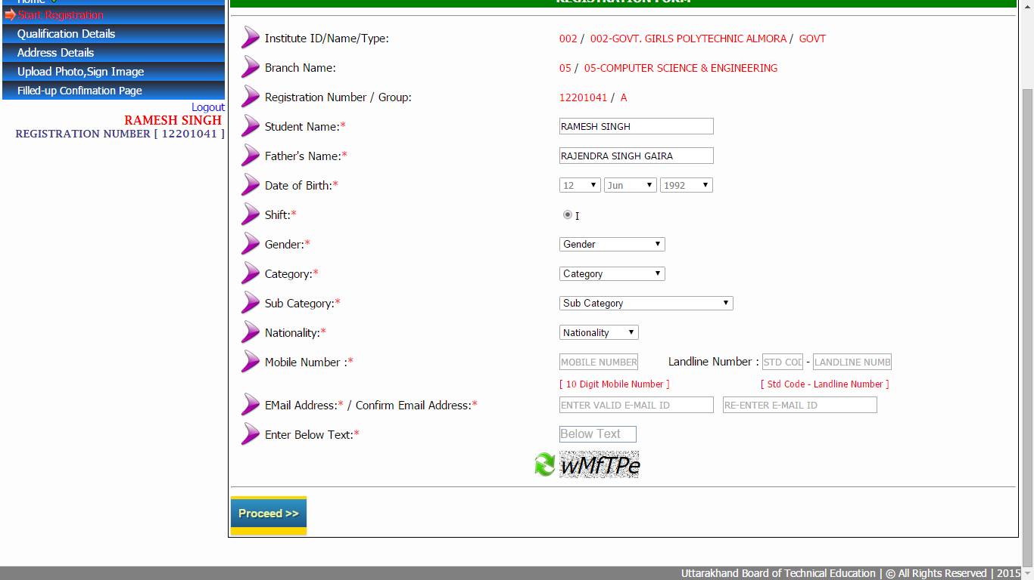

After filling all information click on “Proceed” for Registration

After Completion of Registration below message will be display

**QUALIFICATION**

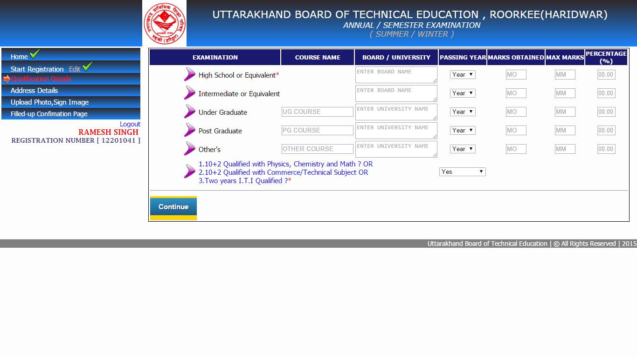

**ADDRESS**

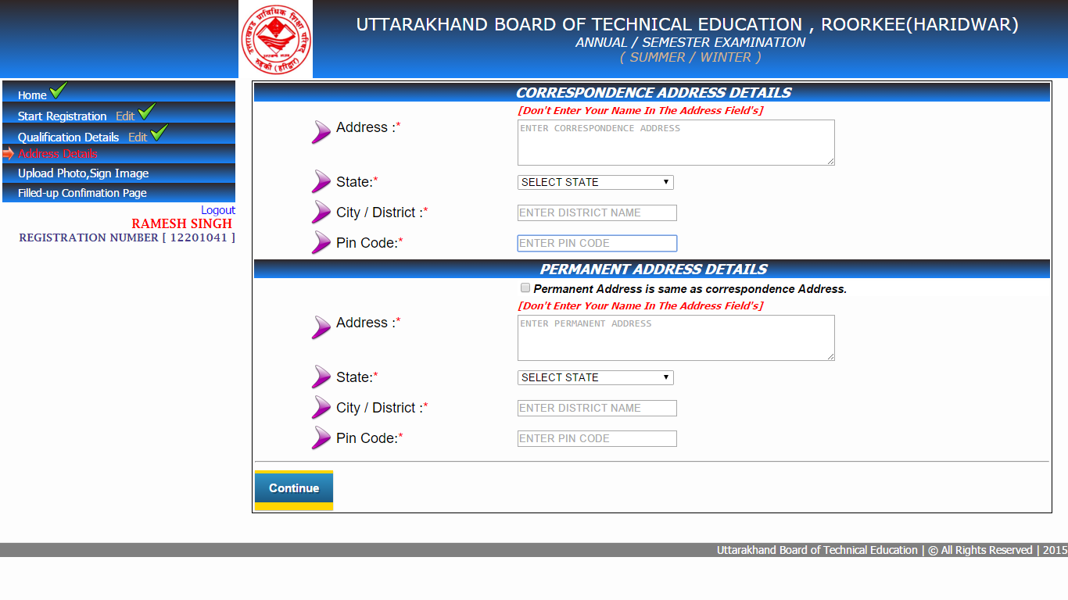

**UPLOAD PHOTO AND SIGN IMAGES**

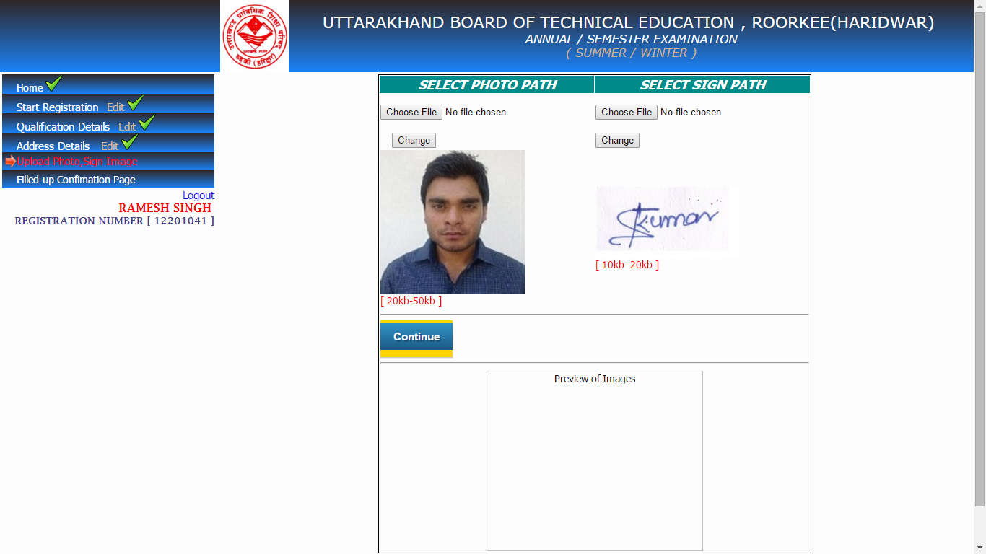

Note: - After uploading of photo and sign EDIT will not be possible for student.

HOW TO SET PHOTO SIGN DIMENSION

PHOTO DIMENSION(200*230)

1.open image in “Paint” click on “Resize”

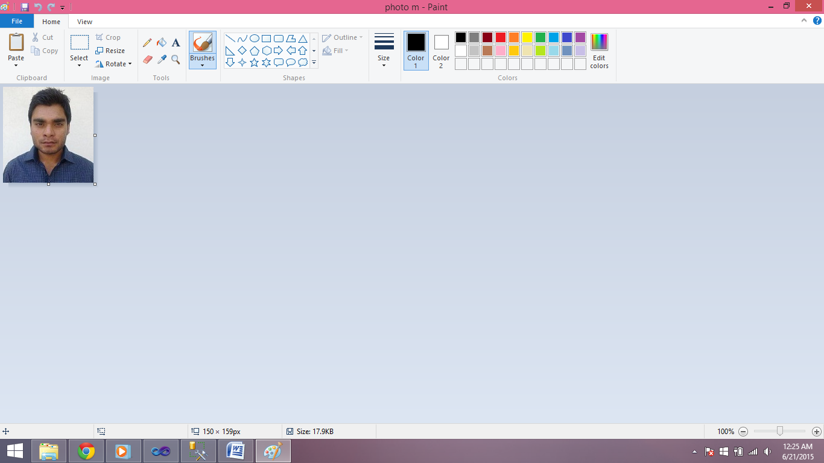

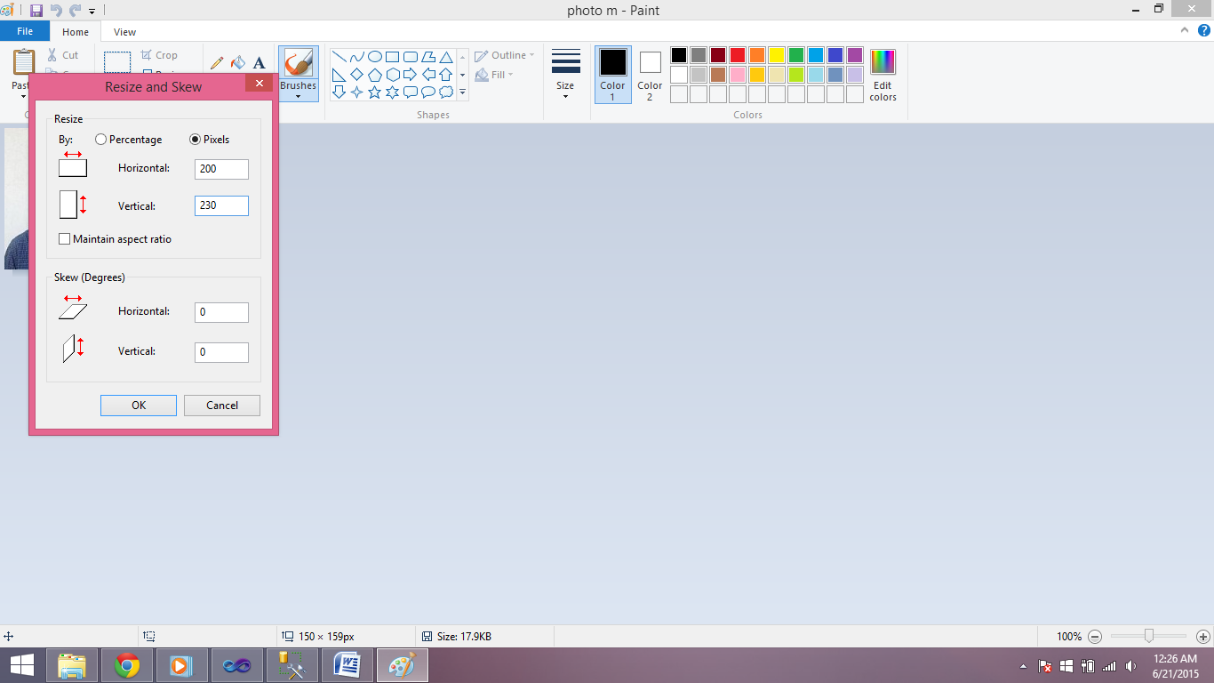

FOR SIGN(140*60)

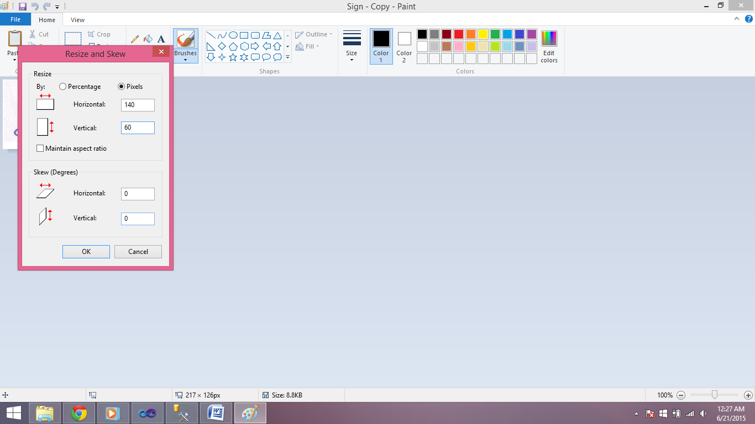

CONFIRMATION PAGE:-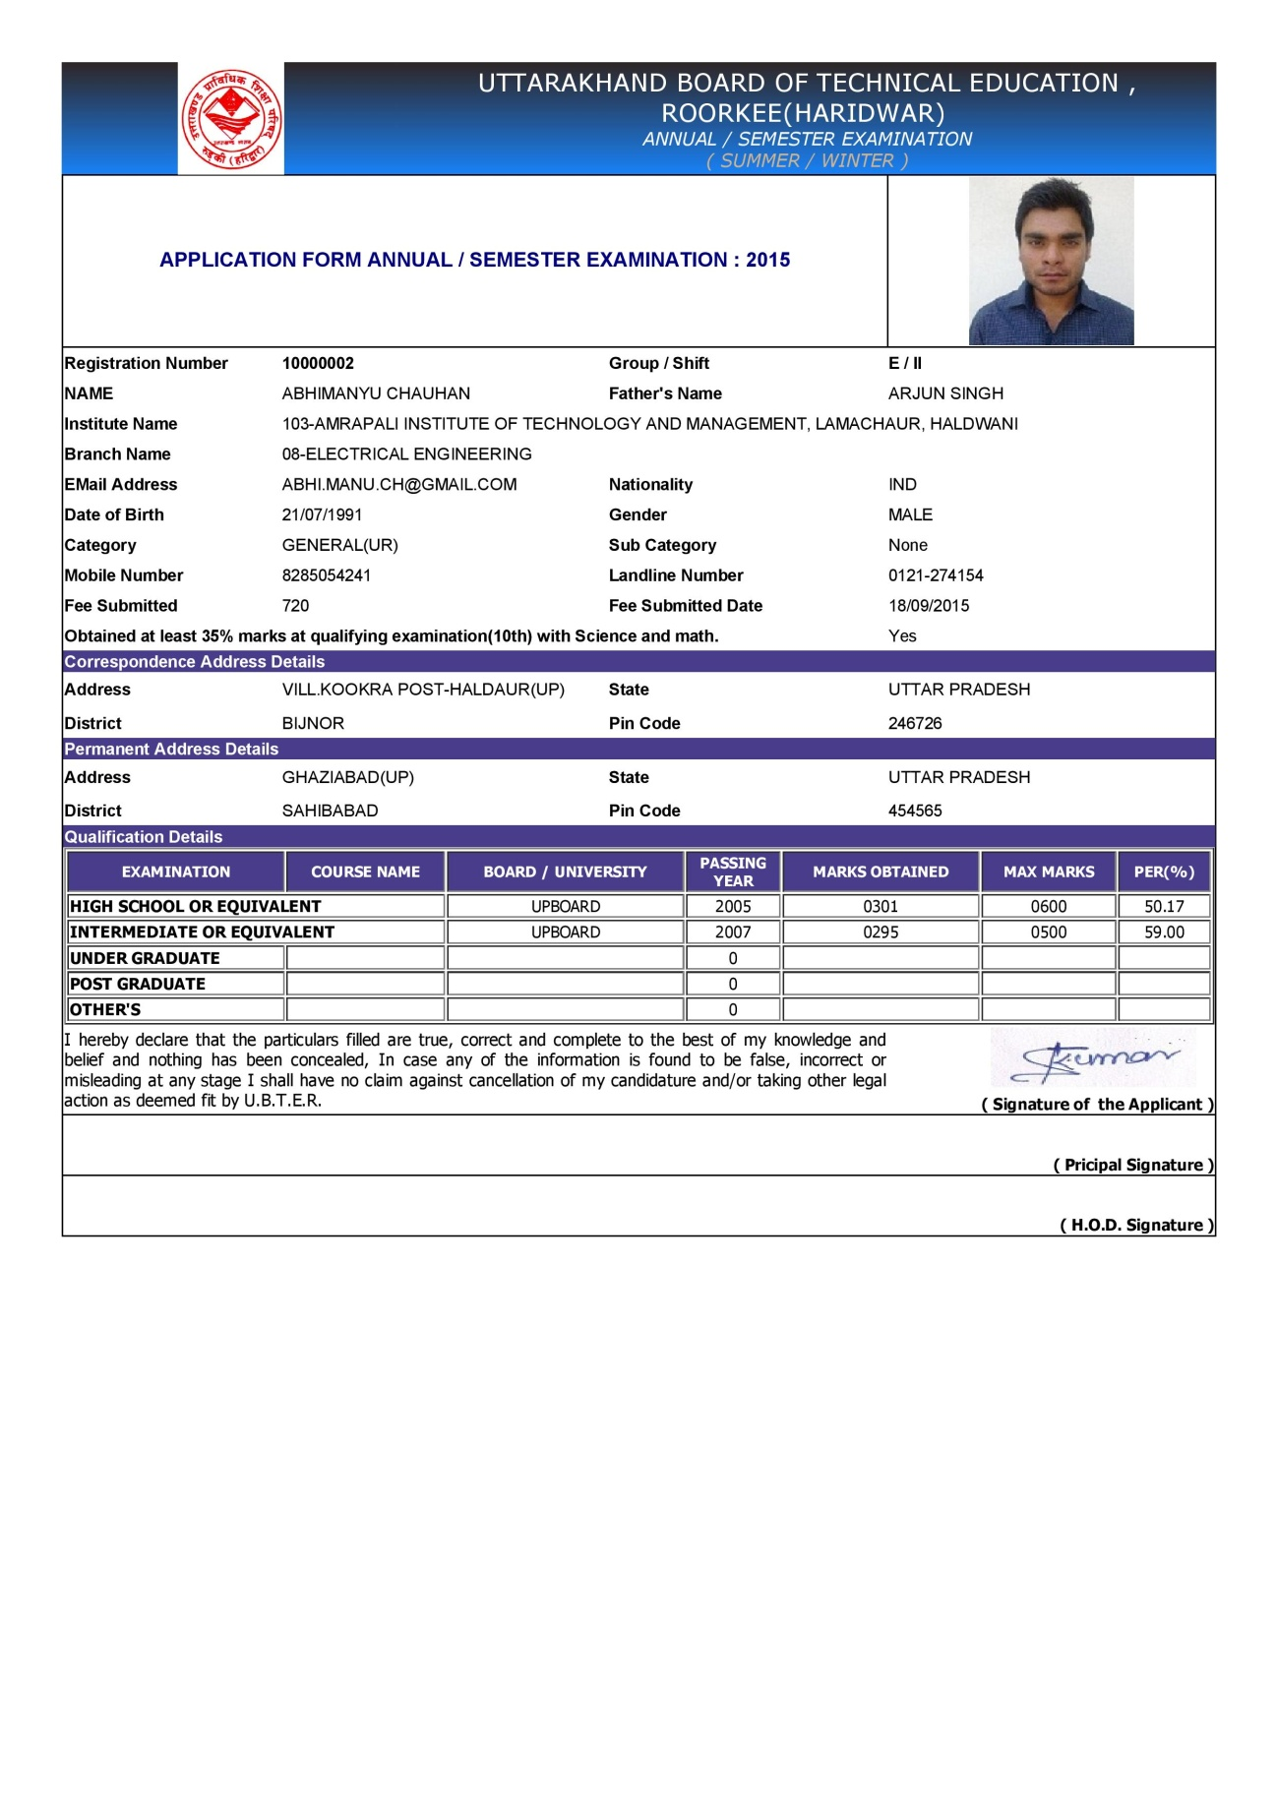

STUDENT HOME PAGE(all complete steps)

