# Report--Assignment 2: The IT World

## Team Profile

### 1. Team Name: IT 365

Motivation: IT has penetrated into our daily life such as medical care, accommodation and travel. 365 mean a whole year, that is, the number of days of a year. So our team named “IT 365”.

### 2. Personal Information

Member 1: Zhen Zhao, s3665004. Email address: [s3665004@student.rmit.edu.au](mailto:s3665004@student.rmit.edu.au).

He likes swimming and watching movies. He is studying in RMIT university for IT. He has been to Melbourne for 2 years, and already has a small business which is travel agency. His interest is using programming to solve actual problems. He expect to learn data mining.

Member 2: Jiaqi Wang, s3678662, Email address: [s3678662@student.rmit.edu.au](mailto:s3678662@student.rmit.edu.au).

He comes from china and chinese is his first language. He will study for bachelor of IT in RMIT from 2018 to 2021. In his extra time, He likes playing the guitar and other instruments. His interest is game programming. He hope he can master some basic knowledge of IT and consolidate IT. In addition, He expect to learn view and solve problems from different angles.

Member 3: Ynjun Shen, s3653819, Email address: [s3653819@rmit.edu.au](mailto:s3653819@rmit.edu.au) .

He is from Shanghai, China. He speaks Shanghainese, mandarin and English as his second language. Since 2013, he first came here to attend high school. He likes cooking Shanghainese dishes (traditional Shanghai style) and music very much. His interest is data processing especially in music file aspect.

Member 4: Fernando Yan, s3717019, Email address:  [s3717019@rmit.edu.au](mailto:%20s3717019@rmit.edu.au) .

He comes from China, and currently lives in Australia. He is studying bachelor of information technology. His interest is the software development. He hope to be a software developer.

### 3. Team Profile

**Test outcomes:**

* The online Myers-Briggs test

1) Zhen Zhao: MEDIATOR (INFP-T)

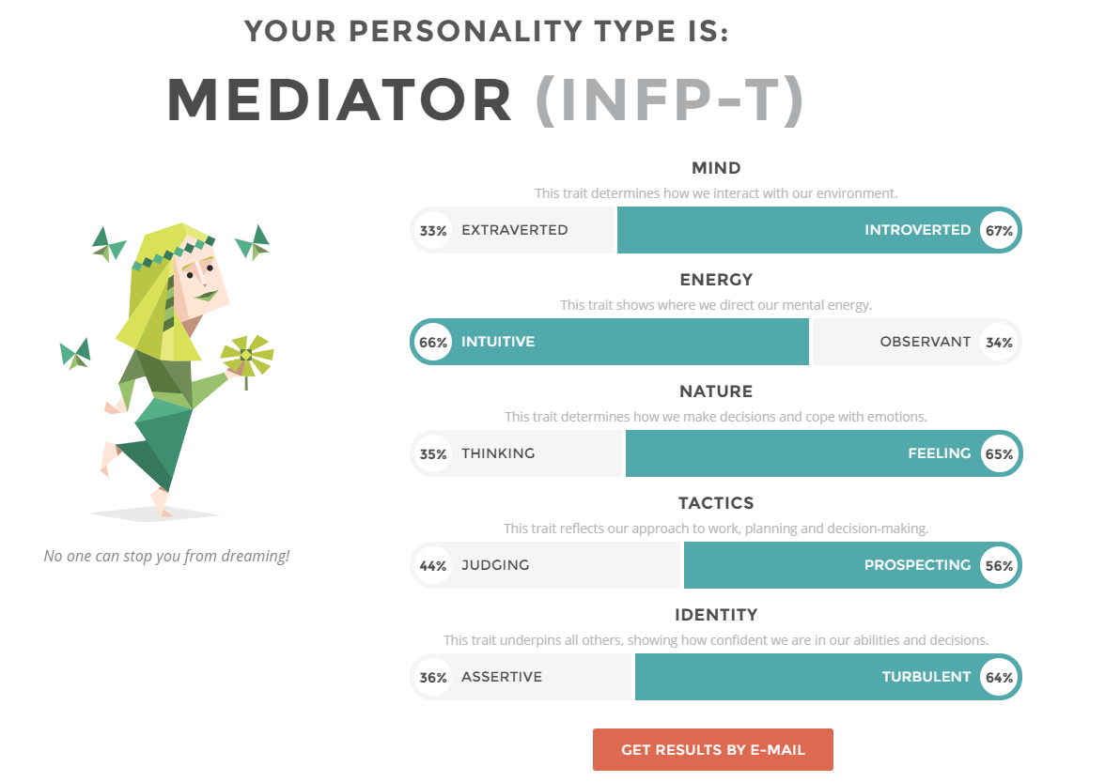

2) Jiaqi Wang: DEFENDER (ISFJ-A)

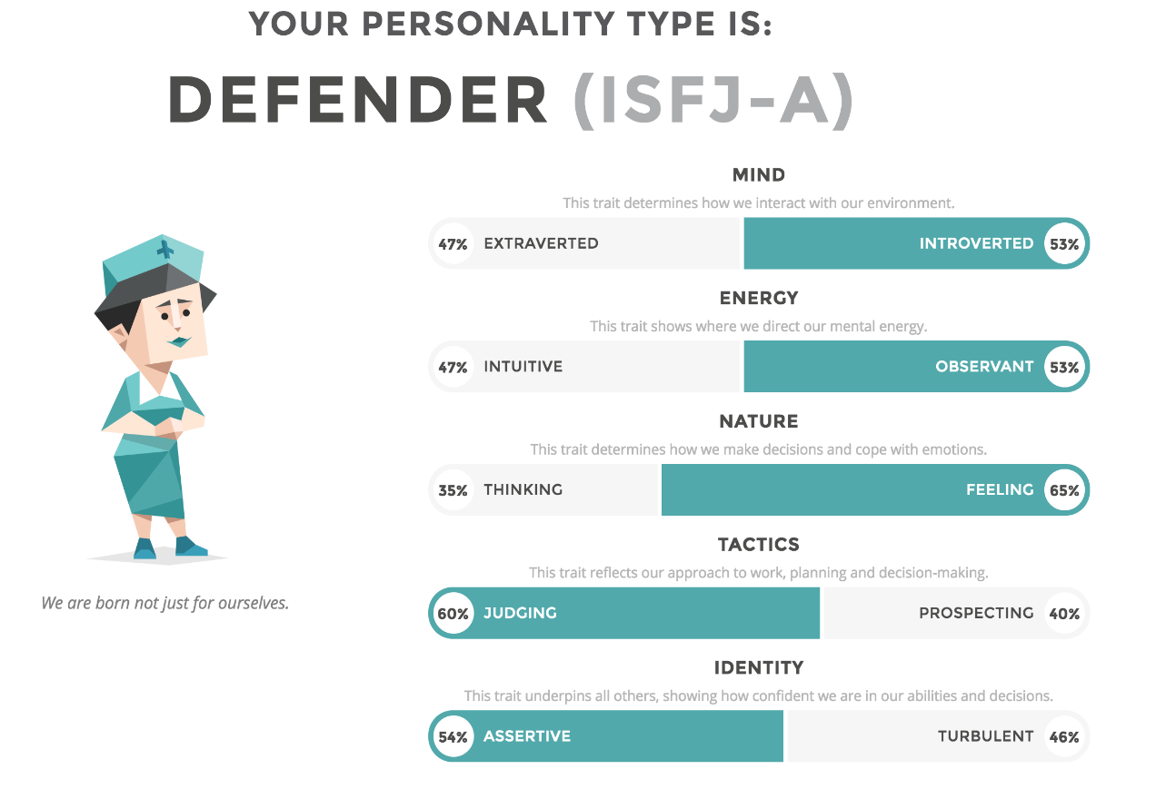

3) Ynjun Shen: ISFJ

The Myers-Briggs test show that he belongs to ISFJ (Introverted Sensing Feeling judging) personality.

4) Fernando Yan: ENTERTAINER (ESFP-T)

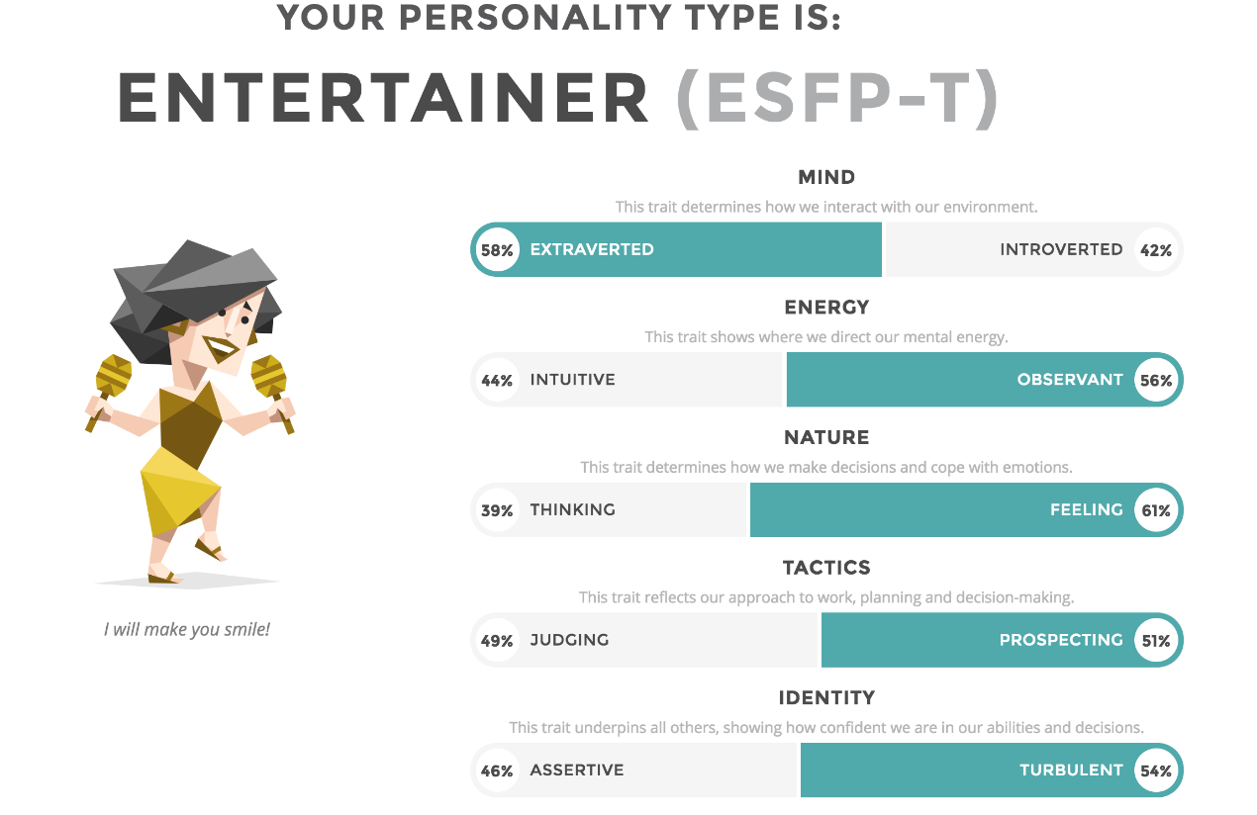

* The online learning style test

1) Zhen Zhao: Visual learner

Scores: - Auditory: 25% -Visual: 45% -Tactile: 30%

2) Jiaqi Wang: Visual learner

3) Ynjun Shen: Visual learner

Scores: - Auditory: 30% -Visual: 55% -Tactile: 15%

4) Fernando Yan: NONE

* Other test

1) Zhen Zhao: Big Five assessment

- Openness: 77% (high) -Conscientiousness: 54% (moderate) -Extraversion: 58% (moderate)

- Agreeableness: 73% (high) -Neuroticism: 50% (moderate)

2) Jiaqi Wang: Leader skills test

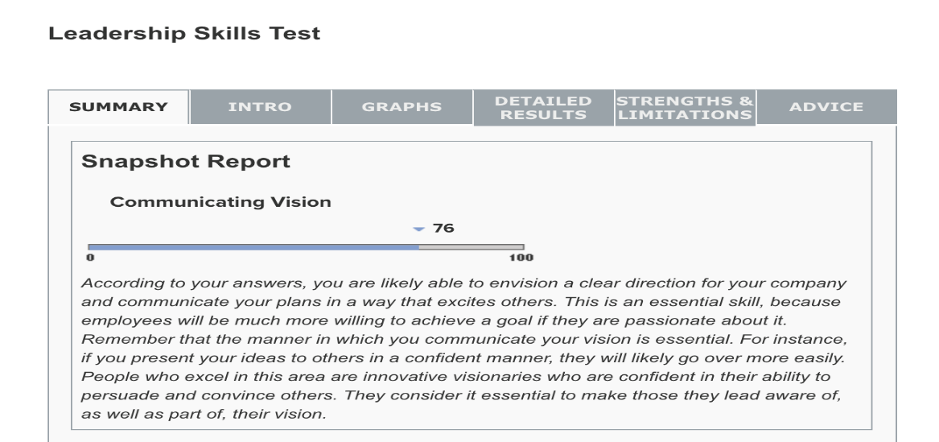

3) Ynjun Shen: The creativity test

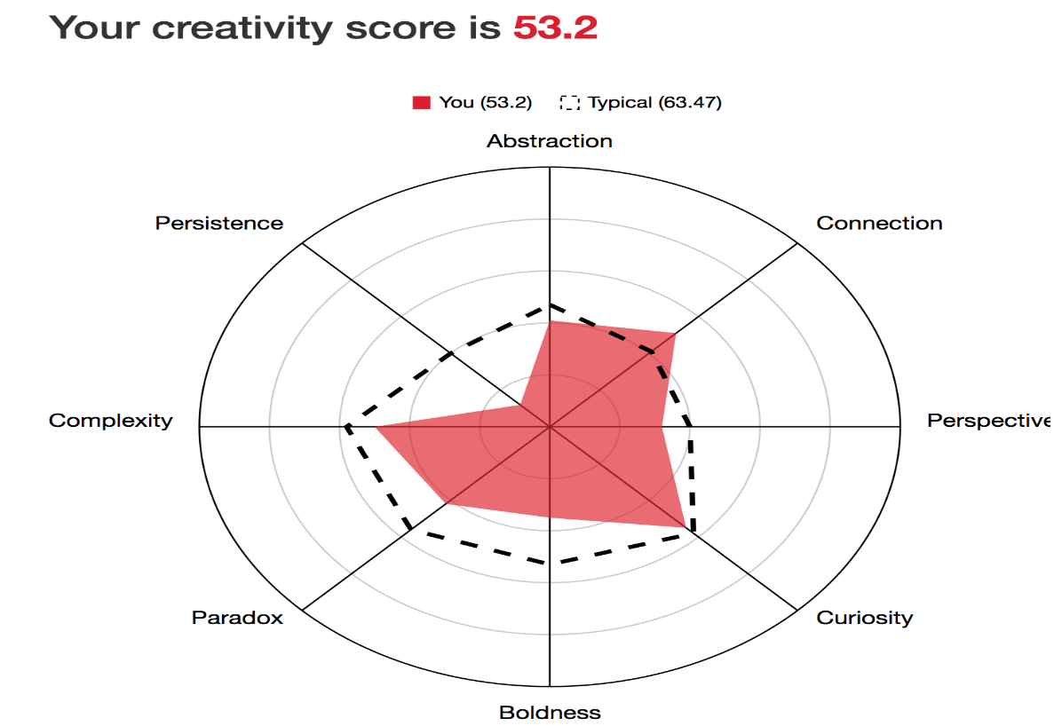

4) Fernando Yan: NONE

**Understanding**

The above tests are commonly used be employers to get preliminary understanding about potential employers. These test results can be used as a reference, and each member can gain a deeper understanding of themselves by virtue of these test results. The advantages of each person are different. Teamwork needs to foster strengths and circumvent weaknesses, taking into account the characteristics of each individual simultaneously. Note that, these test results are not absolute, we should refer these test results from different perspectives.

### 4. Ideal Jobs

|  |  |
| --- | --- |
| Member | Job |
| Zhen Zhao | Software engineer |
| Jiaqi Wang | IT technical staff |
| Ynjun Shen | Audio signal processing algorithms engineer |
| Fernando Yan | Software developer |

Similarity: All members want to work on IT area, where all work requires solid programming skills. However, members are not familiar with the basics of the relevant knowledge, but have a high degree of learning enthusiasm.

Difference: Zhen Zhao is interested in using programming to solve actual problems, and expects to learn data mining. He has a clear understanding of the skills the works required and his acquired skills, and has already set up the corresponding job plan. Jiaqi Wang is interested in game programming, and hopes master basic IT knowledge. He has a high study enthusiasm. Ynjun Shen is keen on data processing especially in music file aspect. He has clear distinction of the future work. Fernando Yan has strong interests on programming, and like to practicing by himself.

## Tools

**Group website link:** <https://ergui22.github.io/>

**Git repository link:** <https://github.com/ergui22/ergui22.github.io.git>

### Comments:

As the most advanced version control system, Git has the following characteristics:

1）Directly record snapshots, not difference comparisons

2）Nearly all operations are performed locally

3）Maintain data integrity at all times.

In addition to the above advantages, Git has many advanced features. The more you use Git, the more you like it.

## Industry Data

Source: Labour Insight Jobs (Burning Glass Technologies)

### Job titles:

**Our job titles:**

software developer and software engineer

**Rank of job titles:**

Based on the statistics of Top IT Job Titles from Mar.24, 2017 to Mar.23, 1028, the ranks of our job titles: software engineer and software developer are 11 and 19, respectively.

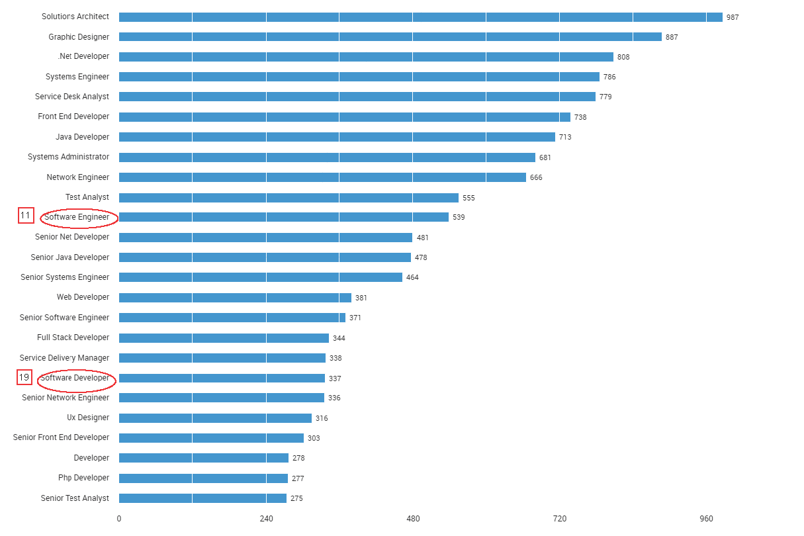

**Our ideal occupations:**

Software developer/engineer, compute programmer, multimedia designer/Animator

**Rank of our ideal occupations:**

Specifically, based on the statistics of Top Burning Glass Occupations ( BGTOCCs), the ranks of our ideal occupations: software developer/engineer, compute programmer, multimedia designer/Animator are 1, 8 and 19, respectively.

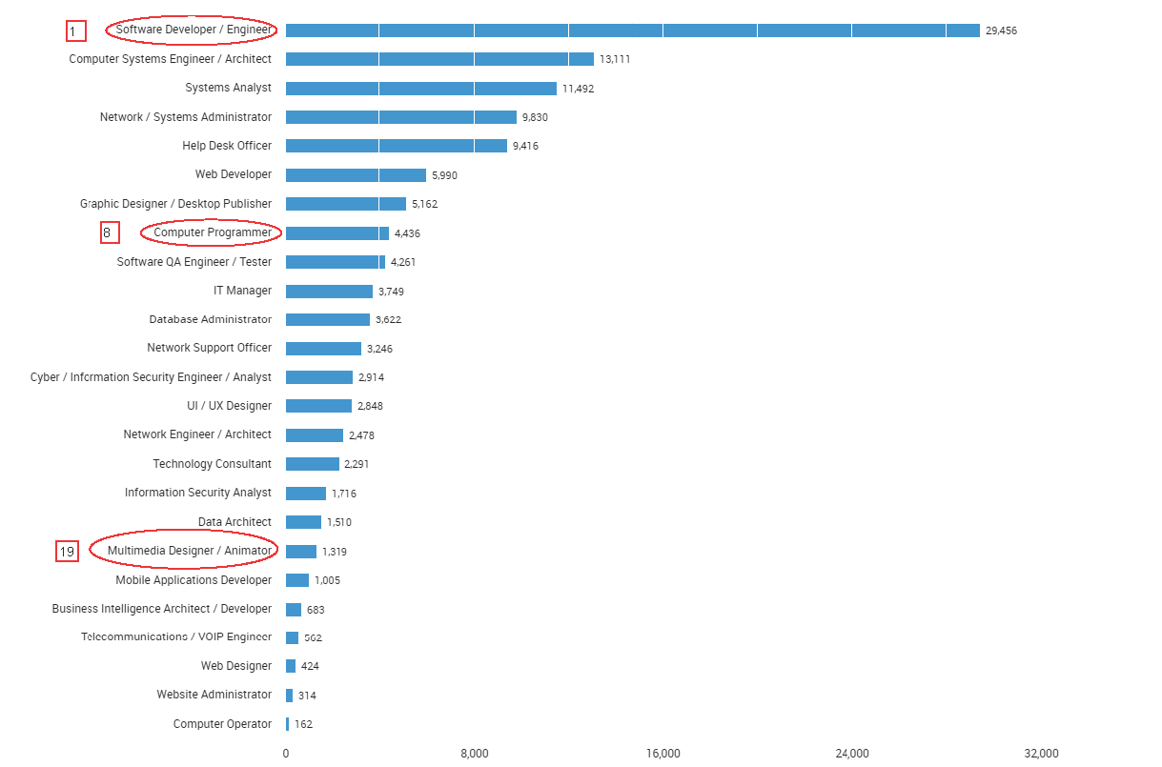

### **Required skill set**

a set of skills required for jobs, these can be divided into general skills (communication, problem solving, writing etc.) and IT-specific skills (Javacript, SQL, etc)

### IT-specific skills

Our main IT-specific skills are Java, SQL, Software engineering and Python

1) rank:

Based on the statistics of Top IT Skills from Dec.24, 2017 to Mar.23, 2018, the ranks of out IT-specific skills: Java, SQL, Software engineering and Python are 3,1, 15, and 22, respectively.

2) the three highest ranked skills not in our required skill set: JavaScript

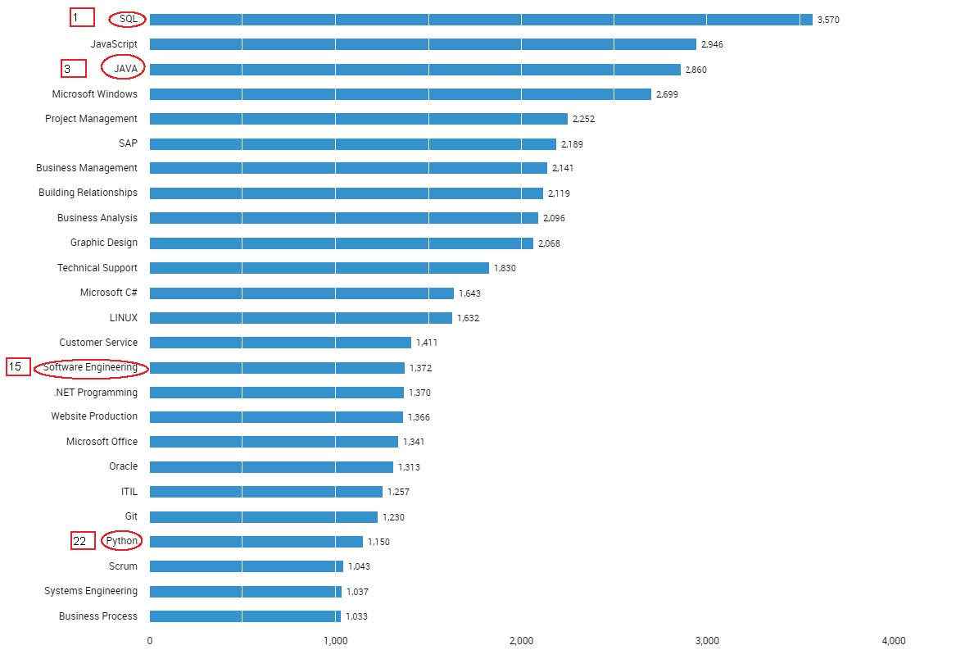

### General skills rank:

Our main general skills are communication skills, problem solving, team work/collaboration and planning.

1) rank:

Based on the statics of Top Generic Skills from Mar.01, 2017 to Feb.28, 1018, the ranks of general skills : communication skills, problem solving, team work/collaboration and planning are 1, 2, 5 and 7, respectively.

2) the three highest ranked skills not in our required skill set: Organisational skills.

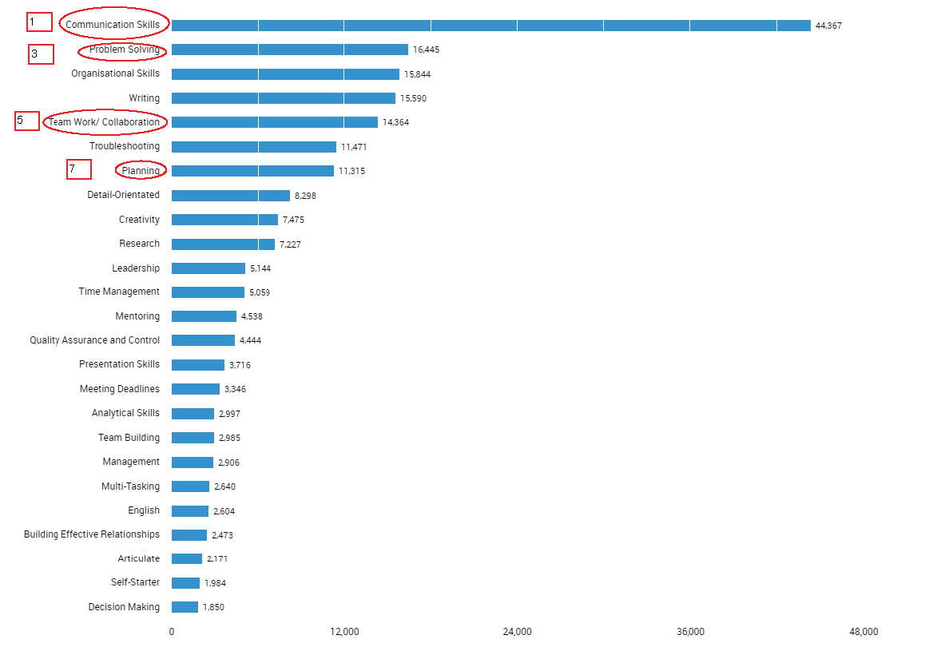

### Opinion of our ideal jobs

We all have not changed our ideal jobs. On the one hand, because there is still a great demand in the market for these jobs, and based on the above statistics, we have a clearer understanding for the need of acquired knowledge and work prospect.

## IT Work

### Sources link:

**5 different IT professionals**:

System administrator, software engineer, IT consultant, security analyst, IT manager

**10 sources:**

1) [One day in the life of an IT professional – Prithiviraj]

<https://www.youtube.com/watch?v=Vx6DZSXo6EQ>

2) [A day in the life of an IT Guy]

<https://www.youtube.com/watch?v=X3RgJLD2SrM>

3) [A typical day working in IT]

<https://www.youtube.com/watch?v=9A9kIOwnVtw>

4) [I.T. story time- Day in the life of a technology professional]

<https://www.youtube.com/watch?v=WGN4Y-fw2PM>

5) [A day in the life of a systems administrator]

<https://www.youtube.com/watch?v=ZEU-EybN4Kk>

6) [Software Engineer’s Daily life]

<https://www.youtube.com/watch?v=0-wyRmgKy2k>

7) [A day in the life of an IT student]

<https://www.youtube.com/watch?v=4YspJ2XWu9U>

8) [A day in the life: IT consultant]

<https://www.youtube.com/watch?v=P-0LOBSE2R4>

9) [A day in the life of a security analyst]

<https://www.youtube.com/watch?v=WE8O5E1RbMU>

10) [What can you do with an IT management degree]

<https://www.rasmussen.edu/degrees/technology/blog/careers-with-information-systems-management-degree/>

### Answer to the following questions:

* What kind of work is done by the IT professional?

Anyone who is involved in information technology can be called an IT person. The IT industry provides various jobs titles, we brief introduce the works of some popular IT jobs:

1) Software engineer: designing and programming system-level software, operating systems, database systems, embedded systems and so on. Need to understand how both software and hardware function. Involve talking to clients and colleagues to assess and define what solution or system is needed.

2) System analyst: investigating and analyzing business problems and then designing information systems that provide a feasible solution.

3) Technical consultant: providing technical expertise, developing and implementing IT systems for external clients.

* What kind of people does the IT professional interact with? Are they other IT

professionals? Clients? Investors? The general public?

The above four kinds of people are needed to interact with for IT professionals. Specifically, IT professional need to communicate with other IT professionals for problems solving and technological innovation, with clients for providing excellent customer service, with investors for commodity demand and investment costs, with general public for commodity improvement.

* Where does the IT professional spend most of their time?

According to the 484 CIOs and IT managers polled, IT properties and strategy spend the most of IT professional’s time. We list the time of IT professional as follows:

(link: <http://www.itmanagerdaily.com/it-managers-time-and-money/> )

1. IT priorities and strategy (16% of IT managers’ time, on average)
2. business priorities and strategy (14%)
3. interacting with internal IT staff members (13%)
4. interacting with other company employees (12%)
5. IT operations (12%)
6. interacting with non-IT executives (11%)
7. interacting with IT contractors and other non-employees (7%)
8. IT governance (6%)
9. IT management and human resources (6%)
10. software development (2%), and
11. other (1%)

* What aspect of their position is most challenging?

One of IT position’s challenges is adjusting to the new trend of IT area. IT pros are faced with a selection of hundreds of certifications that cover various aspects of information technology. Allowing any certification to lapse can endanger future prospects.

## IT Technologies

We select machine learning, autonomous vehicles, natural language processing and chatterbots to make a brief introduction.

### Machine Learning

(Source: <https://www.sas.com/en_us/insights/analytics/machine-learning.html>)

* What does it do?

Machine learning is a method of data analysis that automates analytical model building. It is a branch of artificial intelligence based on the idea that systems can learn from data, identify patterns and make decisions with minimal human intervention.

Because of new computing technologies, machine learning today is not like machine learning of the past. It was born from pattern recognition and the theory that computers can learn without being programmed to perform specific tasks; researchers interested in artificial intelligence wanted to see if computers could learn from data. The iterative aspect of machine learning is important because as models are exposed to new data, they are able to independently adapt. They learn from previous computations to produce reliable, repeatable decisions and results. It’s a science that’s not new – but one that has gained fresh momentum.

While many machine learning algorithms have been around for a long time, the ability to automatically apply complex mathematical calculations to big data – over and over, faster and faster – is a recent development. Here are a few widely publicized examples of machine learning applications you may be familiar with:

* The heavily hyped, self-driving Google car? The essence of machine learning.
* Online recommendation offers such as those from Amazon and Netflix? Machine learning applications for everyday life.
* Knowing what customers are saying about you on Twitter? Machine learning combined with linguistic rule creation.
* Fraud detection? One of the more obvious, important uses in our world today.

Resurging interest in machine learning is due to the same factors that have made data mining and Bayesian analysis more popular than ever. Things like growing volumes and varieties of available data, computational processing that is cheaper and more powerful, and affordable data storage.

All of these things mean it's possible to quickly and automatically produce models that can analyze bigger, more complex data and deliver faster, more accurate results – even on a very large scale. And by building precise models, an organization has a better chance of identifying profitable opportunities – or avoiding unknown risks.

* What is the likely impact?

Most industries working with large amounts of data have recognized the value of machine learning technology. By gleaning insights from this data – often in real time – organizations are able to work more efficiently or gain an advantage over competitors.

* Financial services

Banks and other businesses in the financial industry use machine learning technology for two key purposes: to identify important insights in data, and prevent fraud. The insights can identify investment opportunities, or help investors know when to trade. Data mining can also identify clients with high-risk profiles, or use cybersurveillance to pinpoint warning signs of fraud.

* Health care

Machine learning is a fast-growing trend in the health care industry, thanks to the advent of wearable devices and sensors that can use data to assess a patient's health in real time. The technology can also help medical experts analyze data to identify trends or red flags that may lead to improved diagnoses and treatment.

* Oil and gas

Finding new energy sources. Analyzing minerals in the ground. Predicting refinery sensor failure. Streamlining oil distribution to make it more efficient and cost-effective. The number of machine learning use cases for this industry is vast – and still expanding.

* Government

Government agencies such as public safety and utilities have a particular need for machine learning since they have multiple sources of data that can be mined for insights. Analyzing sensor data, for example, identifies ways to increase efficiency and save money. Machine learning can also help detect fraud and minimize identity theft.

* Marketing and sales

Websites recommending items you might like based on previous purchases are using machine learning to analyze your buying history – and promote other items you'd be interested in. This ability to capture data, analyze it and use it to personalize a shopping experience (or implement a marketing campaign) is the future of retail.

- Transportation

Analyzing data to identify patterns and trends is key to the transportation industry, which relies on making routes more efficient and predicting potential problems to increase profitability. The data analysis and modeling aspects of machine learning are important tools to delivery companies, public transportation and other transportation organizations.

* How will this affect you?

The development of machine learning will affect our lifestyle in the following aspects:

(Source: <https://www.cnbc.com/2018/01/05/how-artificial-intelligence-will-affect-your-life-and-work-in-2018.html> )

* Everybody will have a virtual assistant, and they're going to be pretty smart

"Personal assistant AIs will keep getting smarter. As our personal assistants learn more about our daily routines, I can imagine the day I need not to worry about preparing dinner. My AI knows what I like, what I have in my pantry, which days of the week I like to cook at home, and makes sure that when I get back from work all my groceries are waiting at my doorstep, ready for me to prepare that delicious meal I had been craving." — Alejandro Troccoli, senior research scientist, NVIDIA

* Facial recognition will be the new credit card

"Thanks to AI, the face will be the new credit card, the new driver's license and the new barcode. Facial recognition is already completely transforming security with biometric capabilities being adopted, and seeing how tech and retail are merging, like Amazon is with Whole Foods, I can see a near future where people will no longer need to stand in line at the store." — Georges Nahon, CEO, Orange Silicon Valley; president, Orange Institute, a global research co-laboratory

* Artificial intelligence will generate media specific to your personal preferences

"Given the rapid pace of research, I expect AI to be able to create new personalized media, such as music according to your taste. Imagine a future music service that doesn't just play existing songs you might like, but continually generates new songs just for you." — Jan Kautz, senior director of Visual Computing and Machine Learning Research, NVIDIA

### Autonomous vehicles

* What does it do?

(Source: <https://en.wikipedia.org/wiki/Autonomous_car> )

An automated car (also known as a driverless car and a self-driving car) is a vehicle that is capable of sensing its environment and navigating without human input. Automated cars combine a variety of techniques to perceive their surroundings, including radar, laser light, GPS, odometry, and computer vision. Advanced control systems interpret sensory information to identify appropriate navigation paths, as well as obstacles and relevant signage.

The potential benefits of automated cars include reduced mobility and infrastructure costs, increased safety, increased mobility, increased customer satisfaction, and reduced crime. These benefits also include a potentially significant reduction in traffic collisions; resulting injuries; and related costs, including less need for insurance. Automated cars are predicted to increase traffic flow;[7] provide enhanced mobility for children, the elderly, disabled, and the poor; relieve travelers from driving and navigation chores; lower fuel consumption; significantly reduce needs for parking space; reduce crime; and facilitate business models for transportation as a service, especially via the sharing economy. This shows the vast disruptive potential of the emerging technology.

Experiments have been conducted on automating driving since at least the 1920s; promising trials took place in the 1950s. The first truly automated car was developed in 1977, by the Tsukuba Mechanical Engineering Laboratory in Japan. The vehicle tracked white street markers, which were able to be interpreted by two cameras fitted onto the vehicle, using an analog computer-based technology for signal processing. The Tsukuba automated car was able to achieve speeds up to 30 kilometers per hour (19 mph), with the support of an elevated rail. Autonomous prototype cars appeared in the 1980s, with Carnegie Mellon University's Navlab and ALV projects funded by DARPA starting in 1984 and Mercedes-Benz and Bundeswehr University Munich's EUREKA Prometheus Project in 1987. By 1985 the ALV had demonstrated self-driving speeds on two-lane roads of 31 kilometers per hour (19 mph) with obstacle avoidance added in 1986 and off-road driving in day and nighttime conditions by 1987. From the 1960s up through the second DARPA Grand Challenge in 2005, automated vehicle research in the U.S. was primarily funded by DARPA, the US Army and the U.S. Navy yielding incremental advances in speeds, driving competence in more complex conditions, controls, and sensor systems. Since then, numerous companies and research organizations have developed prototypes.

* What is the likely impact?

(Source: <https://onlinemasters.ohio.edu/blog/5-effects-of-the-adoption-of-autonomous-vehicles/> )

Research projects that the adoption of autonomous vehicles in business and consumer life will have a definite impact on the economy. A study by research group BCG predicts that by the year 2035, 12 million fully autonomous vehicles and 18 million partially autonomous vehicles will be sold globally each year. In this same timeframe, vehicles with autonomous features will hold 25 percent of the new car market, with market growth somewhere between $42 billion and $77 billion.

Jobs currently held by human workers – such as taxi or public transit drivers – could be replaced as a result of autonomous vehicles operating on their own. Self-driving automobiles have the potential for displacing human drivers if used for commercial trucking fleets, taxi services, and school and transit bus services. Farming, manufacturing, and construction workers could feasibly be replaced by autonomous vehicles that are designed to accomplish specific, repetitive tasks in those fields.

The loss of certain human jobs to autonomous vehicles represents only one side of the possible economic effect. For example, a winning proposal in the U.S. Department of Transportation’s $40 million Smart City Challenge for Columbus, Ohio, uses autonomous vehicles to connect unemployed residents in the Linden neighborhood to a job center nearby. Austin and San Francisco officials have plans to use new autonomous technology to provide transportation options to low-income residents.

* How will this affect you?

(Source: <https://www.businessinsider.com/how-driverless-cars-will-change-lives-2016-12#everybody-will-have-more-free-time-5> )

* We may stop drive owner cars

Industry experts predict self-driving cars will dramatically change consumers' traveling habits, spurring them to trade car ownership for on-demand robo-taxis. In fact, vehicle ownership could decline as much as 43% in the US once autonomous cars are adopted, according to a study by the University of Michigan Transportation Research Institute. One big reason for this is because it will be more cost effective to use a shared fleet car as opposed to your own autonomous vehicle. In fact, by taking a shared, driverless fleet vehicle, your cost per mile could be reduced as much as 80% versus a personally owned vehicles when driven 10,000 miles per year, according to Casualty Actuarial Society.

* Traffic accidents will reduced

Autonomous cars will not only help reduce car crashes, they will also likely dramatically reduce traffic congestion. The average commuter in the US spent about 50 hours stuck in traffic during 2015, according to the INRIX 2015 Traffic Scorecard. In total, that means Americans spent 8 billion hours in traffic last year. However, according to a report from KPMG, the platooning of vehicles could increase highway capacity by as much as 500%, meaning less traffic and less wasted time.

* We will have more time

Time spent in traffic is wasted time. But Autonomous cars would enable drivers to spend that time doing something else instead. McKinsey estimates that worldwide time saved everyday by driverless cars could total as much as one billion hours.

### Natural Language processing and chatterbots

* What does it do?

（Source:

<https://www.sas.com/en_us/insights/analytics/what-is-natural-language-processing-nlp.html>

<https://en.wikipedia.org/wiki/Chatbot> ）

Natural language processing (NLP) is a branch of artificial intelligence that helps computers understand, interpret and manipulate human language. NLP draws from many disciplines, including computer science and computational linguistics, in its pursuit to fill the gap between human communication and computer understanding. While natural language processing isn’t a new science, the technology is rapidly advancing thanks to an increased interest in human-to-machine communications, plus an availability of big data, powerful computing and enhanced algorithms. As a human, you may speak and write in English, Spanish or Chinese. But a computer’s native language – known as machine code or machine language – is largely incomprehensible to most people. At your device’s lowest levels, communication occurs not with words but through millions of zeros and ones that produce logical actions. Indeed, programmers used punch cards to communicate with the first computers 70 years ago. This manual and arduous process was understood by a relatively small number of people. Now you can say, “Alexa, I like this song,” and a device playing music in your home will lower the volume and reply, “OK. Rating saved,” in a humanlike voice. Then it adapts its algorithm to play that song – and others like it – the next time you listen to that music station.

A chatbot (also known as a talkbot, chatterbot, Bot, IM bot, interactive agent, or Artificial Conversational Entity) is a computer program or an artificial intelligence which conducts a conversation via auditory or textual methods. Such programs are often designed to convincingly simulate how a human would behave as a conversational partner, thereby passing the Turing test. Chatbots are typically used in dialog systems for various practical purposes including customer service or information acquisition. Some chatterbots use sophisticated natural language processing systems, but many simpler systems scan for keywords within the input, then pull a reply with the most matching keywords, or the most similar wording pattern, from a database. The term "ChatterBot" was originally coined by Michael Mauldin (creator of the first Verbot, Julia) in 1994 to describe these conversational programs. Today, most chatbots are either accessed via virtual assistants such as Google Assistant and Amazon Alexa, via messaging apps such as Facebook Messenger or WeChat, or via individual organizations' apps and websites. Chatbots can be classified into usage categories such as conversational commerce (e-commerce via chat), analytics, communication, customer support, design, developer tools, education, entertainment, finance, food, games, health, HR, marketing, news, personal, productivity, shopping, social, sports, travel and utilities.

* What is the likely impact?

(Source:

<http://www.businesscomputingworld.co.uk/the-rise-of-natural-language-processing-in-chatbots/> )

The promise of natural language processing has been decades in arriving, but now it is here, it opens up a new world in digital communication. The arrival of Siri, Alexa and other talkative assistants is all well and good, but there’s no point if the device or service doesn’t understand what the person is asking for, or talking about. Over the few years of their short lives, they have become better at understanding people thanks to natural language processing (NLP), a technology that learns words and phrases and their meaning to provide a better service.

With chatbots now steaming onto Messenger, Skype and other platforms, acting as a 24/7 concierge or helper there are even more reasons to be aware of these technologies and the role NLP plays in them. Chatbots usually run on a script, but if the human on the other end isn’t following that script, then the conversation will run dry very quickly. NLP allows the chatbot to spot key phrases and go with a different approach.

The likes of Google’s Cloud Natural Language will drive all kinds of services in the cloud, as it and other services scan through documents or conversations for syntax, entities, sentiment and context. Soon the machines will understand everything we write or say. While the focus is on the technology, at the backend, there are now large numbers of people being employed with Machine Learning skills to help develop new systems and drive forward this part of the digital economy

* How will this affect you? (300 words)

(Source:

<https://www.forbes.com/sites/blakemorgan/2017/03/21/how-chatbots-will-transform-customer-experience-an-infographic/#23ef57137fb4> )

One of the reasons the chatbot has so much potential for businesses is its ability to scale. In 2016, 1.6 billion people used mobile messaging apps. That number is expected to reach 2 billion people, or 80% of all smartphone users, in 2018. In April 2016, Facebook said other companies could collaborate with them using the Facebook messenger app--and companies could integrate their bots into the existing app. That means that any company can ride the wave of Facebook Messenger’s success and huge audience to use a chatbot to engage with the customer in any way they want. Since then, tens of thousands of chatbots have been created that tie into the service.

"Chatbots will replace the search window," said Will Wiseman, chief strategy officer of PHD U.S. "There will be a rapid decline in app usage. The last three years, we have gone from brands' desire to have mobile-friendly websites, then apps, and [we] now expect to see app activity get cannibalized by bots." While chatbots are becoming increasingly popular, that doesn’t mean you can build one type of chatbot for everyone. 60% of chatbot users are between 13 and 19 years old, with more females than males. The service seems particularly suited for Millenials and Gen Z-ers, who grew up using many of these on-demand technologies, but it can be difficult for brands to reach other, older demographics through chatbots. When developing a bot, companies need to be aware of their target customers and who they are trying to reach with a new technology. Chatbots are amazingly efficient for both users and brands—they cut costs for companies by winding down the expensive interactions with traditional call center agents or customer service representatives, and they also make it easier and more convenient for customers to communicate with brands, streamlining interactions.

### Robots

* What does it do?

A robot is a machine—especially one programmable by a computer— capable of carrying out a complex series of actions automatically. Robots can be guided by an external control device or the control may be embedded within. Robots may be constructed to take on human form but most robots are machines designed to perform a task with no regard to how they look. Robots can be autonomous or semi-autonomous and range from humanoids such as Honda's Advanced Step in Innovative Mobility (ASIMO) and TOSY's TOSY Ping Pong Playing Robot (TOPIO) to industrial robots, medical operating robots, patient assist robots, dog therapy robots, collectively programmed swarm robots, UAV drones such as General Atomics MQ-1 Predator, and even microscopic nano robots. By mimicking a lifelike appearance or automating movements, a robot may convey a sense of intelligence or thought of its own. Autonomous Things are expected to proliferate in the coming decade, with home robotics and the autonomous car as some of the main drivers.

The branch of technology that deals with the design, construction, operation, and application of robots, as well as computer systems for their control, sensory feedback, and information processing is robotics. These technologies deal with automated machines that can take the place of humans in dangerous environments or manufacturing processes, or resemble humans in appearance, behavior, or cognition. Many of today's robots are inspired by nature contributing to the field of bio-inspired robotics. These robots have also created a newer branch of robotics: soft robotics.

From the time of ancient civilization there have been many accounts of user-configurable automated devices and even automata resembling animals and humans, designed primarily as entertainment. As mechanical techniques developed through the Industrial age, there appeared more practical applications such as automated machines, remote-control and wireless remote-control. Robots have replaced humans in performing repetitive and dangerous tasks which humans prefer not to do, or are unable to do because of size limitations, or which take place in extreme environments such as outer space or the bottom of the sea. There are concerns about the increasing use of robots and their role in society.

Robots are blamed for rising technological unemployment as they replace workers in increasing numbers of functions. The use of robots in military combat raises ethical concerns. The possibilities of robot autonomy and potential repercussions have been addressed in fiction and may be a realistic concern in the future.

* What is the likely impact?

With the development od robotics, almost every occupation has partial automation

potential, we conclude the probability of being replaced for some occupations:

(Source: <http://baijiahao.baidu.com/s?id=1586006427666133918&wfr=spider&for=pc> )

* Designers: 20%

Although there are some AIs taking small (and somewhat creepy) steps in the design space, design is both artistic and technical, making it an ideal role for a human being to carry out. All work needs to be original and created to the client's wishes, so design needs to be created with a human artist all-in-one.

* Chief Executives: 15%

It's nearly impossible to automate leadership -- after all, it's hard enough to teach it. Chief executives have to inform broad strategy, represent companies' missions and objectives, and motivate huge teams of people working for them. Companies may answer to stakeholders and boards of directors, who likely wouldn't want a robot giving them an earnings report, either.

* Healthcare worker: 15%

While automation is playing a bigger role in the treatment of patients, it’s hard to imagine it ever overtaking the need for human providers – and that’s good news for doctors, nurses and other healthcare employees everywhere.

* Creatives: 1.0%

Jobs that rely heavily on the right side of the brain – from actors to novelists – appear safe for the foreseeable future. Computers excel at analyzing structured data, but haven’t yet proved as useful in more imaginative pursuits such as performing.Creative folks everywhere, take heart.

* Teachers: 0.5%

Education is another area in which technology is making a huge impact, as the rise in online classes reveals. Nevertheless, the essence of teaching is deep expertise and complex interactions with other people. And those are the sorts of activities that are least prone to mechanization.

* How will this affect you?

It's not hard to imagine a future in which robots are an integral part of our daily lives. There are dozens of science fiction stories focusing on robots in the future. In some, robots cater to our every need, freeing us from mundane tasks to concentrate on loftier subjects. In others, robots rise up against humanity and become our greatest threat. In any case, robots change the way humans behave and think.

Robots can also evoke an emotional response in us. The Pleo dinosaur robot toy is a good example. People tend to look at Pleo as if it were a real pet. The robot reacts to stimuli and simulates an animal's responses. It seems to be able to express happiness, fear, frustration and even pain. While all of these reactions are artificial, our responses to Pleo are real.

Robots may also become useful tools to help children develop social skills. As we increase our understanding about autism and related conditions, we can design tools to help people integrate into society and understand social cues. Robots may teach us more about ourselves than we would learn otherwise.

Then there are the industrial and military uses for robots. We're already relying on robots to work assembly lines. Military branches and police squads use robots for bomb detection and other hazardous duties. We'll likely see even more widespread use of robots in these industries in the future.

## Project ideas

Networked Temperature System

**Overview**

Every day when you get up, you can check the real-time temperature and historical temperature of the outdoor, even the temperature of public places you plan to visit. This information can provide powerful help for your wardrobe plan. If the temperature of the destination is too low, you can carry more clothes in time to avoid catching a cold. Besides, property management can adjust the temperature of the indoor air conditioning based on the system.

**Motivation**

As a student, we need to attend classes in the classroom, study in the library or attend lectures in the lecture hall, and can’t leave for a long time. However we often don’t know immediately what the temperature is there. Many people might catch a cold due to the wrong temperature in public places, which affects their life and work. This is a problem that does not need to be present. I hope this app can help teachers and students improve their ability to cope with such situations and increase their productivity.

**Description**

The system will collect real-time data. And these data will be uploaded to server in real time. For each sensor, the average temperature within one minute will be stored as the value of that minute in the database. which ensures that real-time temperature information can be fed back to the users, and the information on temperature change can also be stored in the database.

Users can access the data in server through the web page which allows users to access the service without any device constraints, as long as they have a device with web page access function, the service can be accessed.

There are two kinds of data in service: real time and history data. Real-time data represents the temperature and humidity information of a place at the current time; Historical data indicates these information during the past period of time. Both of them will help people to know the changes of temperature and humidity better, so as to make their clothing plan more precisely.

This system supports users to feedback the failure of the temperature sensor. Sensor malfunction can be dealt with by heartbeat packets, but if the information on location is wrong when the sensor is installed, or sensor’s location changes because of surrounding environment, the temperature and humidity detection result might be incorrect.

Abnormal information will be fed back. The system makes abnormal judgment by comparing the historical records with current measured data. It can effectively detect the occurrence of forgetting to open or close air conditioning facilities, as well as the occurrence of dangerous behaviors such as forgetting to close doors and windows.

**Tools and Technologies**

The service needs database facilities, MCU equipment, SOCKET, etc. MYSQL database will be used for data storage and access considering of current data size.Due to cost of equipment, 51 single chip microcomputer combined with dht11 chip will be used for collecting temperature and humidity information. Finally, the data will be uploaded to the target server via socket.

**Skills Required**

In the process of completing this project, skills needed include C language, Python language, SQL language, HTML language, CSS language, etc. C language will be implemented for sensor data acquisition, and SQL language will help with data storage and access. Finally use Python language to write the back end of dynamic web page, and use HTML language combined with CSS for data presentation.

**Outcome**

If the project can succeed, we will have a networked temperature and humidity sensor and a whole set of programs including back-end sensor and front-end server. These can solve the problem of cold caused by the low temperature in the classroom and reduce unnecessary energy consumption. People can check the temperature and humidity in the classroom in real time, and property managers can adjust the room temperature according to the changes of students’ clothing, finally achieve green environmental protection

## Group Reflection

### Personal reflection:

First, all members rates their group participation in a rating scale. And then, they summarizes their feeling in a short paragraph.

1) **Zhen Zhao**：

|  |  |  |  |
| --- | --- | --- | --- |
| Group participation criteria | 1  (Always) | 2  (Sometimes) | 3  (Rarely) |
| I shared my ideas and answers with my group | 1 |  |  |
| I asked questions when I did not understand something | 1 |  |  |
| I helped others to understand when they had problems |  | 2 |  |
| I tried to make people feel comfortable working in the group |  | 2 |  |
| I stayed on the assigned task |  | 2 |  |
| I tried to find out why I did not agree with someone else |  | 2 |  |

In our group, I am good at presenting my own ideas. But it is not good enough to consider the ideas of other members. Next time, I will make an effort in this regard. For our group, everyone gets along very well, but it may be necessary to strengthen the enthusiasm of the task.

2) **Jiaqi Wang**

|  |  |  |  |
| --- | --- | --- | --- |
| Group participation criteria | 1  (Always) | 2  (Sometimes) | 3  (Rarely) |
| I shared my ideas and answers with my group |  | 2 |  |
| I asked questions when I did not understand something | 1 |  |  |
| I helped others to understand when they had problems | 1 |  |  |
| I tried to make people feel comfortable working in the group |  | 2 |  |
| I stayed on the assigned task | 1 |  |  |
| I tried to find out why I did not agree with someone else |  | 2 |  |

In our group, I am responsible for collecting data and sorting it. However, there is no in-depth study of the existing problems. The team members are very friendly and the cooperation is quite enjoyable.

3) **Ynjun Shen**

|  |  |  |  |
| --- | --- | --- | --- |
| Group participation criteria | 1  (Always) | 2  (Sometimes) | 3  (Rarely) |
| I shared my ideas and answers with my group | 1 |  |  |
| I asked questions when I did not understand something | 1 |  |  |
| I helped others to understand when they had problems | 1 |  |  |
| I tried to make people feel comfortable working in the group | 1 |  |  |
| I stayed on the assigned task |  | 2 |  |
| I tried to find out why I did not agree with someone else | 1 |  |  |

In our group, I am mainly responsible for editing, and I also actively put forward my own ideas. Communication with team members is very harmonious. But in the future teamwork, I hope to learn more knowledge.

4) **Fernando Yan**

|  |  |  |  |
| --- | --- | --- | --- |
| Group participation criteria | 1  (Always) | 2  (Sometimes) | 3  (Rarely) |
| I shared my ideas and answers with my group |  | 2 |  |
| I asked questions when I did not understand something |  | 2 |  |
| I helped others to understand when they had problems | 1 |  |  |
| I tried to make people feel comfortable working in the group | 1 |  |  |
| I stayed on the assigned task |  | 2 |  |
| I tried to find out why I did not agree with someone else | 1 |  |  |

In our group, I am good at organizing materials and listening to others' opinions. Next time I will try to do better in presenting my own ideas. I feel that the members of our group are very united and everyone has a clear division of labor.

### Group reflection:

At the beginning, it was not certain for our group to be able to complete the task. But all of our members are different. Each member has its own unique personality. In fact, we are complementary. This is the basis for our team task. We have built a good relationship in teamwork, enabling us to accomplish tasks efficiently. As our relationship gets better and better, we gradually have a sense of belonging to the team and hope that everyone will do well.

Everyone on our team has a different feel. Zhen Zhao is enthusiastic and always proposes innovative ideas. Jiaqi Wang is calm and steady, and is good at listening to other people's opinions. Ynjun Shen is very knowledgeable and likes music. Every time you can always propose a suitable solution. Fernando Yan is outgoing and friendly, and is able to handle the relationship between team members.

Through this teamwork, we realize that it is not enough to perform well, and we must learn to listen to other people's feedback and opinions. For example, in the project idea section, everyone started thinking that they were better. But after a period of discussion and analysis, combined with the opinions of all members, we selected Zhen Zhao 's project idea. The biggest advantage of our team is that we work as a team, not as an individual. Each of us has put a lot of effort into ensuring the smooth completion of the mission. Everyone on the team has a certain contribution.