**I’m Cooking**

Erhan Yaşar - 2021719252

02.01.2024

SWE573 - Fall 2023 - Term Project

Recipe sharing web app

**Github repository:**  <https://github.com/erhan-yasar/SWE573_v2>

**Git Tag Version:** v0.9

**Git Release** **Link:** https://github.com/erhan-yasar/SWE573_v2/releases/tag/v0.9**Demo Video Link:** [**https://drive.google.com/file/d/1Bvq82zev6PLWvJepjI1OC7EGkGPb62qD/view?usp=sharing**](https://drive.google.com/file/d/1Bvq82zev6PLWvJepjI1OC7EGkGPb62qD/view?usp=sharing)

**Deployment (Project) URI:** Not Completed

**HONOR CODE**

Related to the submission of all the project deliverables for the SWE573 2023 Spring semester project reported in this report, I Erhan YAŞAR declare that:

- I am a student in the Software Engineering MS program at Bogazici University and am registered for SWE573 course during the 2023 Fall semester.

- All the material that I am submitting related to my project (including but not limited to the project repository, the final project report, and supplementary documents) have been exclusively prepared by myself.

- I have prepared this material individually without the assistance of anyone else with the exception of permitted peer assistance which I have explicitly disclosed in this report.

Erhan YAŞAR

taslak, el yazısı, hat sanatı, kaligrafi, taramalı çizim içeren bir resim

Açıklama otomatik olarak oluşturuldu

Contents

1. Overview 3

2. Initial Mock Desing Ups 4

3. Current design of the app 11

4. Known issues 15

5. Status of Deployment 16

6. Unit Tests 17

7. System Manual 18

8. Uml diagrams 18

9. Requirements 19

10. User Manual 20

# Overview

This project is about a recipe-sharing web application where users can create recipes with ingredients and steppes and see all the recipes shared within the application.

The app is very easy to use. When you enter main page you can see all the recipes shared within the application. You can click on a recipe to see preparation time, cooking time, ingredients and steppes.

You can add new recipe by clicking the icon on the top left of the page. Here you can enter your recipe name, upload a picture of the meal, add ingredients and steppes.

# Initial Mock Desing Ups

Landing Page

metin, ekran görüntüsü, yemek, gıda içeren bir resim

Açıklama otomatik olarak oluşturuldu

Home Page with Search

metin, çerez, atıştırmalık, çabuk yemek, yemek içeren bir resim

Açıklama otomatik olarak oluşturuldu

Add Recipe Page

metin, çerez, atıştırmalık, çabuk yemek, ekran görüntüsü içeren bir resim

Açıklama otomatik olarak oluşturuldu

# Current design of the app

**Home Page**

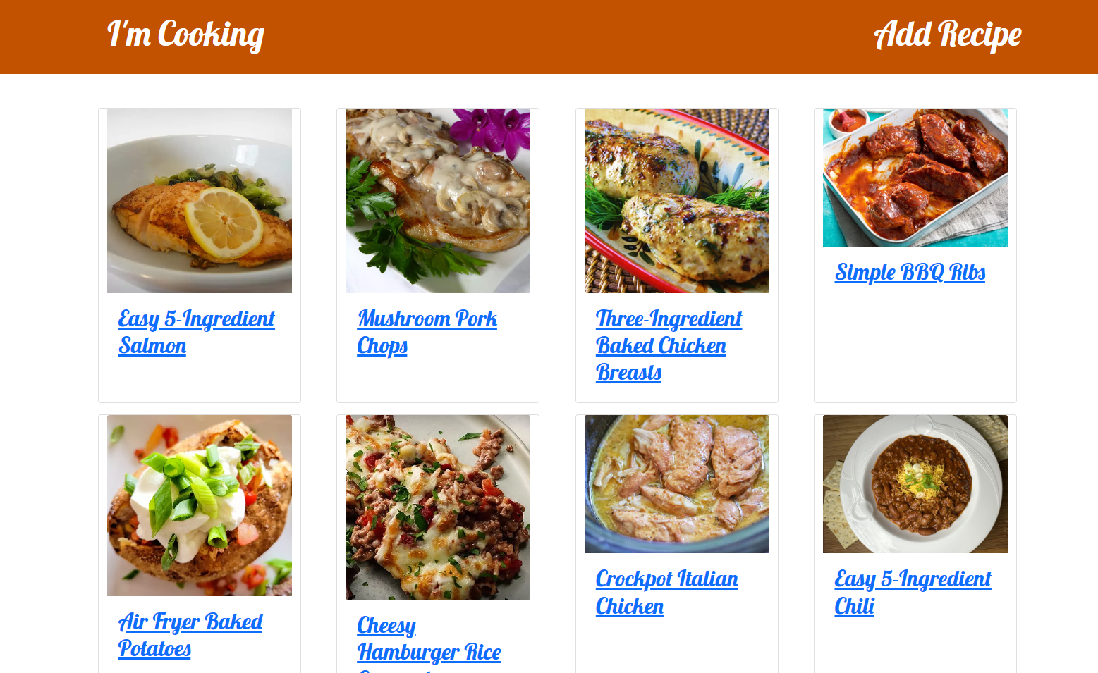

**Add Recipe Page**

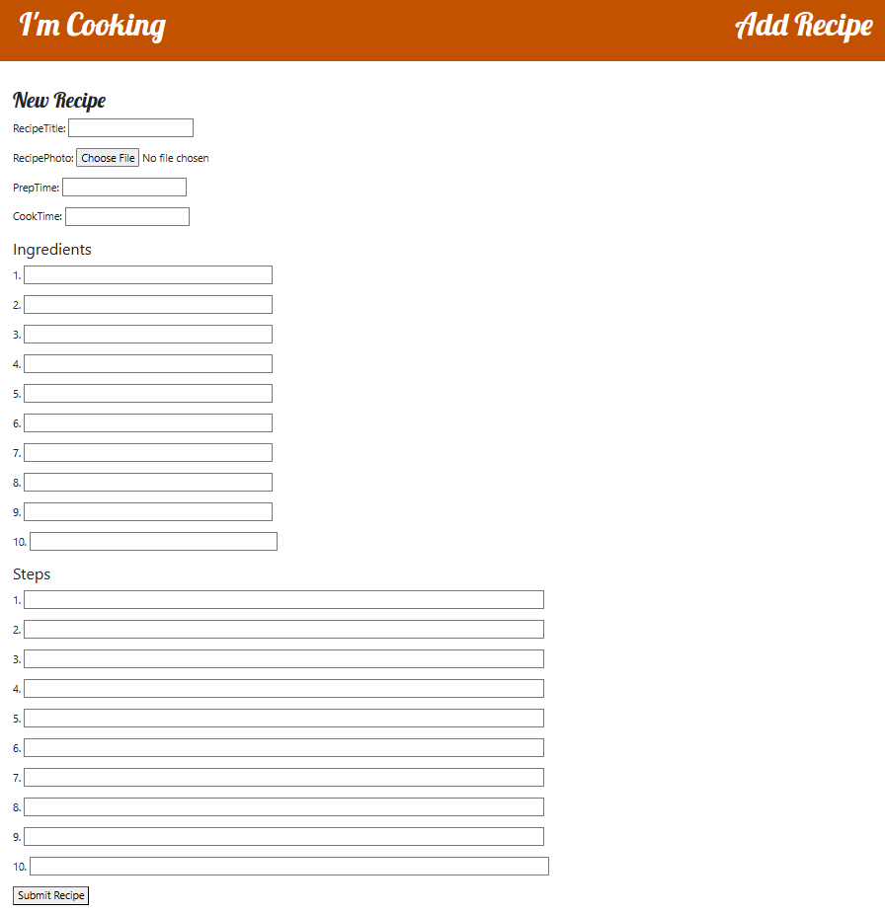

**Recipe Details Page**

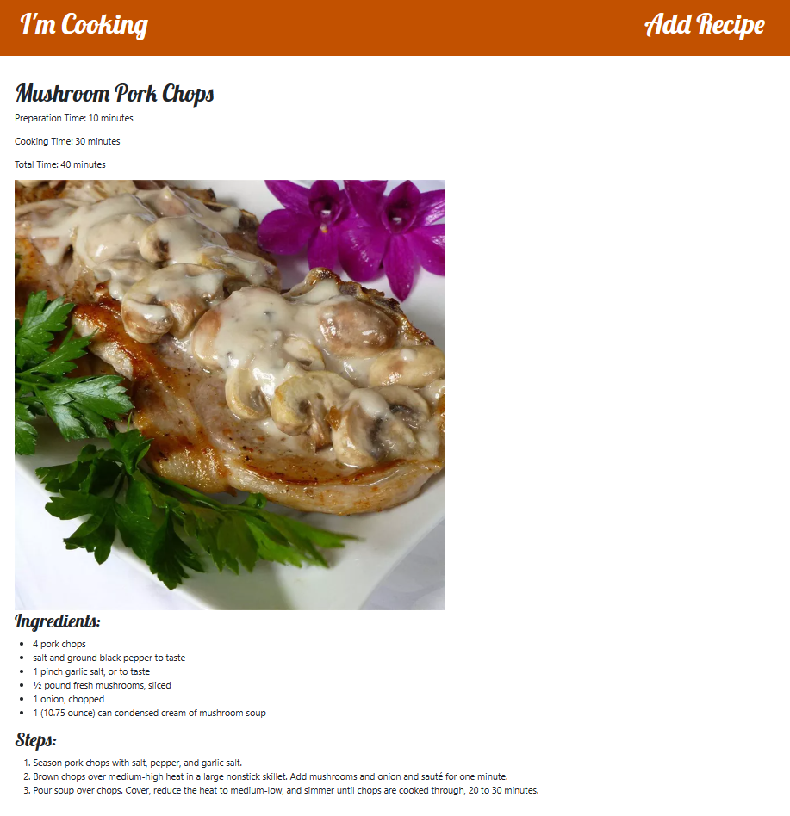

# Known issues

Currently users can enter maximum of 10 ingredients and 10 steppes.

# Status of Deployment

I created Dockerfile and “docker-compose.yml” files and upload them to my repository but I get error when docker tries to do migrations. I couln’t pass this error.

# System Manual

The user should clone the project repository. Then the user need to put .env file into “swe573_v2/imcooking/imcooking folder”

It is recommended that to create a virtual environment by this command

*python -m venv myenv*

*source myenv/bin/activate # for Unix/Linux*

*.\myenv\Scripts\activate # for Windows*

Then install dependencies

*pip install -r requirements.txt*

Run database migrations

*python manage.py makemigrations*

*python manage.py migrate*

Start the development server

python manage.py runserver

# Uml diagrams

metin, diyagram, ekran görüntüsü, paralel içeren bir resim

Açıklama otomatik olarak oluşturuldu

# Requirements

**Technical Requirements:**

1. The system shall have user authentication to allow secure logins.
   * 1.1. Implement user registration with email verification. Not Completed
   * 1.2. Provide password reset functionality. Not Completed
2. The system shall have a relational database for storing user data, recipes, and ingredients.
   * 2.1. Design and implement a normalized database schema. Completed
   * 2.2. Ensure database scalability for large volumes of data. Completed
3. The system shall have a robust recipe search feature with filters.
   * 3.1. Implement keyword-based recipe search. Not Completed
   * 3.2. Allow filtering by dietary preferences and ingredients. Not Completed
   * 3.3. Provide advanced search options, such as sorting and pagination. Not Completed
4. The system shall have an interface for users to add, edit, and manage recipes.
   * 4.1. Create a user-friendly recipe submission form. Completed
   * 4.2. Implement editing and version control for recipes. Not Completed
   * 4.3. Allow recipe owners to manage their recipes. Not Completed
5. The system shall integrate with a nutrient data source to provide nutrition information for ingredients.
   * 5.1. Integrate with a reliable nutrient database or API. Not Completed
   * 5.2. Retrieve and display micro and macro nutrient data for each ingredient. Not Completed
6. The system shall provide user profiles with options for personalization.
   * 6.1. Allow users to set dietary preferences and restrictions. Not Completed
   * 6.2. Provide the option to customize user profiles with avatars and personal information. Not Completed
7. The system shall optimize performance for fast loading times.
   * 7.1. Optimize images and assets for quick loading. Not Completed
   * 7.2. Implement caching mechanisms to reduce server load. Not Completed
8. The system shall allow users to follow other users.
   * 8.1. Implement a "Follow" feature for users to subscribe to recipe creators. Not Completed
9. The system shall allow users to comment and ask questions about recipes.
   * 9.1. Implement a comment section for each recipe. Not Completed
   * 9.2. Allow users to post questions and receive answers from recipe creators. Not Completed
10. The system shall allow users to rate recipes.
    * 10.1. Implement a rating system for users to rate recipes. Not Completed
    * 10.2. Display average ratings and user reviews for each recipe. Not Completed
11. The system shall allow users to derive their version of the recipe.
    * 11.1. Provide a "Derive" or "Adapt" feature for users to create their variations of existing recipes. Not Completed
    * 11.2. Link derived recipes to the original recipe. Not Completed
12. The system shall recommend recipes for users.
    * 12.1 Provide a recommended section that includes users` followers higher rated recipes. Not Completed

**Non-Technical Requirements:**

1. The system may have an intuitive and user-friendly interface to enhance user experience.
   * 1.1. Design an easy-to-navigate user interface (UI). Completed
   * 1.2. Optimize UX with a clear layout and user guidance. Completed
2. The system may maintain high-quality recipe content, including accuracy and completeness.
   * 2.1. Encourage recipe contributors to provide accurate instructions and ingredient quantities. Completed
3. The system can comply with legal requirements, such as copyright and licensing for recipes and nutrient data.
   * 3.1 Ensure recipes and content comply with copyright and licensing regulations. Not Completed
   * 3.2 The System shall comply with KVKK. Completed

# User Manual

When you open the home page, you can see names and pictures of all the recipes added to the application.



By clicking a name of the recipe you can see the details of a recipe. This includes, Preparation time, cooking time, total time, a larger picture of the meal, ingredients used for recipe and finally cooking steppes for the recipe.



By clicking Add Recipe on the top right corner of the page, you can add new recipe.



By clicking the “I’m Cooking” text of the top left page you can go back to home page.