CENG536 ADVANCED UNIX

Programming Assignment 2

15.05.2023

Erhan Cengiz

Halil Taylan Kılıçöz

Part-1)

You can compile the project with following commands in linux environment:

Inside the Part1 folder run commands:

**mkdir build**

**cd build**

**cmake ..**

**cd ..**

**make –C build/**

**./part1 <number of threads> <number of shift operation>**

Here are the outputs of our program:

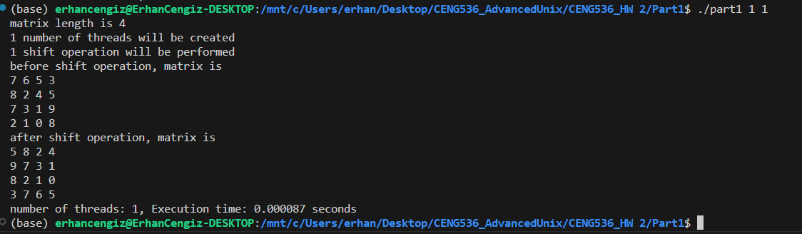

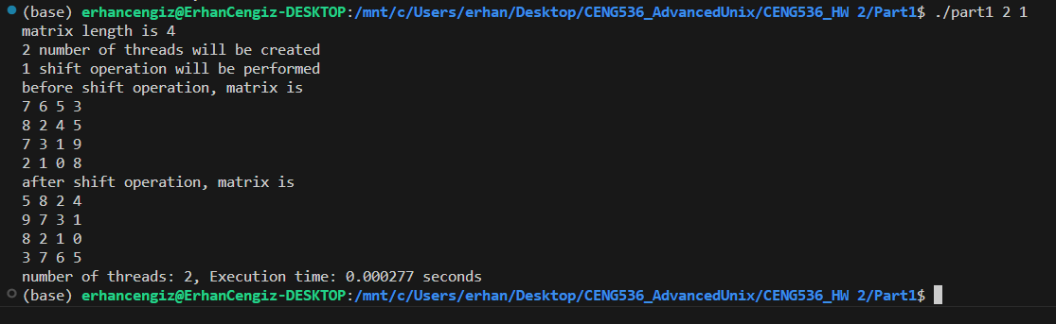

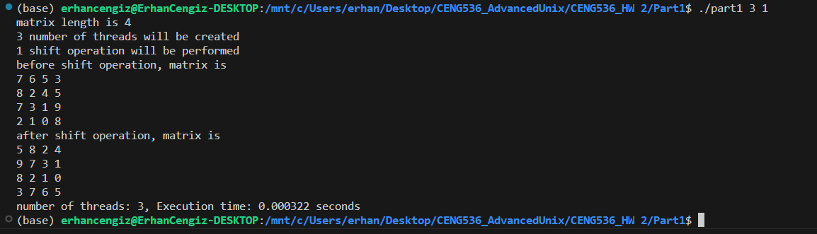

Part-2)

You can compile the project with following commands in linux environment:

Inside the Part2 folder run commands:

**mkdir build**

**cd build**

**cmake ..**

**cd ..**

**make –C build/**

**./part2**

Here is the outputs of our program:

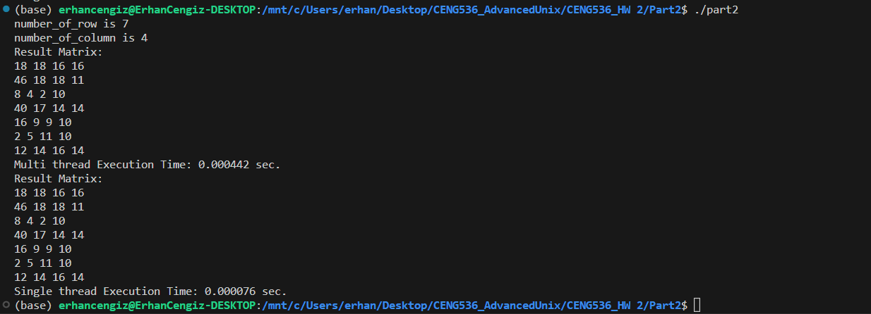

Part-3)

You can compile the project with following commands in linux environment:

Inside the Part3 folder run commands:

**mkdir build**

**cd build**

**cmake ..**

**cd ..**

**make –C build/**

**./part3**

Here is the outputs of our program:

