Theory and Implementation of Peridynamic Theory on Elastictiy

# Peridynamic Theory and Formulation

For a given undeformed state of a body, each material point is referred with its coordinates,

Each material point associated with incremental volume and mass density in which body is decomposed of.

Similarly, position for a material in deformed state is,

Under a deformation, each material point exhibits a displacement,

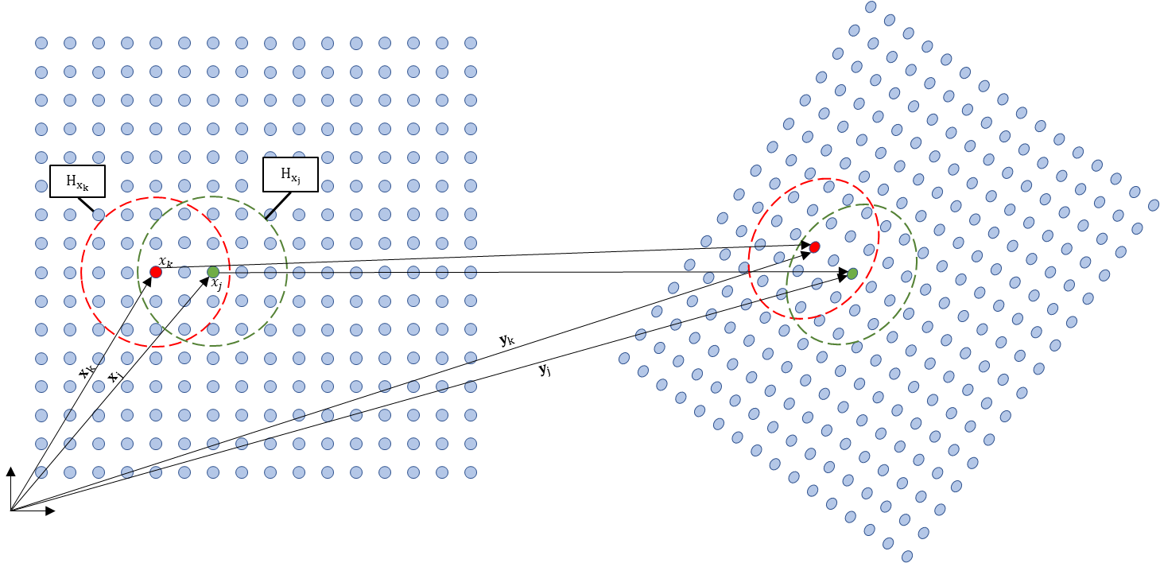

Figure - Reference and Deformed Configurations within a Body

Interaction of material points in a body is defined with a subdomain. Each material point is assigned with a subdomain where it exhibits influence of other material points within this subdomain referred as neighborhood of xk or .

Definition of a neighborhood can be made with a constant range of from the its position.

Stretch between two material points due to a deformation, is the ratio of relative positions after and before deformation such that,

Due to the collective deformation of material points, force interactions between two material points are defined with force density vector functions. ()

Definition of these force densities are not only dependent on pairwise motion of its owners and but also collective deformation of points inside their neighborhoods and .

Figure - Force Density Vectors due to a collective deformation

Energy density of these interactions are defined with a scalar value micropotential function and . Strain energy density of a material point is then the average of summation of these micropotentials;

where;

# Equation of Motion

Total kinetic and potential energies in the body that consists of N material points are defined as,

With principle of virtual work at material point ,

which is satisfied by Lagrange’s equation,

Using micropotentials, total potential energy becomes,

Lagrangian is then becomes,

Rewriting with terms associated with material point ,

Rearranging associated terms with kth material point,

Then,

Substituting into Lagrange’s equation,

Since micropotential functions are functions of relative displacement vectors in deformed state,

Similarly,

By definition of relative position vectors are,

And similarly,

Thus,

which results in,

Then the Lagrange’s equation become,

or,

With the force density definition, equation of motion for material point becomes;

where,

# Ordinary State-Based Peridynamics

With the implementation of principle of virtual work, balances of linear momentum and energy are already embedded in current forms of force density vector definitions. However, angular momentum balance is still required to be satisfied.

This is achieved by imposing two more conditions on force density vector definitions,

1. Direction of the force density vector is parallel to the relative position vector in deformed configuration but opposing with respect to the related neighbor,
2. Magnitude of the force density vector is scaled by auxiliary parameters which can be related with engineering material models

With this form, decoupled representation of distortional and volumetric deformations can be modelled.

Substituting the definition of strain energy density function as the summation of micropotentials and force density function as the summation derivatives of micropotentials with respect to relative positions, force density and strain energy density definitions can be related with,

Imposing above assumptions of unequal magnitudes, parallelism to relative position vector and opposing directions,

where A and B are called auxiliary parameters in which material behavior will be imposed.

# Local to Nonlocal Formulation Expansion

Decoupled volumetric and distortional strain energy definition for isotropic materials in tensor form,

In order to relate local stresses to nonlocal force densities through strain energy density, its expression with stress tensor are required. Due to that reason, terms related with and are derived below.

Stress tensor becomes,

Substituting strain tensor terms in terms of stress tensor terms into strain energy density;

Considering the definition of dilatation,

Substituting into strain energy density function,

or

So, using this final form shown above and the assumption of peridynamic formulations should satisfy local formulation, classical mechanics theory can be imposed over peridynamic formulations.

For the nearest neighbors, nonlocal peridynamic equation of motion for material point is,

Similarly, using Cauchy’s equation of motion in tensorial notation for material point,

Utilizing averages of forward and backward finite differencing for spatial derivatives of stress components with nearest neighbors of material point,

Comparing terms coming from local and peridynamic theory results in,

In general form,

and,

Rewriting strain energy density definition based on stress tensors,

and expanding stress terms to relate PD contributions in local form,

Substituting squared stress definitions,

Rewriting ordinary state based force density functions,

Substituting into strain energy density function,

Before further generalization, similar to the case in bond based PD formulations, linear dependency of force density functions to the stretch between two material points is imposed;

where, a and b are peridynamic parameters.

Similarly considering dilatation term;

Similar assumption of linear dependency of force density vector over stretch, general form for dilatation term becomes,

Furtherly expanding from local to nonlocal neighbors,

where an influence function is inserted to account for variance in influence of distance for each neighbor.

To relate auxiliary parameters A and B to above definitions,

where volume of jth material point arised from implicit assumption while introducing linear dependency of force density function and stretch term in strain energy density function.

Differentiating strain energy density with respect to returns,

Thus, auxiliary parameter A becomes,

Similarly,

with influence function,