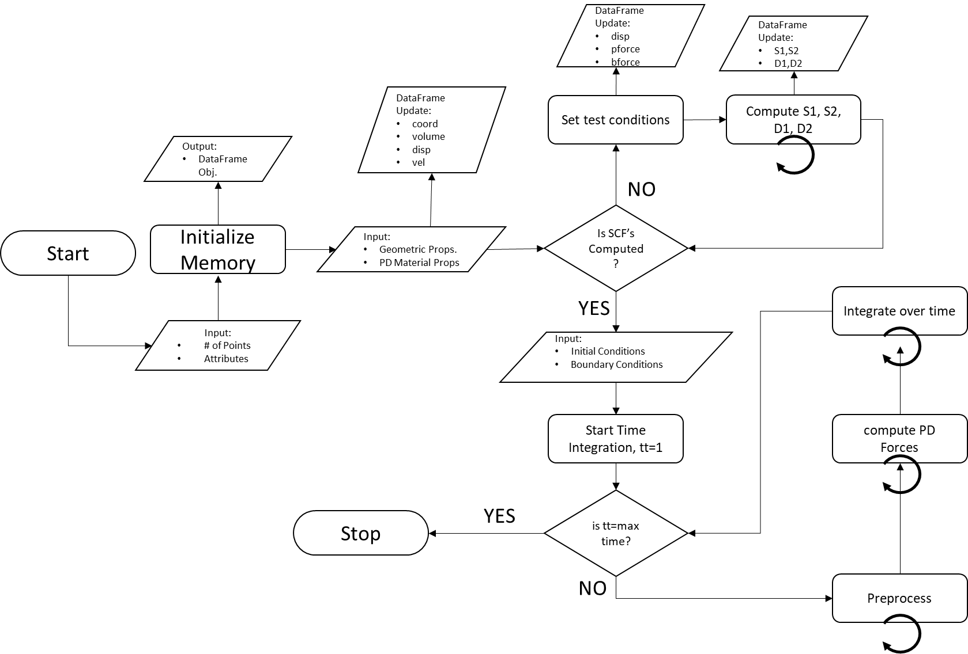

|  |  |  |
| --- | --- | --- |
| **Compute Surface Correction Factors:** | | |
| Require: | $$δ$$ | Horizon Parameter |
| Require: | $$a,b,d$$ | PD Material Properties |
| Require: | $$μ$$ | Shear Modulus |
| Require: | Pandas DataFrame Object | Instance that implements required data structure for PD attributes for all points |
| 1. | **for each** material point i in the body **do** |  |
| 2. | Get neighbor indices of $i^{th}$ material point |  |
| 3. | Compute initial distance, |  |
| 4. | Compute length of the deformed bond, |  |
| 5. | Compute stretch of the deformed bond, |  |
| 6. | Compute Volume Correction Factor, |  |
| 7. | Compute parameter |  |
| 8. | Compute Dilatation Term, $θ$ | $$←θ_{i}=dδ\sum_{j=1}^{N}{s_{ij}Λ_{ij}{v_{c\left(j\right)}V}_{j}}$$ |
| 9. | Compute Strain Energy Density, |  |
| 10. | Set Surface Correction Factor, |  |

|  |  |  |
| --- | --- | --- |
| **Preprocess with Surface Correction Vectors:** | | |
| Require: | $$δ$$ | Horizon Parameter |
| Require: | $$a,b,d$$ | PD Material Properties |
| Require: | Pandas DataFrame Object | Instance that implements required data structure for PD attributes for all points |
| 1. | **for each** material point i in the body **do** |  |
| 2. | Get neighbor indices of $i^{th}$ material point |  |
| 3. | Compute Principal Axes for Surface Correction Ellipsoid, $G_{b}, G_{d}$ | $$←G_{b_{ij}}\&G_{d_{ij}}$$ |
| 4. | Compute initial distance, |  |
| 5. | Compute length of the deformed bond, |  |
| 6. | Compute stretch of the deformed bond, |  |
| 7. | Compute Volume Correction Factor, $v_{c\left(j\right)}$ | $$←v_{c}=\left\{\begin{aligned}\frac{\left(δ+r-ξ_{ij}\right)}{Δ}, δ-\frac{Δ}{2}<ξ_{ij}<δ, \\ 1, ξ_{ij}≤δ-\frac{Δ}{2} \\ 0, ξ_{ij}>δ\end{aligned}\right.$$ |
| 8. | Compute parameter |  |
| 9. | Compute Dilatation Term, $θ$ | $$←θ_{i}=dδ\sum_{j=1}^{N}{G_{d_{ij}}s_{ij}Λ_{ij}{v_{c\left(j\right)}V}_{j}}$$ |
| 10. | Compute Strain Energy Density, |  |

|  |  |  |
| --- | --- | --- |
| **Compute PD Forces and Iteration with Adaptive Dynamic Relaxation:** | | |
| Require: | $$δ$$ | Horizon Parameter |
| Require: | $$a,b,d$$ | PD Material Properties |
| Require: | Pandas DataFrame Object | Instance that implements required data structure for PD attributes for all points |
| 1. | **for each** iteration between 1 to max. iter. **do** |  |
| 2. | **for each** material point i in the body **do** |  |
| 3. | Get neighbor indices of $i^{th}$ material point |  |
| 4. | Compute Principal Axes for Surface Correction Ellipsoid, $G_{b}, G_{d}$ | $$←G_{b_{ij}}\&G_{d_{ij}}$$ |
| 5. | Compute initial distance, |  |
| 6. | Compute length of the deformed bond, |  |
| 7. | Compute stretch of the deformed bond, |  |
| 8. | Compute Volume Correction Factor, $v_{c\left(j\right)}$ | $$←v_{c}=\left\{\begin{aligned}\frac{\left(δ+r-ξ_{ij}\right)}{Δ}, δ-\frac{Δ}{2}<ξ_{ij}<δ, \\ 1, ξ_{ij}≤δ-\frac{Δ}{2} \\ 0, ξ_{ij}>δ\end{aligned}\right.$$ |
| 9. | Compute parameter |  |
| 10. | Compute PD Force |  |
| 11. | Compute PD Force |  |
| 12. | Summation of PD Forces | $$←\sum_{j=1}^{N}{\left(t_{ij}-t_{ji}\right)v_{c\left(j\right)}V_{j}}$$ |
| 13 | Compute Elements of Stiffness Matrix, |  |
| 14. | Compute Diagonal Element of Density Matrix, |  |
| 15. | Initialize $c_{n}=0, c_{num}=0, c_{denom}=0$ |  |
| 16. | **for each** material point i in the body **do** |  |
| 17. | Compute Diagonal Element of Local Stiffness Matrix, ${}_{ }^{1}{K_{ii}^{n}}$ | $$←{}_{ }^{1}{K_{ii}^{n}}=-\left(\frac{\frac{{\left(\sum_{j=1}^{N}{\left(t_{ij}-t_{ji}\right)v_{c\left(j\right)}V_{j}}+b_{i}\right)}^{n}}{λ_{ii}}-\frac{{\left(\sum_{j=1}^{N}{\left(t_{ij}-t_{ji}\right)v_{c\left(j\right)}V_{j}}+b_{i}\right)}^{n-1}}{λ_{ii}}}{Δt {\dot{u}}^{n-\frac{1}{2}}}\right)$$ |
| 18. | Update Numerator and Denominator parts of $c^{n}$ | $$←c_{num}^{n}=c_{num}^{n}+u_{i}^{n}{}_{ }^{1}{K_{ii}^{n}}u_{i}^{n}, c_{denom}^{n}=c_{denom}^{n}+u_{i}^{n}u_{i}^{n},$$ |
| 19. | Update Damping Coefficient $c^{n}$ | $$←c^{n}=2\sqrt{\frac{c_{num}^{n}}{c_{denom}^{n}}}, while c_{denom}^{n}>0 and c^{n}≤2$$ |
| 20. | **for each** material point i in the body **do** |  |
| 21. | **if** 1st iteration then, **do** |  |
| 22. | Compute ${\dot{u}}^{\frac{1}{2}}$ | $$←{\dot{u}}^{\frac{1}{2}}=\frac{{\left(\sum_{j=1}^{N}{\left(t_{ij}-t_{ji}\right)v_{c\left(j\right)}V_{j}}+b_{i}\right)}^{1}}{{2λ}_{ii}}$$ |
| 23. | **else, do** |  |
| 24. | Compute ${\dot{u}}^{n+\frac{1}{2}}$ | $$←{\dot{u}}^{n+\frac{1}{2}}=\frac{\left(\left(2-c^{n}Δt\right){\dot{u}}^{n-\frac{1}{2}}+2Δt\frac{{\left(\sum_{j=1}^{N}{\left(t_{ij}-t_{ji}\right)v_{c\left(j\right)}V_{j}}+b_{i}\right)}^{n}}{λ_{ii}}\right)}{\left(2+c^{n}Δt\right)}$$ |
| 25. | Compute $u^{n+1}$ | $$←u^{n+1}=u^{n}+Δt{\dot{u}}^{n+\frac{1}{2}}$$ |
| 26. | Store ${\dot{u}}^{n-\frac{1}{2}}$ | $$←{\dot{u}}^{n-\frac{1}{2}}={\dot{u}}^{n+\frac{1}{2}}$$ |