WHERE ARE THEY FROM?
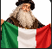  Where is Leonardo Da Vinci from?  ________________________________ |   What nationality is Arda Güler?  ________________________________
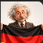  What nationality is Albert Einstein?  ________________________________ | 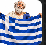  Where is Socrates from?  ________________________________
  Where is Penelope Cruz from?  ________________________________ |   What nationality is Hikaru Utada?  ________________________________
  What nationality is Jackie Chan?  ________________________________ | 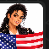  Where is Michael Jackson from?  ________________________________

WHERE ARE THEY FROM?
  Where is Rowan Atkinson (Mr. Bean) from?  ________________________________ |   Where is Maria Sharapova from?  ________________________________
  Where is Kylian Mbappe from?  ________________________________ | 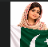  What nationality is Malala Yousafzai?  ________________________________
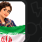  Where is Meryem Mirzakhani from?  ________________________________ |   What nationality is Zaha Hadid?  ________________________________

