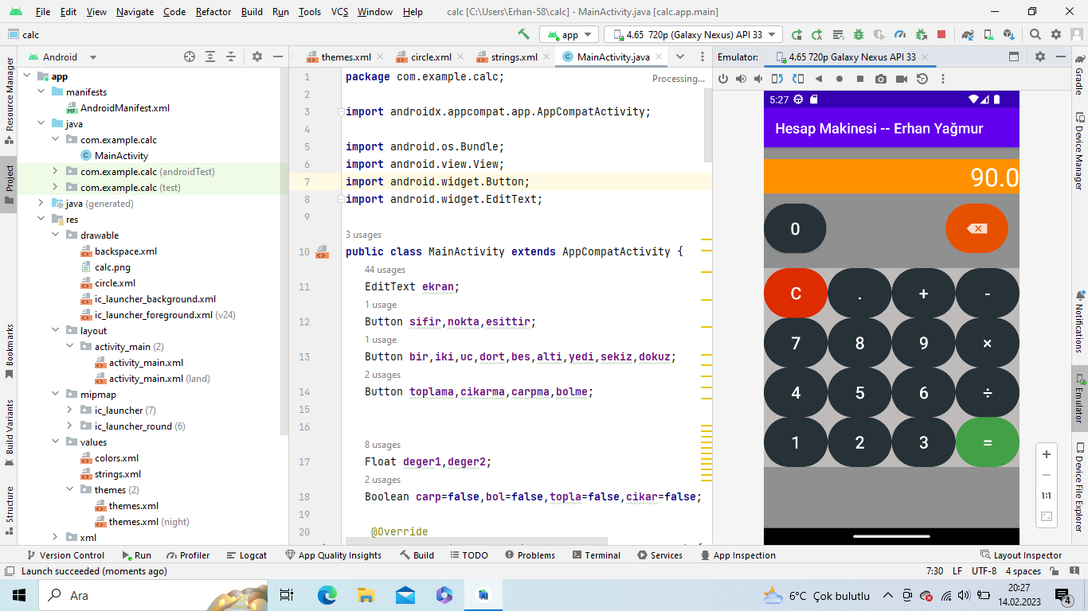activity_main.xml

|  |
| --- |
| *<?***xml version="1.0" encoding="utf-8"***?>* <**androidx.constraintlayout.widget.ConstraintLayout xmlns:android="http://schemas.android.com/apk/res/android"  xmlns:app="http://schemas.android.com/apk/res-auto"  xmlns:tools="http://schemas.android.com/tools"  android:layout_width="match_parent"  android:layout_height="match_parent"  android:background="#75131313"  android:onClick="yazdir"  tools:context=".MainActivity"**>   <**TableLayout  android:id="@+id/tableLayout"  android:layout_width="0dp"  android:layout_height="wrap_content"  android:layout_marginBottom="86dp"  android:background="#BFBBBB"  app:layout_constraintBottom_toBottomOf="parent"  app:layout_constraintEnd_toEndOf="parent"  app:layout_constraintStart_toStartOf="parent"**>   <**TableRow  android:layout_width="match_parent"   android:layout_height="match_parent"**>   <**Button  android:id="@+id/btnC"  style="@style/Widget.AppCompat.Button.Borderless"  android:layout_width="0dp"  android:layout_height="70dp"  android:layout_weight="1"  android:background="@drawable/circle"  android:backgroundTint="#DD2C00"  android:onClick="temizle"  android:text="@string/temzile"  android:textColor="#FFFFFF"  android:textSize="24sp"** />   <**Button  android:id="@+id/btnnokta"  style="@style/Widget.AppCompat.Button.Borderless"  android:layout_width="0dp"  android:layout_height="70dp"  android:layout_weight="1"  android:background="@drawable/circle"  android:onClick="nokta"  android:text="@string/nokta"  android:textColor="#FFFFFF"  android:textSize="24sp"** />   <**Button  android:id="@+id/btnarti"  style="@style/Widget.AppCompat.Button.Borderless"  android:layout_width="0dp"  android:layout_height="70dp"  android:layout_weight="1"  android:background="@drawable/circle"   android:text="@string/arti"  android:textColor="#FFFFFF"  android:textSize="24sp"** />   <**Button  android:id="@+id/btneksi"  style="@style/Widget.AppCompat.Button.Borderless"  android:layout_width="0dp"  android:layout_height="70dp"  android:layout_weight="1"  android:background="@drawable/circle"   android:text="@string/eksi"  android:textColor="#FFFFFF"  android:textSize="24sp"** />  </**TableRow**>   <**TableRow  android:layout_width="match_parent"  android:layout_height="match_parent"**>   <**Button  android:id="@+id/btnyedi"  style="@style/Widget.AppCompat.Button.Borderless"  android:layout_width="0dp"  android:layout_height="70dp"  android:layout_weight="1"  android:background="@drawable/circle"  android:onClick="yedi"  android:text="@string/yedi"  android:textColor="#FFFFFF"  android:textSize="24sp"** />   <**Button  android:id="@+id/btnsekiz"  style="@style/Widget.AppCompat.Button.Borderless"  android:layout_width="0dp"  android:layout_height="70dp"  android:layout_weight="1"  android:background="@drawable/circle"  android:onClick="sekiz"  android:text="@string/sekiz"  android:textColor="#FFFFFF"  android:textSize="24sp"** />   <**Button  android:id="@+id/btndokuz"  style="@style/Widget.AppCompat.Button.Borderless"  android:layout_width="0dp"  android:layout_height="70dp"  android:layout_weight="1"  android:background="@drawable/circle"  android:onClick="dokuz"  android:text="@string/dokuz"  android:textColor="#FFFFFF"  android:textSize="24sp"** />   <**Button  android:id="@+id/btncarp"  style="@style/Widget.AppCompat.Button.Borderless"  android:layout_width="0dp"  android:layout_height="70dp"  android:layout_weight="1"  android:background="@drawable/circle"  android:text="@string/carp"  android:textColor="#FFFFFF"  android:textSize="24sp"** />  </**TableRow**>   <**TableRow  android:layout_width="match_parent"  android:layout_height="match_parent"**>   <**Button  android:id="@+id/btndort"  style="@style/Widget.AppCompat.Button.Borderless"  android:layout_width="0dp"  android:layout_height="70dp"  android:layout_weight="1"  android:background="@drawable/circle"  android:onClick="dort"  android:text="@string/dort"  android:textColor="#FFFFFF"  android:textSize="24sp"** />   <**Button  android:id="@+id/btnbes"  style="@style/Widget.AppCompat.Button.Borderless"  android:layout_width="0dp"  android:layout_height="70dp"  android:layout_weight="1"  android:background="@drawable/circle"  android:onClick="bes"  android:text="@string/bes"  android:textColor="#FFFFFF"  android:textSize="24sp"** />   <**Button  android:id="@+id/btnalti"  style="@style/Widget.AppCompat.Button.Borderless"  android:layout_width="0dp"  android:layout_height="70dp"  android:layout_weight="1"  android:background="@drawable/circle"  android:onClick="alti"  android:text="@string/alti"  android:textColor="#FFFFFF"  android:textSize="24sp"** />   <**Button  android:id="@+id/btnbol"  style="@style/Widget.AppCompat.Button.Borderless"  android:layout_width="0dp"  android:layout_height="70dp"  android:layout_weight="1"  android:background="@drawable/circle"  android:text="@string/bol"  android:textColor="#FFFFFF"  android:textSize="24sp"** />  </**TableRow**>   <**TableRow  android:layout_width="match_parent"  android:layout_height="match_parent"**>   <**Button  android:id="@+id/btnbir"  style="@style/Widget.AppCompat.Button.Borderless"  android:layout_width="0dp"  android:layout_height="70dp"  android:layout_weight="1"  android:background="@drawable/circle"  android:onClick="bir"  android:text="@string/bir"  android:textColor="#FFFFFF"  android:textSize="24sp"** />   <**Button  android:id="@+id/btniki"  style="@style/Widget.AppCompat.Button.Borderless"  android:layout_width="0dp"  android:layout_height="70dp"  android:layout_weight="1"  android:background="@drawable/circle"  android:onClick="iki"  android:text="@string/iki"  android:textColor="#FFFFFF"  android:textSize="24sp"** />   <**Button  android:id="@+id/btnuc"  style="@style/Widget.AppCompat.Button.Borderless"  android:layout_width="0dp"  android:layout_height="70dp"  android:layout_weight="1"  android:background="@drawable/circle"  android:onClick="uc"  android:text="@string/uc"  android:textColor="#FFFFFF"  android:textSize="24sp"** />   <**Button  android:id="@+id/btnesittir"  style="@style/Widget.AppCompat.Button.Borderless"  android:layout_width="0dp"  android:layout_height="70dp"  android:layout_weight="1"  android:background="@drawable/circle"  android:backgroundTint="#43A047"  android:text="@string/esittir"  android:textColor="#FFFFFF"  android:textSize="24sp"** />  </**TableRow**>   </**TableLayout**>   <**EditText  android:id="@+id/txtekran"  android:layout_width="0dp"  android:layout_height="wrap_content"  android:layout_marginTop="114dp"  android:layout_marginBottom="112dp"  android:autofillHints="none"  android:background="#9C9A98"  android:backgroundTint="#FF9100"  android:hint="@string/ekran"  android:text=""  android:textAlignment="textEnd"  android:textColor="#FFFFFF"  android:textSize="36sp"  app:layout_constraintBottom_toTopOf="@+id/btnsifir"  app:layout_constraintEnd_toEndOf="parent"  app:layout_constraintStart_toStartOf="parent"  app:layout_constraintTop_toTopOf="parent"  tools:ignore="LabelFor"** />   <**ImageButton  android:id="@+id/btngeri"  style="@style/Widget.AppCompat.Button.Borderless"  android:layout_width="wrap_content"  android:layout_height="70dp"  android:layout_marginEnd="16dp"  android:layout_marginBottom="21dp"  android:background="@drawable/circle"  android:backgroundTint="#E65100"  android:contentDescription="@string/gerial"   android:onClick="gerial"  android:textColor="#FFFFFF"  android:textSize="24sp"  app:layout_constraintBottom_toTopOf="@+id/tableLayout"  app:layout_constraintEnd_toEndOf="parent"  app:srcCompat="@drawable/backspace"** />   <**Button  android:id="@+id/btnsifir"  android:layout_width="wrap_content"  android:layout_height="0dp"  android:background="@drawable/circle"   android:onClick="sifir"  android:text="@string/sifir"  android:textColor="#FFFFFF"  android:textSize="24sp"  app:layout_constraintBottom_toBottomOf="@+id/btngeri"  app:layout_constraintStart_toStartOf="parent"  app:layout_constraintTop_toTopOf="@+id/btngeri"** /> </**androidx.constraintlayout.widget.ConstraintLayout**> |

MainActivity.java

|  |
| --- |
| **package** com.example.calc;  **import** androidx.appcompat.app.AppCompatActivity;  **import** android.os.Bundle; **import** android.view.View; **import** android.widget.Button; **import** android.widget.EditText;  **public class** MainActivity **extends** AppCompatActivity {  EditText **ekran**;  Button **sifir**,**nokta**,**esittir**;  Button **bir**,**iki**,**uc**,**dort**,**bes**,**alti**,**yedi**,**sekiz**,**dokuz**;  Button **toplama**,**cikarma**,**carpma**,**bolme**;    Float **deger1**,**deger2**;  Boolean **carp**=**false**,**bol**=**false**,**topla**=**false**,**cikar**=**false**;   @Override  **protected void** onCreate(Bundle savedInstanceState) {  **super**.onCreate(savedInstanceState);  setContentView(R.layout.***activity_main***);   **ekran**=findViewById(R.id.***txtekran***);  **ekran**.setShowSoftInputOnFocus(**false**);   **sifir**=findViewById(R.id.***btnsifir***);  **bir**=findViewById(R.id.***btnbir***);  **iki**=findViewById(R.id.***btniki***);  **uc**=findViewById(R.id.***btnuc***);  **dort**=findViewById(R.id.***btndort***);  **bes**=findViewById(R.id.***btnbes***);  **alti**=findViewById(R.id.***btnalti***);  **yedi**=findViewById(R.id.***btnyedi***);  **sekiz**=findViewById(R.id.***btnsekiz***);  **dokuz**=findViewById(R.id.***btndokuz***);   **nokta**=findViewById(R.id.***btnnokta***);  **esittir**=findViewById(R.id.***btnesittir***);   **toplama**=findViewById(R.id.***btnarti***);  **cikarma**=findViewById(R.id.***btneksi***);  **carpma**=findViewById(R.id.***btncarp***);  **bolme**=findViewById(R.id.***btnbol***);     **toplama**.setOnClickListener(**new** View.OnClickListener() {  @Override  **public void** onClick(View v) {  **if**(**ekran**==**null**){  **ekran**.setText(**""**);  }**else**{  **deger1**=Float.*parseFloat*(**ekran**.getText()+**""**);  **topla**=**true**;  **ekran**.setText(**null**);  }  }  });  **cikarma**.setOnClickListener(**new** View.OnClickListener() {  @Override  **public void** onClick(View v) {   **deger1**=Float.*parseFloat*(**ekran**.getText()+**""**);  **cikar**=**true**;  **ekran**.setText(**null**);   }  });  **carpma**.setOnClickListener(**new** View.OnClickListener() {  @Override  **public void** onClick(View v) {   **deger1**=Float.*parseFloat*(**ekran**.getText()+**""**);  **carp**=**true**;  **ekran**.setText(**null**);   }  });  **bolme**.setOnClickListener(**new** View.OnClickListener() {  @Override  **public void** onClick(View v) {   **deger1**=Float.*parseFloat*(**ekran**.getText()+**""**);  **bol**=**true**;  **ekran**.setText(**null**);   }  });  **esittir**.setOnClickListener(**new** View.OnClickListener() {  @Override  **public void** onClick(View v) {  **deger2**=Float.*parseFloat*(**ekran**.getText()+**""**);  **if**(**topla**==**true**){  **ekran**.setText(String.*valueOf*(**deger1**+**deger2**));  **topla**=**false**;  }  **if**(**cikar**==**true**){  **ekran**.setText(String.*valueOf*(**deger1**-**deger2**));  **topla**=**false**;  }  **if**(**carp**==**true**){  **ekran**.setText(String.*valueOf*(**deger1**\***deger2**));  **topla**=**false**;  }  **if**(**bol**==**true**){  **ekran**.setText(String.*valueOf*(**deger1**/**deger2**));  **topla**=**false**;  }  }  });    }  **public void** sifir(View view){  **ekran**.setText(**ekran**.getText()+**"0"**);  }  **public void** bir(View view){  **ekran**.setText(**ekran**.getText()+**"1"**);  }  **public void** iki(View view){  **ekran**.setText(**ekran**.getText()+**"2"**);  }  **public void** uc(View view){  **ekran**.setText(**ekran**.getText()+**"3"**);  }  **public void** dort(View view){  **ekran**.setText(**ekran**.getText()+**"4"**);  }  **public void** bes(View view){  **ekran**.setText(**ekran**.getText()+**"5"**);  }  **public void** alti(View view){  **ekran**.setText(**ekran**.getText()+**"6"**);  }  **public void** yedi(View view){  **ekran**.setText(**ekran**.getText()+**"7"**);  }  **public void** sekiz(View view){  **ekran**.setText(**ekran**.getText()+**"8"**);  }  **public void** dokuz(View view){  **ekran**.setText(**ekran**.getText()+**"9"**);  }  **public void** nokta(View view){  **ekran**.setText(**ekran**.getText()+**"."**);  }   **public void** temizle(View view){  **ekran**.setText(**""**);  }  **public void** gerial(View view){  **int** cursorPos=**ekran**.getSelectionStart();  **if**(cursorPos>0){  String eskideger=**ekran**.getText().toString();  String soltaraf=eskideger.substring(0,cursorPos-1);  String sagtaraf=eskideger.substring(cursorPos);  String yenideger=soltaraf+sagtaraf;  **ekran**.setText(yenideger);  **ekran**.setSelection(cursorPos-1);  }  }  } |

circle.xml

|  |
| --- |
| *<?***xml version="1.0" encoding="utf-8"***?>* <**selector xmlns:android="http://schemas.android.com/apk/res/android"**>  <**item**>  <**shape android:shape="rectangle"**>  <**corners android:radius="1000dp"**/>  <**solid android:color="#263238"**/>  </**shape**>  </**item**> </**selector**> |

backspace.xml

|  |
| --- |
| *<?***xml version="1.0" encoding="utf-8"***?>* <**selector xmlns:android="http://schemas.android.com/apk/res/android"**>  <**item  android:drawable="@android:drawable/ic_input_delete"  android:width="40dp"  android:height="40dp"** /> </**selector**> |

strings.xml

|  |
| --- |
| <**resources**>  <**string name="app_name"**>Hesap Makinesi -- Erhan Yağmur</**string**>   <**string name="sifir"**>0</**string**>  <**string name="bir"**>1</**string**>  <**string name="iki"**>2</**string**>  <**string name="uc"**>3</**string**>  <**string name="dort"**>4</**string**>  <**string name="bes"**>5</**string**>  <**string name="alti"**>6</**string**>  <**string name="yedi"**>7</**string**>  <**string name="sekiz"**>8</**string**>  <**string name="dokuz"**>9</**string**>   <**string name="temzile"**>C</**string**>  <**string name="gerial"**>BACK</**string**>  <**string name="esittir"**>**&#0061;**</**string**>  <**string name="arti"**>**&#0043;**</**string**>  <**string name="eksi"**>**&#0045;**</**string**>  <**string name="carp"**>**&#0215;**</**string**>  <**string name="bol"**>**&#0247;**</**string**>  <**string name="nokta"**>.</**string**>   <**string name="ekran"**></**string**>  </**resources**> |