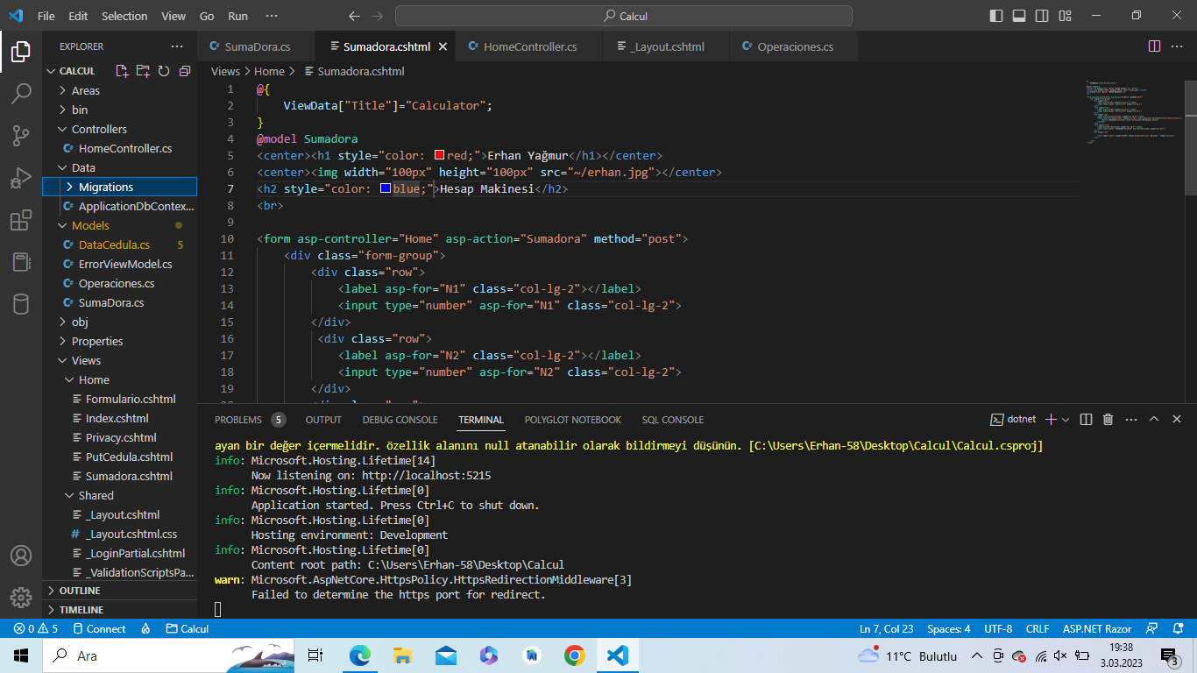Operaciones.cs

|  |
| --- |
| namespace Calcul.Models  {      public enum Operaciones      {          Suma,          Resta,          Division,          Multiplicacion      }  } |

SumaDora.cs

|  |
| --- |
| using System.ComponentModel.DataAnnotations;  namespace Calcul.Models{      public class Sumadora      {          [Display(Name="1.Sayıyı Giriniz")]          public double N1 { get; set; }           [Display(Name="2. Sayıyı Giriniz")]          public double N2 { get; set; }           [Display(Name="Sonuç")]          public double Resultado { get; set; }          [Display(Name="Operatör")]          public Operaciones operaciones { get; set; }      }  } |

Sumadora.cshtml

|  |
| --- |
| @{      ViewData["Title"]="Calculator";  }  @model Sumadora  <center><h1 style="color: red;">Erhan Yağmur</h1></center>  <center><img width="100px" height="100px" src="~/erhan.jpg"></center>  <h2 style="color: blue;">Hesap Makinesi</h2>  <br>  <form asp-controller="Home" asp-action="Sumadora" method="post">      <div class="form-group">          <div class="row">              <label asp-for="N1" class="col-lg-2"></label>              <input type="number" asp-for="N1" class="col-lg-2">          </div>           <div class="row">              <label asp-for="N2" class="col-lg-2"></label>              <input type="number" asp-for="N2" class="col-lg-2">          </div>          <div class="row">              <label asp-for="operaciones" class="col-lg-2"></label>              <select asp-for="operaciones" class="col-lg-2" asp-items="Html.GetEnumSelectList<Operaciones>()">                   <option selected="selected" value="Seleccione">Seçiminiz</option>              </select>          </div>           <div class="row">              <label asp-for="Resultado" class="col-lg-2"></label>              <input type="number" disabled="disabled" asp-for="Resultado" class="col-lg-2">          </div>          <div class="row">                <input type="submit" value="GÖNDER" style="background-color: orange;"  class="col-lg-2">          </div>      </div>  </form> |

_Layout.cshtml

|  |
| --- |
| <!DOCTYPE html>  <html lang="en">  <head>      <meta charset="utf-8" />      <meta name="viewport" content="width=device-width, initial-scale=1.0" />      <title>@ViewData["Title"] - Calcul</title>      <link rel="stylesheet" href="~/lib/bootstrap/dist/css/bootstrap.min.css" />      <link rel="stylesheet" href="~/css/site.css" asp-append-version="true" />      <link rel="stylesheet" href="~/Calcul.styles.css" asp-append-version="true" />  </head>  <body>      <header>          <nav class="navbar navbar-expand-sm navbar-toggleable-sm navbar-light bg-white border-bottom box-shadow mb-3">              <div class="container-fluid">                  <a class="navbar-brand" asp-area="" asp-controller="Home" asp-action="Index">Calcul</a>                  <button class="navbar-toggler" type="button" data-bs-toggle="collapse" data-bs-target=".navbar-collapse" aria-controls="navbarSupportedContent"                          aria-expanded="false" aria-label="Toggle navigation">                      <span class="navbar-toggler-icon"></span>                  </button>                  <div class="navbar-collapse collapse d-sm-inline-flex justify-content-between">                      <ul class="navbar-nav flex-grow-1">                          <li class="nav-item">                              <a class="nav-link text-dark" asp-area="" asp-controller="Home" asp-action="Index">Home</a>                          </li>                          <li class="nav-item">                              <a class="nav-link text-dark" asp-area="" asp-controller="Home" asp-action="Privacy">Privacy</a>                          </li>                           <li class="nav-item">                              <a class="nav-link text-dark" asp-area="" asp-controller="Home" asp-action="Sumadora">Calculator</a>                          </li>                      </ul>                      <partial name="_LoginPartial" />                  </div>              </div>          </nav>      </header>      <div class="container">          <main role="main" class="pb-3">              @RenderBody()          </main>      </div>      <footer class="border-top footer text-muted">          <div class="container">              &copy; 2023 - Calcul - <a asp-area="" asp-controller="Home" asp-action="Privacy">Privacy</a>          </div>      </footer>      <script src="~/lib/jquery/dist/jquery.min.js"></script>      <script src="~/lib/bootstrap/dist/js/bootstrap.bundle.min.js"></script>      <script src="~/js/site.js" asp-append-version="true"></script>      @await RenderSectionAsync("Scripts", required: false)  </body>  </html> |

HomeController.cs

|  |
| --- |
| using System.Diagnostics;  using Microsoft.AspNetCore.Mvc;  using Calcul.Models;  namespace Calcul.Controllers;  public class HomeController : Controller  {      private readonly ILogger<HomeController> _logger;      public HomeController(ILogger<HomeController> logger)      {          _logger = logger;      }      public IActionResult Index()      {          return View();      }      public IActionResult Privacy()      {          return View();      }       public IActionResult ErrorNExiste()      {          return View();      }       public IActionResult ErrorPagina()      {          return View();      }  [HttpGet]       public IActionResult Sumadora()      {          return View();      }      [HttpPost]       public IActionResult Sumadora(Sumadora model)      {          if(model.operaciones==Operaciones.Suma)          {              model.Resultado=model.N1+model.N2;          }           if(model.operaciones==Operaciones.Resta)          {                model.Resultado=model.N1-model.N2;          }           if(model.operaciones==Operaciones.Division)          {              model.Resultado=model.N1/model.N2;          }           if(model.operaciones==Operaciones.Multiplicacion)          {              model.Resultado=model.N1*model.N2;          }          return View(model);      }        [ResponseCache(Duration = 0, Location = ResponseCacheLocation.None, NoStore = true)]      public IActionResult Error()      {          return View(new ErrorViewModel { RequestId = Activity.Current?.Id ?? HttpContext.TraceIdentifier });      }  } |

ErrorViewModel.cs

|  |
| --- |
| namespace Calcul.Models;  public class ErrorViewModel  {      public string? RequestId { get; set; }      public bool ShowRequestId => !string.IsNullOrEmpty(RequestId);  } |