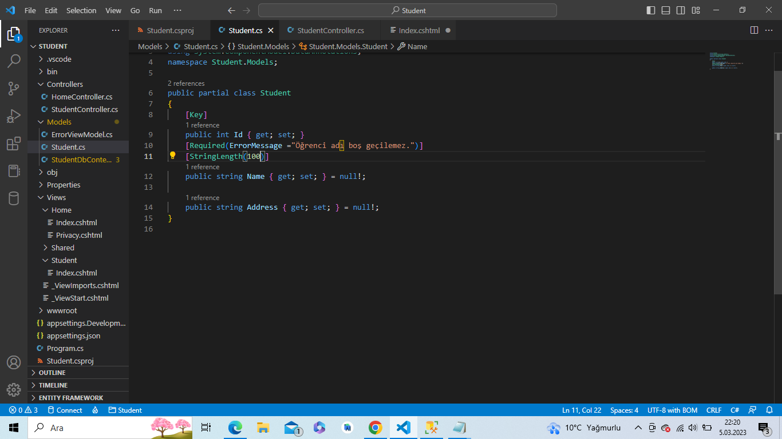

Student.cs

|  |
| --- |
| using System;  using System.Collections.Generic;  using System.ComponentModel.DataAnnotations;  namespace Student.Models;  public partial class Student  {      [Key]      public int Id { get; set; }      [Required(ErrorMessage ="Öğrenci adı boş geçilemez.")]      [StringLength(100)]      public string Name { get; set; } = null!;      public string Address { get; set; } = null!;  } |

StudentController.cs

|  |
| --- |
| using System;  using System.Collections.Generic;  using System.Linq;  using System.Threading.Tasks;  using Student.Models;  using Microsoft.AspNetCore.Mvc;  namespace Student.Controllers  {      public class StudentController:Controller      {          StudentDbContext db = new StudentDbContext();          public IActionResult Index()          {              return View(db.Students.ToList());          }      }  } |

Index.cshtml

|  |
| --- |
| @{      ViewData["Title"] = "Index";  }  <div>      <p>@Html.ActionLink("Create New Student Record","Create","Student")</p>  </div>  <table class="table">      <thead>          <tr>              <th>Student ID</th>              <th>Student Name</th>              <th>Address</th>              <th>Update</th>              <th>Detail</th>              <th>Delete</th>          </tr>      </thead>      <tbody>          @foreach (var item in Model)          {             <tr>                  <td>@item.Id</td>                  <td>@item.Name</td>                  <td>@item.Address</td>                  <td>@Html.ActionLink("Update","Update",new{Id=item.Id})</td>                  <td>@Html.ActionLink("Details","Details",new{Id=item.Id})</td>                  <td>@Html.ActionLink("Delete","Delete",new{Id=item.Id})</td>             </tr>          }      </tbody>  </table> |