Class description

|  |  |  |
| --- | --- | --- |
| Folder | Class | Description |
|  | Backlog | Class containing method that calcultes how many points does the sprint have based on the tasks' estimates. A readonly field is used. |
|  | Company | A singleton class describing company properties and events such as 'Salary time' and 'Tasks from client' |
|  | EmployeeProficiencyComparer | Custom implementatoin of IEqualityComparer to return a single employee per his/her Proficiency |
|  | Fibonacci | Static class containing method that returns a number from Fibonacci sequence based on the input index |
|  | Filler | Class containing several methods that that fill employee or task data. |
|  | RandomEnum | Class containig a method that randomly generates any enum value based on the entered enum type. |
|  | Reporter | Static class containing methods that produce file reports based on employee and task data |
|  | SalaryPaidEventArgs | Class describing Salary event |
|  | Scrumteam | Abstract class describing the header of the scrum team |
|  | TaskFromClientEventArgs | Class describing Tasks from client event |
| SystemMembers | Developer | Class describing properties of developers and method used for Task solving |
|  | Manager | Class describing method of task distribution and subscription to Tasks from client event |
|  | SystemMember | Class describing employee properties and random data generator method |
|  | Tester | Class describing properties of testers and method used for Task testing. |
| Tasks | SystemTask | Class describing task property |
|  | Tasks | Class describing task properties and random data generator method |

Business logic description

Track System is a console application used to display scrum team members and sprint size based on tasks; handle Salary and Task from client event; show task distribution by developers and testers.

No user input is required since employee and task data are randomly filled by default: 5 devs/5 testers/20 tasks.

Test case

1. Displaying scrum team members:

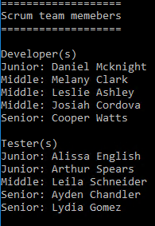

1. Salary event occurs several times during the run of the application and can be displayed on the screen is chaotic manner.

Both developers and testers are subscribed to Salary time event.



1. When the Tasks from client event occurs then sprint size is displayed:

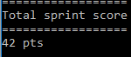

1. When the Tasks from client event occurs manager distributes all tasks to developers and testers who try to solve/test tasks based on employee’s proficiency, total limit of tasks each can take and task’s priority.

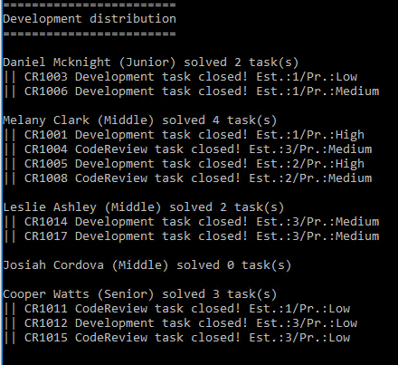

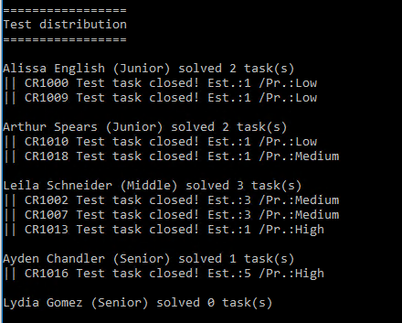

1. Reports are generated during the run of the application. They can be found using the link displayed at the bottom of the console screen:

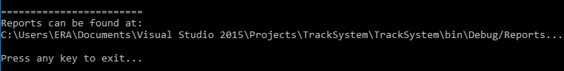

Types of reports:

1. Compare Salary – sorts employee based on their salary in each of the Proficiency groups

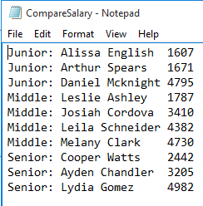

1. Compare task – sorts tasks based on their estimate in each of the Priority groups

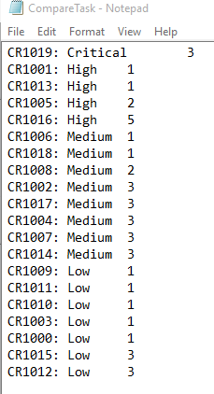

1. GroupDevByAmountOfTasks – groups developers by amount of tasks they solved during distribution

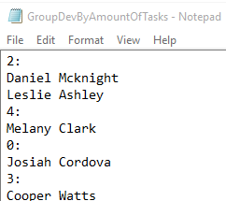

1. SearchForNameStartingWithA – finds employee with name starting with A

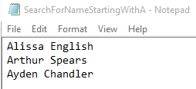

1. SingleTesterPerProficiency – displays one tester from each Proficiency category

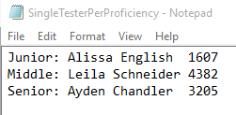

1. Sort TesterSalary – sorts testers based on their salary

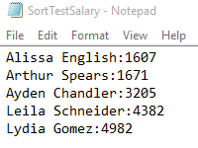

1. ShowDevLevel – shows all developers of Junior proficiency

