Prediction of Early Periprosthetic Joint Infection after Total Hip Arthroplasty: development and external validation of a multivariable model based on observational registry data from Sweden and Denmark
Erik Bülow,^{1,2} Ina Trolle Andersen,³ Ute Hahn,^{3,4} Ola Rolfson,^{1,2} Alma Besic Pedersen,^{3,5} Nils P. Hailer⁶
2021-06-23
- The Swedish Arthroplasty Register, Gothenburg, Sweden
- Department of Orthopaedics, Institute of Clinical Sciences, The Sahlgrenska Academy, University of Gothenburg, Gothenburg, Sweden
- Department of Clinical Epidemiology, Aarhus university hospital, Aarhus, Denmark
- Department of Mathematics, Aarhus University
- Department of Clinical Medicine, Aarhus university
- Department Surgical Sciences/Orthopaedics, Uppsala University Hospital, Uppsala, Sweden
Author details:
- EB: Senior statistician, MSc, PhD, erik.bulow@gu.se
- IT: Statistician, MSc, PhD, ita@clin.au.dk
- UH: Biostatistician, PhD, associate professor, ute@math.au.dk
- OR: Orthopaedic consultant, PhD, professor, register director, ola.rolfson@gu.se
- ABP: Orthopaedic consultant, PhD, DMSc, professor, abp@clin.au.dk
- NPH: Orthopaedic consultant, PhD, professor, nils.Hailer@surgsci.uu.se
Correspondence: erik.bulow@gu.se; +46 70 08 234 28; The Swedish Arthroplasty Register, Registercentrum Västra Götaland, SE-413 45, Sweden
Guarantor: NPH, as the principal investigator, affirms that this manuscript is an honest, accurate, and transparent account of the study being reported; that no important aspects of the study have been omitted; and that any discrepancies from the study as planned have been explained.

PAGE BREAK

Abstract
OJECTIVE: We developed a parsimonious prediction model for prosthesis joint infection (PJI) within 90 days after total hip arthroplasty (THA).
DESIGN: Logistic LASSO regression with bootstrap ranking applied to prospectively collected patient data from multiple linked national registers.
SETTING: Model derivation and internal (external) validation for all hospitals performing THA in Sweden (Denmark).
PARTICIPANTS: 88,830 patients from the Swedish Hip Arthroplasty Register with elective THA 2008-2015, and 18,854 patients from the Danish Hip Arthroplasty Register with THA 2016-2018.
MAIN OUTCOME MEASURES: PJI as identified either as reason for re-operation, or as recorded by ICD-10 or NOMESCO codes at later hospital visits.
RESULTS: Incidence of PJI was 2.45 % in Sweden and 2.17 % in Denmark. A model with the the underlying diagnosis for THA, body mass index (BMI), American Society for Anesthesiologists (ASA) class, sex, age, and the presence of arrhythmia, central nervous system (CNS) disease, fluid electrolyte disorders, liver disease or lung and airways disease, had an AUC = 0.68 (95 % CI: 0.66 to 0.69) in Sweden, and 0.66 (95 % CI: 0.64 to 0.69) in Denmark. This was superior to traditional models based on ASA class, Charlson, Elixhauser, or the Rx Risk V comorbidity indices (with and without adjustment for age and sex). Calibration was good for predicted probabilities up to 10 %.
CONCLUSION: Our model, based on easily accessible data available before THA, had superior discriminatory ability compared to ASA class alone or more complex comorbidity indices. It had good calibration and was externally validated in Denmark. We provide a web-based calculator (https://erikbulow.shinyapps.io/thamortpred/) to enable shared decision making by patients and surgeons.

PAGE BREAK

Summary box

What is already known on this topic
- Periprosthetic joint infection (PJI) is the most devastating of early complications after total hip arthroplasty (THA).
- Attempts have been made to develop individualized risk prediction models for clinical usage in the US and Australia.
- None of those models have gained general acceptance due to limited samples, low discriminating ability, sub-optimal calibration or absence of external model validation.

What this study adds
- Our model, based on easily accessible data available before THA, had superior discriminatory ability compared to more complex comorbidity indices.
- Our model had good calibration, was externally validated in Denmark, and can be used in clinical practice by a simple web calculator (https://erikbulow.shinyapps.io/thamortpred/).

PAGE BREAK

Introduction
Periprosthetic joint infection (PJI) is the most devastating of early complications after total hip arthroplasty (THA), mainly due to its association with increased mortality, re-operation risk, long-term antibiotic treatment, and often persistently impaired quality of life.[1–3] Many risk factors for the development of PJI are identified, with anaemia, diabetes, and obesity being important, to some extent modifiable risk factors, whereas advanced age and male sex are examples of non-modifiable risk factors.[4–12] Individualized PJI risk stratification would be a highly relevant tool in the pre-operative assessment of patients scheduled for THA. Both the American Society for Anesthesiologists’ (ASA) classification or considerably more complex comorbidity indices can be used for risk profiling, but their use is rather challenging. Although high ASA class is a risk factor for worse clinical outcomes, it was never developed for the purpose of predicting PJI [13,14]. The Charlson[15] and Elixhauser[16] comorbidity indices are based on 17 or 31 conditions according to the International Classification of Diseases (ICD), respectively, but they are cumbersome to use in a clinical setting, and they were also not designed for prediction of specific adverse events after THA. The same is true for the Rx Risk V-classification with 46 conditions codified along the Anatomical Therapeutic Chemical (ATC) Classification.[17,18] Several attempts have been made at developing prognostic individualized risk prediction models for clinical usage, with the Universal American College of Surgeons National Surgical Quality Improvement Program (ACS NSQIP) Surgical Risk Calculator being one of the first.[19,20] Additional models have since been derived on US or Australian cohorts, but none has gained general acceptance.[20–22] This is mainly due to often limited, sometimes single-center based samples, low discriminating ability or sub-optimal calibration of the prediction models, or the absence of external model validation. We therefore aimed to develop a prognostic prediction model of PJI within 90 days after THA that is based on easily accessible data that are available in the setting of clinical decision-making. Furthermore, we aimed to validate the model both internally in Sweden, as well as externally on a Danish national cohort.

Patients and Methods
We used data from the Swedish Hip Arthroplasty Register (SHAR) for model derivation and internal validation of discrimination and calibration. The best model was then validated externally on a cohort from the Danish Hip Arthroplasty Register (DHR). We followed the TRIPOD checklist for the reporting of the study.

Derivation cohort (Sweden)
All Swedish hospitals performing THA (82 units in 2020), report their data to SHAR. The derivation cohort was obtained from SHAR 2008-2015, with the choice of 2008 as the starting year because registration of ASA class and body mass index (BMI) was initiated then. Deterministic data linkage was achieved by using personal identity numbers that are assigned to all Swedish residents at birth or immigration.[23,24] The diagnosis underlying the index THA procedure (categorized into primary osteoarthritis, secondary osteoarthritis, sequelae after childhood hip disease, avascular necrosis of the femoral head [AVN] and inflammatory joint disease), type of THA fixation (cemented or uncemented stem and cup respectively), age at index surgery, sex, BMI prior to surgery, ASA class at the time of surgery, type of hospital, and year of surgery, were obtained from the SHAR. Data on comorbidities for one year prior to index surgery were obtained from the National Patient Register (NPR) where diagnoses based on in- and outpatient episodes in all private and public hospitals are coded according to ICD-10 together with admission and discharge dates. Data on marital status and the educational level of patients was obtained from the longitudinal integration database for health insurance and labour market studies (LISA) from Statistics Sweden. The SHAR has completeness of 96-98 % and 100 % coverage,[25] the LISA has coverage of 98 % with 85 % accuracy, and completeness for the NPR is above 99 % and the positive predictive value is 85-95 %.[26] Death dates were linked from the national population register. Only the last operated hip was considered for patients with bilateral THA.[27] Patients with missing information on ASA class, or an ASA class of IV and above, were excluded, as were patients with missing information on BMI or a measurement above 50. Patients with missing information on educational levels or the type of hospital performing index surgery were also excluded.

External validation cohort (Denmark)
Danish THA patients were operated from 2016 until the last of September 2018. This period was chosen due to availability of ASA and BMI data and possibility for all patients to have 90 days of follow up.
The DHR is a clinical quality database established in 1995 on all primary and revision THA surgeries, with registration completeness of more than 95 % during the last decade for both primary and revision THAs.[28] All hospitals performing THA in Denmark (40 in 2019) are included in the register. All surgery related variables, ASA and BMI were obtained from the DHR. The Danish National Patient Register holds data on ICD-10 codes as well as all procedures codes for hospitalizations and outpatient visits at Danish public and private hospitals.[29] Data on education and civil status were obtained from Statistics Denmark.[30]

Definitions of covariates and outcomes
The Charlson and Elixhauser comorbidity indices are based on the presence of ICD-10 codes grouped into 17 and 31 categories each [31]. Such codes were identified from reported in- and outpatient hospital visits recorded in the national patient registers during one year prior to surgery. Diagnostic categories from those indices were combined to define 21 categories of comorbidity that were chosen in order to be easily identifiable in a clinical setting (Tab. 1).
Table 1: Categorization of comorbidities from the Charlson, Elixhauser and Rx Risk V comorbidities. (CNS = central nervous system.)
Comorbidities by groups | Charlson | Elixhauser
AIDS/HIV | AIDS/HIV | AIDS/HIV
Anemia |  | Blood loss anemia, Deficiency anemia
Arrhythmia |  | Cardiac arrhythmias
Arterial hypertension |  | Hypertension uncomplicated, Hypertension complicated
Cancer | Malignancy, Metastatic solid tumor | Lymphoma, Metastatic cancer, Solid tumor
CNS disease | Dementia, Hemiplegia or paraplegia | Depression, Paralysis, Other neurological disorders, Psychoses
Coagulopathy |  | Coagulopathy
Diabetes | Diabetes without complication, Diabetes complication | Diabetes uncomplicated, Diabetes complicated
Drug alcohol abuse |  | Alcohol abuse, Drug abuse
Fluid electrolyte disorders |  | Fluid electrolyte disorders
Heart condition | Congestive heart failure | Congestive heart failure, Valvular disease
Myocardial infarction | Myocardial infarction
Hypothyroidism |  | Hypothyroidism
Kidney disease | Renal disease | Renal failure
Liver disease | Mild liver disease, Moderate or severe liver disease | Liver disease
Lung and airways disease | Chronic pulmonary disease | Chronic pulmonary disease, Pulmonary circulation disorder
Obesity |  | Obesity
Peptic ulcer | Peptic ulcer disease | Peptic ulcer disease
Rheumatic disease | Rheumatic disease | Rheumatoid arthritis
Vascular disease | Peripheral vascular disease, Cerebrovascular disease | Peripheral vascular disorder
Weight loss |  | Weight loss
Some of the combined comorbidities were observed for less than 10 patients with or without PJI, and these diagnoses were not considered as potential predictors to reduce the risk of overfitting to spurious events.
PJI was defined by the occurrence of relevant ICD-10 or procedural Nordic Medico-Procedural Committee (NOMESCO)-codes recorded in the NPR within 90 days (Tab. 2), or if the patient was reported to SHAR or DHR as re-operated due to infection within the same time frame.
Table 2: Codes identifying PJI if recorded in the Swedish and Danish National Patient Registers within 90 days after THA.
classification | codes
ICD-10 | M000, M000F, M001, M002, M002F, M008, M008F, M009, M009F, M860F, M861F, M866, M866F, T814, T845, T845F, T845X, T847, T847F
NOMESCO | NFS09, NFS19, NFS29, NFS39, NFS49, NFS59, NFS99

Model development
Model development was performed by bootstrap ranking and a logistic least absolute shrinkage and selection operator (LASSO).[32–34] Age was normalized prior to modelling, and the estimated coefficients thus indicated variable importance on the same scale as categorical variables. BMI was divided into four categories based on the six intervals proposed by the World Health Organization (WHO; BMI $<25$: under- or normal weight, $25-29.9$: overweight, $30-34.9$: class I obesity, and BMI $≥35$: class II-III obesity).
Ten-fold cross validation was performed with a range of potential penalty values ($λ_{i}$:s) in the LASSO model, keeping the $λ$ that minimized the mean cross-validated deviance. 100 bootstrap samples were then drawn from the observed data set.[35]
Logistic LASSO regression was performed for each sample using the chosen $λ$ as penalty term. Regression coefficients were ranked based on their absolute values as a measure of variable importance. We then used Bayesian methods to estimate a posterior distribution and to identify two change points in a linear segmented piecewise regression model. The second change point was then used as a break-point. Influential predictors with absolute coefficients value above this point scored a point and the entire process was repeated 100 times, yielding 10,000 bootstrap samples in total. Potential predictors that were selected at least 10 out of 100 times were then used in a main effects multivariable logistic regression model without penalty and without pre-normalization of numeric variables. An even more parsimonious “reduced” model with potential predictors chosen at least 80 out of 100 times was evaluated for comparison.

Reference models
Univariable prediction models based on either ASA class, the Charlson, Elixhauser, or the Rx Risk V comorbidity indices were fitted for comparison, as well as multivariable models combining those measures with age, sex and BMI (10 models in total). The Rx Risk V index is a comorbidity index based on medical prescriptions coded by the Anatomical Therapeutic Chemical (ATC) classification system during one year prior to surgery. This data was retrieved from the Swedish and Danish[36] national prescription registers and classified according to Pratt et al.[18] Odds ratios for the final models were estimated with 95 % confidence intervals based on the whole cohort.

Model validation
The main, reduced and the 10 reference models were used to predict the probability of PJI within 90 days for patients derived from the SHAR (internal validation). Receiver operating characteristic (ROC) curves and their corresponding areas under the curve (AUC) were used to describe discrimination with 95 % confidence intervals based on an asymptotic approximation suggested by DeLong et al.[37] The bias-corrected Somers’ $D_{xy}$ rank correlation based on 100 resamples was used to adjust for optimism, but the correction for optimism only affected the third decimals in the presented results, and will therefore not be further discussed. Predicted probabilities and observed proportions were plotted with 95 % confidence intervals to graphically assess model calibration.[38] Coefficients of determination were estimated by Nagelkerke’s $R^{2}$ for each model. The model with the lowest $R^{2}$ ($R_{0}^{2}$) was compared to the other $k=1,…,11$ models, by $1-R_{0}^{2}/R_{k}^{2}$. This is the fraction of new information, or the proportion of added explainable variation for model $k$ compared to a chosen baseline model.[39]
The derived model was then externally validated on the Danish cohort, both with the coefficient estimates from the Swedish cohort and with new estimates based on the Danish cohort. The 10 reference models, with adopted coefficient estimates, were also applied to the Danish cohort for comparison. Finally, the new coefficient estimates for the derived model, re-estimated with Danish data, were empirically compared to analogues estimates derived from subsamples of the Swedish data with sample sizes to match the Danish cohort (supplementary, Tab 7 and Fig. 7).

Statistical tools
We used R version 4.1.0 (2021-05-18) (R Foundation for Statistical Computing, Vienna, Austria) with significant packages coder,[40] decoder, furrr, pROC, rms, tidymodels and tidyverse. We build a shiny-based web calculator was build to aid clinical usage of the model (https://erikbulow.shinyapps.io/thamortpred/).

Patient and Public Involvement
Patient representatives are elected as ordinary members of the steering committees for the Swedish Arthroplasty Register and the Danish Hip Arthroplasty Register, where the development of shared decision making has been discussed. Our web calculator will be available for (potential) patients and the public.

Ethical approval
Ethical approval for this study was obtained from the Regional Ethical Review Board in Gothenburg (360-13). The study was approved by the Danish Data Protection Agency (journal number 2015-57-0002) and recorded at Aarhus University (journal number 2016-051-000001).

Results

Study participants
We included 88,830 patients (44 % males) with a mean age of 68 (SD = 11) years in the derivation cohort from the SHAR (Fig. 1). 2.45 % (n = 2,173) of these developed a PJI within 90 days (Tab. 3). The proportion of patients with ASA class III was 17 % (n = 14,945); 24 % (n = 21,393) had at least one comorbidity according to the Charlson comorbidity index, 43 % (n = 38,617) according to Elixhauser index, and 71 % (n = 62,874) had medications classified according to Rx Risk V.
In addition, 18,854 patients (42.1 % males) with a mean age of 70 (SD = 11) years were included in the external validation cohort (Fig. 2). 2.2 % (n = 410) of these developed a PJI within 90 days (Tab. 3). The proportion of patients with ASA class III was 18 % (n = 3,334); 14 % (n = 2,722) had at least one comorbidity according to the Charlson comorbidity index, 22 % (n = 4,101) according to Elixhauser index, and 56 % (n = 10,625) had medications classified according to Rx Risk V.
Table 3: Patient characteristics in Sweden (2008-2015) and Denmark (2016 to the September 2018). Educational levels were classified as low (up to 9 years), middle (10-12 years) and high (more than 12 years). Data on hospital levels were not available for the Danish cohort. Some additional cells have been intentionally left blank due to small numbers and privacy concerns for the Danish cohort. BMI = Body mass index. ASA class = American Society for Anaesthesiologists classification. CNS = central nervous system.
what | level | SE PJI | SE No PJI | SE Total | DK PJI | DK No PJI | DK Total
Total |  | 2173 | 86657 | 88830 | 410 | 18444 | 18854
Age | <50 | 104 ( 4.8) | 4541 ( 5.2) | 4645 ( 5.2) | 9 (2.2) | 871 (4.7) | 880 (4.7)
 | 50-<60 | 231 ( 10.6) | 11581 ( 13.4) | 11812 ( 13.3) | 45 (11.0) | 2415 (13.1) | 2460 (13.0)
 | 60-<70 | 609 ( 28.0) | 28372 ( 32.7) | 28981 ( 32.6) | 112 (27.3) | 5114 (27.7) | 5226 (27.7)
 | 70-<80 | 776 ( 35.7) | 29610 ( 34.2) | 30386 ( 34.2) | 164 (40.0) | 7037 (38.2) | 7201 (38.2)
 | 80+ | 453 ( 20.8) | 12553 ( 14.5) | 13006 ( 14.6) | 80 (19.5) | 3007 (16.3) | 3087 (16.4)
Sex | female | 1062 ( 48.9) | 49089 ( 56.6) | 50151 ( 56.5) | 209 (51.0) | 10706 (58.0) | 10915 (57.9)
 | male | 1111 ( 51.1) | 37568 ( 43.4) | 38679 ( 43.5) | 201 (49.0) | 7738 (42.0) | 7939 (42.1)
BMI | under/normal weight | 487 ( 22.4) | 28944 ( 33.4) | 29431 ( 33.1) | 101 (24.6) | 6746 (36.6) | 6847 (36.3)
 | overweight | 863 ( 39.7) | 37280 ( 43.0) | 38143 ( 42.9) | 152 (37.1) | 7264 (39.4) | 7416 (39.3)
 | class i obesity | 531 ( 24.4) | 15693 ( 18.1) | 16224 ( 18.3) | 86 (21.0) | 3261 (17.7) | 3347 (17.8)
 | class ii-iii obesity | 292 ( 13.4) | 4740 ( 5.5) | 5032 ( 5.7) | 71 (17.3) | 1173 (6.4) | 1244 (6.6)
ASA class | I | 302 ( 13.9) | 20785 ( 24.0) | 21087 ( 23.7) | 44 (10.7) | 3898 (21.1) | 3942 (20.9)
 | II | 1228 ( 56.5) | 51570 ( 59.5) | 52798 ( 59.4) | 253 (61.7) | 11325 (61.4) | 11578 (61.4)
 | III | 643 ( 29.6) | 14302 ( 16.5) | 14945 ( 16.8) | 113 (27.6) | 3221 (17.5) | 3334 (17.7)
Diagnosis | primary osteoarthritis | 1766 ( 81.3) | 76812 ( 88.6) | 78578 ( 88.5) | 329 (80.2) | 15597 (84.6) | 15926 (84.5)
 | secondary osteoarthritis | 232 ( 10.7) | 5039 ( 5.8) | 5271 ( 5.9) | 57 (13.9) | 1781 (9.7) | 1838 (9.7)
 | sequelae after childhood hip disease | 41 ( 1.9) | 1821 ( 2.1) | 1862 ( 2.1) |  |  | 626 (3.3)
 | avascular necrosis of the femoral head (avn) | 77 ( 3.5) | 1818 ( 2.1) | 1895 ( 2.1) | 15 (3.7) | 303 (1.6) | 318 (1.7)
 | inflammatory joint disease | 57 ( 2.6) | 1167 ( 1.3) | 1224 ( 1.4) |  |  | 146 (0.8)
Cemented stem |  | 1600 ( 73.6) | 59777 ( 69.0) | 61377 ( 69.1) | 106 (25.9) | 4933 (26.7) | 5039 (26.7)
Cemented cup |  | 1739 ( 80.0) | 68147 ( 78.6) | 69886 ( 78.7) | 45 (11.0) | 1456 (7.9) | 1501 (8.0)
Hospital | university | 776 ( 35.7) | 33162 ( 38.3) | 33938 ( 38.2)
 | county | 851 ( 39.2) | 28369 ( 32.7) | 29220 ( 32.9)
 | rural | 319 ( 14.7) | 17406 ( 20.1) | 17725 ( 20.0)
 | private | 227 ( 10.4) | 7720 ( 8.9) | 7947 ( 8.9)
Education | low | 453 ( 20.8) | 22207 ( 25.6) | 22660 ( 25.5) | 164 (40.0) | 5994 (32.5) | 6158 (32.7)
 | middle | 814 ( 37.5) | 28509 ( 32.9) | 29323 ( 33.0) | 163 (39.8) | 8409 (45.6) | 8572 (45.5)
 | high | 906 ( 41.7) | 35941 ( 41.5) | 36847 ( 41.5) | 83 (20.2) | 4041 (21.9) | 4124 (21.9)
Civil status | married | 1134 ( 52.2) | 47999 ( 55.4) | 49133 ( 55.3) | 204 (49.8) | 10724 (58.1) | 10928 (58.0)
 | single | 647 ( 29.8) | 25283 ( 29.2) | 25930 ( 29.2) | 123 (30.0) | 4393 (23.8) | 4516 (23.9)
 | widow/widower | 392 ( 18.0) | 13375 ( 15.4) | 13767 ( 15.5) | 83 (20.2) | 3327 (18.0) | 3410 (18.1)
Charlson | 0 | 1413 ( 65.0) | 66024 ( 76.2) | 67437 ( 75.9) | 328 (80.0) | 15804 (85.7) | 16132 (85.6)
 | 1 | 423 ( 19.5) | 12281 ( 14.2) | 12704 ( 14.3) | 63 (15.4) | 2180 (11.8) | 2243 (11.9)
 | 2+ | 337 ( 15.5) | 8352 ( 9.6) | 8689 ( 9.8) | 19 (4.6) | 460 (2.5) | 479 (2.5)
Elixhauser | 0 | 946 ( 43.5) | 49267 ( 56.9) | 50213 ( 56.5) | 280 (68.3) | 14473 (78.5) | 14753 (78.2)
 | 1 | 539 ( 24.8) | 20809 ( 24.0) | 21348 ( 24.0) | 77 (18.8) | 2639 (14.3) | 2716 (14.4)
 | 2 | 372 ( 17.1) | 10362 ( 12.0) | 10734 ( 12.1) | 35 (8.5) | 865 (4.7) | 900 (4.8)
 | 3+ | 316 ( 14.5) | 6219 ( 7.2) | 6535 ( 7.4) | 18 (4.4) | 467 (2.5) | 485 (2.6)
RxRiskV | -5-0 | 448 ( 20.6) | 25508 ( 29.4) | 25956 ( 29.2) | 123 (30.0) | 8106 (43.9) | 8229 (43.6)
 | 1-3 | 711 ( 32.7) | 30846 ( 35.6) | 31557 ( 35.5) | 153 (37.3) | 6277 (34.0) | 6430 (34.1)
 | 4-6 | 547 ( 25.2) | 19304 ( 22.3) | 19851 ( 22.3) | 86 (21.0) | 2684 (14.6) | 2770 (14.7)
 | 7+ | 467 ( 21.5) | 10999 ( 12.7) | 11466 ( 12.9) | 48 (11.7) | 1377 (7.5) | 1425 (7.6)
AIDS/HIV |  | 1 ( 0.0) | 15 ( 0.0) | 16 ( 0.0) | 0 (0.0) | 8 (0.0) | 8 (0.0)
Anemia |  | 20 ( 0.9) | 599 ( 0.7) | 619 ( 0.7) | 0 (0.0) | 49 (0.3) | 49 (0.3)
Arrhythmia |  | 271 ( 12.5) | 6097 ( 7.0) | 6368 ( 7.2) | 28 (6.8) | 815 (4.4) | 843 (4.5)
Arterial hypertension |  | 753 ( 34.7) | 23305 ( 26.9) | 24058 ( 27.1) | 45 (11.0) | 1395 (7.6) | 1440 (7.6)
Cancer |  | 142 ( 6.5) | 3855 ( 4.4) | 3997 ( 4.5) | 20 (4.9) | 802 (4.3) | 822 (4.4)
CNS disease |  | 166 ( 7.6) | 2976 ( 3.4) | 3142 ( 3.5) | 17 (4.1) | 293 (1.6) | 310 (1.6)
Coagulopathy |  | 9 ( 0.4) | 320 ( 0.4) | 329 ( 0.4) | 0 (0.0) | 17 (0.1) | 17 (0.1)
Diabetes |  | 212 ( 9.8) | 5761 ( 6.6) | 5973 ( 6.7) | 17 (4.1) | 476 (2.6) | 493 (2.6)
Drug alcohol abuse |  | 30 ( 1.4) | 652 ( 0.8) | 682 ( 0.8) | 6 (1.5) | 99 (0.5) | 105 (0.6)
Fluid electrolyte disorders |  | 29 ( 1.3) | 505 ( 0.6) | 534 ( 0.6) | 8 (2.0) | 187 (1.0) | 195 (1.0)
Heart condition |  | 149 ( 6.9) | 3544 ( 4.1) | 3693 ( 4.2) | 13 (3.2) | 408 (2.2) | 421 (2.2)
Myocardial infarction |  | 105 ( 4.8) | 2982 ( 3.4) | 3087 ( 3.5) | 0 (0.0) | 73 (0.4) | 73 (0.4)
Hypothyroidism |  | 82 ( 3.8) | 2501 ( 2.9) | 2583 ( 2.9)
Kidney disease |  | 36 ( 1.7) | 847 ( 1.0) | 883 ( 1.0)
Liver disease |  | 33 ( 1.5) | 491 ( 0.6) | 524 ( 0.6)
Lung airways disease |  | 172 ( 7.9) | 4145 ( 4.8) | 4317 ( 4.9) | 20 (4.9) | 517 (2.8) | 537 (2.8)
Peptic ulcer |  | 21 ( 1.0) | 515 ( 0.6) | 536 ( 0.6)
Rheumatic disease |  | 144 ( 6.6) | 3782 ( 4.4) | 3926 ( 4.4) | 12 (2.9) | 372 (2.0) | 384 (2.0)
Vascular disease |  | 89 ( 4.1) | 2434 ( 2.8) | 2523 ( 2.8) | 21 (5.1) | 485 (2.6) | 506 (2.7)
Weight loss |  | 5 ( 0.2) | 64 ( 0.1) | 69 ( 0.1) | 0 (0.0) | 29 (0.2) | 29 (0.2)

Model development and internal validation
Patients with AIDS/HIV, coagulopathy and weight loss were uncommon, why these comorbidities were excluded as potential predictors prior to further modelling.
Results from the 100 bootstrap replicates for variable selection were mostly coherent. Diagnosis, BMI and some comorbidities where selected each time. Age was selected 82 out of 100 times, and some factors, such as civil status and type of hospital, were only sporadically selected (Tab. 4).
Table 4: Variables selected by the bootstrap ranking procedure. Variables selected at least 10 out of 100 times were used in the main model. Variables chosen at least 80 times were kept in the reduced model as well. (BMI = body mass index. ASA class = American Society for Anaesthesiologists classification. CNS = central nervous system.)
variable | n
CNS disease | 100
Fluid electrolyte disorders | 100
Liver disease | 100
ASA class: III | 100
BMI: class I obesity | 100
BMI: class II III obesity | 100
BMI: overweight | 100
Diagnosis: Avascular necrosis of the femoral head (AVN) | 100
Diagnosis: Inflammatory joint disease | 100
Diagnosis: Secondary osteoarthritis | 100
Sex Male | 100
Arrhythmia | 95
Diagnosis: Sequelae after childhood hip disease | 95
Lung airways disease | 93
Age | 82
Rheumatidisease | 68
Cancer | 57
Peptiulcer | 43
Cemented cup | 41
Hospital County | 33
ASA class: II | 23
Civil status widow widower | 8
Hypothyroidism | 3
Heart infarct | 1
The reduced model for the prediction of PJI within 90 days in the Swedish cohort included the underlying diagnosis for THA, BMI, ASA class, sex, age, and the presence of arrhythmia, CNS disease, fluid electrolyte disorders, liver disease or lung and airways disease (Tab. 5).
Table 5: Estimated coefficients (beta) and odds ratios (OR) with 95 % confidence intervals for the reduced models. BMI = body mass index (under/normal weight as baseline). CNS = central nervous system. ASA = American Society for Anesthesiologists
variable | level | beta | OR 95 % CI | p
(Intercept) |  | -6.31
Age |  | 0.02 | 1.02 (1.02-1.03) | <0.001
Arrhythmia |  | 0.27 | 1.30 (1.13-1.49) | <0.001
ASA class | I | 0.00 | (ref)
 | II | 0.18 | 1.20 (1.05-1.37) | 0.009
 | III | 0.44 | 1.56 (1.33-1.83) | <0.001
BMI | under/normal weight | 0.00 | (ref)
 | overweight | 0.39 | 1.47 (1.32-1.65) | <0.001
 | class I obesity | 0.81 | 2.24 (1.97-2.55) | <0.001
 | class II-III obesity | 1.40 | 4.05 (3.46-4.75) | <0.001
CNS disease |  | 0.69 | 2.00 (1.68-2.35) | <0.001
Diagnosis | Primary osteoarthritis | 0.00 | (ref)
 | Sequelae after childhood hip disease | 0.39 | 1.48 (1.06-2.01) | 0.016
 | Avascular necrosis of the femoral head ((AVN)) | 0.58 | 1.79 (1.40-2.26) | <0.001
 | Secondary osteoarthritis | 0.74 | 2.09 (1.80-2.41) | <0.001
 | Inflammatory joint disease | 0.94 | 2.55 (1.91-3.33) | <0.001
Fluid electrolyte disorders |  | 0.42 | 1.52 (1.01-2.20) | 0.034
Liver disease |  | 0.75 | 2.11 (1.44-3.00) | <0.001
Lung airways disease |  | 0.27 | 1.31 (1.11-1.54) | 0.001
Sex | Female | 0.00 | (ref)
 | Male | 0.37 | 1.45 (1.33-1.59) | <0.001
ROC-curves (Fig. 3 left panel) and AUC-values (Fig. 4 left panel) for the main and reduced models were very similar, and for simplicity, we therefore focused on the reduced model.
The reduced model had an , whereas univariable models with ASA class (AUC = 0.59, 95 % CI: 0.58 to 0.60), the Charlson comorbidity index (AUC = 0.56, 95 % CI: 0.55 to 0.57), the Elixhauser comorbidity index (AUC = 0.58, 95 % CI: 0.57 to 0.60), and Rx Risk V (AUC = 0.58, 95 % CI: 0.57 to 0.59) had less discriminatory abilities (Fig. 3 left panel and 4 left panel). The univariable model with the Charlson comorbidity index had the lowest AUC and Nagelkerke’s $R^{2}$ (0.73; Tab. 6), and compared to this model, the fraction of new information for the reduced model was 84 %.
Table 6: Model performance based on the Swedish derivation cohort. The area under the receiver operating characteristics curve (AUC) is a measure of discriminatory ability. Nagelkerke’s pseudo-coefficient of determination (R2) is an estimate of the proportion of explained variance for each model (the correlation between observed and predicted values). The univariable Charlson model had the lowest R2 and was therefore used as reference for the fraction of new information (FNI) added by the other models.
Model | AUC (95 % CI) | R2 (%) | FNI (%)
Main model | 0.68 (0.67; 0.69) | 4.86 | 85
Reduced model | 0.68 (0.66; 0.69) | 4.72 | 84
ASA + BMI + Age + Sex | 0.65 (0.64; 0.66) | 3.32 | 78
BMI + Age + Sex | 0.64 (0.62; 0.65) | 2.75 | 73
ASA + Age + Sex | 0.62 (0.60; 0.63) | 1.94 | 62
Elixhauser + Age + Sex | 0.61 (0.60; 0.62) | 1.75 | 58
ASA | 0.59 (0.58; 0.60) | 1.57 | 53
Elixhauser | 0.58 (0.57; 0.60) | 1.29 | 43
Charlson + Age + Sex | 0.60 (0.58; 0.61) | 1.26 | 42
Rx Risk | 0.58 (0.57; 0.59) | 1.03 | 29
Rx Risk + Age + Sex | 0.58 (0.57; 0.59) | 1.03 | 29
Charlson | 0.56 (0.55; 0.57) | 0.73 | 0
The reduced model had good internal calibration (Fig. 6). Estimated probability density curves for patients with and without PJI were partially overlapping, but patients with PJI had on average higher predicted probabilities for this outcome (Fig. 5).

External validation
The reduced model derived from the Swedish cohort produced a very similar ROC curve when applied to the Danish cohort (Fig. 3 right panel), and its AUC value was 0.66 (95% CI: 0.64 to 0.69). This did not change for the model with re-estimated coefficient values based on the Danish cohort (0.67, 95 % CI: 0.65 to 0.7). AUC values for some of the reference models, estimated on the Danish cohort, did differ from the Swedish cohort, but all those models were less accurate than the reduced model (Fig. 4 right panel). The re-estimated model coefficients of the reduced model were coherent with the estimates based on the Swedish data (supplementary Tab. 7).
Calibration was good for predictions up to 3 %, but there was some tendency to over-estimate higher probabilities. This improved after initial re-calibration of the model intercept to the Danish PJI incidence (Fig. 6).

Discussion

Principal findings
A model based on the underlying diagnosis for THA, BMI, ASA class, sex, age, and the presence of arrhythmia, CNS disease, fluid electrolyte disorders, liver disease or lung and airways disease was better at predicting PJI within 90 days after THA than models based on either ASA class or the Charlson, Elixhauser or Rx Risk V comorbidity indices, in terms of AUC, Nagelkerke’s $R^{2}$ and calibration.

Strengths and weaknesses
Our external validation is a strength, which showed that the model works equally well in Denmark, despite some differences between the countries (Tab. 3).
Both Sweden and Denmark have strived for mass higher education.[41] This is, to a higher degree achieved via the university sector in Sweden, while the educational system is more diverse in Denmark.[42] National comparisons of educational levels are therefore difficult, since the Danish student register does not include adult- or continuing education.[43]
Patient distribution among ASA classes were similar in both countries, but the comorbidity burden seems to differ. ICD-10 and NOMESCO codes are recorded for both in- and outpatient hospital visits in the national patient registries in both countries, but the recording of (optional) secondary diagnoses is 23 % in Denmark,[29] compared to 47 % in the Swedish cohort. Serious comorbidities such as cancer, are therefore reported equally in both countries, while for example arterial hypertension, is less documented in Denmark. Also, patients with chronic conditions, such as diabetes, are more commonly treated in primary care settings in Denmark, and are therefore not reported to their national patient register.[29]
The RxRisk V index is a weighted index, which is difficult to compare without further analysis. Prescription patterns might differ by indications based on different national guidelines, different subsidization, and different medications sold over-the-counter. Also, the Danish, but not the Swedish, national prescription register, includes prescriptions from nursery homes and other long-term care facilities.
The dominance of cemented components in Sweden, however, is real, and has been described elsewhere.[44]

Strengths and weaknesses in relation to other studies
Cancer seems to confer an increased risk of PJI in several observational studies,[9,20,45,46] but this comorbidity was not included in our model. Neither was diabetes, which has been included in previous risk calculators.[20,47,48] On the other hand, diabetes is not consistently found to be associated with the risk of surgical site infection or PJI after THA surgery.[49]
Information on peri-operative hyperglycaemia, morning blood glucose, HBA1c,[50,51] or low preoperative haemoglobin,[11] could have improved our model. But although we had access to the ICD codes defining the presence of anaemia, we had no information on actual laboratory findings. Use of subcutaneously applied Tumour Necrosis Factor-alpha blockers,[52,53] intra-articular steroid application[54] or operating time,[12,14,55] are also associated with the risk of PJI after THA. However, we chose to only consider factors available before surgery and are thus able to use the model as a tool for shared decision making using the implemented web calculator. This is a strength of our model.
We also confirmed that, although mentioned as risk factors for surgical site infections after joint arthroplasty,[11,22] prediction models based on the comorbidity indices developed by Charlson or Elixhauser and the RxRisk V index, resulted in poor predictive power. This agrees with previous findings describing that these measures of comorbidity rather poorly predict mortality and patient reported outcomes after THA.[56,57] However, when used in conjunction with information on age and sex, the AUC for these comorbidity indices increased, although never quite reaching the AUC of our model (Fig. 4 and Tab. 6).

Meaning of the study
Our model can be presented in a simple formula $\hat{p}=1/[1+exp(-\hat{α}-x'\hat{β})]$ where $\hat{p}$ is the estimated probability, $\hat{α}$ and $\hat{β}=({\hat{β}}_{1},{\hat{β}}_{2},…,{\hat{β}}_{k})$ are the estimated intercept and coefficients (Tab. 5) and $x=(x_{1},x_{2},…,x_{k})$ are corresponding patient characteristics. For example, a 60-year-old female with normal BMI and primary osteoarthritis without comorbidities would have a probability of $1/[1+exp(6.31-60⋅0.02)]≈$ 0.7 % of suffering from a PJI within 90 days, whereas an 85-year-old male with overweight, secondary osteoarthritis, psoriasis, dementia and ASA class III would have a probability of 15.1 %. Note, however, that observed proportions above 10 % were rare, and predicted probabilities above this limit are subject to extrapolation.
It should be noted that the aim of prediction is different from traditional statistical inference. As such, confidence intervals presented for the model coefficients (Table 5) were based solely on the final logistic regression model. Additional uncertainty introduced by the variable selection process was not incorporated. Hence, those intervals should not be interpreted in support of any implicit hypothesis testing concerning the relevance of any individual variables. Also, the individual odds ratios should not be interpreted as effect measures of individual relations since some variables are correlated.
Patients with primary osteoarthritis seem less prone to developing PJI than patients receiving THA for other reasons.[9,22,58,59] Obesity is associated with an increased risk of reoperations or adverse events after THA[60] and with an increased risk of developing surgical site infections or PJI after total hip or knee arthroplasty.[6,10,12,45,47] CNS disease (cerebrovascular disease, dementia, hemiplegia, and Parkinson’s disease) has also been previously associated with PJI,[9] as have male sex,[20,47,59] liver disease [61] and ASA class.[14,49,62] Taken together, the above cited findings support that the predictor variables in our models seem to be relevant in the context of predicting PJI.
THA fixation using cement without antibiotics confers an increased risk of PJI,[59] but such cement brands were not in clinical use in Sweden during the studied period. We found no indication that the type of fixation was associated with the risk of PJI, and the mode of THA fixation was also not selected as a potential predictor variable in any of the iterations during model development.

Unanswered questions and future research
The proportion of explained variation (Nagelkerke’s $R^{2}$ = 4.72) was low. The question of what other variables might be needed to further refine prediction models remains open, but information that is notoriously difficult to obtain within the setting of large register studies, such as smoking status, might be of value. In addition, a potential underlying susceptibility to PJI -— as has been described for patients with osteomyelitis -— could be a factor of considerable influence on the outcome, but information on single nucleotide polymorphisms in genes that have been associated with musculoskeletal infections was unavailable to us. Such shortcomings could be addressed by future genome-wide association studies.

Conclusion
Our results indicate that the risk of early PJI after THA can be pre-operatively assessed by a parsimonious prediction model. We hope that this model, with its accompanying web calculator, will facilitate shared decision-making between physicians and their patients in need of THA.

Page break

Contribution of authors
NPH initiated the study. OR managed the ethical review board application in Sweden and ABP in Denmark. EB developed the statistical model. IT and UH performed the external validation. NPH and EB drafted, and all authors edited and finalized the manuscript.

Acknowledgement
We would like to thank Aurelie Mailhac, statistician at the Department of Clinical Epidemiology at Aarhus university, for help with the external validation.

Data sharing
Data access is granted after permission from the Västra Götaland Region as the central personal data controller for the Swedish Arthroplasty Register in accordance with the European General Data Protection Regulation (GDPR), as well as Swedish laws and regulations (https://registercentrum.se/vara-tjaenster/datauttag/p/B1eeV66QE).

Conflicts of interest
All authors have completed the ICMJE uniform disclosure form at http://icmje.org/downloads/coi_disclosure.docx and declare: no support from any organisation for the submitted work; OR is principal investigator for research partly founded by Pfizer; OR is register director of the Swedish Arthroplasty Register (SAR) and board member of the International Society of Arthroplasty Registries; NPH has received institutional support from Waldemar Link GmbH, and Zimmer Biomet; NPH is president of the Nordic Arthroplasty Register Association, member of the steering committee of SAR, and Co-Editor of Acta Orthopaedica; no other relationships or activities that could appear to have influenced the submitted work.

PAGE BREAK
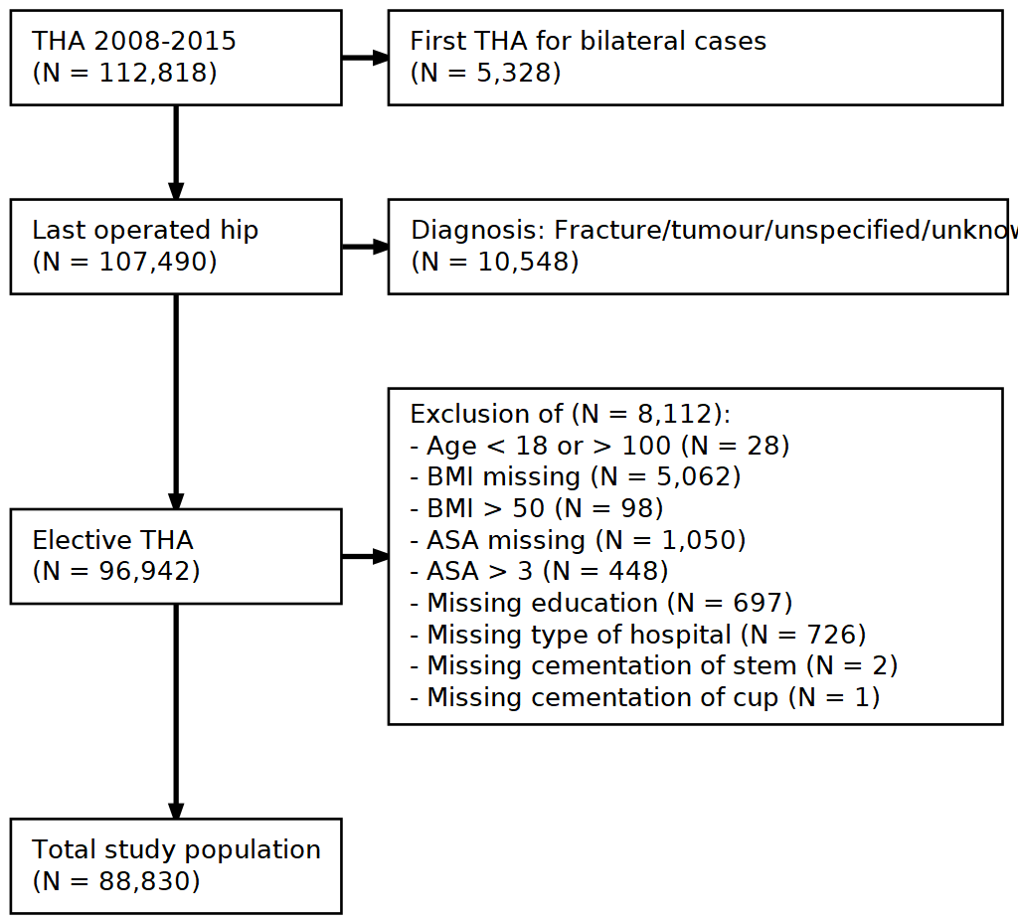
Figure 1: Flowchart with inclusion criteria and number of patients. Data from the Swedish Hip Arthroplasty Register were used for model derivation and internal validation
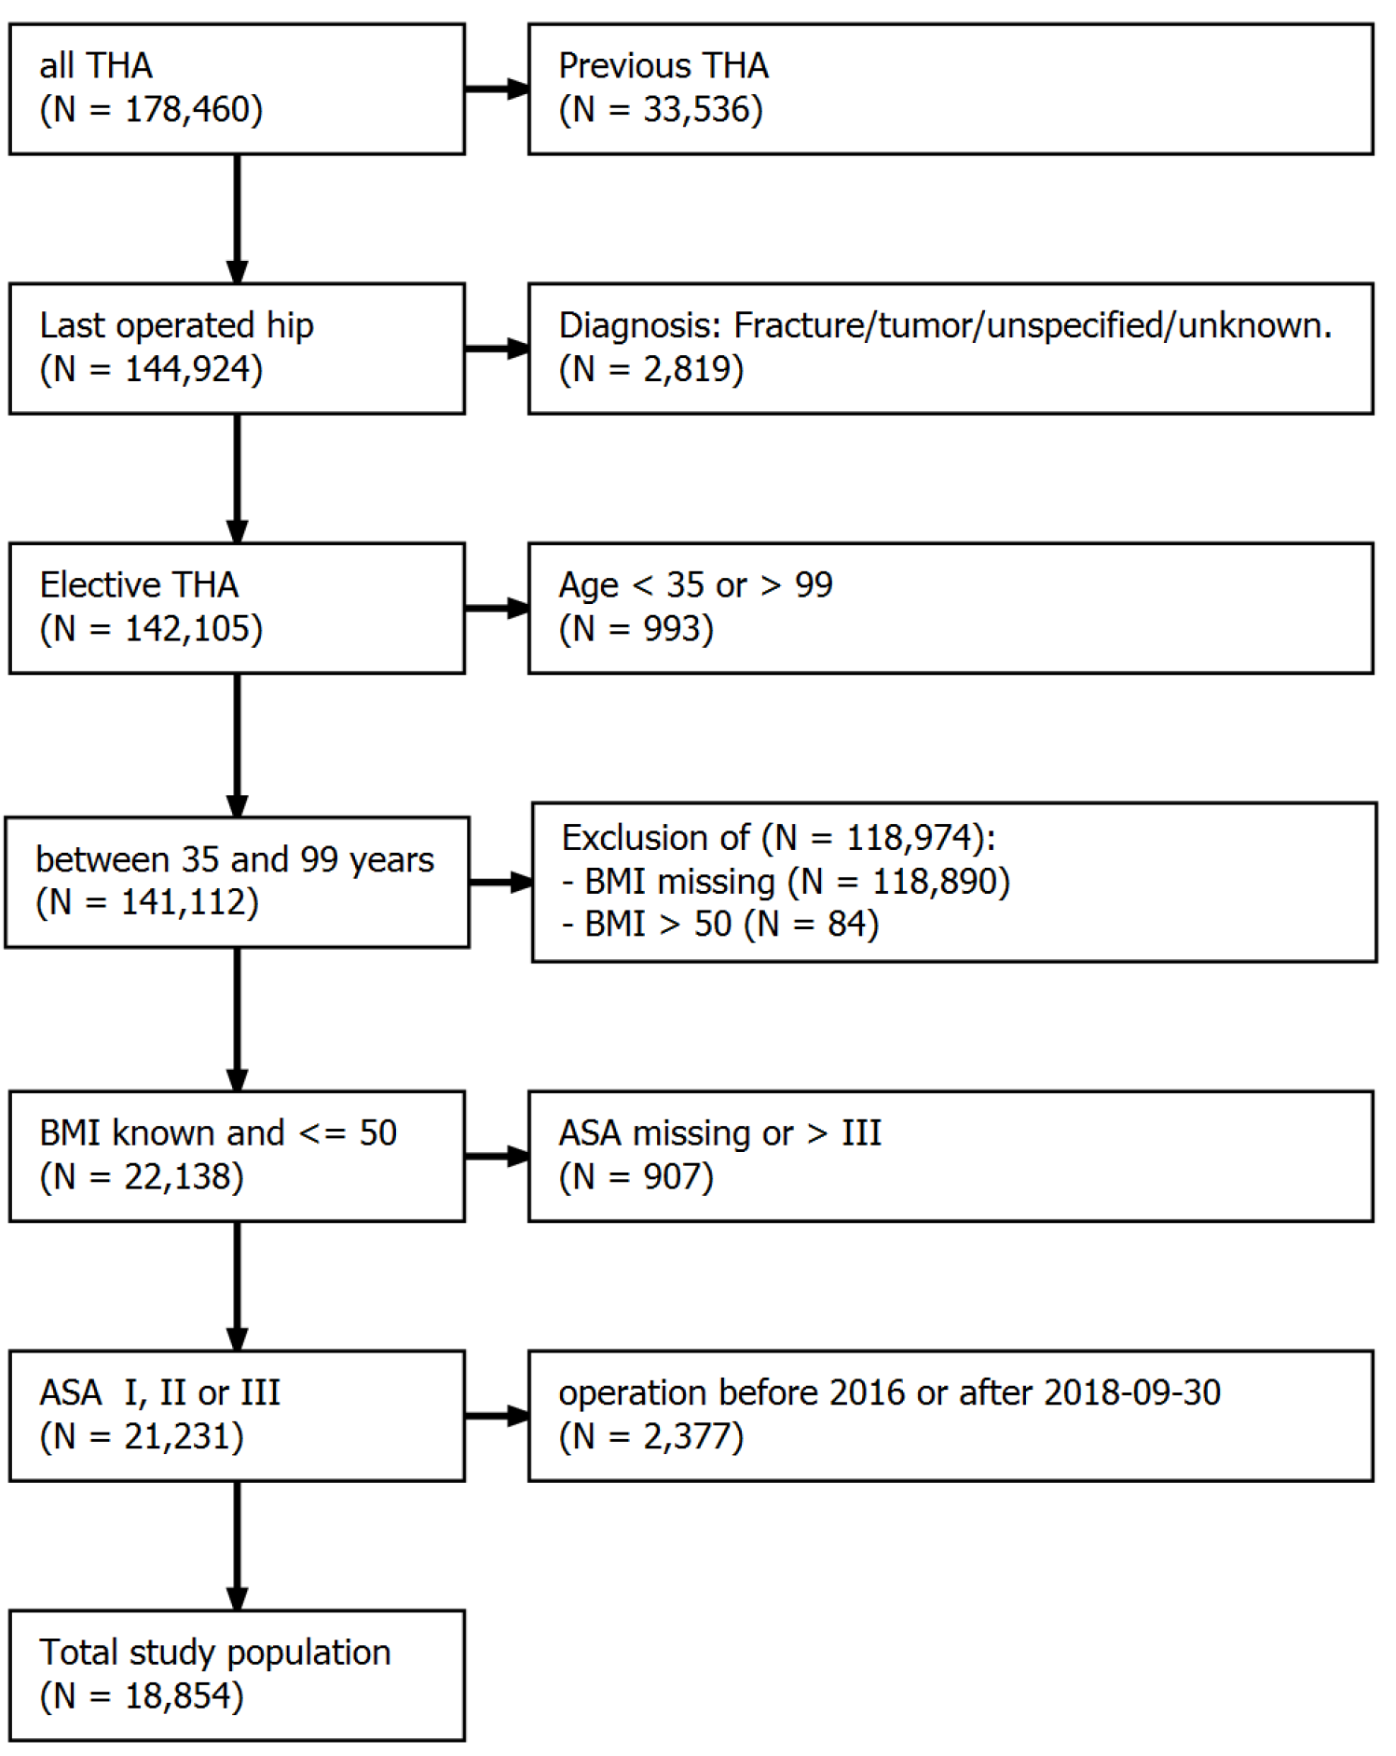
Figure 2: Flowchart with inclusion criteria and number of patients. Data from the Danish Hip Arthroplasty Register were used for external model validation.

PAGE BREAK
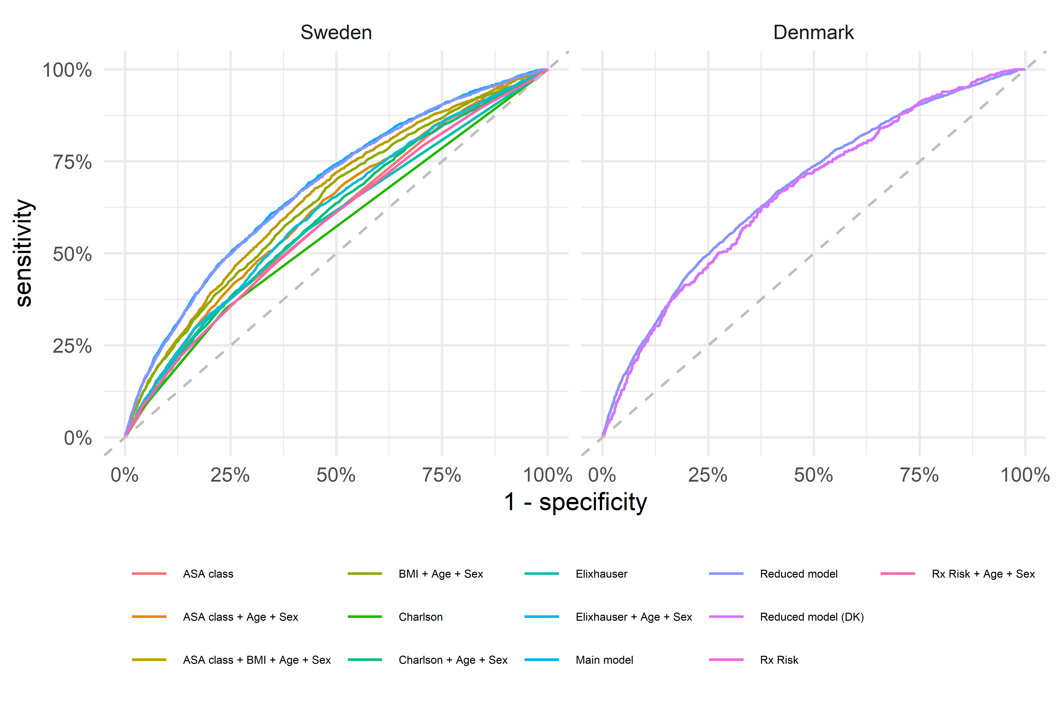
Figure 3: Receiver Operation Characteristics (ROC) curves combines sensitivity and specificity to illustrate discriminative abilities of the different models. The main and reduced models performed almost identical for prediction of PJI within 90 days after surgery. They both performed better than all other models (left panel). The reduced model performed as well when applied to the Danish validation data set (right panel).

PAGE BREAK
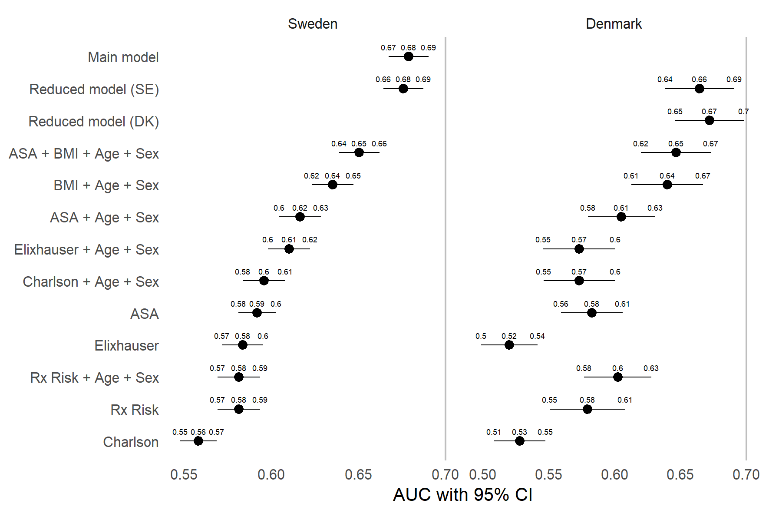
Figure 4: Area Under the Receiver Operation Characteristics Curve (AUC) as a measure of predictive discriminative ability with 95 % confidence intervals (De-Long). The reduced model performed no different than the main model on the Swedish data, and both of these models performed better than all other models (left panel). Similar models were fitted to the Danish cohort (right panel). Coefficient values based on the Swedish data, Reduced model (SE), performed almost as good as the reduced model (DK) with coefficient values refitted to the Danish cohort.

PAGE BREAK
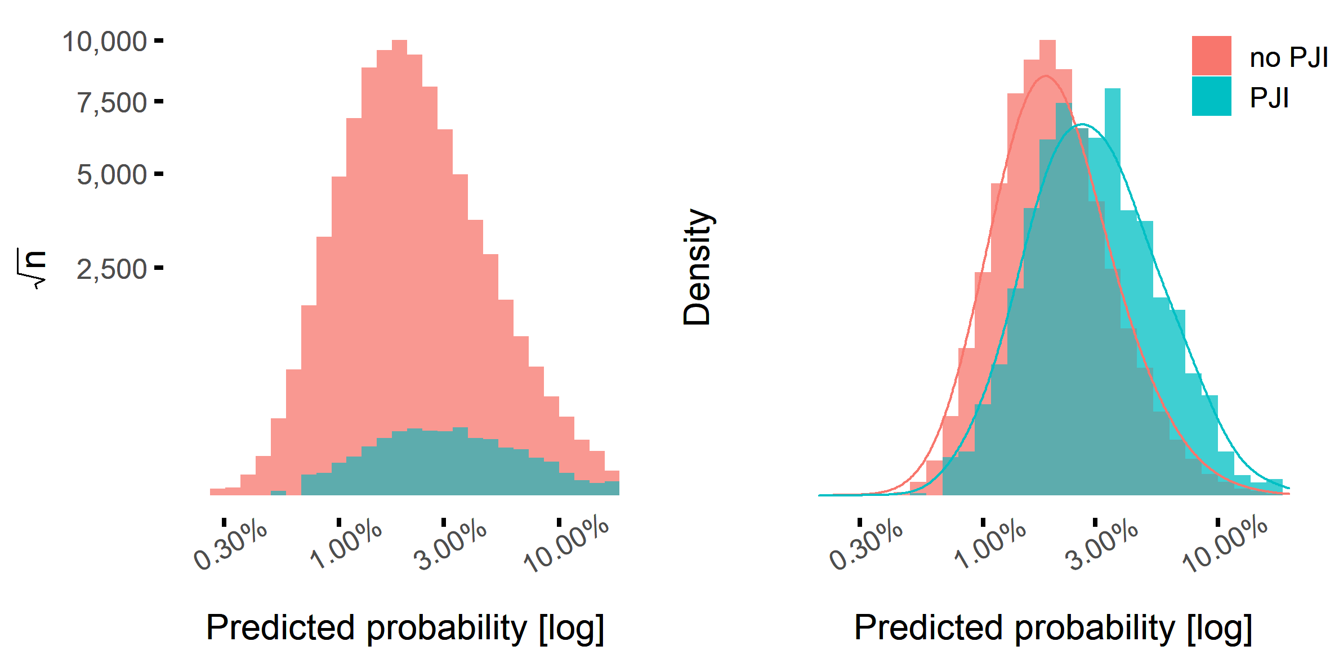
Figure 5: Separation between patients with and without PJI within 90 days versus their predicted probabilities of this event. Most patients did not have PJI, wherefore the pink bars dominate the histogram (left panel; note the scales). A normalized density plot reveals, however, that patients with PJI had, on average, higher predicted probabilities for this adverse event (right panel).

PAGE BREAK
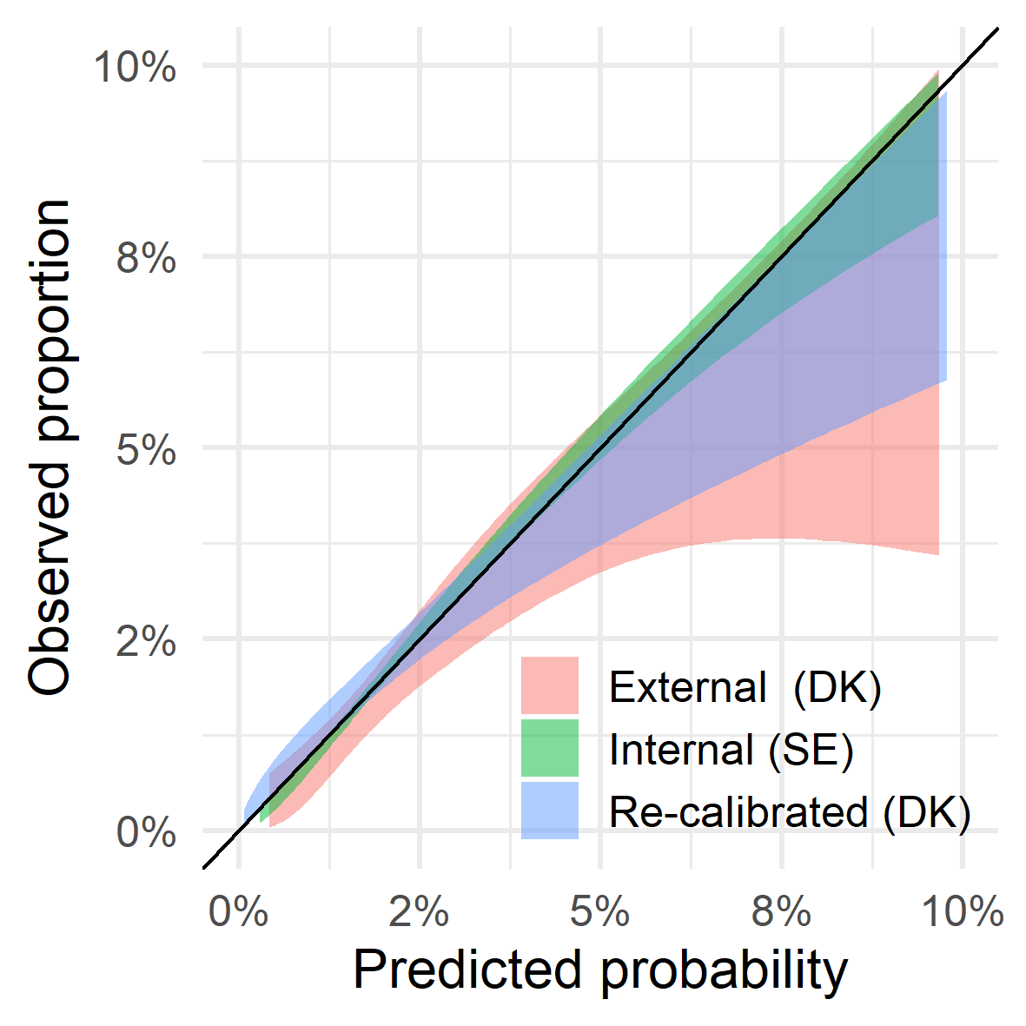
Figure 6: Calibration for the reduced model. Proportions of PJI above 10 % were rarely observed and therefore omitted. Internal calibration (green 95 % confidence band) is good; predicted probabilities are similar to observed proportions, as indicated by close proximity to the diagonal line. External calibration with the same model (pink) indicates some over-estimation and less accuracy. This is expected due to smaller sample size and some national differences. Calibration improves after re-calibration of the model intercept to better resamble the Danish incidence (blue).

PAGE BREAK

Supplementary

Model coefficients
Variable selection and coefficient estimates were based on the Swedish cohort. The reduced model was then used to predict PJI also in Denmark. The coefficient values of the reduced model were also re-fitted to the Danish cohort for comparison. We compared the estimates from the Swedish and Danish cohort and found most values to be of similar magnitude. The only coefficient with reversed direction was for patients with a diagnose of “sequelae after childhood hip disease”. This is a rare condition, with very few observed PJI:s within 90 days. We also re-estimated the model coefficients 1,000 times based on the Swedish data. Each time, we took a random sample of the same size ($N=18,854$) as was observed in the Danish cohort. The 2.5th and 97.5th percentiles were then used to form empirical 95 % confidence intervals for each coefficient (Tab. 7 and Fig. 7). The estimated effect of “sequelae after childhood hip disease” fall outside this empirical CI. Applying multiplicity correction by Bonferroni or similar, would eliminate this significance. Hence, it seems that both cohorts are similar in respect to association between the studied covariates and the risk of PJI within 90 days of THA.
Table 7: Estimated coefficients for the reduced model based on the Swedish derivation cohort (Swedish), as well as re-estimated coefficient values based on the Danish cohort (Danish). Empirical confidence intervals (95 % CI) based on 1,000 resamples from the Swedish cohort of the same sample size (N = 18,854) as used in the Danish cohort.
variable | level | Swedish | Danish | 95 % CI
(Intercept) |  | -6.31 | -6.26
Age |  | 0.02 | 0.02 | (0.01, 0.03)
Arrhythmia |  | 0.27 | 0.14 | (-0.04, 0.52)
ASA class | I | 0.00 | 0.00
 | II | 0.18 | 0.38 | (-0.06, 0.45)
 | III | 0.44 | 0.51 | (0.12, 0.76)
BMI | under/normal weight | 0.00 | 0.00
 | overweight | 0.39 | 0.42 | (0.16, 0.62)
 | class I obesity | 0.81 | 0.69 | (0.56, 1.08)
 | class II-III obesity | 1.40 | 1.55 | (1.08, 1.70)
CNS disease |  | 0.69 | 0.79 | (0.32, 0.99)
Diagnosis | Primary osteoarthritis | 0.00 | 0.00
 | Sequelae after childhood hip disease | 0.39 | -0.52 | (-0.37, 0.89)
 | Avascular necrosis of the femoral head ((AVN)) | 0.58 | 0.82 | (0.00, 0.99)
 | Secondary osteoarthritis | 0.74 | 0.44 | (0.44, 1.00)
 | Inflammatory joint disease | 0.94 | 0.41 | (0.27, 1.38)
Fluid electrolyte disorders |  | 0.42 | 0.27 | (-0.70, 1.05)
Liver disease |  | 0.75 | 0.48 | (-0.20, 1.39)
Lung airways disease |  | 0.27 | 0.30 | (-0.07, 0.55)
Sex | Female | 0.00 | 0.00
 | Male | 0.37 | 0.32
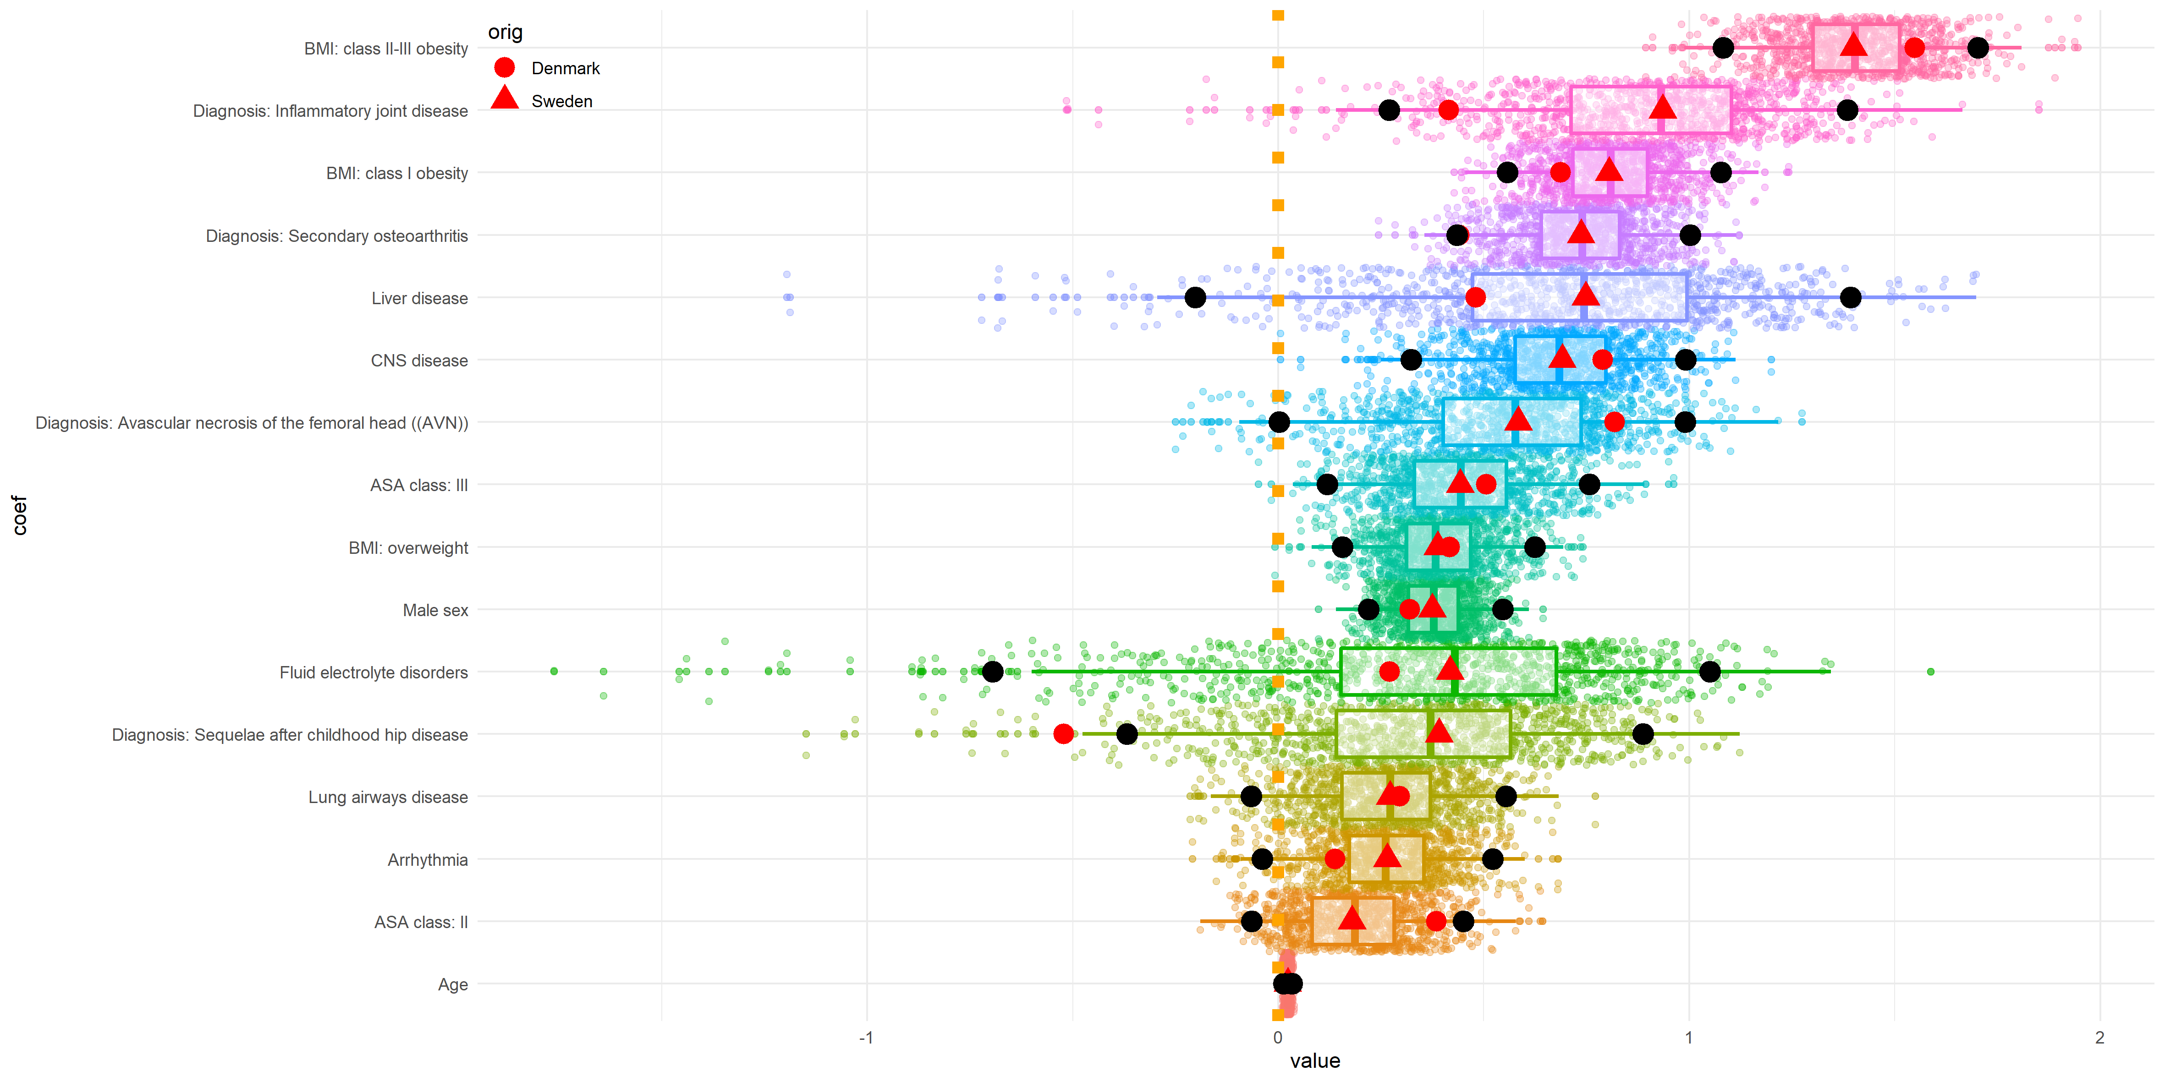
Figure 7: Estimated coefficient values for the reduced model. Red triangles indicate estimates from the Swedish derivation data set. Red circles indicate re-estimated coefficient values for the same model based on the Danish validation cohort. Small coloured dots are empirical estimates from 1000 subsamples based on the Swedish data set, of the same sample size as used in the Danish validation cohort. Black dots indicate the outer limits of 95 % empirical confidence intervals. The Danish estimates almost always fall within those CIs.

PAGE BREAK

Bibliography
1 Zimmerli W. Prosthetic-joint-associated infections. Best Practice & Research Clinical Rheumatology 2006;20:1045–63. doi:10.1016/j.berh.2006.08.003
2 Kapadia BH, Berg RA, Daley JA, et al. Periprosthetic joint infection. The Lancet 2016;387:386–94. doi:10.1016/S0140-6736(14)61798-0
3 Shohat N, Bauer T, Buttaro M, et al. Hip and Knee Section, What is the Definition of a Periprosthetic Joint Infection (PJI) of the Knee and the Hip? Can the Same Criteria be Used for Both Joints?: Proceedings of International Consensus on Orthopedic Infections. The Journal of Arthroplasty 2019;34:S325–7. doi:10.1016/j.arth.2018.09.045
4 Ridgeway S, Wilson J, Charlet A, et al. Infection of the surgical site after arthroplasty of the hip. The Journal of Bone and Joint Surgery British volume 2005;87-B:844–50. doi:10.1302/0301-620X.87B6.15121
5 Lai K, Bohm ER, Burnell C, et al. Presence of Medical Comorbidities in Patients With Infected Primary Hip or Knee Arthroplasties. The Journal of Arthroplasty 2007;22:651–6. doi:10.1016/j.arth.2006.09.002
6 Malinzak RA, Ritter MA, Berend ME, et al. Morbidly Obese, Diabetic, Younger, and Unilateral Joint Arthroplasty Patients Have Elevated Total Joint Arthroplasty Infection Rates. The Journal of Arthroplasty 2009;24:84–8. doi:10.1016/j.arth.2009.05.016
7 Ong KL, Kurtz SM, Lau E, et al. Prosthetic Joint Infection Risk After Total Hip Arthroplasty in the Medicare Population. The Journal of Arthroplasty 2009;24:105–9. doi:10.1016/j.arth.2009.04.027
8 Pedersen AB, Mehnert F, Johnsen SP, et al. Risk of revision of a total hip replacement in patients with diabetes mellitus: A POPULATION-BASED FOLLOW UP STUDY. The Journal of Bone and Joint Surgery British volume 2010;92-B:929–34. doi:10.1302/0301-620X.92B7.24461
9 Bozic KJ, Lau E, Kurtz S, et al. Patient-related risk factors for periprosthetic joint infection and postoperative mortality following total hip arthroplasty in medicare patients. The Journal of Bone and Joint Surgery (American) 2012;94:794–800. doi:10.2106/JBJS.K.00072
10 Jämsen E, Nevalainen P, Eskelinen A, et al. Obesity, Diabetes, and Preoperative Hyperglycemia as Predictors of Periprosthetic Joint Infection: A Single-Center Analysis of 7181 Primary Hip and Knee Replacements for Osteoarthritis. The Journal of Bone and Joint Surgery-American Volume 2012;94:e101-1-9. doi:10.2106/JBJS.J.01935
11 Rasouli MR, Restrepo C, Maltenfort MG, et al. Risk Factors for Surgical Site Infection Following Total Joint Arthroplasty: The Journal of Bone and Joint Surgery-American Volume 2014;96:e158-1-5. doi:10.2106/JBJS.M.01363
12 Maoz G, Phillips M, Bosco J, et al. The Otto Aufranc Award: Modifiable versus Nonmodifiable Risk Factors for Infection After Hip Arthroplasty. Clin Orthop Relat Res 2015;473:453–9. doi:10.1007/s11999-014-3780-x
13 Haynes SR, Lawler PG. An assessment of the consistency of ASA physical status classification allocation. Anaesthesia 1995;50:195–9.http://www.ncbi.nlm.nih.gov/pubmed/7717481
14 Berbari EF, Osmon DR, Lahr B, et al. The Mayo Prosthetic Joint Infection Risk Score: Implication for Surgical Site Infection Reporting and Risk Stratification. Infect Control Hosp Epidemiol 2012;33:774–81. doi:10.1086/666641
15 Charlson ME, Pompei P, Ales KL, et al. A new method of classifying prognostic comorbidity in longitudinal studies: Development and validation. Journal of Chronic Diseases 1987;40:373–83. doi:10.1016/0021-9681(87)90171-8
16 Elixhauser A, Steiner C, Harris DR, et al. Comorbidity measures for use with administrative data. Medical care 1998;36:8–27.
17 Sloan KL, Sales AE, Liu C-F, et al. Construction and characteristics of the RxRisk-V: A VA-adapted pharmacy-based case-mix instrument. Medical care 2003;41:761–74. doi:10.1097/01.MLR.0000064641.84967.B7
18 Pratt NL, Kerr M, Barratt JD, et al. The validity of the Rx-Risk comorbidity index using medicines mapped to the anatomical therapeutic chemical (ATC) classification system. BMJ Open 2018;8. doi:10.1136/bmjopen-2017-021122
19 Edelstein AI, Kwasny MJ, Suleiman LI, et al. Can the american college of surgeons risk calculator predict 30-Day complications after knee and hip arthroplasty? Journal of Arthroplasty 2015;30:5–10. doi:10.1016/j.arth.2015.01.057
20 Wingert NC, Gotoff J, Parrilla E, et al. The ACS NSQIP Risk Calculator Is a Fair Predictor of Acute Periprosthetic Joint Infection: Clinical Orthopaedics and Related Research 2016;474:1643–8. doi:10.1007/s11999-016-4717-3
21 Bozic KJ, Ong K, Lau E, et al. Estimating risk in medicare patients with THA: An electronic risk calculator for periprosthetic joint infection and mortality. Clinical Orthopaedics and Related Research 2013;471:574–83. doi:10.1007/s11999-012-2605-z
22 Inacio MCS, Pratt NL, Roughead EE, et al. Predicting Infections After Total Joint Arthroplasty Using a Prescription Based Comorbidity Measure. The Journal of Arthroplasty 2015;30:1692–8. doi:10.1016/j.arth.2015.05.004
23 Ludvigsson JF, Otterblad-Olausson P, Pettersson BU, et al. The Swedish personal identity number: Possibilities and pitfalls in healthcare and medical research. European Journal of Epidemiology 2009;24:659–67. doi:10.1007/s10654-009-9350-y
24 Cnudde P, Rolfson O, Nemes S, et al. Linking Swedish health data registers to establish a research database and a shared decision-making tool in hip replacement. BMC Musculoskeletal Disorders 2016;17:414. doi:10.1186/s12891-016-1262-x
25 Kärrholm J, Mohaddes M, Odin D, et al. Svenska höftprotesregistret årsrapport 2017. 2018. https://doi.org/10.18158/ryAO-C4pW
26 Ludvigsson JF, Andersson E, Ekbom A, et al. External review and validation of the Swedish national inpatient register. BMC Public Health 2011;11:450. doi:10.1186/1471-2458-11-450
27 Bülow E, Nemes S, Rolfson O. Are the first or the second hips of staged bilateral THAs more similar to unilateral procedures? A study from the swedish hip arthroplasty register. Clinical Orthopaedics and Related Research 2020;2020:11262–70. doi:10.1097/CORR.0000000000001210
28 Gundtoft PH, Varnum C, Pedersen AB, et al. The Danish Hip Arthroplasty Register. CLEP 2016;8:509–14. doi:10.2147/CLEP.S99498
29 Schmidt M, Schmidt SAJ, Sandegaard JL, et al. The Danish National Patient Registry: A review of content, data quality, and research potential. Clin Epidemiol 2015;7:449–90. doi:10.2147/CLEP.S91125
30 Data for research. https://www.dst.dk/en/TilSalg/Forskningsservice (accessed 17 Jun 2021).
31 Quan H, Sundararajan V, Halfon P, et al. Coding algorithms for defining comorbidities in ICD-9-CM and ICD-10 administrative data. Medical care 2005;43:1130–9. doi:10.1097/01.mlr.0000182534.19832.83
32 Guo P, Zeng F, Hu X, et al. Improved variable selection algorithm using a LASSO-Type penalty, with an application to assessing hepatitis B infection relevant factors in community residents. PLOS ONE 2015;10:e0134151. doi:10.1371/journal.pone.0134151
33 Baranowski R, Chen Y, Fryzlewicz P. Ranking-based variable selection for high-dimensional data. Statistica Sinica Published Online First: 2020. doi:10.5705/ss.202017.0139
34 Garland A, Bülow E, Lenguerrand E, et al. Prediction of 90-day mortality after total hip arthroplasty. The Bone & Joint Journal 2021;103-B:469–78. doi:10.1302/0301-620X.103B3.BJJ-2020-1249.R1
35 Austin PC, Tu JV. Bootstrap methods for developing predictive models. The American Statistician 2004;58:131–7. doi:10.1198/0003130043277
36 Kildemoes HW, Sørensen HT, Hallas J. The Danish National Prescription Registry. Scand J Public Health 2011;39:38–41. doi:10.1177/1403494810394717
37 DeLong ER, DeLong DM, Clarke-Pearson DL. Comparing the Areas under Two or More Correlated Receiver Operating Characteristic Curves: A Nonparametric Approach. Biometrics 1988;44:837–45. doi:10.2307/2531595
38 Nattino G, Finazzi S, Bertolini G. A new test and graphical tool to assess the goodness of fit of logistic regression models. Statistics in Medicine 2016;35:709–20. doi:10.1002/sim.6744
39 Harrell F. Statistically Efficient Ways to Quantify Added Predictive Value of New Measurements. Statistical Thinking. 2018.https://www.fharrell.com/post/addvalue/ (accessed 11 May 2021).
40 Bülow E. Coder: An R package for code-based item classification and categorization. Journal of Open Source Software 2020;5:2916. doi:10.21105/joss.02916
41 Isopahkala-Bouret U, Börjesson M, Beach D, et al. Access and stratification in Nordic higher education. A review of cross-cutting research themes and issues*. Education Inquiry 2018;9:142–54. doi:10.1080/20004508.2018.1429769
42 Kim L. Lika olika: En jämförande studie av högre utbildning och forskning i de nordiska länderna. Stockholm: : Högskoleverket 2002.
43 The Student Registre: Statistical presentation. https://www.dst.dk/en/Statistik/dokumentation/documentationofstatistics/the-student-registre/statistical-presentation (accessed 22 Jun 2021).
44 Bunyoz KI, Malchau E, Malchau H, et al. Has the Use of Fixation Techniques in THA Changed in This Decade? The Uncemented Paradox Revisited. Clinical Orthopaedics and Related Research 2020;478:697–704. doi:10.1097/CORR.0000000000001117
45 Everhart JS, Altneu E, Calhoun JH. Medical Comorbidities Are Independent Preoperative Risk Factors for Surgical Infection After Total Joint Arthroplasty. Clin Orthop Relat Res 2013;471:3112–9. doi:10.1007/s11999-013-2923-9
46 Poultsides LA, Ma Y, Della Valle AG, et al. In-Hospital Surgical Site Infections after Primary Hip and Knee Arthroplasty Incidence and Risk Factors. The Journal of Arthroplasty 2013;28:385–9. doi:10.1016/j.arth.2012.06.027
47 Tan TL, Maltenfort MG, Chen AF, et al. Development and evaluation of a preoperative risk calculator for periprosthetic joint infection following total joint arthroplasty. The Journal of Bone and Joint Surgery Published Online First: 2018. doi:10.2106/JBJS.16.01435
48 Inacio MCS, Pratt NL, Roughead EE, et al. Comparing co-morbidities in total joint arthroplasty patients using the RxRisk-V, Elixhauser, and Charlson Measures: A cross-sectional evaluation. BMC Musculoskeletal Disorders 2015;16:385. doi:10.1186/s12891-015-0835-4
49 Namba RS, Inacio MCS, Paxton EW. Risk factors associated with surgical site infection in 30 491 primary total hip replacements. The Journal of Bone and Joint Surgery British volume 2012;94-B:1330–8. doi:10.1302/0301-620X.94B10.29184
50 Mraovic B, Suh D, Jacovides C, et al. Perioperative Hyperglycemia and Postoperative Infection after Lower Limb Arthroplasty. J Diabetes Sci Technol 2011;5:412–8. doi:10.1177/193229681100500231
51 Iorio R, Williams KM, Marcantonio AJ, et al. Diabetes Mellitus, Hemoglobin A1C, and the Incidence of Total Joint Arthroplasty Infection. The Journal of Arthroplasty 2012;27:726–729.e1. doi:10.1016/j.arth.2011.09.013
52 Gilson M, Gossec L, Mariette X, et al. Risk factors for total joint arthroplasty infection in patients receiving tumor necrosis factor $α$-blockers: A case-control study. Arthritis Res Ther 2010;12:R145. doi:10.1186/ar3087
53 Momohara S, Kawakami K, Iwamoto T, et al. Prosthetic joint infection after total hip or knee arthroplasty in rheumatoid arthritis patients treated with nonbiologic and biologic disease-modifying antirheumatic drugs. Modern Rheumatology 2011;21:469–75. doi:10.3109/s10165-011-0423-x
54 Cancienne JM, Werner BC, Luetkemeyer LM, et al. Does Timing of Previous Intra-Articular Steroid Injection Affect the Post-Operative Rate of Infection in Total Knee Arthroplasty? The Journal of Arthroplasty 2015;30:1879–82. doi:10.1016/j.arth.2015.05.027
55 Willis-Owen CA, Konyves A, Martin DK. Factors affecting the incidence of infection in hip and knee replacement: AN ANALYSIS OF 5277 CASES. The Journal of Bone and Joint Surgery British volume 2010;92-B:1128–33. doi:10.1302/0301-620X.92B8.24333
56 Bülow E, Rolfson O, Cnudde P, et al. Comorbidity does not predict long-term mortality after total hip arthroplasty. Acta Orthopaedica 2017;88:1–6. doi:10.1080/17453674.2017.1341243
57 Bülow E, Cnudde P, Rogmark C, et al. Low predictive power of comorbidity indices identified for mortality after acute arthroplasty surgery undertaken for femoral neck fracture. The Bone & Joint Journal 2019;101-B:104–12. doi:10.1302/0301-620X.101B1.BJJ-2018-0894.R1
58 Pedersen AB, Svendsson JE, Johnsen SP, et al. Risk factors for revision due to infection after primary total hip arthroplasty: A population-based study of 80,756 primary procedures in the Danish Hip Arthroplasty Registry. Acta Orthopaedica 2010;81:542–7. doi:10.3109/17453674.2010.519908
59 Dale H, Fenstad AM, Hallan G, et al. Increasing risk of prosthetic joint infection after total hip arthroplasty: 2,778 revisions due to infection after 432,168 primary THAs in the Nordic Arthroplasty Register Association (NARA). Acta Orthopaedica 2012;83:449–58. doi:10.3109/17453674.2012.733918
60 Sayed-Noor AS, Mukka S, Mohaddes M, et al. Body mass index is associated with risk of reoperation and revision after primary total hip arthroplasty: A study of the Swedish Hip Arthroplasty Register including 83,146 patients. Acta Orthopaedica 2019;90:220–5. doi:10.1080/17453674.2019.1594015
61 Deleuran T, Vilstrup H, Overgaard S, et al. Cirrhosis patients have increased risk of complications after hip or knee arthroplasty: A Danish population-based cohort study. Acta Orthopaedica 2015;86:108–13. doi:10.3109/17453674.2014.961397
62 Pulido L, Ghanem E, Joshi A, et al. Periprosthetic Joint Infection: The Incidence, Timing, and Predisposing Factors. Clin Orthop Relat Res 2008;466:1710–5. doi:10.1007/s11999-008-0209-4

