# Supplementary

## Model coefficients

Variable selection and coefficient estimates were based on the Swedish cohort. The reduced model was then used to predict PJI also in Denmark. The coefficient values of the reduced model were also re-fitted to the Danish cohort for comparison. We compared the estimates from the Swedish and Danish cohorts and found most values to be of similar magnitude. The only coefficient with reversed direction was for patients with a diagnose of “sequelae after childhood hip disease.” This is a rare condition, with very few observed PJI:s within 90 days. We also re-estimated the model coefficients 1,000 times based on the Swedish data. Each time, we took a random sample of the same size ($N=18,854$) as was observed in the Danish cohort. The 2.5th and 97.5th percentiles were then used to form empirical 95 % confidence intervals for each coefficient (Tab. 7 and Fig. 7). The estimated effect of “sequelae after childhood hip disease” fall outside this empirical CI. Applying multiplicity correction by Bonferroni or similar, would eliminate this significance. Hence, it seems that both cohorts are similar in respect to association between the studied covariates and the risk of PJI within 90 days of THA.

Table 7: Estimated coefficients for the reduced model based on the Swedish derivation cohort (Swedish), as well as re-estimated coefficient values based on the Danish cohort (Danish). Empirical confidence intervals (95 % CI) based on 1,000 resamples from the Swedish cohort of the same sample size (n = 18,854) as used in the Danish cohort. The Danish estimates fall within most of the CIs, indicating no support to reject the null hypothesis of no differneces between the countries.

|  |  |  |  |  |
| --- | --- | --- | --- | --- |
| variable | level | Swedish | Danish | 95 % CI |
| (Intercept) |  | -6.31 | -6.26 |  |
| Age |  | 0.02 | 0.02 | (0.01, 0.03) |
| Arrhythmia |  | 0.27 | 0.14 | (-0.04, 0.52) |
| ASA class | I | 0.00 | 0.00 |  |
|  | II | 0.18 | 0.38 | (-0.06, 0.45) |
|  | III | 0.44 | 0.51 | (0.12, 0.76) |
| BMI | under/normal weight | 0.00 | 0.00 |  |
|  | overweight | 0.39 | 0.42 | (0.16, 0.62) |
|  | class I obesity | 0.81 | 0.69 | (0.56, 1.08) |
|  | class II-III obesity | 1.40 | 1.55 | (1.08, 1.70) |
| CNS disease |  | 0.69 | 0.79 | (0.32, 0.99) |
| Diagnosis | Primary osteoarthritis | 0.00 | 0.00 |  |
|  | Sequelae after childhood hip disease | 0.39 | -0.52 | (-0.37, 0.89) |
|  | Avascular necrosis of the femoral head ((AVN)) | 0.58 | 0.82 | (0.00, 0.99) |
|  | Secondary osteoarthritis | 0.74 | 0.44 | (0.44, 1.00) |
|  | Inflammatory joint disease | 0.94 | 0.41 | (0.27, 1.38) |
| Fluid electrolyte disorders |  | 0.42 | 0.27 | (-0.70, 1.05) |
| Liver disease |  | 0.75 | 0.48 | (-0.20, 1.39) |
| Lung airways disease |  | 0.27 | 0.30 | (-0.07, 0.55) |
| Sex | Female | 0.00 | 0.00 |  |
|  | Male | 0.37 | 0.32 |  |

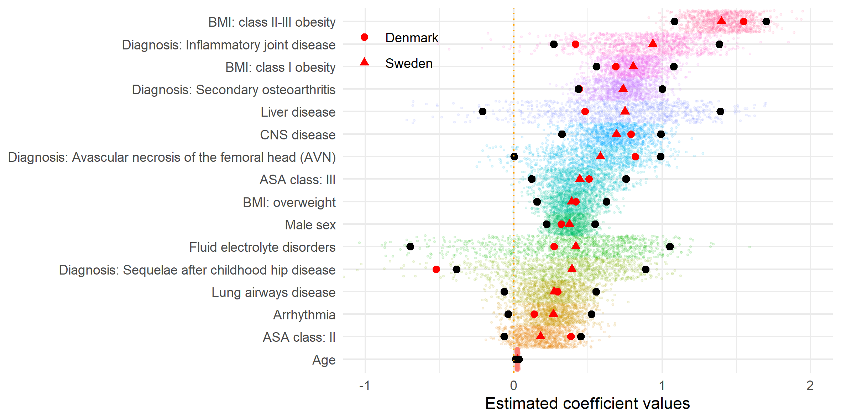

Figure 7: Estimated coefficient values for the reduced model applied to the Swedish (red triangles) and Danish cohorts (red dots). Small coloured dots are empirical estimates from 1000 subsamples based on the Swedish data set, of the same sample size as used in the Danish validation cohort (outliers not shown). Black dots indicate the outer limits of 95 % empirical confidence intervals. The Danish estimates almost always fall within those CIs.