Prediction of Periprosthetic Joint Infection after Total Hip Arthroplasty: a simplified and externally validated model based on observational registry data from Sweden and Denmark

Erik Bulow,1,2 Alma Besic Pedersen,3 Ina Trolle Andersen,4 Ola Rolfson,1,2 Nils P. Hailer5

2020-10-01

1. The Swedish Hip Arthroplasty Register, Gothenburg, Sweden
2. Department of Orthopaedics, Institute of Clinical Sciences, The Sahlgrenska Academy, University of Gothenburg, Gothenburg, Sweden
3. Department of Clinical Medicine - Department of Clinical Epidemiology, Aarhus university, Aarhus, Denmark
4. XXX, Denmark
5. Department of Orthopaedics, Institute of Surgical Sciences, Uppsala University Hospital, Uppsala, Sweden

**Correspondance:** [erik.bulow@vgregion.se](mailto:erik.bulow@vgregion.se); +46 70 08 234 28; Svenska Hoftprotesregistret, Registercentrum Vastra Gotaland, SE-413 45, Sweden

# Note!

Most text in the article is automatically generated! Bold text is not! It is thus possible that this text does not correspond to the rest! It must be updated manually!

##### PAGE BREAK

# Abstract

**OJECTIVE:** Periprosthetic joint infection (PJI) after total hip arthroplasty (THA) is a devastating complication with enormous impact on mortality, quality of life, and healthcare resources. Previous attempts at developing risk calculators are hampered by poor predictive performance of the proposed models or a lack of external validation, and no model is derived on a European population. We thus developed a parsimonious model to predict PJI within 90 days and two years after elective THA.

**PARTICIPANTS AND METHODS:** We analysed 88,830 patients recorded in the Swedish Hip Arthroplasty Register 2008-2015 and obtained data on comorbidities and socioeconomic background variables from the National Patient Register and Statistics Sweden. Logistic least absolute shrinkage and selection operator (LASSO) regression was applied to develop prediction models for PJI within 90 days or two years after surgery. Models were internally validated by bootstrapping and externally validated on a cohort of **XXX** patients from **XXX**. We assessed model performance by analysing the area under the receiver operation characteristics curve (AUC) and by calibration belt plots.

**RESULTS:** The crude incidence rate of PJI after THA was 2.35 % within 90, days and 3.39 % within two years in the Swedish derivation cohort. A prediction model for PJI within 90 days combined the underlaying diagnosis for THA, body mass index, ASA class, gender, and the precense of CNS disease, fluid electrolyte disorders, osteoporosis pagets or psoriasis, resulting in an AUC = 0.67 (95 % CI: 0.65 to 0.68) internally and **(AUC=XXX, 95% CI: XXX to XXX)** externally. A model for PJI within two years had similar performance internally (AUC = 0.66, 95 % CI: 0.65 to 0.67) and externally **XXX (95% CI: XXX to XXX)**. These models were superior to traditional models based on the American Society for Anesthesiologists (ASA) classification (AUC = 0.59, 95 % CI: 0.58 to 0.60), Charlson (AUC = 0.56, 95 % CI: 0.55 to 0.57), Elixhauser (AUC = 0.58, 95 % CI: 0.57 to 0.60), and the Rx Risk V (AUC = 0.58, 95 % CI: 0.57 to 0.59) comorbidity indices.

**CONCLUSION:** The proposed prediction models for PJI after THA are relatively parsimonious since they are based on easily accessible clinical data, and they are superior to predictions based on ASA class or more complex comorbidity indices. Our web-based calculator could simplify the individualized assessment of the risk of developing PJI prior to THA surgery and enable risk-stratified patient management.

##### PAGE BREAK

# Introduction

Periprosthetic joint infection (PJI) is the most devastating of early complications after total hip arthroplasty (THA), mainly due to its severity in terms of increased mortality, the required number of re-operations, long-term antibiotic treatment, and often persistently impaired quality of life.1–3 Many risk factors for the development of PJI are identified, with anemia, diabetes, and obesity being important, to some extent modifiable risk factors, whereas advanced age and male gender are examples of non-modifiable risk factors.4–12 Individualized PJI risk stratification would be a highly desirable tool in the pre-operative assessment of patients scheduled for THA, but established measures of comorbidity such as the American Society for Anesthesiologists (ASA) classification or considerably more complex comorbidity indices cannot be used in this context. Although high ASA class is a risk factor associated with development of PJI, this classification is imprecise, and it was never developed for the purpose of predicting this specific complication.13,14 The Charlson15 and Elixhauser16 comorbidity indices are based on 17 or 31 conditions according to the International Classification of Diseases (ICD), respectively, but they are cumbersome to use in a clinical setting, and they were also not designed for prediction of specific adverse events after THA. The same is true for the Rx Risk V-classification with 46 conditions codified along the Anatomical Therapeutic Chemical (ATC) Classification.17,18 Several attempts have been made at developing individualized risk prediction models for clinical usage, with the Universal American College of Surgeons National Surgical Quality Improvement Program (ACS NSQIP) Surgical Risk Calculator being one of the first.19,20 Several other risk calculators for the risk of PJI after THA have since been derived on US or Australian cohorts, but none has gained general acceptance.20–22 This is mainly due to often limited, sometimes single-center based samples, low discriminative ability or low accuracy of the prediction models, or the absence of external model validation. Thus, there is an urgent need for improved prediction models of PJI. We therefore developed a prediction model of PJI within 90 days or two years after THA that is based upon easily accessible data that are available in the setting of clinical decision-making.

# Patients and Methods

We used data from the Swedish Hip Arthroplasty Register (SHAR) for model derivation and internal validation of discrimination and calibration. The best models were then validated externally on a cohort from the **XXX**.

## Derivation cohort (Sweden)

The derivation cohort was obtained from patients recorded in the SHAR 2008-2015. The starting point was chosen because registration of ASA class and body mass index (BMI) in the SHAR was initiated in 2008, and we had no access to data from the national patient register (NPR) after 2015. Data linkage was achieved by using personal identity numbers that are assigned to all Swedish residents at birth or immigration.23,24 The diagnosis underlying the index THA procedure (categorized into primary osteoarthritis, secondary osteoarthritis, sequelae after childhood hip disease, avascular necrosis of the femoral head [AVN] and inflammatory joint disease), type of fixation (cemented or uncemented stem and cup respectively), age at index surgery, sex, BMI, ASA class, type of hospital, and year of surgery, were obtained from the SHAR. Data on comorbidities for one year prior to index surgery were obtained from the NPR where diagnoses based on in- and outpatient episodes in all private and public hospitals are coded according to the ICD-10 together with admission and discharge dates. Data on marital status and the educational level of patients was obtained from the longitudinal integration database for health insurance and labor market studies (LISA) from Statistics Sweden. The SHAR has completeness of 96-98 % and 100 % coverage,25 the LISA has coverage of 98 % with 85 % accuracy, and completeness for the NPR is above 99 % and the positive predictive value is 85-95 %.26 Death dates were linked from the national population register. Only the last operated hip was considered for patients with bilateral THA.27. Patients with missing information on, or an ASA class of IV and above, were excluded, as were patients with missing information on BMI or a measurement above 50. Patients with missing information on educational levels or the type of hospital performing index surgery were also excluded.

## External validation cohort (XXX)

## Definitions of comorbidity and outcomes

The Charlson, Elixhauser and Rx Risk V comorbidity indices are based on the presence of ICD-10 and ATC codes grouped into main categories (17, 31, and 46 categories, respectively).18,28 Diagnostic categories from all indices were combined to define 34 categories of comorbidity that were chosen in order to be easily identifiable in a clinical setting (Tab. 1). Some of the combined comorbidities were observed for less than 10 patients with or without PJI, and these diagnoses were not considered as potential predictors to reduce the risk of overfitting to spurious events. PJI was defined by the occurrence of relevant ICD-10 or procedural NOMESCO-code recorded in the NPR within 90 days or 2 years (Tab. 2), or if the patient was reported to SHAR as re-operated due to infection within the same time frame.

## Model development

Model development was performed by bootstrap ranking and a logistic least absolute shrinkage and selection operator (LASSO).29,30 Age was normalized prior to modeling, and the estimated coefficients thus indicated variable importance on the same scale as categorical variables. BMI was divided into four categories based on the six intervals proposed by the World Health Organization (WHO; : under- or normal weight, : overweight, : class I obesity, : class II-III obesity).

For each outcome (PJI within 90 days or 2 years), ten-fold cross validation was performed with a range of potential penalty values (:s) in a logistic LASSO regression model. We kept the that minimized the mean cross-validated deviance. 100 bootstrap samples were then drawn from the observed data set.31

Logistic LASSO regression was performed for each sample using the chosen as penalty term. Regression coefficients were ranked based on their absolute values as a measure of variable importance. We then used Bayesian methods to estimate a posterior distribution and to identify two change points in a linear segmented piecewise regression model. The second change point was then used as a break-point. Influential predictors with absolute coefficients value above this point, scored a point. The whole process, each with 100 Bootstrap replicates, was repeated 100 times (yielding 10,000 bootstrap samples in total). Potential predictors that were selected at least once out of 100 were then used in main effects multivariable logistic regression models without penalty and without pre-normalization of numeric variables. Even more parsimonious models with potential predictors chosen at least 50 out of 100 times were evaluated for comparison. Univariable prediction models based on either ASA class, the Charlson, Elixhauser, or the Rx Risk V comorbidity indices were fitted for comparison. Odds ratios for the final models were estimated with 95 % confidence intervals.

## Model validation

Each developed model was used to predict the probability of PJI within 90 days or two years for patients derived from the SHAR (internal validation). Receiver operating characteristic (ROC) curves and their corresponding areas under those curve (AUC) were used to describe discrimination with 95 % confidence intervals that were based on percentiles from 2,000 non-parametric bootstrap samples. The bias-corrected Somers’ rank correlation based on 100 resamples was used to adjust for optimism, but the correction for optimism only affected the third decimals in the presented results, and will therefore not be further discussed. Predicted probabilities and observed proportions were plotted with 95 % confidence intervals to graphically assess model calibration.32 The derived models were externally validated on a **XXX** cohort, and re-calibration of model intercepts was performed to account for different PJI incidences in Sweden compared to **XXX**. Calibration for this re-calibrated model was illustrated in the same calibration belt plot as after internal calibration.

## Statistical tools

We built an online web calculator available at https **XXX** to be used in clinical practice. R software (version 3.6.1; R Foundation for Statistical Computing, Vienna, Austria) with significant packages tidyverse, tidymodels, furrr, pROC, decoder, coder and shiny were used.

## Ethical approval

Ethical approval for this study was obtained from the Regional Ethical Review Board in Gothenburg (360-13) and **XXX**.

# Results

## Study participants

We included 88,830 patients (43.54 % males) with a mean age of 68 (SD = 11) years in the derivation cohort from the SHAR (Fig. 1, left panel). 2.35 % (n = 2089) of the patients developed a PJI within 90 days, and 3.39 % (n = 3009) within 2 years (Tab. 3). The proportion of patients with ASA class III was 17 % (n = 14,945); 24 % (n = 21,393) had at least one comorbidity according to the Charlson comorbidity index, 43 % (n = 38,617) according to Elixhauser index, and 71 % (n = 62,874) had medications classified according to Rx Risk V. In addition, **XXX** patients from **XXX** were included as an external validation cohort (Fig. 1, right panel).

## Model development and internal validation

Patients with hyperkalaemia, malnutrition and weight loss were uncommon, wherefore those comorbidities were excluded as potential predictors prior to further modeling. ROC-curves (Fig. 2) and AUC-values (Fig. 3) for the main and reduced models were very similar, and for simplicity, we therefore focused on the reduced models. Estimated probability density curves for patients with and without PJI were partially overlapping, although patients with PJI had on average higher predicted probabilities for this outcome (Fig. 4).

The reduced model for the prediction of PJI within 90 days in the Swedish cohort included the underlaying diagnosis for THA, body mass index, ASA class, gender, and the precense of CNS disease, fluid electrolyte disorders, osteoporosis pagets or psoriasis (Tab. 5). This reduced model for the predicition of PJI within 90 days had an AUC = 0.67 (95 % CI: 0.65 to 0.68), whereas ASA class (AUC = 0.59, 95 % CI: 0.58 to 0.60), the Charlson comorbidity index (AUC = 0.56, 95 % CI: 0.55 to 0.57), the Elixhauser comorbidity index (AUC = 0.58, 95 % CI: 0.57 to 0.60), and Rx Risk V (AUC = 0.58, 95 % CI: 0.57 to 0.59) had less discriminative ability (Fig. 2 and 3). The reduced model had good accuracy as visualized by the calibration plot (Fig. 5, left panel).

The reduced model for PJI within two years included the same predictors, with the addition of the precense of cancer, drug alcohol abuse, liver disease, pancreatic insufficiency or rheumatic disease (Tab. 5). Predictors conferring a statistically significant risk increase were those **mentioned as predictive for PJI within 90 days, excluding osteoporosis or Paget’s disease, and additionally included an underlying diagnosis of AVN or inflammatory joint disease, and the presence of CNS disease**. The reduced model for the prediction of PJI within two years had an AUC = 0.66 (95 % CI: 0.65 to 0.67), whereas ASA class (AUC = 0.59, 95 % CI: 0.58 to 0.60), the Charlson comorbidity index (AUC = 0.56, 95 % CI: 0.56 to 0.57), the Elixhauser comorbidity index (AUC = 0.58, 95 % CI: 0.57 to 0.60), and Rx Risk V (AUC = 0.58, 95 % CI: 0.57 to 0.59) again had less discriminative ability (Fig. 2 and 3). Calibration was good for the reduced model (Fig. 5, right panel).

## External validation

XXX

# Discussion

## Principal findings

We found that a multivariable main effects logistic regression model based on some easily identifiable clinical conditions, gender, and BMI was considerably better at predicting PJI within 90 days after THA than models based on either ASA class or the Charlson, Elixhauser or Rx Risk V comorbidity indices. A similarly developed model to predict PJI within two years included similar predictors as the model developed to predict PJI within 90 days, but added the precense of cancer, drug alcohol abuse, liver disease, pancreatic insufficiency or rheumatic disease to the list of predictor variables. This model also performed better than the established comorbidity measures in terms of AUC and calibration.

## Clinical usage

Since the prediction models both for PJI within 90 days and within two years were based on easily accessible information they can be translated into a simple formula where is the estimated probability, and are the estimated intercept and coefficients (Tab. 5) and are corresponding patient characteristics. For example, a female with normal BMI, primary osteoarthritis and no co-morbidities would have a probability of 1.1 % for PJI within 90 days; a male with overweight, secondary osteoarthritis, proriasis, dementia (CNS disease) and ASA class III would have a probability of 16.7 %.

## Model predictors

The predictors in our models were chosen based on a strict analytical approach, not on proposed relevance of patient or procedure characteristics. The majority of the identified predictor variables are however associated with the risk of developing PJI in previously developed prediction models and within the setting of observational studies, which is supportive of our own models.

Patients with primary osteoarthritis seem less prone to developing PJI than patients receiving THA for other reasons, and in agreement with previous observational data we found that both AVN and secondary osteoarthritis conferred a nearly two-fold increased risk of PJI in our prediction models.33,34 Rheumatoid arthritis as the diagnosis underlying THA surgery is pointed out as a risk factor for PJI,9,22 and this predictor variable was statistically significance in our model of PJI within two years.

Obesity is associated with an increase in the risk of reoperations or adverse events after THA35 and with the risk of developing surgical site infections or PJI after total hip or knee arthroplasty.6,10,12,36 Obesity is identified as a risk factor for PJI in a risk calculator derived on two independent US institutional cohorts, which agrees with our identification of obesity as a predictor variable in both models.37 In accordance with observational studies10 we found the presence of CNS diseases to be a predictor of PJI within two years, and our rather broad category encompasses both cerebrovascular disease, dementia, hemiplegia, and Parkinson’s disease which were all associated with a risk increase in the cited study.

Male gender is associated with an increased risk of developing PJI after arthroplasty surgery,34 and gender is included as a predictor variable in several previously developed risk calculators.20,37 Patients with liver cirrhosis are described to have a more than doubled risk of suffering from PJI within one year after THA, supporting our finding of the presence of liver diseases among our predictor variables.38Taken together, the above cited findings support that the predictor variables in our models seem to be relevant in the context of predicting PJI.

Some previously mentioned risk factors for developing PJI were not selected during our model development. High ASA class is frequently associated with an increased risk of PJI,14,39,40 as are comorbidity in a broader sense, and, more specifically, the presence of cardiovascular comorbidity.7,41 In contrast, we found that ASA class alone was an insufficient predictor of PJI, and none of the cardiovascular disease categories remained as a predictor variable in our final main model.

Cancer seems to confer an increased risk of PJI in several observational studies,9,36,42 and it is one of the defined comorbidities in the ACS NSQIP Surgical Risk Calculator,20 20 but this comorbidity did not reach statistical significance in our models.

THA fixation using cement without antibiotics confers an increased risk of PJI,34 but such cement brands were not in clinical use in Sweden during the studied period. We found no indication that the type of fixation was associated with the risk of PJI, and this variable was also not selected as a potential predictor variable in any of the iterations during model development.

Although mentioned as risk factors for surgical site infections after joint arthroplasty,11,22 prediction models based on the comorbidity indices developed by Charlson or Elixhauser and the RxRisk V index alone, resulted in poor predictive power. This agrees with previous findings describing that these measures of comorbidity rather poorly predict mortality and patient reported outcomes after THA.43,44

## Strengths and limitations

Our study is hampered by the limitations inherent to observational research, such as misclassification, and residual confounding due to known confounders that we had no information on, or due to unknown confounders. Importantly, some previously identified risk factors for PJI were not included in our models, mostly because we lacked detailed information on laboratory findings and non-prescribed medications.

The presence of diabetes was not among the predictor variables selected in our models, although it was almost double as frequent among patients with PJI than among those without (data not shown). This is in disagreement with numerous observational studies describing an increased risk of developing PJI after both THA or total knee arthroplasty,8,12,36 and diabetes is also found among the risk factors in previously developed risk calculators.20,37,45 On the other hand, diabetes is not consistently found to be associated with the risk of surgical site infection or PJI after THA surgery.40 Peri-operative hyperglycemia is a predictor of PJI after total joint replacement of the hip or knee, and information on laboratory parameters such as morning blood glucose or HBA1c could have improved the predictive power of our models, but we had no access to such information.46,47 In analogy, low preoperative hemoglobin is associated with the risk of developing surgical site infection,11 but although we had access to the ICD codes defining the presence of anemia, we had no information on actual laboratory findings. Use of TNF-a blockers may be associated with the risk of developing PJI.48,49 Similarly, intra-articular steroid application may enhance this risk,50 but injections given by physicians would not necessarily be identifiable within a Swedish registry setting. Operating times, or, in the case of knee surgery, tourniquet times, are associated with the risk of PJI after hip or knee joint replacement,12,51 and procedure time is one of the risk factors in the Mayo PJI risk score,14 but we had no information on this potentially important parameter. The question of what other variables might be needed to further refine prediction models remains open, but information that is notoriously difficult to obtain within the setting of large register studies, such as smoking status, might be of value.

Taken together, the inclusion of some or all of the variables mentioned above – unfortunately unavailable to us – might improve the predictive power of PJI risk assessment models.

## Conclusion

Our results indicate that the risk of PJI after THA can be pre-operatively assessed by a parsimonious prediction model. We hope that this model, with its accompanying web calculator, will facilitate shared decision-making between physicians and their patients in need of THA.

##### Page break

# Contribution of authors

NPH initiated the study, OR managed the ethical review board application in Sweden, EB developed the statistical model, **XXX** performed external validation with data from **XXX**. NPH and EB drafted, and all authors edited and finalized the manuscript.

# Competing interest statement

All authors have completed the ICMJE uniform disclosure form at www.icmje.org/coi_disclosure.pdf and declare …

# Transparency Statement

NH, the principal investigator of this study, affirms that this is an accurate report with no relevant data or aspects omitted.

# Public and patient involvement statement

There is a patient representative at SHAR to ensure the patients’ interests are respected in planned research.

# Data sharing statement

Data is available upon reasonable request to the principal investigator.

# Acknowledgement

We would like to thank .

##### PAGE BREAK

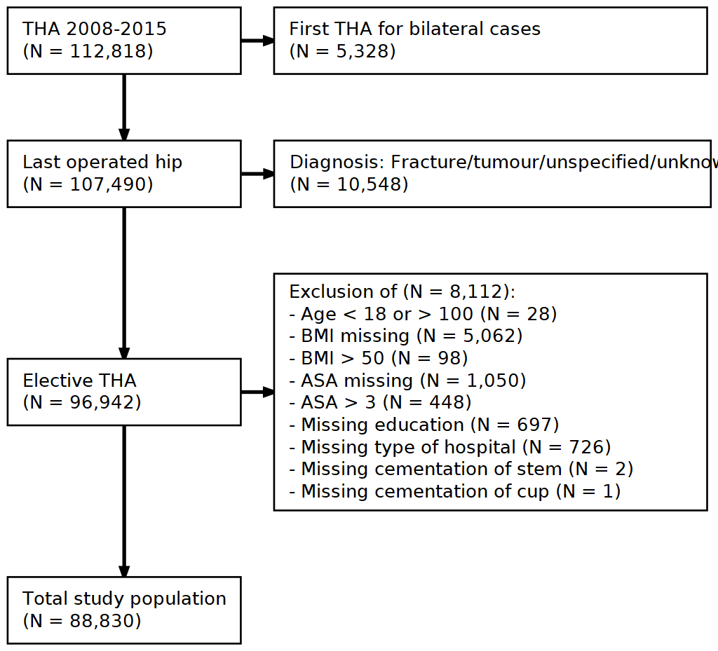

Figure 1: Flowchart with inclusion criteria and number of patients. Data from the Swedish Hip Arthroplasty Register were used for model derivation and internal validation (left). Data from XXX were used for external validation (right).

##### PAGE BREAK

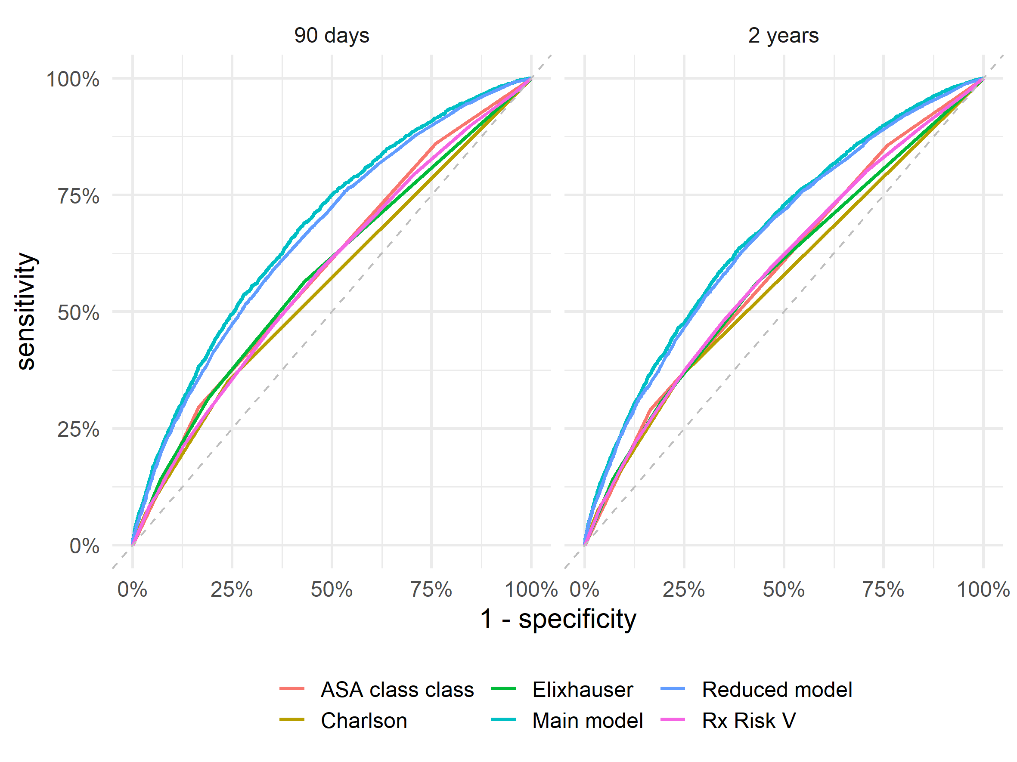

Figure 2: Receiver Operation Characteristics (ROC) curves combines sensitivity and specificity tp illustrate discriminative abilities of the different models. The reduced model perform almost as good as the main model for prediction of PJI within 90 days after surgery, and as good for PJI within 2 years.

##### PAGE BREAK

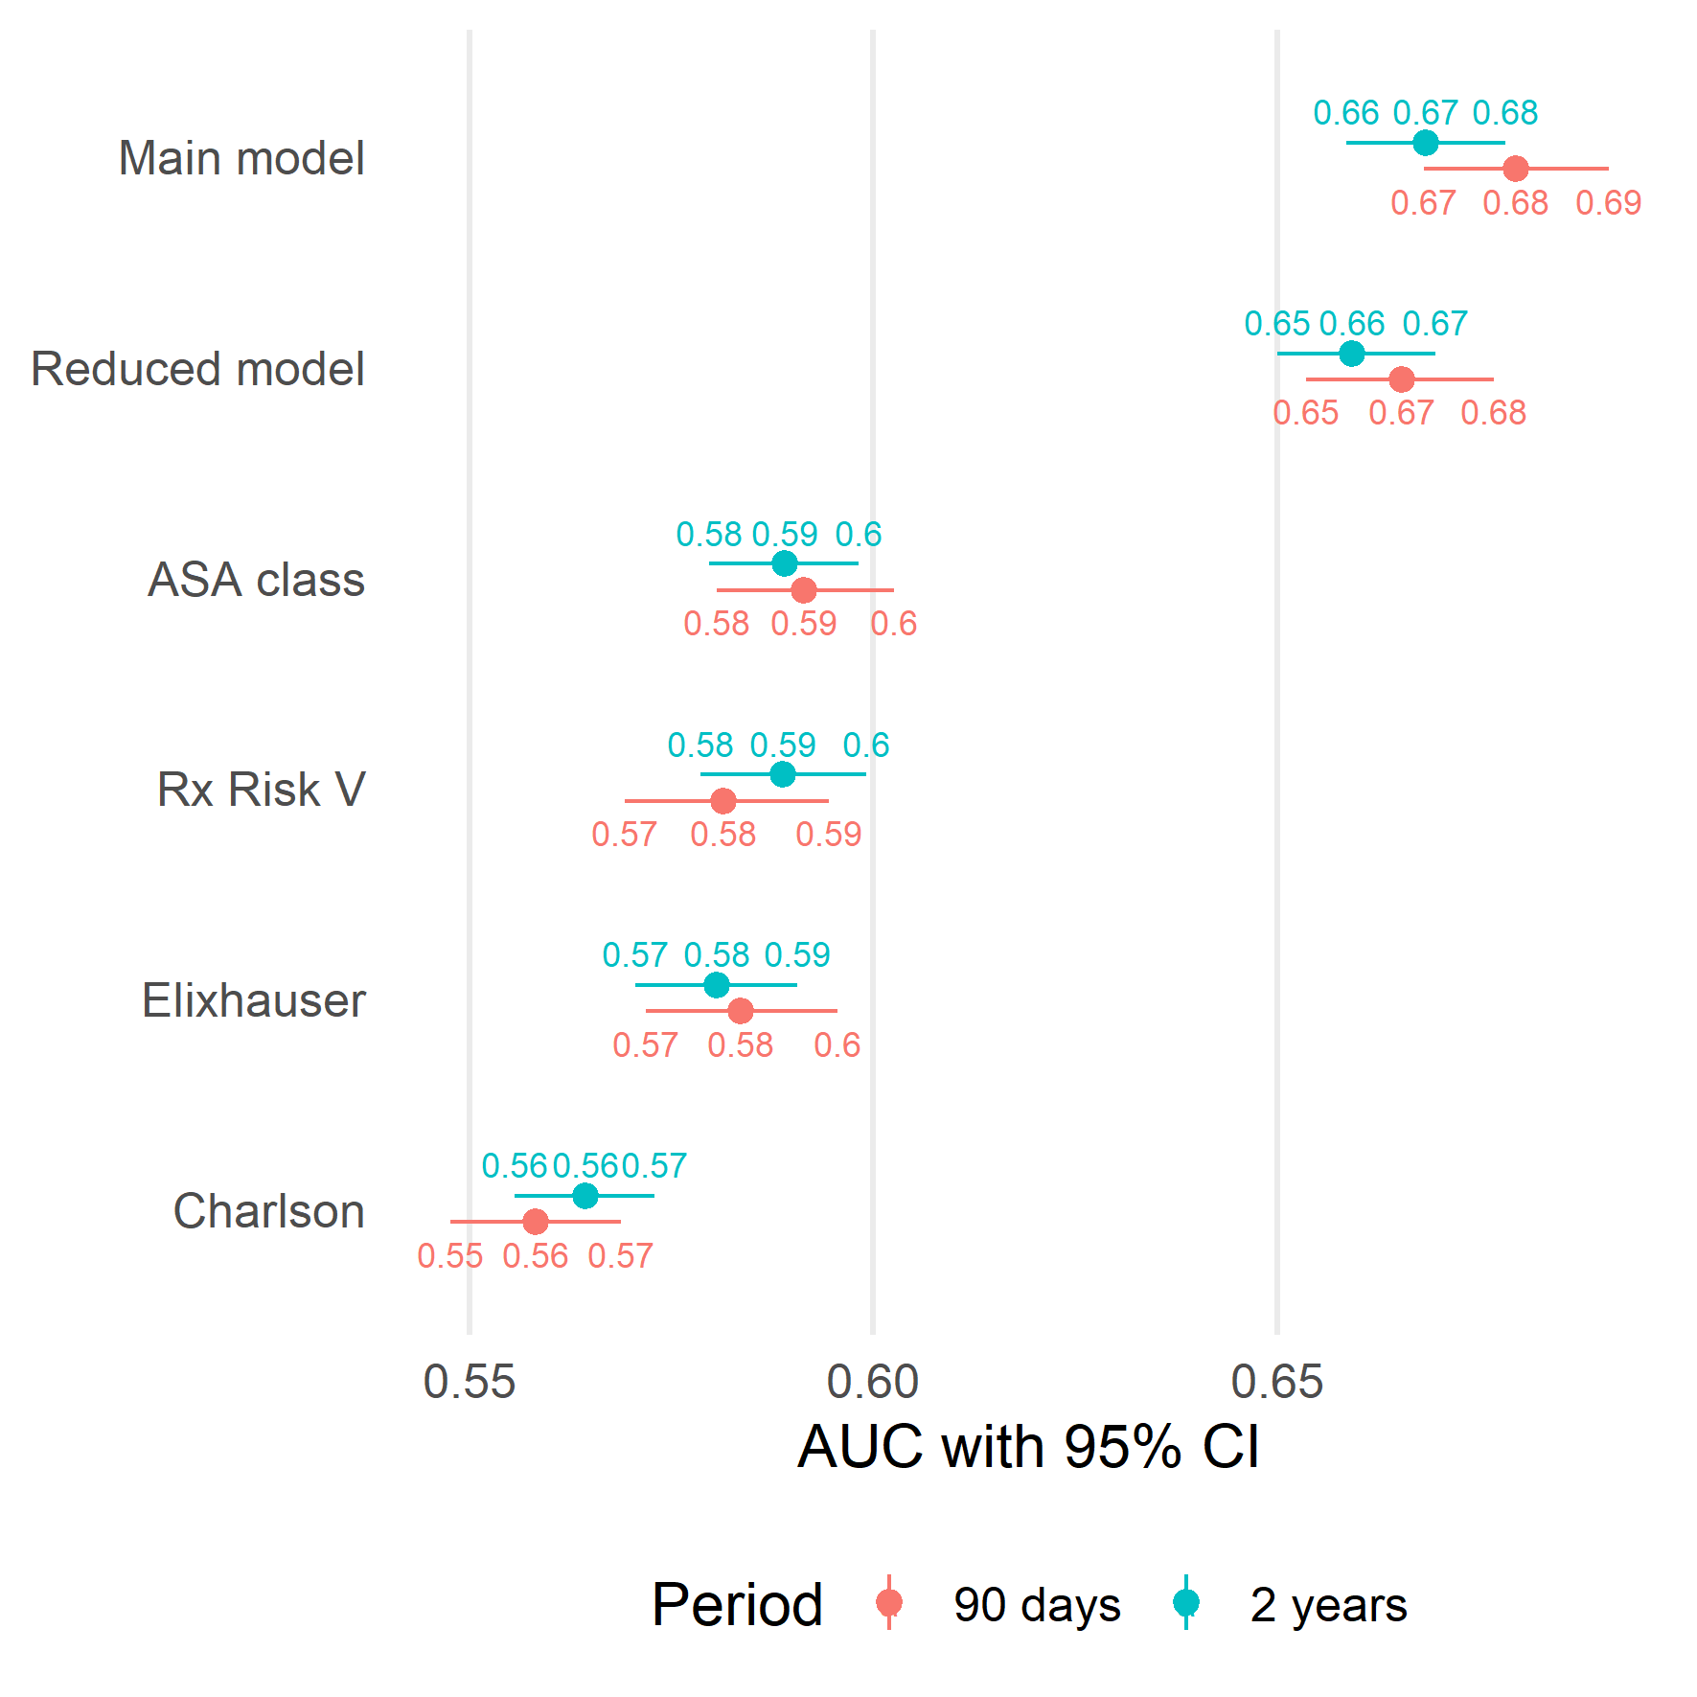

Figure 3: Area Under the Receiver Operation Characteristics Curve (AUC) as a measure of predictive discriminative ability with 95 % bootstrap confidence intervals. The reduced model performs no different than the main model, but both of these perform better than traditional comorbidity measures alone.

##### PAGE BREAK

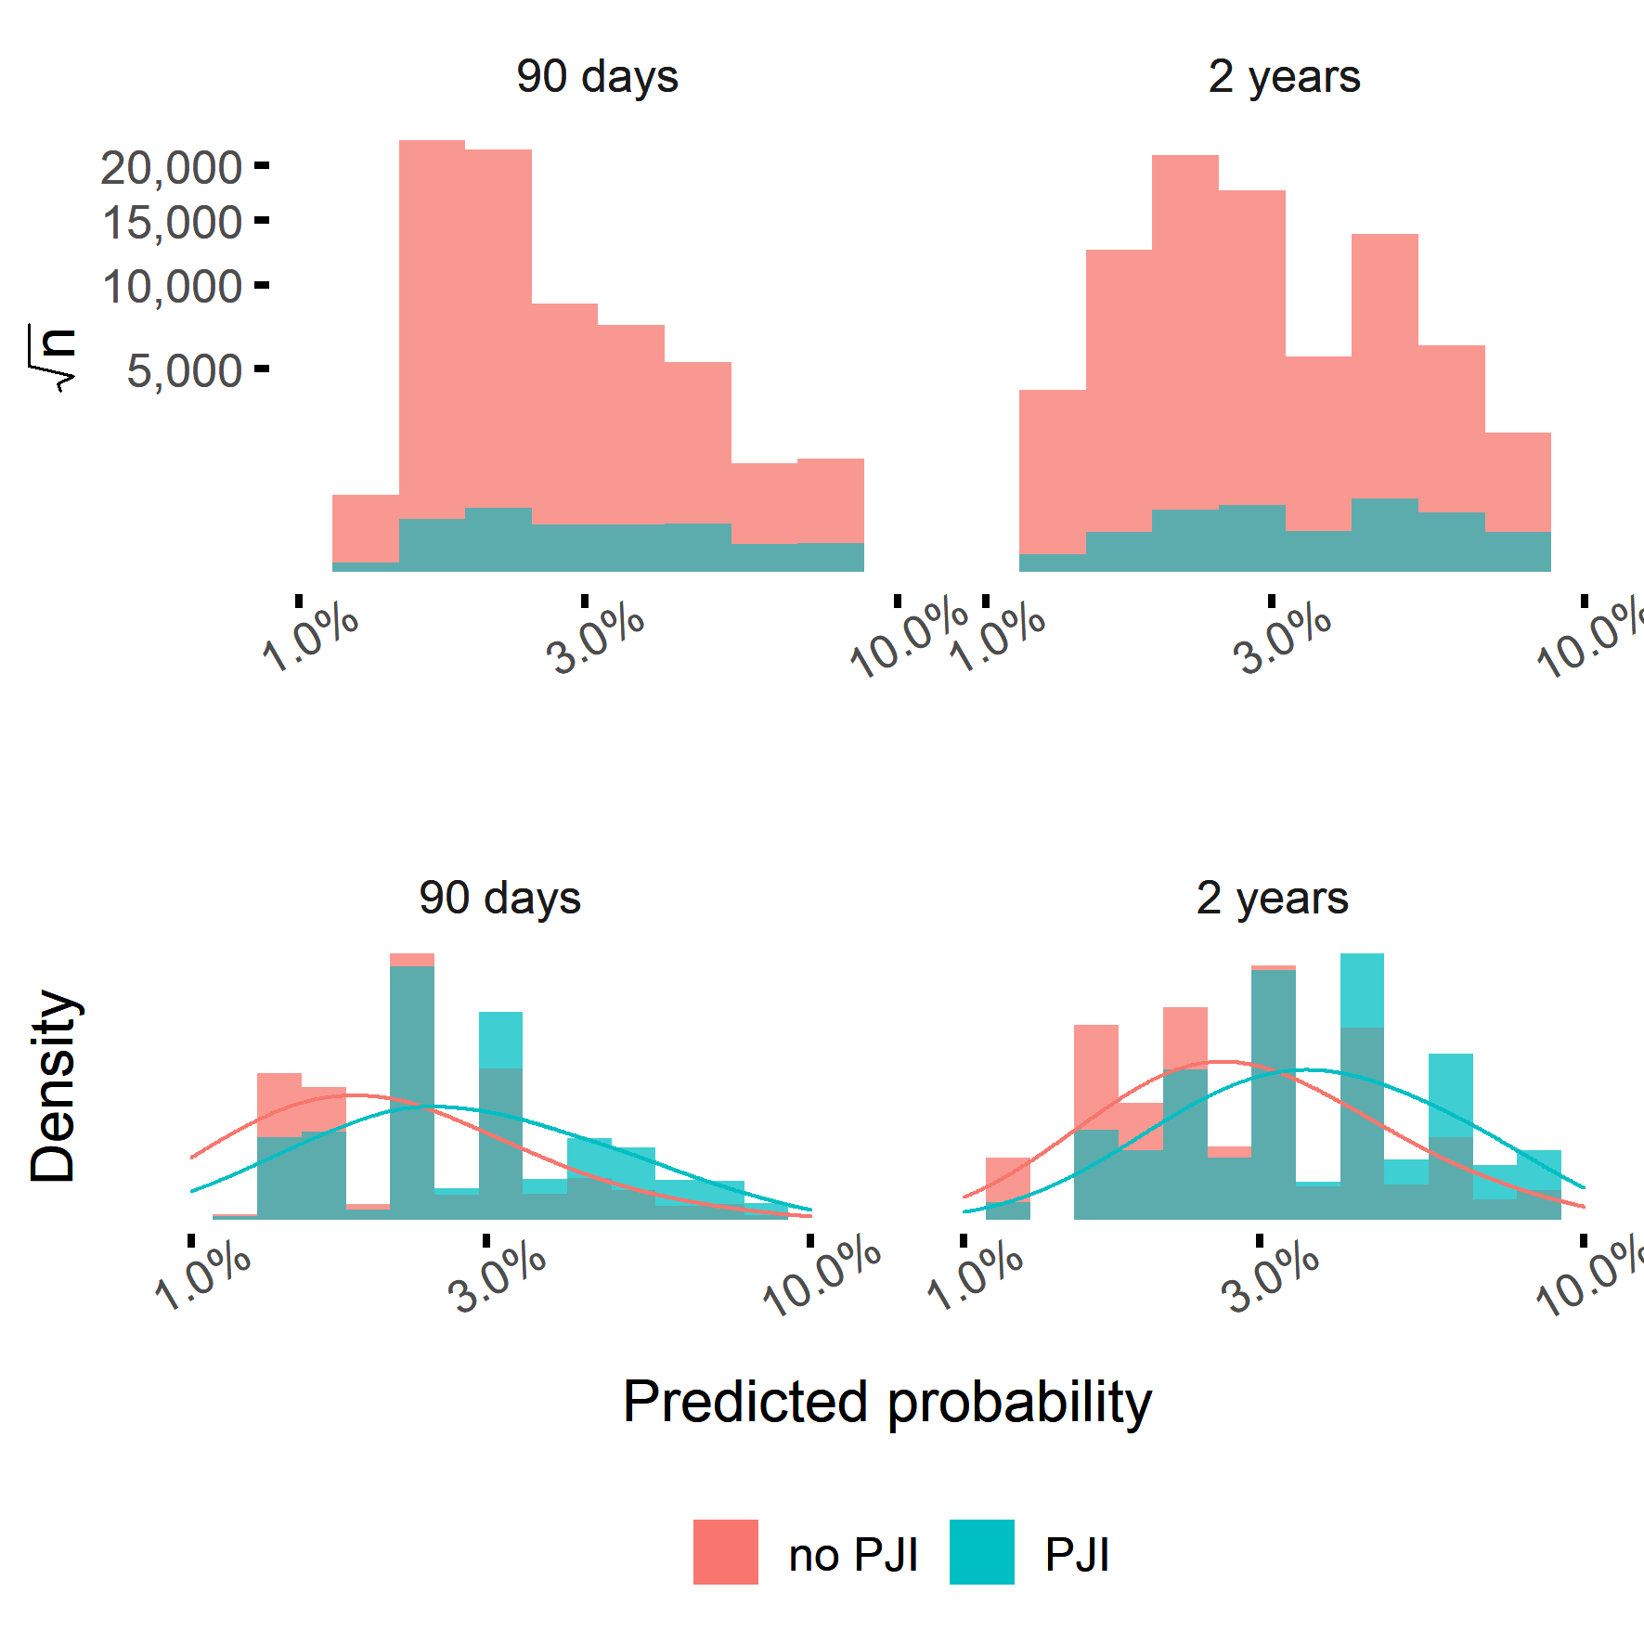

Figure 4: The vast majority of patients did not have PJI. Hence, the blue bars dominates the histograms (upper panels; note the scales). Normalized density plots reveals however, that patients with PJI had, on average, higher estimated probabilities for this adverse event (lower panels).

##### PAGE BREAK

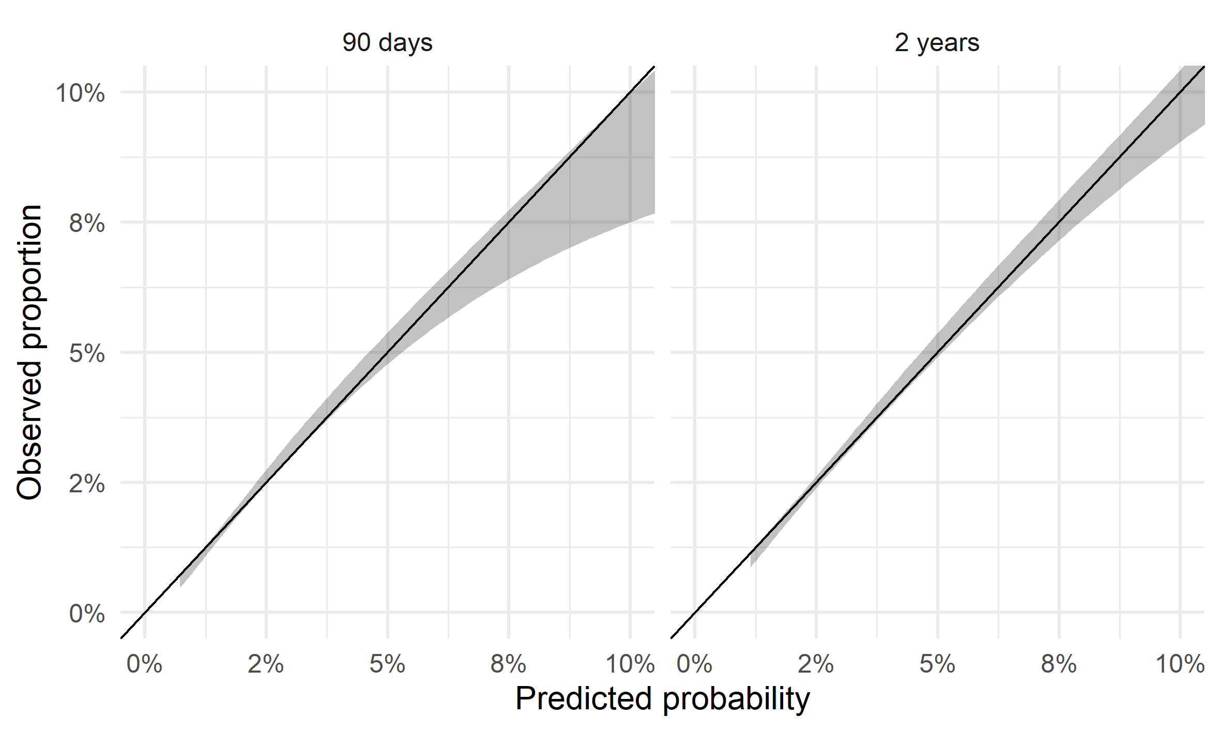

Figure 5: This figure illustrates calibration between observed proportions and predicted probabilities with 95 % confidence intervals. Calibration is good for predictions up to 5 %, although higher probabilities tend to over-estimate the observed outcome.

##### PAGE BREAK

Table 1: Categorization of comorbidities from the Charlson, Elixhauser and Rx RIsk V comorbidities. (CNS = central nervous system.)

|  |  |  |  |
| --- | --- | --- | --- |
| Comorbidities by groups | Charlson | Elixhauser | Rx |
| AIDS/HIV | Aids/hiv | Aids/hiv | Hiv |
| Allergies |  |  | Allergies |
| Anemia |  | Blood loss anemia, Deficiency anemia |  |
| Arrhythmia |  | Cardiac arrhythmias | Arrhythmia |
| Arterial hypertension |  | Hypertension uncomplicated, Hypertension complicated | Hypertension |
| Benign prostatic hyperplasia |  |  | Benign prostatic hyperplasia |
| Cancer | Malignancy, Metastatic solid tumor | Lymphoma, Metastatic cancer, Solid tumor | Malignancies |
| CNS disease | Dementia, Hemiplegia or paraplegia | Depression, Paralysis, Other neurological disorders, Psychoses | Dementia, Depression, Anxiety, Bipolar disorder, Epilepsy, Migraine, Parkinson s disease, Psychotic illness |
| Coagulopathy |  | Coagulopathy |  |
| Diabetes | Diabetes without complication, Diabetes complication | Diabetes uncomplicated, Diabetes complicated | Diabetes |
| Drug alcohol abuse |  | Alcohol abuse, Drug abuse | Alcohol dependence |
| Fluid electrolyte disorders |  | Fluid electrolyte disorders |  |
| Glaucoma |  |  | Glaucoma |
| Gout |  |  | Gout |
| Heart condition | Congestive heart failure | Congestive heart failure, Valvular disease | Congestive heart failure |
| Myocardial infarction | Myocardial infarction |  | Ischemic heart disease angina, Ischaemic heart disease hypertension |
| Hyperkalaemia |  |  | Hyperkalaemia |
| Hyperlipidaemia |  |  | Hyperlipidaemia |
| Hypothyroidism |  | Hypothyroidism | Hyperthyroidism |
| Kidney disease | Renal disease | Renal failure | Renal disease |
| Liver disease | Mild liver disease, Moderate or severe liver disease | Liver disease | Liver failure, Hepatitis c |
| Lung airways disease | Chronic pulmonary disease | Chronic pulmonary disease, Pulmonary circulation disorder | Smoking cessation, Chronic airways disease, Tuberculosis |
| Malnutrition |  |  | Malnutrition |
| Obesity |  | Obesity |  |
| Osteoporosis pagets |  |  | Osteoporosis paget s |
| Pain |  |  | Pain |
| Pancreatic insufficiency |  |  | Pancreatic insufficiency |
| Peptic ulcer | Peptic ulcer disease | Peptic ulcer disease | Gastrooesophageal reflux disease, Irritable bowel syndrome |
| Psoriasis |  |  | Psoriasis |
| Rheumatic disease | Rheumatic disease | Rheumatoid arthritis |  |
| Steroid responsive diseases |  |  | Steroid responsive disease |
| Transplant |  |  | Transplant |
| Vascular disease | Peripheral vascular disease, Cerebrovascular disease | Peripheral vascular disorder | Anticoagulants, Antiplatelets |
| Weight loss |  | Weight loss |  |

##### PAGE BREAK

Table 2: Codes identifying infection if recorded in the national patient register within 90 days or 2 years after THA respectively.

|  |  |
| --- | --- |
| classification | codes |
| ICD-10 | M000, M000F, M001, M002, M002F, M008, M008F, M009, M009F, M860F, M861F, M866, M866F, T814, T845, T845F, T845X, T847, T847F |
| NOMESCO | NFS09, NFS19, NFS29, NFS39, NFS49, NFS59, NFS99 |

##### PAGE BREAK

Table 3: Patient characteristics in the model derivation cohort. Educational levels were classified as low (up to 9 years), middle (10-12 years) and high (at least 12 years). BMI = Body mass index. ASA class = American Society for Anesthesiologists classification. CNS = central nervous system.

|  |  |  |  |  |  |  |
| --- | --- | --- | --- | --- | --- | --- |
| what | level | PJI < 90 days | No PJI < 90 days | PJI < 2 years | No PJI < 2 years | Total |
| n |  | 2089 | 86741 | 3009 | 85821 | 88830 |
| Age (mean (SD)) |  | 70.28 (11.28) | 68.39 (10.71) | 69.71 (11.07) | 68.39 (10.71) | 68.44 (10.73) |
| Sex = Male (%) |  | 1076 (51.5) | 37603 (43.4) | 1550 (51.5) | 37129 (43.3) | 38679 (43.5) |
| BMI (%) |  |  |  |  |  |  |
|  | Under/normal weight | 457 (21.9) | 28974 (33.4) | 709 (23.6) | 28722 (33.5) | 29431 (33.1) |
|  | Overweight | 837 (40.1) | 37306 (43.0) | 1212 (40.3) | 36931 (43.0) | 38143 (42.9) |
|  | Class I obesity | 517 (24.7) | 15707 (18.1) | 730 (24.3) | 15494 (18.1) | 16224 (18.3) |
|  | Class II-III obesity | 278 (13.3) | 4754 ( 5.5) | 358 (11.9) | 4674 ( 5.4) | 5032 ( 5.7) |
| ASA class (%) |  |  |  |  |  |  |
|  | I | 292 (14.0) | 20795 (24.0) | 430 (14.3) | 20657 (24.1) | 21087 (23.7) |
|  | II | 1179 (56.4) | 51619 (59.5) | 1705 (56.7) | 51093 (59.5) | 52798 (59.4) |
|  | III | 618 (29.6) | 14327 (16.5) | 874 (29.0) | 14071 (16.4) | 14945 (16.8) |
| Diagnosis (%) |  |  |  |  |  |  |
|  | Primary osteoarthritis | 1706 (81.7) | 76872 (88.6) | 2465 (81.9) | 76113 (88.7) | 78578 (88.5) |
|  | Secondary osteoarthritis | 213 (10.2) | 5058 ( 5.8) | 293 ( 9.7) | 4978 ( 5.8) | 5271 ( 5.9) |
|  | Sequelae after childhood hip disease | 41 ( 2.0) | 1821 ( 2.1) | 54 ( 1.8) | 1808 ( 2.1) | 1862 ( 2.1) |
|  | Avascular necrosis of the femoral head (AVN) | 73 ( 3.5) | 1822 ( 2.1) | 109 ( 3.6) | 1786 ( 2.1) | 1895 ( 2.1) |
|  | Inflammatory joint disease | 56 ( 2.7) | 1168 ( 1.3) | 88 ( 2.9) | 1136 ( 1.3) | 1224 ( 1.4) |
| Cemented stem (%) |  | 1536 (73.5) | 59841 (69.0) | 2168 (72.1) | 59209 (69.0) | 61377 (69.1) |
| Cemented cup (%) |  | 1670 (79.9) | 68216 (78.6) | 2390 (79.4) | 67496 (78.6) | 69886 (78.7) |
| Hospital (%) |  |  |  |  |  |  |
|  | University | 747 (35.8) | 33191 (38.3) | 1068 (35.5) | 32870 (38.3) | 33938 (38.2) |
|  | County | 815 (39.0) | 28405 (32.7) | 1121 (37.3) | 28099 (32.7) | 29220 (32.9) |
|  | Rural | 307 (14.7) | 17418 (20.1) | 482 (16.0) | 17243 (20.1) | 17725 (20.0) |
|  | Private | 220 (10.5) | 7727 ( 8.9) | 338 (11.2) | 7609 ( 8.9) | 7947 ( 8.9) |
| Education (%) |  |  |  |  |  |  |
|  | Low | 440 (21.1) | 22220 (25.6) | 637 (21.2) | 22023 (25.7) | 22660 (25.5) |
|  | Middle | 786 (37.6) | 28537 (32.9) | 1109 (36.9) | 28214 (32.9) | 29323 (33.0) |
|  | High | 863 (41.3) | 35984 (41.5) | 1263 (42.0) | 35584 (41.5) | 36847 (41.5) |
| Civil status (%) |  |  |  |  |  |  |
|  | Married | 1094 (52.4) | 48039 (55.4) | 1596 (53.0) | 47537 (55.4) | 49133 (55.3) |
|  | Single | 620 (29.7) | 25310 (29.2) | 906 (30.1) | 25024 (29.2) | 25930 (29.2) |
|  | Widow/widower | 375 (18.0) | 13392 (15.4) | 507 (16.8) | 13260 (15.5) | 13767 (15.5) |
| Charlson (%) |  |  |  |  |  |  |
|  | 0 | 1358 (65.0) | 66079 (76.2) | 1930 (64.1) | 65507 (76.3) | 67437 (75.9) |
|  | 1 | 404 (19.3) | 12300 (14.2) | 577 (19.2) | 12127 (14.1) | 12704 (14.3) |
|  | 2 | 183 ( 8.8) | 5471 ( 6.3) | 277 ( 9.2) | 5377 ( 6.3) | 5654 ( 6.4) |
|  | 3 | 81 ( 3.9) | 1695 ( 2.0) | 124 ( 4.1) | 1652 ( 1.9) | 1776 ( 2.0) |
|  | 4+ | 63 ( 3.0) | 1196 ( 1.4) | 101 ( 3.4) | 1158 ( 1.3) | 1259 ( 1.4) |
| Elixhauser (%) |  |  |  |  |  |  |
|  | 0 | 909 (43.5) | 49304 (56.8) | 1321 (43.9) | 48892 (57.0) | 50213 (56.5) |
|  | 1 | 517 (24.7) | 20831 (24.0) | 767 (25.5) | 20581 (24.0) | 21348 (24.0) |
|  | 2 | 363 (17.4) | 10371 (12.0) | 488 (16.2) | 10246 (11.9) | 10734 (12.1) |
|  | 3+ | 300 (14.4) | 6235 ( 7.2) | 433 (14.4) | 6102 ( 7.1) | 6535 ( 7.4) |
| RxRiskV (mean (SD)) |  | 3.61 (3.33) | 2.68 (3.09) | 3.69 (3.35) | 2.66 (3.08) | 2.70 (3.10) |
| AIDS/HIV hiv (%) |  | 31 ( 1.5) | 1330 ( 1.5) | 43 ( 1.4) | 1318 ( 1.5) | 1361 ( 1.5) |
| Allergies (%) |  | 236 (11.3) | 8372 ( 9.7) | 359 (11.9) | 8249 ( 9.6) | 8608 ( 9.7) |
| Anemia (%) |  | 20 ( 1.0) | 599 ( 0.7) | 32 ( 1.1) | 587 ( 0.7) | 619 ( 0.7) |
| Arrhythmia (%) |  | 281 (13.5) | 6571 ( 7.6) | 371 (12.3) | 6481 ( 7.6) | 6852 ( 7.7) |
| Arterial hypertension (%) |  | 1120 (53.6) | 37083 (42.8) | 1566 (52.0) | 36637 (42.7) | 38203 (43.0) |
| Benign prostatihyperplasia (%) |  | 138 ( 6.6) | 3440 ( 4.0) | 201 ( 6.7) | 3377 ( 3.9) | 3578 ( 4.0) |
| Cancer (%) |  | 143 ( 6.8) | 4053 ( 4.7) | 233 ( 7.7) | 3963 ( 4.6) | 4196 ( 4.7) |
| Cns disease (%) |  | 600 (28.7) | 17772 (20.5) | 875 (29.1) | 17497 (20.4) | 18372 (20.7) |
| Coagulopathy (%) |  | 8 ( 0.4) | 321 ( 0.4) | 15 ( 0.5) | 314 ( 0.4) | 329 ( 0.4) |
| Diabetes (%) |  | 272 (13.0) | 7865 ( 9.1) | 376 (12.5) | 7761 ( 9.0) | 8137 ( 9.2) |
| Drug alcohol abuse (%) |  | 35 ( 1.7) | 821 ( 0.9) | 58 ( 1.9) | 798 ( 0.9) | 856 ( 1.0) |
| Fluid electrolyte disorders (%) |  | 29 ( 1.4) | 505 ( 0.6) | 36 ( 1.2) | 498 ( 0.6) | 534 ( 0.6) |
| Glaucoma (%) |  | 115 ( 5.5) | 3855 ( 4.4) | 152 ( 5.1) | 3818 ( 4.4) | 3970 ( 4.5) |
| Gout (%) |  | 84 ( 4.0) | 2006 ( 2.3) | 123 ( 4.1) | 1967 ( 2.3) | 2090 ( 2.4) |
| Heart condition (%) |  | 1038 (49.7) | 35423 (40.8) | 1476 (49.1) | 34985 (40.8) | 36461 (41.0) |
| Myocardial infarction (%) |  | 931 (44.6) | 31330 (36.1) | 1302 (43.3) | 30959 (36.1) | 32261 (36.3) |
| Hyperkalaemia (%) |  | 1 ( 0.0) | 71 ( 0.1) | 3 ( 0.1) | 69 ( 0.1) | 72 ( 0.1) |
| Hyperlipidaemia (%) |  | 542 (25.9) | 19950 (23.0) | 774 (25.7) | 19718 (23.0) | 20492 (23.1) |
| Hypothyroidism (%) |  | 203 ( 9.7) | 7464 ( 8.6) | 286 ( 9.5) | 7381 ( 8.6) | 7667 ( 8.6) |
| Kidney disease (%) |  | 40 ( 1.9) | 1043 ( 1.2) | 66 ( 2.2) | 1017 ( 1.2) | 1083 ( 1.2) |
| Liver disease (%) |  | 204 ( 9.8) | 4927 ( 5.7) | 302 (10.0) | 4829 ( 5.6) | 5131 ( 5.8) |
| Lung airways disease (%) |  | 338 (16.2) | 9851 (11.4) | 484 (16.1) | 9705 (11.3) | 10189 (11.5) |
| Malnutrition (%) |  | 0 | 6 ( 0.0) | 1 ( 0.0) | 5 ( 0.0) | 6 ( 0.0) |
| Osteoporosis pagets (%) |  | 136 ( 6.5) | 3870 ( 4.5) | 184 ( 6.1) | 3822 ( 4.5) | 4006 ( 4.5) |
| Pain (%) |  | 1151 (55.1) | 40666 (46.9) | 1724 (57.3) | 40093 (46.7) | 41817 (47.1) |
| Pancreatiinsufficiency (%) |  | 10 ( 0.5) | 240 ( 0.3) | 16 ( 0.5) | 234 ( 0.3) | 250 ( 0.3) |
| Peptiulcer (%) |  | 563 (27.0) | 20594 (23.7) | 845 (28.1) | 20312 (23.7) | 21157 (23.8) |
| Psoriasis (%) |  | 33 ( 1.6) | 683 ( 0.8) | 49 ( 1.6) | 667 ( 0.8) | 716 ( 0.8) |
| Rheumatidisease (%) |  | 139 ( 6.7) | 3787 ( 4.4) | 222 ( 7.4) | 3704 ( 4.3) | 3926 ( 4.4) |
| Steroid responsive diseases (%) |  | 269 (12.9) | 8688 (10.0) | 412 (13.7) | 8545 (10.0) | 8957 (10.1) |
| Transplant (%) |  | 7 ( 0.3) | 251 ( 0.3) | 16 ( 0.5) | 242 ( 0.3) | 258 ( 0.3) |
| Vascular disease (%) |  | 874 (41.8) | 27566 (31.8) | 1234 (41.0) | 27206 (31.7) | 28440 (32.0) |
| Weight loss (%) |  | 5 ( 0.2) | 64 ( 0.1) | 5 ( 0.2) | 64 ( 0.1) | 69 ( 0.1) |

##### PAGE BREAK

Table 4: Variables selected by the bootstrap ranking procedure, and therefore kept in the main model. Variables chosen at least 33 times out of 100 were kept in the reduced model as well. (BMI = body mass index. ASA class = American Society for Anesthesiologists classification. CNS = central nervous system.)

|  |  |  |
| --- | --- | --- |
| Predictor | 90 days | 2 years |
| Psoriasis | 100 | 100 |
| BMI: class I obesity | 100 | 100 |
| BMI: class II III obesity | 100 | 100 |
| Diagnosis: Inflammatory joint disease | 100 | 100 |
| Diagnosis: Secondary osteoarthritis | 100 | 100 |
| Male gender | 98 | 98 |
| ASA class: III | 78 | 97 |
| Diagnosis: Avascular necrosis of the femoral head AVN | 98 | 97 |
| Cns disease | 77 | 95 |
| BMI: overweight | 93 | 82 |
| Cancer |  | 73 |
| Pancreatiinsufficiency | 25 | 73 |
| Drug alcohol abuse | 10 | 71 |
| Liver disease | 42 | 67 |
| Rheumatic disease |  | 54 |
| Fluid electrolyte disorders | 98 | 44 |
| Benign prostatihyperplasia | 12 | 25 |
| Pain |  | 22 |
| Lung airways disease | 7 | 20 |
| Arrhythmia | 33 | 16 |
| AIDS/HIV hiv |  | 3 |
| Osteoporosis pagets | 61 | 2 |
| Age | 24 | 1 |
| ASA class: II |  | 1 |
| Diagnosis: Sequelae after childhood hip disease | 67 |  |
| Cemented cup | 1 |  |

##### PAGE BREAK

Table 5: Estimated coefficients (beta) and odds ratios (OR) with 95 % confidence intervals for the reduced models. BMI = body mass index ("under/normal weight as baseline). CNS = central nervous system. Primary osteoarthritis was baseline for diagnosis and female was baseline for sex.

|  |  |  |  |  |  |
| --- | --- | --- | --- | --- | --- |
| time | variable | level | beta | OR 95 % CI | p |
| 90 days | (Intercept) |  | -4.92 |  |  |
|  | ASA class | I | 0.00 | (baseline) |  |
|  |  | II | 0.35 | 1.42 (1.25-1.62) | <0.01 |
|  |  | III | 0.77 | 2.16 (1.87-2.51) | <0.01 |
|  | BMI | under/normal weight | 0.00 | (baseline) |  |
|  |  | overweight | 0.37 | 1.45 (1.29-1.63) | <0.01 |
|  |  | class I obesity | 0.72 | 2.06 (1.81-2.35) | <0.01 |
|  |  | class II-III obesity | 1.21 | 3.36 (2.87-3.93) | <0.01 |
|  | Cns disease |  | 0.37 | 1.45 (1.31-1.60) | <0.01 |
|  | Diagnosis | Primary osteoarthritis | 0.00 | (baseline) |  |
|  |  | Sequelae after childhood hip disease | 0.16 | 1.17 (0.84-1.58) | 0.33 |
|  |  | Avascular necrosis of the femoral head (AVN) | 0.46 | 1.58 (1.23-2.00) | <0.01 |
|  |  | Secondary osteoarthritis | 0.61 | 1.83 (1.57-2.12) | <0.01 |
|  |  | Inflammatory joint disease | 0.70 | 2.01 (1.51-2.63) | <0.01 |
|  | Fluid electrolyte disorders |  | 0.61 | 1.84 (1.23-2.65) | <0.01 |
|  | Osteoporosis pagets |  | 0.38 | 1.47 (1.22-1.76) | <0.01 |
|  | Psoriasis |  | 0.52 | 1.69 (1.16-2.37) | <0.01 |
|  | Sex | Female | 0.00 | (baseline) |  |
|  |  | Male | 0.40 | 1.49 (1.36-1.63) | <0.01 |
| 2 years | (Intercept) |  | -4.46 |  |  |
|  | ASA class | I | 0.00 | (baseline) |  |
|  |  | II | 0.32 | 1.37 (1.23-1.53) | <0.01 |
|  |  | III | 0.70 | 2.02 (1.79-2.29) | <0.01 |
|  | BMI | under/normal weight | 0.00 | (baseline) |  |
|  |  | overweight | 0.30 | 1.35 (1.23-1.49) | <0.01 |
|  |  | class I obesity | 0.63 | 1.88 (1.69-2.10) | <0.01 |
|  |  | class II-III obesity | 1.04 | 2.83 (2.47-3.23) | <0.01 |
|  | Cancer |  | 0.37 | 1.45 (1.26-1.66) | <0.01 |
|  | Cns disease |  | 0.38 | 1.46 (1.34-1.58) | <0.01 |
|  | Diagnosis | Primary osteoarthritis | 0.00 | (baseline) |  |
|  |  | Sequelae after childhood hip disease | 0.06 | 1.06 (0.80-1.38) | 0.67 |
|  |  | Avascular necrosis of the femoral head (AVN) | 0.45 | 1.57 (1.28-1.91) | <0.01 |
|  |  | Secondary osteoarthritis | 0.52 | 1.69 (1.48-1.92) | <0.01 |
|  |  | Inflammatory joint disease | 0.61 | 1.83 (1.41-2.36) | <0.01 |
|  | Drug alcohol abuse |  | 0.22 | 1.25 (0.93-1.63) | 0.12 |
|  | Liver disease |  | 0.40 | 1.49 (1.31-1.69) | <0.01 |
|  | Pancreatiinsufficiency |  | 0.42 | 1.52 (0.87-2.46) | 0.11 |
|  | Psoriasis |  | 0.57 | 1.76 (1.29-2.35) | <0.01 |
|  | Rheumatidisease |  | 0.33 | 1.39 (1.18-1.64) | <0.01 |
|  | Sex | Female | 0.00 | (baseline) |  |
|  |  | Male | 0.38 | 1.46 (1.36-1.58) | <0.01 |

##### PAGE BREAK

# Bibliography

1 Zimmerli W. Prosthetic-joint-associated infections. *Best Practice & Research Clinical Rheumatology* 2006; **20**: 1045–63.

2 Kapadia BH, Berg RA, Daley JA, Fritz J, Bhave A, Mont MA. Periprosthetic joint infection. *The Lancet* 2016; **387**: 386–94.

3 Shohat N, Bauer T, Buttaro M *et al.* Hip and Knee Section, What is the Definition of a Periprosthetic Joint Infection (PJI) of the Knee and the Hip? Can the Same Criteria be Used for Both Joints?: Proceedings of International Consensus on Orthopedic Infections. *The Journal of Arthroplasty* 2019; **34**: S325–7.

4 Ridgeway S, Wilson J, Charlet A, Kafatos G, Pearson A, Coello R. Infection of the surgical site after arthroplasty of the hip. *The Journal of Bone and Joint Surgery British volume* 2005; **87-B**: 844–50.

5 Lai K, Bohm ER, Burnell C, Hedden DR. Presence of Medical Comorbidities in Patients With Infected Primary Hip or Knee Arthroplasties. *The Journal of Arthroplasty* 2007; **22**: 651–6.

6 Malinzak RA, Ritter MA, Berend ME, Meding JB, Olberding EM, Davis KE. Morbidly Obese, Diabetic, Younger, and Unilateral Joint Arthroplasty Patients Have Elevated Total Joint Arthroplasty Infection Rates. *The Journal of Arthroplasty* 2009; **24**: 84–8.

7 Ong KL, Kurtz SM, Lau E, Bozic KJ, Berry DJ, Parvizi J. Prosthetic Joint Infection Risk After Total Hip Arthroplasty in the Medicare Population. *The Journal of Arthroplasty* 2009; **24**: 105–9.

8 Pedersen AB, Mehnert F, Johnsen SP, Sørensen HT. Risk of revision of a total hip replacement in patients with diabetes mellitus: A POPULATION-BASED FOLLOW UP STUDY. *The Journal of Bone and Joint Surgery British volume* 2010; **92-B**: 929–34.

9 Bozic KJ, Lau E, Kurtz S *et al.* Patient-related risk factors for periprosthetic joint infection and postoperative mortality following total hip arthroplasty in medicare patients. *The Journal of Bone and Joint Surgery (American)* 2012; **94**: 794–800.

10 Jämsen E, Nevalainen P, Eskelinen A, Huotari K, Kalliovalkama J, Moilanen T. Obesity, Diabetes, and Preoperative Hyperglycemia as Predictors of Periprosthetic Joint Infection: A Single-Center Analysis of 7181 Primary Hip and Knee Replacements for Osteoarthritis. *The Journal of Bone and Joint Surgery-American Volume* 2012; **94**: e101–1–9.

11 Rasouli MR, Restrepo C, Maltenfort MG, Purtill JJ, Parvizi J. Risk Factors for Surgical Site Infection Following Total Joint Arthroplasty: *The Journal of Bone and Joint Surgery-American Volume* 2014; **96**: e158–1–5.

12 Maoz G, Phillips M, Bosco J *et al.* The Otto Aufranc Award: Modifiable versus Nonmodifiable Risk Factors for Infection After Hip Arthroplasty. *Clin Orthop Relat Res* 2015; **473**: 453–9.

13 Haynes SR, Lawler PG. An assessment of the consistency of ASA physical status classification allocation. *Anaesthesia* 1995; **50**: 195–9.

14 Berbari EF, Osmon DR, Lahr B *et al.* The Mayo Prosthetic Joint Infection Risk Score: Implication for Surgical Site Infection Reporting and Risk Stratification. *Infect Control Hosp Epidemiol* 2012; **33**: 774–81.

15 Charlson ME, Pompei P, Ales KL, MacKenzie CR. A new method of classifying prognostic comorbidity in longitudinal studies: Development and validation. *Journal of Chronic Diseases* 1987; **40**: 373–83.

16 Elixhauser A, Steiner C, Harris DR, Coffey RM. Comorbidity measures for use with administrative data. *Medical care* 1998; **36**: 8–27.

17 Sloan KL, Sales AE, Liu C-F *et al.* Construction and characteristics of the RxRisk-V: A VA-adapted pharmacy-based case-mix instrument. *Medical care* 2003; **41**: 761–74.

18 Pratt NL, Kerr M, Barratt JD *et al.* The validity of the Rx-Risk comorbidity index using medicines mapped to the anatomical therapeutic chemical (ATC) classification system. *BMJ Open* 2018; **8**. DOI:[10.1136/bmjopen-2017-021122](https://doi.org/10.1136/bmjopen-2017-021122).

19 Edelstein AI, Kwasny MJ, Suleiman LI *et al.* Can the american college of surgeons risk calculator predict 30-Day complications after knee and hip arthroplasty? *Journal of Arthroplasty* 2015; **30**: 5–10.

20 Wingert NC, Gotoff J, Parrilla E, Gotoff R, Hou L, Ghanem E. The ACS NSQIP Risk Calculator Is a Fair Predictor of Acute Periprosthetic Joint Infection: *Clinical Orthopaedics and Related Research* 2016; **474**: 1643–8.

21 Bozic KJ, Ong K, Lau E *et al.* Estimating risk in medicare patients with THA: An electronic risk calculator for periprosthetic joint infection and mortality. *Clinical Orthopaedics and Related Research* 2013; **471**: 574–83.

22 Inacio MCS, Pratt NL, Roughead EE, Graves SE. Predicting Infections After Total Joint Arthroplasty Using a Prescription Based Comorbidity Measure. *The Journal of Arthroplasty* 2015; **30**: 1692–8.

23 Ludvigsson JF, Otterblad-Olausson P, Pettersson BU, Ekbom A. The Swedish personal identity number: Possibilities and pitfalls in healthcare and medical research. *European Journal of Epidemiology* 2009; **24**: 659–67.

24 Cnudde P, Rolfson O, Nemes S *et al.* Linking Swedish health data registers to establish a research database and a shared decision-making tool in hip replacement. *BMC Musculoskeletal Disorders* 2016; **17**: 414.

25 Kärrholm J, Mohaddes M, Odin D, Vinblad J, Rogmark C, Rolfson O. Svenska höftprotesregistret årsrapport 2017. 2018 <https://doi.org/10.18158/ryAO-C4pW>.

26 Ludvigsson JF, Andersson E, Ekbom A *et al.* External review and validation of the Swedish national inpatient register. *BMC Public Health* 2011; **11**: 450.

27 Bülow E, Nemes S, Rolfson O. Are the first or the second hips of staged bilateral THAs more similar to unilateral procedures? A study from the swedish hip arthroplasty register. *Clinical Orthopaedics and Related Research* 2020; **2020**: 11262–1270.

28 Quan H, Sundararajan V, Halfon P *et al.* Coding algorithms for defining comorbidities in ICD-9-CM and ICD-10 administrative data. *Medical care* 2005; **43**: 1130–9.

29 Guo P, Zeng F, Hu X *et al.* Improved variable selection algorithm using a LASSO-Type penalty, with an application to assessing hepatitis B infection relevant factors in community residents. *PLOS ONE* 2015; **10**: e0134151.

30 Baranowski R, Chen Y, Fryzlewicz P. Ranking-based variable selection for high-dimensional data. *Statistica Sinica* 2020. DOI:[10.5705/ss.202017.0139](https://doi.org/10.5705/ss.202017.0139).

31 Austin PC, Tu JV. Bootstrap methods for developing predictive models. *The American Statistician* 2004; **58**: 131–7.

32 Nattino G, Finazzi S, Bertolini G. A new test and graphical tool to assess the goodness of fit of logistic regression models. *Statistics in Medicine* 2016; **35**: 709–20.

33 Pedersen AB, Svendsson JE, Johnsen SP, Riis A, Overgaard S. Risk factors for revision due to infection after primary total hip arthroplasty: A population-based study of 80,756 primary procedures in the Danish Hip Arthroplasty Registry. *Acta Orthopaedica* 2010; **81**: 542–7.

34 Dale H, Fenstad AM, Hallan G *et al.* Increasing risk of prosthetic joint infection after total hip arthroplasty: 2,778 revisions due to infection after 432,168 primary THAs in the Nordic Arthroplasty Register Association (NARA). *Acta Orthopaedica* 2012; **83**: 449–58.

35 Sayed-Noor AS, Mukka S, Mohaddes M, Kärrholm J, Rolfson O. Body mass index is associated with risk of reoperation and revision after primary total hip arthroplasty: A study of the Swedish Hip Arthroplasty Register including 83,146 patients. *Acta Orthopaedica* 2019; **90**: 220–5.

36 Everhart JS, Altneu E, Calhoun JH. Medical Comorbidities Are Independent Preoperative Risk Factors for Surgical Infection After Total Joint Arthroplasty. *Clin Orthop Relat Res* 2013; **471**: 3112–9.

37 Tan TL, Maltenfort MG, Chen AF *et al.* Development and evaluation of a preoperative risk calculator for periprosthetic joint infection following total joint arthroplasty. *The Journal of Bone and Joint Surgery* 2018. DOI:[10.2106/JBJS.16.01435](https://doi.org/10.2106/JBJS.16.01435).

38 Deleuran T, Vilstrup H, Overgaard S, Jepsen P. Cirrhosis patients have increased risk of complications after hip or knee arthroplasty: A Danish population-based cohort study. *Acta Orthopaedica* 2015; **86**: 108–13.

39 Pulido L, Ghanem E, Joshi A, Purtill JJ, Parvizi J. Periprosthetic Joint Infection: The Incidence, Timing, and Predisposing Factors. *Clin Orthop Relat Res* 2008; **466**: 1710–5.

40 Namba RS, Inacio MCS, Paxton EW. Risk factors associated with surgical site infection in 30 491 primary total hip replacements. *The Journal of Bone and Joint Surgery British volume* 2012; **94-B**: 1330–8.

41 Higuera CA, Elsharkawy K, Klika AK, Brocone M, Barsoum WK. 2010 Mid-America Orthopaedic Association Physician in Training Award: Predictors of Early Adverse Outcomes after Knee and Hip Arthroplasty in Geriatric Patients. *Clin Orthop Relat Res* 2011; **469**: 1391–400.

42 Poultsides LA, Ma Y, Della Valle AG, Chiu Y-L, Sculco TP, Memtsoudis SG. In-Hospital Surgical Site Infections after Primary Hip and Knee Arthroplasty Incidence and Risk Factors. *The Journal of Arthroplasty* 2013; **28**: 385–9.

43 Bülow E, Rolfson O, Cnudde P, Rogmark C, Garellick G, Nemes S. Comorbidity does not predict long-term mortality after total hip arthroplasty. *Acta Orthopaedica* 2017; **88**: 1–6.

44 Bülow E, Cnudde P, Rogmark C, Rolfson O, Nemes S. Low predictive power of comorbidity indices identified for mortality after acute arthroplasty surgery undertaken for femoral neck fracture. *The Bone & Joint Journal* 2019; **101-B**: 104–12.

45 Inacio MCS, Pratt NL, Roughead EE, Graves SE. Using medications for prediction of revision after total joint arthroplasty. *The Journal of arthroplasty* 2015; **30**: 2061–70.

46 Mraovic B, Suh D, Jacovides C, Parvizi J. Perioperative Hyperglycemia and Postoperative Infection after Lower Limb Arthroplasty. *J Diabetes Sci Technol* 2011; **5**: 412–8.

47 Iorio R, Williams KM, Marcantonio AJ, Specht LM, Tilzey JF, Healy WL. Diabetes Mellitus, Hemoglobin A1C, and the Incidence of Total Joint Arthroplasty Infection. *The Journal of Arthroplasty* 2012; **27**: 726–729.e1.

48 Gilson M, Gossec L, Mariette X *et al.* Risk factors for total joint arthroplasty infection in patients receiving tumor necrosis factor -blockers: A case-control study. *Arthritis Res Ther* 2010; **12**: R145.

49 Momohara S, Kawakami K, Iwamoto T *et al.* Prosthetic joint infection after total hip or knee arthroplasty in rheumatoid arthritis patients treated with nonbiologic and biologic disease-modifying antirheumatic drugs. *Modern Rheumatology* 2011; **21**: 469–75.

50 Cancienne JM, Werner BC, Luetkemeyer LM, Browne JA. Does Timing of Previous Intra-Articular Steroid Injection Affect the Post-Operative Rate of Infection in Total Knee Arthroplasty? *The Journal of Arthroplasty* 2015; **30**: 1879–82.

51 Willis-Owen CA, Konyves A, Martin DK. Factors affecting the incidence of infection in hip and knee replacement: AN ANALYSIS OF 5277 CASES. *The Journal of Bone and Joint Surgery British volume* 2010; **92-B**: 1128–33.