ORIGINAL RESEARCH
Bulow et al.

Restricted mean survival time decrease with increased comorbidity for patients with total hip arthroplasty: An observational register study of 150,367 patients from the Swedish Hip Arthroplasty Register 1999-2015
Erik Bulow^{1,2} Ola Rolfson^{1,2} Szilard Nemes^{1,2}
¹ Swedish Hip Arthroplasty Register, Gothenburg, Sweden. ² Department of Orthopaedics, Institute of Clinical Sciences, The Sahlgrenska Academy, University of Gothenburg, Gothenburg, Sweden.
Correspondence: Erik Bulow, SHPR, Registercentrm Vastra Gotaland, 415 43 Gothenburg, Sweden. Tel: +46 7008234 28. E-mail: erik.bulow@rccvast.se

Abstract
Purpose — We investigated the long-term association between increased comorbidity and remaining life time, for patients with total hip arthroplasty (THA) in a Swedish national cohort.
Patients and methods — We studied 150,367 patients operated with THA 1999-2015, recorded in the Swedish Hip Arthroplasty Register, linked to the National Patient Register from the National Board of Health and Welfare. We estimated the restricted mean survival time (RMST), and the restricted mean time lost (RMTL) stratified by the Elixhauser comorbidity index.
Results — RMTL 90 days after surgery ranged from 0.1 to 1.1 days and increased by comorbidity. Differences were statistically significant but likely clinically irrelevant. RMTL 10 years after surgery ranged from 338 days (no comorbidity) to 3.3 years (4 or more comorbidities). Those differences were statistically significant and clinically relevant.
Conclusion — Baseline comorbidity indicates expected long-term survival after THA.
Keywords: survival analysis, hip replacement, Elixhauser, register study

Introduction
Comorbidity indices (such as proposed by Elixhauser et al.¹ or Charlson et al.²) are common components of joint replacement studies. It has been showed however that they add little to the understanding of health-related quality of life³, occurrence of re-operations⁴ or mortality⁵. Beside considering comorbidity indices and joint replacement, these papers have yet another common theme, they are predictive studies, and their assessment strictly applies to predictions. Prediction and estimation are often used interchangeably, although a clear distinction should be made⁶. Predictive studies or risk calculators aim to predict the outcome for a specific patient (or groups of patients with similar characteristics). Baseline comorbidity indices seemingly adds little in this case. Etiological studies of association between exposures and outcomes on the other hand, could still benefit from considering comorbidity on a population level. Such studies have showed that comorbidity indices are associated with survival⁷, as well as medical expenses⁸, for patients on average.
Our aim in this paper was to assess the association between the Elixhauser comorbidity index and the expected remaining survival time after total hip arthroplasty (THA). This study is descriptive and departs from usual regression modeling as it does not rely on hazard ratios. Instead, we focus on group specific survival times, a clinically meaningful and model-free measure^{9,10}. The restricted mean survival time and the restricted mean time lost¹¹ give the average remaining life expectancy of patients, and inversely the life time lost up to a pre-defined time point. Both measures are easily interpreted as their unit is a measure of time (days, months or years) and they are easily estimated at clinically meaningful time points.

Patients and Methods

Patients
We identified patients from the Swedish Hip Arthroplasty Register (SHAR) who underwent THA for primary hip osteoarthritis 1999–2015 and who matched our inclusion criteria (Figure 1). For patients with bilateral THA, start time was set at the second hip arthroplasty¹².
These patients were linked to the Swedish National Patient Register (NPR)¹³ which provided ICD-10 codes recorded at hospital visits for each patietn during one year before surgery. Individual ICD-10 codes were first identified as different comorbidities, then combined by the Elixhauser Comorbidity classification. The number of identified comorbidities were summed to an un-weighted index. The window for inclusion ICD-10 codes was set from 366 to 1 day prior to surgery. Patients with no recorded pre-opetative hospital visit were assumed to have no comorbidity, thus index = 0. For further details on the patient data please see⁵.

Statistical methods

Survival analysis
For each patient we recorded three data points, the follow-up time, an event indicator and the pre-operative Elixhauser comorbidity index. The event indicator takes value 1 if the patient deceased, 0 otherwise. We used the Kaplan-Meier estimator to calculate survival curves, $S(t)$, stratified by the Elixhauser comorbidity index. The mean survival time is given by $E[T]=\int_{0}^{∞}{S}(t)dt$. This measure however can only be estimated if we do not have any censoring, hence if the life length of every patient is known. This is not the case.

Restricted Mean Time Survival
An alternative to $E[T]$ is the $τ$-restricted mean survival time (RMST). Here, we do not aim to follow all patients to their death, but only to a pre-defined length of time, $τ≤T$.
RMST is estimated as $μ(τ)=\int_{0}^{τ}{S}(t)dt$, and is the average number of years (or a period of any other time unit) survived before time $τ$. A natural estimator for $μ(τ)$ is $\hat{μ}(τ)=\int_{0}^{τ}{\hat{S}}(t)dt$ where we the survival function $S$ is estimated by $\hat{S}$, the Kaplan-Meier curve.

Restricted Mean Time Lost
Instead of looking at the life expectancy up to a certain time point, we could also estimate the time lost up to that timepoint, the Restricted mean time lost ($RMTL(τ)=τ-RMST(τ)$. If $τ$ is known and fixed, then $RMTL(τ)$ is normally distributed with variance
$$σ_{RMLT(τ)}^{2}=σ_{RMST(τ)}^{2}=2\int_{0}^{t}{S}(t)dt-[\int_{0}^{t}{t}S(t)dt]^{2}$$
¹¹.
$RMST$ and $RMTL$ are asymptotically normally distributed¹⁴, so standard statistical routines can be used for confidence interval building and statistical inference.
Statistical analyses were run in R version 3.6.1 (R Foundation, Vienna, Austria). R scripts for the analysis are found at XXX.

Ethics
Ethics approval was obtained from the Regional Ethical Review Board in Gothenburg, Sweden (decision 271-14).

Results
There were 150,367 patients included in the study (Figure 1). 64 % had no comorbidities, 21 % had one, 10 % had two, 4 % three and 2 % had four or more (Table 1). From the onset of the follow-up we saw a clear association between survival and the Elixhauser comorbidity index (Figure 2). The expected life time lost (RMTL) increased with comorbidity (Table 2). Differences were statistically significant. Although, at the beginning of the follow-up this difference was small. The time lost in the first 30 days after hip replacement did not exceed 6 hours. This differnece is most likely clinically irrelevant. At 10 years however, patients with no pre-operative comorbidity (Elixhauser = 0) had lost less than 1 years of their expected life time, while patients with at least four comorbidities lost more than 3 years. This differnece is clinically relevant.
The restricted mean time lost was between factor 1.5 and factor 7.7 higher in groups with comorbidities than in patients with Elixhauser index = 0. This was less notable with passing time (Figure 3).

Discussion
Neither a clinician nor a survival curve can accurately predict how long a patient will live. We have also previsouly showed that ranking of individual survival times based on comorbidity, such as the Elixhauser index, have low precision^{5,15}. We have seen here however that there is a clear separation on group level between patients with different Elixhauser scores. Thus, for health administrative purposes there might be added value in considering comorbidities, although less so for individual patient predictions.
There is a known increase in short-term mortality after hip replacement^{16,17}, which is likely influenced by patient co-morbidity. We also saw that the relative RMTL was higher in the beginning of the follow-up period, compared to the end (Figure 3), but that the absolute values of RMST decreased with time for all comorbidity groups (Figure 2). The 90-day RMTL for patients with at least four comorbidities was only 1 day, approximatively 7.7 times longer than for patients without comorbidity. This relative difference decreased with time. At 10-years follow up, patients with at least four comorbidities lost 3.6 times as mush life time, compared to the group without comorbidity. This convergence of relative RMTL coincides with previsoulsy reported time-decreasing predictive power of comorbidity on mortality⁵.
If we follow the dichotomy by Shmueli et al. ⁶ we could conclude that predictive studies/risk calculators gain litle from considering the Elixhauser comorbidity index. However, for studies that aim to estimate effects of different treatment options, comorbidity indices can be important confounders and are important for case-mix adjustments¹⁸. Health-care administrators for example might gain knowledge from considering comorbidities to better estimate the future need of revisions. The revision rate of hip replacements is low¹⁹ but patient survival increase over time²⁰. It is thererefore important to estimate the long-term survival for patietns at risk, wherefor comorbidities are relevant.

Conclusion
Baseline comorbidity indicates expected long-term survival after THA.

Disclosure
Grants from the Swedish state under the agreement between the Swedish government and the county councils, the ALF-agreement (ALFGBG-522591), contributed to this study. The authors declare no conflicts of interest.
Table 1: Demography for the 150,367 patients with total hip arthroplasty.
 | Censored | Dead
n | 107771 | 42596
Sex = Female (%) | 61652 (57.2) | 23192 (54.4)
Age (mean (SD)) | 67.37 (9.55) | 75.50 (7.91)
ECI (%)
0 | 70519 (65.4) | 25200 (59.2)
1 | 22815 (21.2) | 8975 (21.1)
2 | 9755 ( 9.1) | 4966 (11.7)
3 | 3304 ( 3.1) | 2170 ( 5.1)
4+ | 1378 ( 1.3) | 1285 ( 3.0)
Table 2: Restricted mean time survival (RMST) and restricted mean time lost (RMTL) for the 150,367 patients with total hip arthroplasty.
ECI | Measure | 1 year | 5 years | 10 years
0 | RMST | 1.00 (0.99-1.00) | 4.84 (4.84-4.85) | 9.07 (9.06-9.09)
 | RMTL | 0.00 (0.00-0.01) | 0.16 (0.15-0.16) | 0.93 (0.91-0.94)
1 | RMST | 0.99 (0.99-0.99) | 4.75 (4.74-4.76) | 8.66 (8.63-8.69)
 | RMTL | 0.01 (0.01-0.01) | 0.25 (0.24-0.26) | 1.34 (1.31-1.37)
2 | RMST | 0.99 (0.99-0.99) | 4.64 (4.62-4.66) | 8.14 (8.09-8.19)
 | RMTL | 0.01 (0.01-0.01) | 0.36 (0.34-0.38) | 1.86 (1.81-1.91)
3 | RMST | 0.98 (0.98-0.99) | 4.47 (4.44-4.50) | 7.56 (7.48-7.65)
 | RMTL | 0.02 (0.01-0.02) | 0.53 (0.50-0.56) | 2.44 (2.35-2.52)
4+ | RMST | 0.97 (0.96-0.98) | 4.21 (4.15-4.26) | 6.69 (6.55-6.83)
 | RMTL | 0.03 (0.02-0.04) | 0.79 (0.74-0.85) | 3.31 (3.17-3.45)
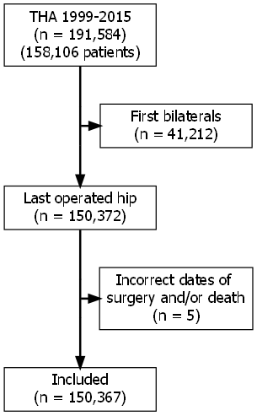
Figure 1: Flowchart over study population.
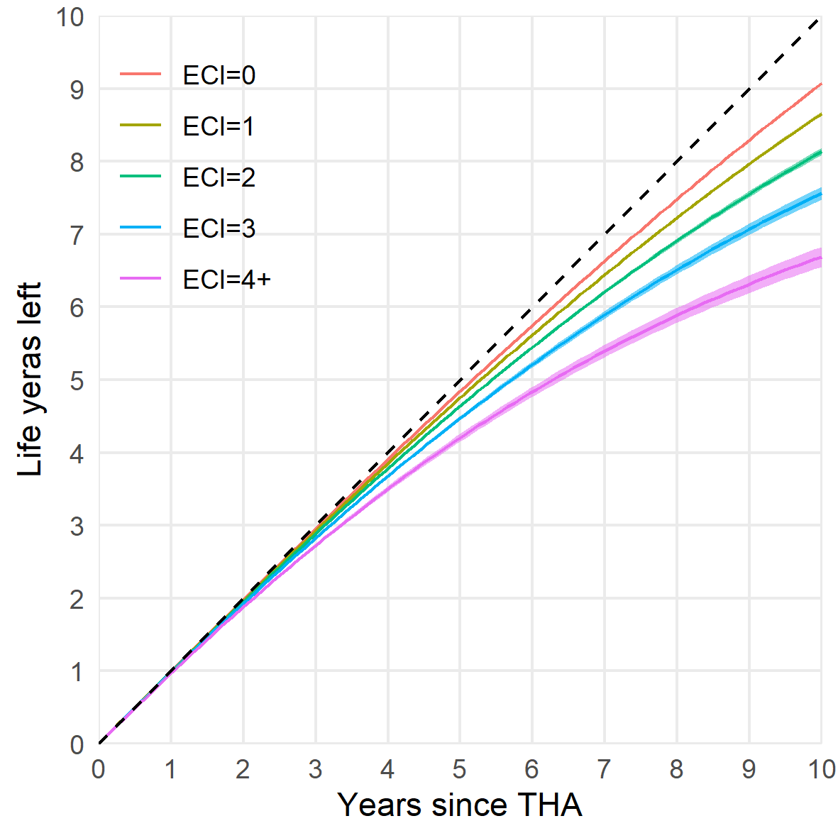
Figure 2: Restricted mean time lost during 10 years follow-up stratified by the Elixhauser comorbidity index.
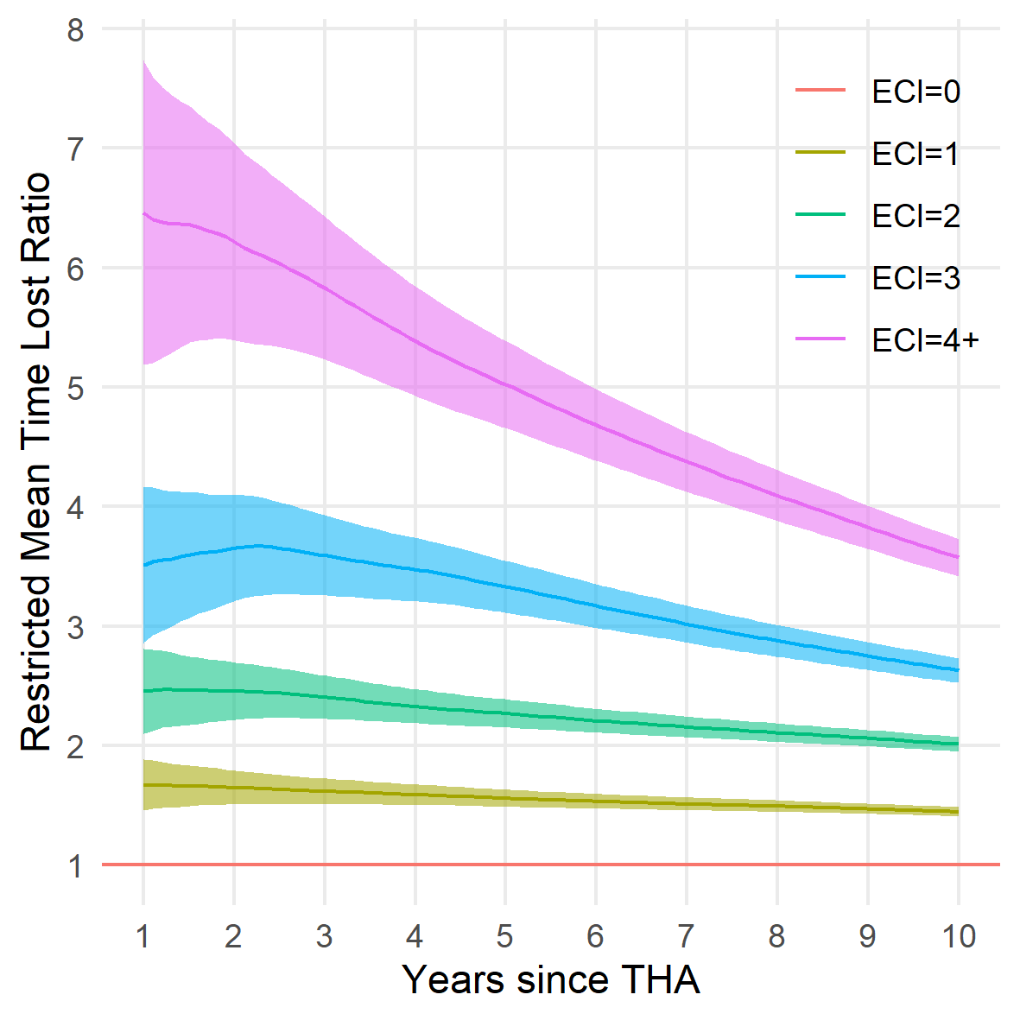
Figure 3: Relative change in restricted mean time lost with increasing Elixhauser comorbidity index with comorbidity free patients as reference.

References
1. Elixhauser A, Steiner C, Harris DR, Coffey RM. Comorbidity Measures for Use with Administrative Data. Medical care. 1998;36(1):8-27.
2. Charlson ME, Pompei P, Ales KL, MacKenzie CR. A new method of classifying prognostic comorbidity in longitudinal studies: Development and validation. Journal of Chronic Diseases. 1987;40(5):373-383. doi:10.1016/0021-9681(87)90171-8
3. Greene ME, Rolfson O, Gordon M, Garellick G, Nemes S. Standard Comorbidity Measures Do Not Predict Patient-reported Outcomes 1 Year After Total Hip Arthroplasty. Clinical Orthopaedics and Related Research. 2015;473(11):3370-3379. doi:10.1007/s11999-015-4195-z
4. Gordon M, Stark A, Sköldenberg OG, Kärrholm J, Garellick G. The influence of comorbidity scores on re-operations following primary total hip replacement: comparison and validation of three comorbidity measures. The bone & joint journal. 2013;95-B(9):1184-1191. doi:10.1302/0301-620X.95B9.31006
5. Bülow E, Rolfson O, Cnudde P, Rogmark C, Garellick G, Nemes S. Comorbidity does not predict long-term mortality after total hip arthroplasty. Acta Orthopaedica. 2017;88(July):1-6. doi:10.1080/17453674.2017.1341243
6. Shmueli G. To Explain or to Predict? Statistical Science. 2011;25(3):289-310. doi:10.1214/10-STS330
7. Glassou EN, Pedersen AB, Hansen TB. Is decreasing mortality in total hip and knee arthroplasty patients dependent on patients’ comorbidity? Acta Orthopaedica. 2017;88(3):288-293. doi:10.1080/17453674.2017.1279496
8. Penna S, Bell KL, Kuo F-C, Henderson RA, Foltz C, Chen AF. Impact of Co-Morbidities on the Cost of Care in Primary Elective Joint Arthroplasty. The Journal of Arthroplasty. 2019;34(5):834-838. doi:10.1016/J.ARTH.2019.01.038
9. Uno H, Claggett B, Tian L, et al. Moving Beyond the Hazard Ratio in Quantifying the Between-Group Difference in Survival Analysis. Journal of Clinical Oncology. 2014;32(22):2380-2385. doi:10.1200/JCO.2014.55.2208
10. Irwin JO. The standard error of an estimate of expectation of life, with special reference to expectation of tumourless life in experiments with mice. Journal of Hygiene. 1949;47(2):188-189. doi:10.1017/S0022172400014443
11. Royston P, Parmar MK. Restricted mean survival time: An alternative to the hazard ratio for the design and analysis of randomized trials with a time-to-event outcome. BMC Medical Research Methodology. 2013;13(1). doi:10.1186/1471-2288-13-152
12. Bülow E. Second is better! Large similarities between unilateral and second two-stage bilateral total hip arthroplasty for 70,694 patients with osteoarthritis. In: 8th International Congress of Arthroplasty Registries. Leiden; 2019:No 14.
13. Cnudde P, Rolfson O, Nemes S, et al. Linking Swedish health data registers to establish a research database and a shared decision-making tool in hip replacement. BMC Musculoskeletal Disorders. 2016;17(1):414. doi:10.1186/s12891-016-1262-x
14. Andersen PK, Borgan O, Gill RD, Keiding N. Statistical models based on counting processes. Springer Science & Business Media; 2012.
15. Bülow E, Cnudde P, Rogmark C, Rolfson O, Nemes S. Low predictive power of comorbidity indices identified for mortality after acute arthroplasty surgery undertaken for femoral neck fracture. The Bone & Joint Journal. 2019;101-B(1):104-112. doi:10.1302/0301-620X.101B1.BJJ-2018-0894.R1
16. Pedersen AB, Baron JA, Overgaard S, Johnsen SP. Short- and long-term mortality following primary total hip replacement for osteoarthritis. The Journal of Bone and Joint Surgery British volume. 2011;93-B(2):172-177. doi:10.1302/0301-620X.93B2.25629
17. Cnudde P, Rolfson O, Timperley AJ, et al. Do Patients Live Longer After THA and Is the Relative Survival Diagnosis-specific? Clinical Orthopaedics and Related Research. 2018;476(6).
18. Inacio MCS, Pratt NL, Roughead EE, Graves SE. Comparing co-morbidities in total joint arthroplasty patients using the RxRisk-V, Elixhauser, and Charlson Measures: a cross-sectional evaluation. BMC Musculoskeletal Disorders. 2015;16(1):385. doi:10.1186/s12891-015-0835-4
19. Bayliss LE, Culliford D, Monk AP, et al. The effect of patient age at intervention on risk of implant revision after total replacement of the hip or knee: a population-based cohort study. The Lancet. 2017;389(10077):1424-1430. doi:10.1016/S0140-6736(17)30059-4
20. Schwartsmann CR, Spinelli L de F, Boschin LC, et al. Correlation between patient age at total hip replacement surgery and lifeexpectancy. Acta Ortopédica Brasileira. 2015;23(6):323-325. doi:10.1590/1413-785220152306148609

