# Co-morbidity decreased restricted mean survival time for patients with total hip arthroplasty: An observational register study of 150,367 patients from the Swedish Hip Arthroplasty Register 1999-2015

Erik Bülow1,2 Ola Rolfson1,2 Szilard Nemes1,2

1 Swedish Hip Arthroplasty Register, Gothenburg, Sweden. 2 Department of Orthopaedics, Institute of Clinical Sciences, The Sahlgrenska Academy, University of Gothenburg, Gothenburg, Sweden.

*Correspondence:* Erik Bülow, SHPR, Registercentrum Västra Götaland, 415 43 Gothenburg, Sweden. Tel: +46 7008234 28. E-mail: [erik.bulow@vgregion.se](mailto:erik.bulow@vgregion.se)

# Abstract

**Purpose —**  We investigated association between increased co-morbidity and remaining life time, for patients with elective total hip arthroplasty (THA) in a Swedish national cohort.

**Patients and methods —**  We studied 150,367 patients operated with THA due to osteoarthritis 1999-2015, recorded in the Swedish Hip Arthroplasty Register, linked to the National Patient Register from the National Board of Health and Welfare. We estimated the restricted mean survival time (RMST), and the restricted mean time lost (RMTL) stratified by the Elixhauser co-morbidity index. Covariate adjustment were made performed using pseudo-observations and generalized estimation equations (GEE).

**Results —**  RMTL 90 days (95 % CI) after surgery ranged from 0.14 (0.12-0.16) to 1.11 (0.77-1.45) days and increased by co-morbidity. RMTL 10 years after surgery ranged from 0.93 (0.91-0.94) years for no co-morbidity to 3.31 (3.17-3.44) years for 4 or more co-morbidities. Adjustment for age and sex led to similar results, although age was more important for long-term survival.

**Conclusion —**  Baseline co-morbidity indicates decreased long-term survival after THA. Health administrators should be aware of the potential risk of shortened life in patients with multiple co-morbidities. This has important implications for an ageing population and with a widening range of patients deemed suitable for THA.

**Keywords:** survival analysis, hip replacement, Elixhauser, register study

# Introduction

Co-morbidity, such as measured by the Elixhauser comorbidity index,1 is a common components of joint replacement studies. It has been showed however that co-morbidity add little to the understanding of health-related quality of life,2 occurrence of re-operations3 or mortality.4 Beside considering co-morbidity indices and joint replacement, those findings have yet another common theme. They are predictive studies, and their assessment strictly applies to predictions. Prediction and estimation are often used interchangeably, although a clear distinction should be made.5 Predictive studies or risk calculators aim to predict the outcome for a specific patient (or groups of patients with similar characteristics). Baseline co-morbidity indices seemingly adds little in this case. Etiological studies of association between exposures and outcomes on the other hand, could still benefit from considering co-morbidity on a population level. Such studies have showed that co-morbidity indices are associated with for example survival,6 as well as with medical expenses,7 for patients on average.

Our aim in this paper was to assess the association between the Elixhauser co-morbidity index and the expected remaining survival time after total hip arthroplasty (THA). This study is descriptive and departs from usual regression modeling as it does not rely on hazard ratios. Instead, we focus on group specific survival times, a clinically meaningful and model-free measure.8,9 The restricted mean survival time and the restricted mean time lost10 give the average remaining life expectancy of patients, and inversely the life time lost up to a pre-defined time point. Both measures are easily interpreted as their unit is a measure of time (days, months or years) and they are easily estimated at clinically meaningful time points.

# Patients and Methods

We identified patients from the Swedish Hip Arthroplasty Register (SHAR) who underwent THA for primary hip osteoarthritis 1999–2015 (Figure 1). For patients with bilateral THA, start time was set at the second hip arthroplasty.11

These patients were linked to the Swedish National Patient Register (NPR) using the unique Swedish identity numbers, assigned to all residents at birth or immigration.4,12 NPR provided ICD-10 codes recorded at hospital visits for each patient during one year before surgery. Individual ICD-10 codes were first identified as different co-morbidities by the Elixhauser co-morbidity classification.13 The number of identified co-morbidities were then summed to an un-weighted index. Patients with no recorded pre-operative hospital visit were assumed to have no co-morbidity, thus Elixhauser = 0.

## Statistical methods

We recorded five data points for each patient: the follow-up time from THA to death or censoring, an event indicator, 1 if dead or 0 if censored, the pre-operative Elixhauser co-morbidity index, age and sex. We used the Kaplan-Meier estimator to calculate survival curves, $S(t)$, stratified by the Elixhauser co-morbidity index. The mean survival time is given by $E[T]=\int_{0}^{∞}{S}(t)dt$. This measure however can only be estimated if we do not have any censoring, hence if the life length of every patient is known. This is not the case due to administrative censoring. All patients, still alive by the 31st of December 2017, where censored by this date. We did not know how long they survived thereafter.

An alternative to $E[T]$ is the $τ$-restricted mean survival time (RMST). Here, we do not aim to follow all patients to their death, $T$, but only to a pre-defined time point, $τ≤T$. RMST $=μ(τ)=\int_{0}^{τ}{S}(t)dt$ where we estimate the survival ($S$) by Kaplan-Meier ($\hat{S}$). RMST is the average number of years (or a period of any other time unit) survived before time $τ$.

We could also estimate the inverse of RMST, the restricted mean time lost, $RMTL(τ)=τ-RMST(τ)$, up to a certain time-point. If $τ$ is known and fixed, both RMST and RMTL are asymptotically normally distributed14 with variance10 . Standard routines can therefore be used for confidence intervals and inference. Differences were considered statistically significant if 95 % confidence intervals did not overlap. Such hypothesis were evaluated for 90 days, as well as 1, 5 and 10 years after THA.

Additional covariate adjustments were made for age and sex in a regression model. This was based on pseudo-observations defined as ${\hat{S}}_{i}(t)=n⋅\hat{S}(t)-(n-1){\hat{S}}^{-i}(t)$ for each patient $i=1,…,n$ where $\hat{S}$ and ${\hat{S}}^{-i}$ are the Kaplan-Meier estimators based on all, and all but the $i$:th, patient respectively. RMST was then estimated by $\int_{0}^{τ}{{\hat{S}}_{i}}(t)dt$ and regressed by generalized estimation equations (EEG).15

We used R version 3.6.1 (R Foundation, Vienna, Austria) for statistical analysis, with significant packages: survival, prodlim and geepack. R scripts are available at <https://doi.org/10.5281/zenodo.3458030>. We are not able to share patient data however due to privacy concerns.

## Ethics

Ethics approval was obtained from the Regional Ethical Review Board in Gothenburg, Sweden (decision 271-14).

# Results

There were 150,367 patients included in the study (Figure 1). 64 % had no co-morbidities according to Elixhauser, 21 % had one, 10 % had two, 4 % three and 2 % had four or more. Each co-morbidity, except uncomplicated hypertension, was more common among patients who died (Table 1). From the onset of the follow-up, we saw a clear association between survival and the Elixhauser co-morbidity index (Figure 2). The expected life time lost (RMTL) increased with co-morbidity (Table 2). Differences were statistically significant with non-overlapping confidence intervals.

RMTL at 90 days (95 % CI) ranged from 0.14 (0.12-0.16) days for patients with no co-morbidity to 1.11 (0.77-1.45) days for patients with at least 4 co-morbidities. At 10 years, patients with no pre-operative co-morbidity (Elixhauser = 0) had lost 0.93 (0.91-0.94) year of life, while patients with at least four co-morbidities lost 3.31 (3.17-3.44) years. This difference is clinically relevant.

RMTL was between factor 1.52 and factor 8.61 higher in groups with co-morbidities compared to patients without. The difference got less notable with passing time (Figure 3).

Regression modelling with and without adjustment for age and sex led to similar results (Figure 3). The effect of age at surgery and sex increased by longer follow-up. With 10 year follow-up, each additional year of age decreased life expectancy with almost a month, -27.95 (-28.42; -27.48) days. The shortening effect of being male was almost twice the effect of having 1 versus 0 co-morbidities: -151.79 (-160.87; -142.72) versus -78.53 (-89.82; -67.24) less days.

# Discussion

Neither a clinician nor a survival curve can accurately predict how long a patient will live. We have also previously showed that ranking of individual survival times based on co-morbidity, such as the Elixhauser index, have low precision.4,16 We have seen here however that there is a clear separation on group level between patients with different Elixhauser scores. Thus, for health administrative purposes there might be added value in considering co-morbidities, although less so for individual patient predictions.

There is a known increase in short-term mortality after hip replacement,17,18 which is likely influenced by patient co-morbidity. We also saw that the relative RMTL was higher in the beginning of the follow-up period, compared to the end (Figure 3), but that the absolute values of RMST decreased with time for all co-morbidity groups (Figure 2). The 90-day RMTL for patients with at least four co-morbidities was only 1 day, approximately 8.61 times longer than for patients without co-morbidity. This relative difference decreased with time. At 10-years follow up, patients with at least four co-morbidities lost 3.98 times as much life time, compared to the group without co-morbidity. This convergence of relative RMTL coincides with previously reported time-decreasing predictive power of co-morbidity on mortality.4

If we follow the dichotomy by Shmueli et al. 5 we could conclude that predictive studies/risk calculators gain little from considering the Elixhauser co-morbidity index. However, for studies that aim to estimate effects of different treatment options, co-morbidity indices can be important confounders and are relevant for case-mix adjustments.19 Health-care administrators for example might gain knowledge from considering co-morbidities to better estimate the future need of revisions. The revision rate of hip replacements is low20 but patient survival increase over time.21 It is therefore important to estimate the long-term survival for patients at risk, wherefore co-morbidities are relevant.

A possible limitation is the reliance on administrative data for the Elixhauser co-morbidity index. Severe co-morbidities have good coverage in the patient register, but less severe conditions, such s hypertension and obesity are less well recorded.22 We assumed that patients with no recorded hospital visits during the year before THA had no co-morbidity. Additional co-morbidities might be found from primary care, but such data were not available to us. We do think the assumption of no co-morbidity is reasonable however, since the population with elective THA is generally healthy.18

We consider the regression analysis a strength of the study.23 Regression is mainstream in survival analysis when modelling the hazard function, but less so for RMST. Several methods have been suggested: based on ANCOVA, piece-wise exponentials, accelerated failure time, or either synthetic- or pseudo-data.15,23,24 We choose the last method where every patient was assigned a pseudo-observation and where generalised estimation equations (GEE) relates regression coefficients directly to the RMST. The interpretation is intuitive and free of parametric assumptions.

# Conclusion

Baseline co-morbidity indicates decreased long-term survival after THA. Health administrators should be aware of the potential greater risk of shortened life in patients with multiple co-morbidities. This has important implications for an ageing population and with a widening range of patients deemed suitable for THA.

# Disclosure

Grants from the Swedish state under the agreement between the Swedish government and the county councils, the ALF-agreement (ALFGBG-522591), contributed to this study. The authors declare no conflicts of interest.

# Table and figure captions

Table 1: Demography for the 150,367 patients with total hip arthroplasty.

|  |  |  |  |
| --- | --- | --- | --- |
|  | Censored | Dead | p |
| n | 141555 | 50029 |  |
| Age (mean (SD)) | 66.69 (9.50) | 75.00 (8.05) | <0.001 |
| Sex = Female (%) | 81952 (57.9) | 27397 (54.8) | <0.001 |
| Elixhauser (%) |  |  | <0.001 |
| 0 | 94967 (67.1) | 30122 (60.2) |  |
| 1 | 29042 (20.5) | 10456 (20.9) |  |
| 2 | 11922 ( 8.4) | 5582 (11.2) |  |
| 3 | 3974 ( 2.8) | 2449 ( 4.9) |  |
| 4+ | 1650 ( 1.2) | 1420 ( 2.8) |  |
| Congestive heart failure (%) | 1849 ( 1.4) | 2455 ( 5.1) | <0.001 |
| Cardiac arrhythmias (%) | 6853 ( 5.0) | 4403 ( 9.2) | <0.001 |
| Valvular disease (%) | 1797 ( 1.3) | 1344 ( 2.8) | <0.001 |
| Pulmonary circulation disorder (%) | 388 ( 0.3) | 227 ( 0.5) | <0.001 |
| Peripheral vascular disorder (%) | 859 ( 0.6) | 652 ( 1.4) | <0.001 |
| Hypertension uncomplicated (%) | 28524 (21.0) | 9631 (20.2) | <0.001 |
| Hypertension complicated (%) | 579 ( 0.4) | 534 ( 1.1) | <0.001 |
| Paralysis (%) | 172 ( 0.1) | 81 ( 0.2) | 0.034 |
| Other neurological disorders (%) | 1027 ( 0.8) | 668 ( 1.4) | <0.001 |
| Chronic pulmonary disease (%) | 4340 ( 3.2) | 2239 ( 4.7) | <0.001 |
| Diabetes uncomplicated (%) | 6126 ( 4.5) | 3097 ( 6.5) | <0.001 |
| Diabetes complicated (%) | 1097 ( 0.8) | 834 ( 1.7) | <0.001 |
| Hypothyroidism (%) | 3170 ( 2.3) | 1085 ( 2.3) | 0.495 |
| Renal failure (%) | 637 ( 0.5) | 629 ( 1.3) | <0.001 |
| Liver disease (%) | 436 ( 0.3) | 231 ( 0.5) | <0.001 |
| Peptic ulcer disease (%) | 308 ( 0.2) | 261 ( 0.5) | <0.001 |
| AIDS/HIV (%) | 20 ( 0.0) | 3 ( 0.0) | 0.240 |
| Lymphoma (%) | 333 ( 0.2) | 239 ( 0.5) | <0.001 |
| Metastatic cancer (%) | 169 ( 0.1) | 279 ( 0.6) | <0.001 |
| Solid tumor (%) | 3882 ( 2.9) | 2674 ( 5.6) | <0.001 |
| Rheumatoid arthritis (%) | 3433 ( 2.5) | 1640 ( 3.4) | <0.001 |
| Coagulopathy (%) | 368 ( 0.3) | 184 ( 0.4) | <0.001 |
| Obesity (%) | 2217 ( 1.6) | 452 ( 0.9) | <0.001 |
| Weight loss (%) | 42 ( 0.0) | 42 ( 0.1) | <0.001 |
| Fluid electrolyte disorders (%) | 419 ( 0.3) | 251 ( 0.5) | <0.001 |
| Blood loss anemia (%) | 46 ( 0.0) | 60 ( 0.1) | <0.001 |
| Deficiency anemia (%) | 594 ( 0.4) | 354 ( 0.7) | <0.001 |
| Alcohol abuse (%) | 438 ( 0.3) | 232 ( 0.5) | <0.001 |
| Drug abuse (%) | 133 ( 0.1) | 72 ( 0.2) | 0.004 |
| Psychoses (%) | 200 ( 0.1) | 77 ( 0.2) | 0.530 |
| Depression (%) | 1577 ( 1.2) | 549 ( 1.2) | 0.901 |

Table 2: Restricted mean time survival (RMST) and restricted mean time lost (RMTL) for the 150,367 patients with total hip arthroplasty. RMST + RMTL should equal the whole period in each column. RMST decrease by increased co-morbidity.

|  |  |  |  |  |  |
| --- | --- | --- | --- | --- | --- |
| Elixhauser | Measure | 90 days | 365 days | 5 years | 10 years |
| 0 | RMST | 89.9 (89.8-89.9) | 363.3 (363.1-363.4) | 4.84 (4.83-4.84) | 9.07 (9.05-9.08) |
|  | RMTL | 0.1 (0.1-0.2) | 1.7 (1.6-1.9) | 0.16 (0.15-0.16) | 0.93 (0.91-0.94) |
| 1 | RMST | 89.8 (89.7-89.8) | 362.1 (361.8-362.4) | 4.75 (4.74-4.76) | 8.66 (8.63-8.68) |
|  | RMTL | 0.2 (0.2-0.3) | 2.9 (2.6-3.2) | 0.25 (0.24-0.26) | 1.34 (1.31-1.37) |
| 2 | RMST | 89.7 (89.6-89.7) | 360.8 (360.2-361.3) | 4.64 (4.62-4.65) | 8.13 (8.08-8.18) |
|  | RMTL | 0.3 (0.3-0.4) | 4.2 (3.7-4.8) | 0.36 (0.34-0.37) | 1.86 (1.81-1.91) |
| 3 | RMST | 89.5 (89.3-89.6) | 359.0 (357.9-360.0) | 4.47 (4.44-4.50) | 7.56 (7.47-7.65) |
|  | RMTL | 0.5 (0.4-0.7) | 6.0 (5.0-7.1) | 0.53 (0.50-0.56) | 2.43 (2.35-2.52) |
| 4+ | RMST | 88.9 (88.6-89.2) | 353.9 (351.8-355.9) | 4.20 (4.15-4.26) | 6.69 (6.55-6.82) |
|  | RMTL | 1.1 (0.8-1.4) | 11.1 (9.1-13.2) | 0.79 (0.74-0.85) | 3.31 (3.17-3.44) |

Table 3: Crude, as well as age- and sex-adjusted regression coefficients from a generalized estimation equation (GEE) model applied to pseudo survival observations. The mean age (70 years) was subtracted from the age variable to yield a more interpretable base line. All estimates are given in days.

|  |  |  |  |  |
| --- | --- | --- | --- | --- |
|  | 90 days | 365 days | 5 years | 10 years |
| **Crude** |  |  |  |  |
| (Intercept) | 89.86 (89.84; 89.88) | 363.27 (363.13; 363.40) | 4.84 (4.83; 4.84) | 9.07 (9.06; 9.09) |
| Elixhauser 1 | -0.08 (-0.13; -0.04) | -1.16 (-1.48; -0.83) | -0.09 (-0.10; -0.08) | -0.41 (-0.44; -0.38) |
| 2 | -0.20 (-0.28; -0.11) | -2.52 (-3.06; -1.97) | -0.20 (-0.22; -0.18) | -0.90 (-0.95; -0.85) |
| 3 | -0.39 (-0.55; -0.22) | -4.35 (-5.38; -3.31) | -0.37 (-0.40; -0.33) | -1.44 (-1.52; -1.35) |
| 4+ | -0.98 (-1.33; -0.64) | -9.46 (-11.50; -7.42) | -0.63 (-0.68; -0.58) | -2.26 (-2.39; -2.12) |
| **Adjusted** |  |  |  |  |
| (Intercept) | 89.89 (89.86; 89.91) | 363.54 (363.37; 363.70) | 4.86 (4.85; 4.86) | 9.13 (9.11; 9.15) |
| Age (- 70) | -0.02 (-0.02; -0.01) | -0.17 (-0.18; -0.15) | -0.01 (-0.01; -0.01) | -0.08 (-0.08; -0.08) |
| Male sex | -0.13 (-0.17; -0.09) | -1.24 (-1.51; -0.97) | -0.09 (-0.10; -0.08) | -0.42 (-0.44; -0.39) |
| Elixhauser 1 | -0.04 (-0.09; 0.00) | -0.73 (-1.05; -0.40) | -0.05 (-0.06; -0.04) | -0.22 (-0.25; -0.18) |
| 2 | -0.13 (-0.21; -0.04) | -1.77 (-2.32; -1.22) | -0.14 (-0.15; -0.12) | -0.56 (-0.61; -0.52) |
| 3 | -0.30 (-0.47; -0.14) | -3.45 (-4.49; -2.41) | -0.29 (-0.32; -0.26) | -1.03 (-1.12; -0.95) |
| 4+ | -0.89 (-1.23; -0.54) | -8.43 (-10.46; -6.39) | -0.54 (-0.60; -0.49) | -1.79 (-1.92; -1.66) |

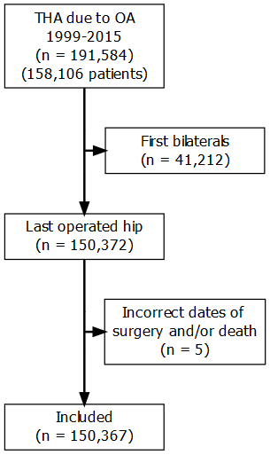

Figure 1: Flowchart over study population.

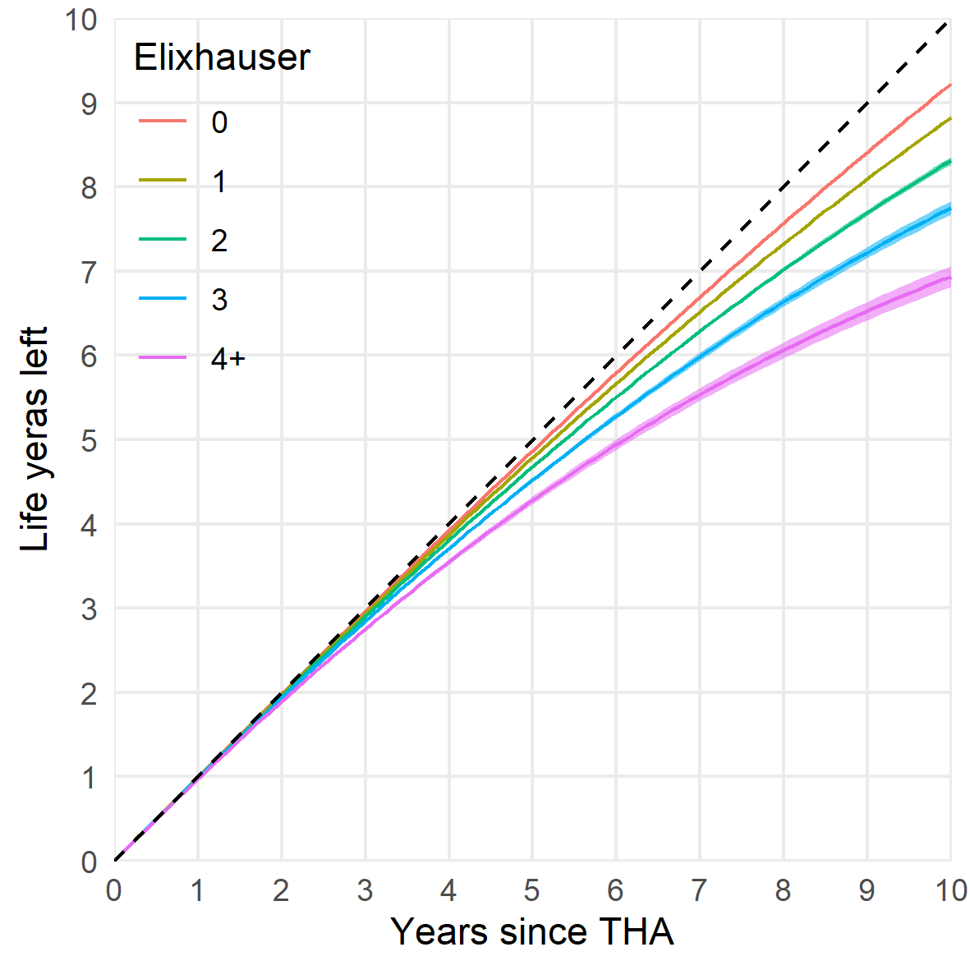

Figure 2: Restricted mean survival time (RMST) during 10 years follow-up stratified by the Elixhauser co-morbidity index. The dashed line indicates potential RMST equal to complete follow-up. Deviations below this line indicates shorter RMST. For example with 10 years follow-up (x-axis), patients with at least four co-morbidities survived, on average, less than 7 years (y-axis).

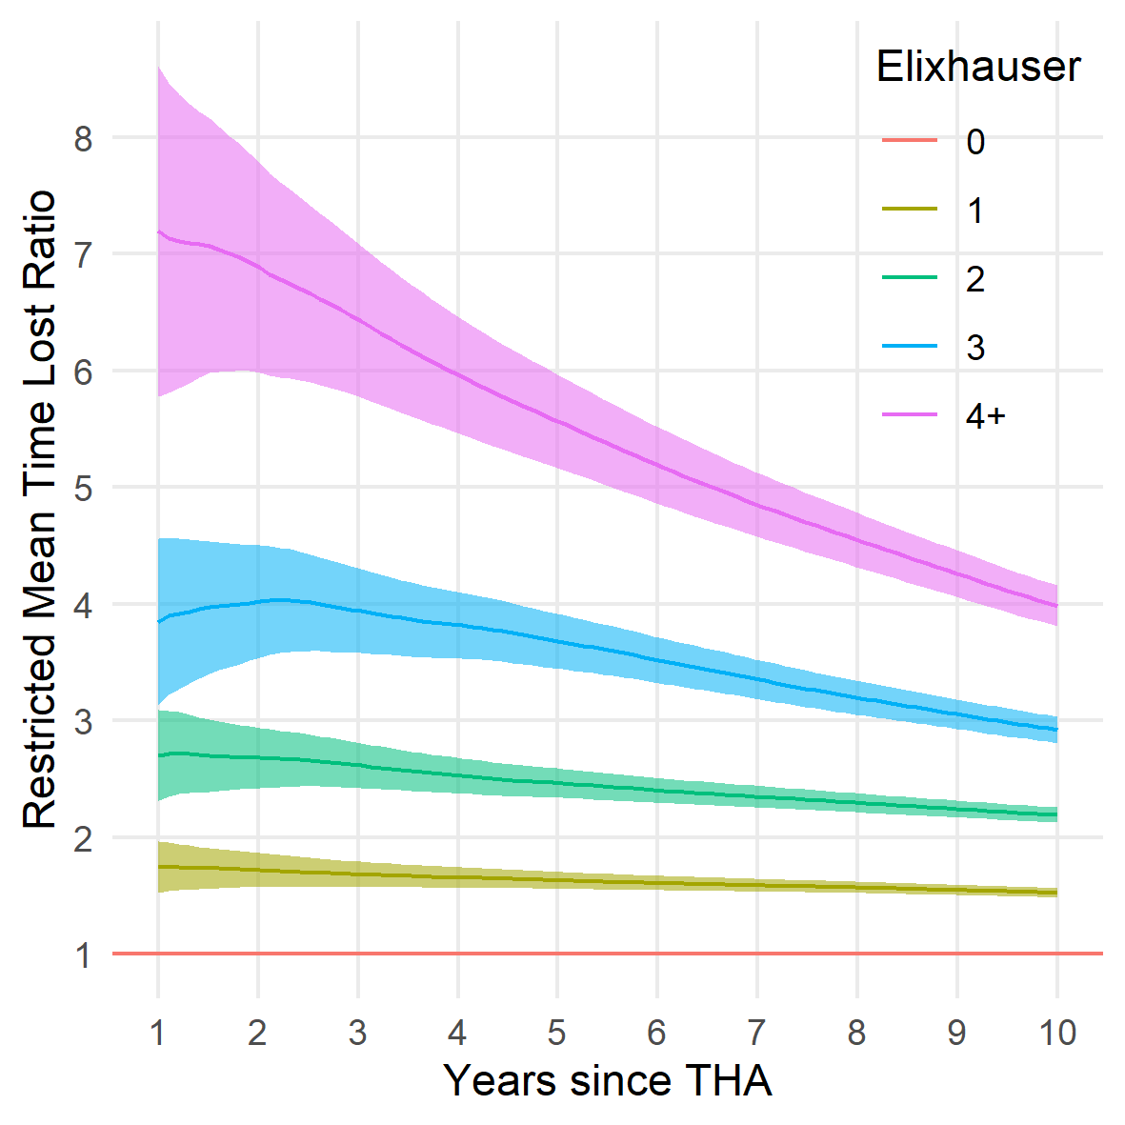

Figure 3: Relative change in restricted mean time lost (RMLT) with increasing Elixhauser co-morbidity index with co-morbidity free patients as reference. Shaded areas illustrate 95 % confidence intervals.

# References

1. Elixhauser A, Steiner C, Harris DR, Coffey RM. Comorbidity Measures for Use with Administrative Data. *Medical care*. 1998;36(1):8-27.

2. Greene ME, Rolfson O, Gordon M, Garellick G, Nemes S. Standard Comorbidity Measures Do Not Predict Patient-reported Outcomes 1 Year After Total Hip Arthroplasty. *Clinical Orthopaedics and Related Research*. 2015;473(11):3370-3379. doi:[10.1007/s11999-015-4195-z](https://doi.org/10.1007/s11999-015-4195-z)

3. Gordon M, Stark A, Sköldenberg OG, Kärrholm J, Garellick G. The influence of comorbidity scores on re-operations following primary total hip replacement: comparison and validation of three comorbidity measures. *The bone & joint journal*. 2013;95-B(9):1184-1191. doi:[10.1302/0301-620X.95B9.31006](https://doi.org/10.1302/0301-620X.95B9.31006)

4. Bülow E, Rolfson O, Cnudde P, Rogmark C, Garellick G, Nemes S. Comorbidity does not predict long-term mortality after total hip arthroplasty. *Acta Orthopaedica*. 2017;88(July):1-6. doi:[10.1080/17453674.2017.1341243](https://doi.org/10.1080/17453674.2017.1341243)

5. Shmueli G. To Explain or to Predict? *Statistical Science*. 2011;25(3):289-310. doi:[10.1214/10-STS330](https://doi.org/10.1214/10-STS330)

6. Glassou EN, Pedersen AB, Hansen TB. Is decreasing mortality in total hip and knee arthroplasty patients dependent on patients’ comorbidity? *Acta Orthopaedica*. 2017;88(3):288-293. doi:[10.1080/17453674.2017.1279496](https://doi.org/10.1080/17453674.2017.1279496)

7. Penna S, Bell KL, Kuo F-C, Henderson RA, Foltz C, Chen AF. Impact of Co-Morbidities on the Cost of Care in Primary Elective Joint Arthroplasty. *The Journal of Arthroplasty*. 2019;34(5):834-838. doi:[10.1016/J.ARTH.2019.01.038](https://doi.org/10.1016/J.ARTH.2019.01.038)

8. Uno H, Claggett B, Tian L, et al. Moving Beyond the Hazard Ratio in Quantifying the Between-Group Difference in Survival Analysis. *Journal of Clinical Oncology*. 2014;32(22):2380-2385. doi:[10.1200/JCO.2014.55.2208](https://doi.org/10.1200/JCO.2014.55.2208)

9. Irwin JO. The standard error of an estimate of expectation of life, with special reference to expectation of tumourless life in experiments with mice. *Journal of Hygiene*. 1949;47(2):188-189. doi:[10.1017/S0022172400014443](https://doi.org/10.1017/S0022172400014443)

10. Royston P, Parmar MKB. Restricted mean survival time: An alternative to the hazard ratio for the design and analysis of randomized trials with a time-to-event outcome. *BMC Medical Research Methodology*. 2013;13(1). doi:[10.1186/1471-2288-13-152](https://doi.org/10.1186/1471-2288-13-152)

11. Bülow E. Second is better! Large similarities between unilateral and second two-stage bilateral total hip arthroplasty for 70,694 patients with osteoarthritis. In: *8th International Congress of Arthroplasty Registries*. Leiden; 2019:No 14.

12. Cnudde P, Rolfson O, Nemes S, et al. Linking Swedish health data registers to establish a research database and a shared decision-making tool in hip replacement. *BMC Musculoskeletal Disorders*. 2016;17(1):414. doi:[10.1186/s12891-016-1262-x](https://doi.org/10.1186/s12891-016-1262-x)

13. Quan H, Sundararajan V, Halfon P, et al. Coding algorithms for defining comorbidities in ICD-9-CM and ICD-10 administrative data. *Medical care*. 2005;43(11):1130-1139. doi:[10.1097/01.mlr.0000182534.19832.83](https://doi.org/10.1097/01.mlr.0000182534.19832.83)

14. Andersen PK, Borgan O, Gill RD, Keiding N. *Statistical models based on counting processes*. Springer Science & Business Media; 2012.

15. Andersen PK, Pohar Perme M. Pseudo-observations in survival analysis. *Statistical Methods in Medical Research*. 2010;19(1):71-99. doi:[10.1177/0962280209105020](https://doi.org/10.1177/0962280209105020)

16. Bülow E, Cnudde P, Rogmark C, Rolfson O, Nemes S. Low predictive power of comorbidity indices identified for mortality after acute arthroplasty surgery undertaken for femoral neck fracture. *The Bone & Joint Journal*. 2019;101-B(1):104-112. doi:[10.1302/0301-620X.101B1.BJJ-2018-0894.R1](https://doi.org/10.1302/0301-620X.101B1.BJJ-2018-0894.R1)

17. Pedersen AB, Baron JA, Overgaard S, Johnsen SP. Short- and long-term mortality following primary total hip replacement for osteoarthritis. *The Journal of Bone and Joint Surgery British volume*. 2011;93-B(2):172-177. doi:[10.1302/0301-620X.93B2.25629](https://doi.org/10.1302/0301-620X.93B2.25629)

18. Cnudde P, Rolfson O, Timperley AJ, et al. Do Patients Live Longer After THA and Is the Relative Survival Diagnosis-specific? *Clinical Orthopaedics and Related Research*. 2018;476(6).

19. Inacio MCS, Pratt NL, Roughead EE, Graves SE. Comparing co-morbidities in total joint arthroplasty patients using the RxRisk-V, Elixhauser, and Charlson Measures: a cross-sectional evaluation. *BMC Musculoskeletal Disorders*. 2015;16(1):385. doi:[10.1186/s12891-015-0835-4](https://doi.org/10.1186/s12891-015-0835-4)

20. Bayliss LE, Culliford D, Monk AP, et al. The effect of patient age at intervention on risk of implant revision after total replacement of the hip or knee: a population-based cohort study. *The Lancet*. 2017;389(10077):1424-1430. doi:[10.1016/S0140-6736(17)30059-4](https://doi.org/10.1016/S0140-6736(17)30059-4)

21. Schwartsmann CR, Spinelli L de F, Boschin LC, et al. Correlation between patient age at total hip replacement surgery and lifeexpectancy. *Acta Ortopédica Brasileira*. 2015;23(6):323-325. doi:[10.1590/1413-785220152306148609](https://doi.org/10.1590/1413-785220152306148609)

22. Ludvigsson JF, Andersson E, Ekbom A, et al. External review and validation of the Swedish national inpatient register. *BMC public health*. 2011;11(1):450. doi:[10.1186/1471-2458-11-450](https://doi.org/10.1186/1471-2458-11-450)

23. Karrison T, Kocherginsky M. Restricted mean survival time: Does covariate adjustment improve precision in randomized clinical trials? *Clinical Trials*. 2018;15(2):178-188. doi:[10.1177/1740774518759281](https://doi.org/10.1177/1740774518759281)

24. Tian L, Zhao L, Wei LJ. Predicting the restricted mean event time with the subject’s baseline covariates in survival analysis. *Biostatistics*. 2014;15(2):222-233. doi:[10.1093/biostatistics/kxt050](https://doi.org/10.1093/biostatistics/kxt050)