Prediction of 90-day mortality after Total Hip Arthroplasty: a simplified and externally validated model based on observational register data from Sweden, England and Wales
Anne Garland^{1,2,3}, Erik Bulow^{2,4}, Erik Lenguerrand⁵, Ashley Blom⁶, Mark Wilkinson⁷, Adrian Sayers⁸, Szilard Nemes^{2,4}, Ola Rolfson^{2,4}, Nils P. Hailer^{1,2}
2019-10-17

Affiliation and contact
- Department of Orthopaedics, Institute of Surgical Sciences, Uppsala University Hospital, Uppsala, Sweden
- Swedish Hip Arthroplasty Register, Gothenburg, Sweden
- Department of Orthopaedics, Visby Hospital, Visby, Sweden
- Department of Orthopaedics, Institute of Clinical Sciences, The Sahlgrenska Academy, University of Gothenburg, Gothenburg, Sweden
- Translational Health Sciences, Bristol Medical School, University of Bristol, England.
- …
- …
- …
Correspondence: [OR EB?] anne.garland@surgsci.uu.se, Phone: +46 498 26 80 00, Postal: Orthopedic Department, Visby Hospital, St Goransgatan 10, 621 84 Visby, Sweden

Abstract
OBJECTIVE: Shared decision making is essential before total hip arthroplasty (THA) surgery. Comorbidities are associated with an increased risk of 90-day morbidity and mortality, but diagnosis code-based instruments such as the Charlson or Elixhauser comorbidity indices are impossible to use in a clinical setting, and the American Society for Anesthesiologists (ASA) grade is imprecise. We searched for a simple model to predict early mortality after THA.
PATIENTS AND METHODS: We studied 53,099 Swedish patients operated with a cemented THA due to primary osteoarthritis and linked data from several national registries in order to collect information on demographics and comorbidities. Bootstrap ranking procedures were used together with logistic regression to develop prediction models for death within 90 days, and predictive accuracy was assessed by the areas under the receiver operating characteristic curve (AUC). The final model was externally validated on a data-set from the National Joint Registry of England and Wales .
RESLUTS: The unadjusted cumulative 90-day mortality was 0.33 % (95 % CI: 0.28 - 0.38). Best predictive performance for 90-day mortality was found for a model combining age, sex, ASA grade and the precense of cancer, CNS disease, kidney disease and obesity (AUC = 0.78 (95% CI: 0.75-0.82)). This model was superior to the Charlson (AUC = 0.66 (95% CI: 0.62-0.70)) and Elixhauser (AUC = 0.64 (95% CI: 0.59-0.68)) comorbidity measures. A web calculator to aid clinical usage was published at https://erikbulow.shinyapps.io/thamortpred/.
CONCLUSION: We found a relatively simple prediction model of 90 day mortality after THA. This model requires less data and is easier to use compared to previously well-known comorbidity indices.

Introduction
Shared decision making has evolved into an integral part of patient-physician interactions prior to surgical interventions, and the weighing of risks against benefits is central to this process. In terms of gained quality of life and cost-utility, total hip arthroplasty (THA) is an enormously successful procedure, but the risk of adverse events in the short and long term is an essential part of preoperative discussions and various risk prediction models have been developed.¹
90-day mortality after THA surgery performed due to osteoarthritis is low, ranging between 0.2% and 0.6% in large joint registry analyses where adjustment for comorbidities is possible.^{2,3}
The presence of comorbidities is associated with a shorter remaining life span, but the Charlson and Elixhauser comorbidity indices poorly predict mortality after THA and total knee arthroplasty.^{4,5} Additionally, these complex comorbidity instruments are based on the availability of extensive data-sets including in- and outpatient data coded by the 10th revision of the international classification of diseases (ICD-10), and each of the comorbidity indices exists in numerous versions.^{6,7} Interpretation and comparison of different studies is therefore difficult.
Comorbidity data are used to construct universal or arthroplasty-specific risk prediction tools, but no model has so far been broadly accepted to predict mortality after elective THA.^{4,8} In order to propel arthroplasty surgery into the age of precision medicine, easily applicable tools to predict short- and long-term complications are urgently needed. We aimed to define a model that accurately predicts the risk of 90-day postoperative mortality after cemented THA performed due to osteoarthritis .

Patients and Methods
Patients recorded in the Swedish Hip Arthroplasty Register (SHAR) with cemented primary hip osteoarthritis 2008 - 2015 were used to develop, and internally validate, the prediction model (Figure 1). Data from the National Joint Register in England and Wales (NJR) was later used for external validation. Only the last operated hip was accounted for in patients with bilateral THA⁹.
Data linkage, based on the 10-digit identity numbers assigned to all Swedish residents,¹⁰ were used to collect data from a variety of sources, as previously described.¹¹
Age, sex, body mass index (BMI), the American Society for Anesthesiologists (ASA) grade, type of hospital (university/county/rural/private) and year of surgery were collected from the SHAR, which has a completeness of 96-98%.¹² Data on education level (low = up to 9 years/middle = 10-12 years/high = at least 12 years) and civil status (married/un-married/divorced/widow[er]), were collected from the longitudinal integration database for health insurance and labor market studies from Statistics Sweden.¹³ The Swedish National Patient Register was used to assess comorbidities during the year preceding index surgery. This register contains all relevant diagnoses coded by ICD-10, as well as dates of admission and discharge for in- and outpatient episodes in all private and public hospitals.¹⁴ Death dates were linked from the national population register.
Comorbidity was defined by individual ICD-10 codes grouped into 17 categories according to Charlson^{15–17} and 31 categories according to Elixhauser.^{17,18}
Some comorbidities were identified by both Charlson and Elixhauser, and some distinct comorbidities were closely related (such as hypertension with and without complications, or abuse of either drugs or alcohol). We therefore combined individual categories to establish 21 broader categories of comorbidity (Table 1). Conditions were merged according to clinical relevance as to be recognized in a patient-doctor meeting without access to external register data.

Statistics
We used the Kaplan-Meier estimator to assess unadjusted mortality.
Further analysis were based on logistic regression since no censoring occurred within the 90 day study period. We used a modelling procedure with bootstrap ranking and logistic least absolute shrinkage and selection operator (LASSO) model.¹⁹ Numeric variables (age and BMI) were normalized before modelling to have mean = 0 and standard deviation = 1.
Comorbidities recorded for at least one patient who died within 90 days, and one who did not, were included in the modelling process. 1,000 bootstrap samples were drawn from the observed data set.²⁰ We used 10-fold cross validation for every bootstrap sample with a broad range of potential penalty values ($λ$:s) in a logistic LASSO model. We then only kept $λ$:s minimizing the mean cross-validated deviances in each sample. Those $λ$:s were used to estimate model coefficients for each potential predictor. Absolute values from those estimates were used as a measure of variable importance. Piece-wise linear regression was used to detect a break point where a significant drop in variable importance were observed. Potential predictors with variable importance above this break point were considered important and kept as model candidates. The whole process was repeated 100 times.
Covariates that were selected at least one out of the 100 times were used in a main effects model of multivariable logistic regression without penalty, and without pre-normalization of numeric variables. We will call this model “BRL” for bootstrap ranking LASSO. A reduced model with variables chosen at least 33 out of the 100 times, is called “BRL reduced”. Univariable models with the ASA grade, Charlson or Elixhauser comorbidity indices were used for benchmarking, as well as a multivariable model with age and sex. Each model including age was fitted three times, once with age as a main effect and twice with restricted cubic splines, either by two or three knots.
Each of those models were used to predict the probability of death within 90 days for each patient. Sensitivity and specificity were estimated to form receiver operating characteristic (ROC) curves and the area under those curves (AUC) were used as a measure of predictive accuracy. Models with a lower 95% confidence limit above 0.7, were considered good. Those intervals were based on percentiles from 2,000 non-parametric bootstrap samples for internal validation. The bias-corrected Somers’ $D_{xy}$ rank correlation was used to adjust those intervals for optimism based on 100 re-samples.²¹ Calibration bands were made to graphically assess model calibration.²²
Odds ratios for the final model were estimated with 95% confidence intervals based on interpolations of profile traces.²³
We also built an online web calculator available at https://erikbulow.shinyapps.io/thamortpred/. Patients can use it to easily estimate their own risk of mortality. This estimate can be used in a discussion of shared decision making on whether to operate or not.
We used R version 3.6.1 (R Foundation for Statistical Computing, Vienna, Austria) with significant packages tidyverse, tidymodels, furrr, pROC and shiny. All R-scripts and necessary configurations (but no personal data) is available at zenodo.org/XXX. A linked Binder environment is also available for interactive usage.

Ethical approval
Ethical approval for this study was obtained from the Regional Ethical Review Board in Gothenburg (271-14 and 360-13). [COI?]

Results
After application of exclusion criteria, 53,099 patients (age 35 - 99, 61% females) were included in the analysis (Figure 1). 175 (0.33%) patients died within 90 days and no one was censored before that. The unadjusted risk of 90 day mortality was 0.33 % (95 % CI: 0.28 - 0.38).
Characteristics of the study population are presented in Table 2. 26% of all patients had at least one pre-surgery comorbidity according to Charlson, and 48% according to Elixhauser. The proportion of patients with ASA grade 3 was 18%. Most comorbidities were more common among patients who died.
There were 5 comorbidities that were not recorded for any patient who died: AIDS/HIV, coagulopathy, fluid electrolyte disorders, liver disease and weight loss, and these variables were thus excluded from the modelling process.
The “BRL” model included age, sex, ASA grade and the precense of cancer, CNS disease, kidney disease, obesity, heart condition, anemia and heart infarct. The “BRL reduced” model only used age, sex, ASA grade and the precense of cancer, CNS disease, kidney disease and obesity (Table 3).
We observed no relevant differences between models based on age described by restricted cubic splines with two versus three knots and therefore only present results for models based on three knots. The use of splines did however not improve the accuracy of the models when compared to simpler main effect models. The “BRL” model had an estimated AUC of 0.79 (95% CI: 0.75-0.82), and the reduced version performed equally good with AUC 0.78 (95% CI: 0.75-0.82). Univariable models with ASA grade, Charlson or Elixhauser performed poorly with an AUC that was lower than 0.7. A model based on only age and sex performed slightly better but still with an AUC not statistically significantly above 0.7 (Table 4 and Figure 2).
AUCs and 95% confidence intervals, with and without adjustments for optimism, are illustrated for some models in Figure 3).
The ability of the “BRL reduced” model to estimate probabilities of death within 90 days is illustrated in Figure 4. Patients who died had, on average, higher predicted probabilities to do so. The model calibration was good for probabilities up to 3%, while higher probabilities might be over-estimated (Figure 5).
Estimated coefficients and corresponding odds ratios for the “BRL reduced” model is presented in Table 5.
We have provided a web calculator to aid clinical model usage in practice (https://erikbulow.shinyapps.io/thamortpred/).

Discussion
We found that a multivariable main effects logistic regression model with age, sex, ASA grade and the precense of cancer, CNS disease, kidney disease and obesity was able to better predict 90-day mortality than more complex models such as the Charlson or Elixhauser comorbidity indices.
The resulting “BRL reduced” model can predict the probability of death within 90 days as: $p=1/[1+exp(βX)]$ where
$$\begin{matrix}βX= & -13.28 \\ & +0.71⋅Cancer \\ & +0.90⋅CNS disease \\ & +1.33⋅Kidney disease \\ & +0.88⋅ASA grade = 2 \\ & +1.66⋅ASA grade = 3 \\ & +0.08⋅Age \\ & +0.77⋅Obesity \\ & +0.61⋅Male sex\end{matrix}.$$
This formula is valid for patients within the observed age range (35 - 99 years) with observed combinations of diseases.
For example a 35 year old woman with ASA grade = 1 and none of the important comorbidities would have a 0.0028 % risk to die within 90 days of surgery. Another woman, 67 years old (the first age quantile), have an elevated risk of 0.037 %. A 78 years old man (the third age quantile) with ASA grade = 3 and a previous heart condition would have a risk of 0.87 %. If that man was instead 99 years old (the maximum observed age), with cancer as well, his risk would be 8.8 %. Note however that observed covariate patters with predicted probabilities above 3% were rare. Only 0.48% (253 patients) had those (Figure 4). Estimated mortality risks above 3% are therefore subject to extrapolation. Some risk calculators ignore this problem,²⁴ but we think this is a risk to consider.
Obesity in the “BRL reduced” model was not statistically significant by itself ($p=$ 0.050) but is relevant as a predictor due to unobserved heterogeneity.²⁵ We note that the proportion of patients with BMI > 30 (23.23%) is much higher than the proportion of patients with ICD-10 = E66* (obesity) from the national patient register (1.88%). This proportion corresponds to patients with BMI of at least 39. Thus, obesity might be indicated in the risk calculator only if the condition is severe.
The “BRL reduced” model without cancer had the same AUC as a model with cancer. The AUC value itself is a rank-based and scale-invariant measure that does not account for model calibration. Both models were however equally well calibrated as well, for estimated probabilities within the recommended range (0-3%). The model without cancer however performed worse for probabilities above 3%.
It is known that male sex is associated with earlier deaths and that the remaining life span will decrease with increased age. It is less obvious that this relation must be linear. We used restricted cubic splines to allow a more flexible relation, but found that a linear relationship was equally good. Our model includes ASA grade, which is routinely assessed pre-operatively in most developed countries. It is however known to have a high degree of internal variability.²⁶ It has previously been compared to the Charlson comorbidity index, but not with respect to mortality after THA.^{27,28} Patients with ASA grade 4-6 were excluded since those categories describe severe disease, moribund and brain-dead individuals. Patients with those conditions are unlikely to get elective THA.
Comorbidity burden is also known to influence the outcome after THA.^{3,5,29,30} Coding algorithms on the other hand are complex and not used in clinical settings since the administrative burden is too high. The Charlson classification comprise 1,178 ICD-10 codes and the Elixhauser 1,516. Those indices are therefore only used by researchers.
Risk prediction may be useful in the process of patient selection prior to surgery, in the preoperative risk management including a review of current medications, and in perioperative anesthesia management. A number of risk prediction tools of various complexity for adverse events after total joint replacements have been introduced but none has been broadly accepted.^{1,8} In the context of trauma surgery, outcome prediction tools are common, and it seems possible to reduce the number of items without losing predictive accuracy.³¹ Our results indicate that the risk of early postoperative mortality after THA could be assessed by a relatively simple prediction model.
A strength of this study is the nationwide design with a large cohort of primary THA patients. We were able to use exact data linkage by the Swedish identity numbers and had no censoring. Our data sources are valid with low proportions of missing data.^{12,14,32,33}
The risk of coding errors might be a limitation to the study, especially so if coding routines might change over time. It should also be remembered that the risk model does not study THA as an observed intervention. We merely followed the cohort who did already have THA. Hence, deaths within 90 days might occur for the patients regardless if THA is inserted or not. The proximity in dates however, the maximum of 90 days from THA to death, is an indication that the operation might have influenced the deaths observed. The insertion of an elective THA is always preceded by a clinical judgement. Hence, no patient with a foreseen death near-by is given THA to begin with. We therefore believe that at least a non-significant proportion of deaths within 90 days are related to the THA surgery, or with complications thereafter.
We hope that the supplied web calculator and the transparent reporting of this model might lead to clinical usage that can be part of a pre-surgery discussion between doctors and patients in need of THA.

Contribution of authors
[ADD NJR CONTRIBUTIONS!] AG and NH initiated the study and managed the ethical review board application. EB developed the statistical model. EL and AS performed external validation with data from NJR. AG and EB drafted the manuscript. All authors edited and finalized the manuscript.

Acknowledgement
We would like to thank Szilard Nemes, previous senior statistician at the Swedish Hip Arthroplasty Register, for involvement in planning and interpreting the study.

PAGE BREAK
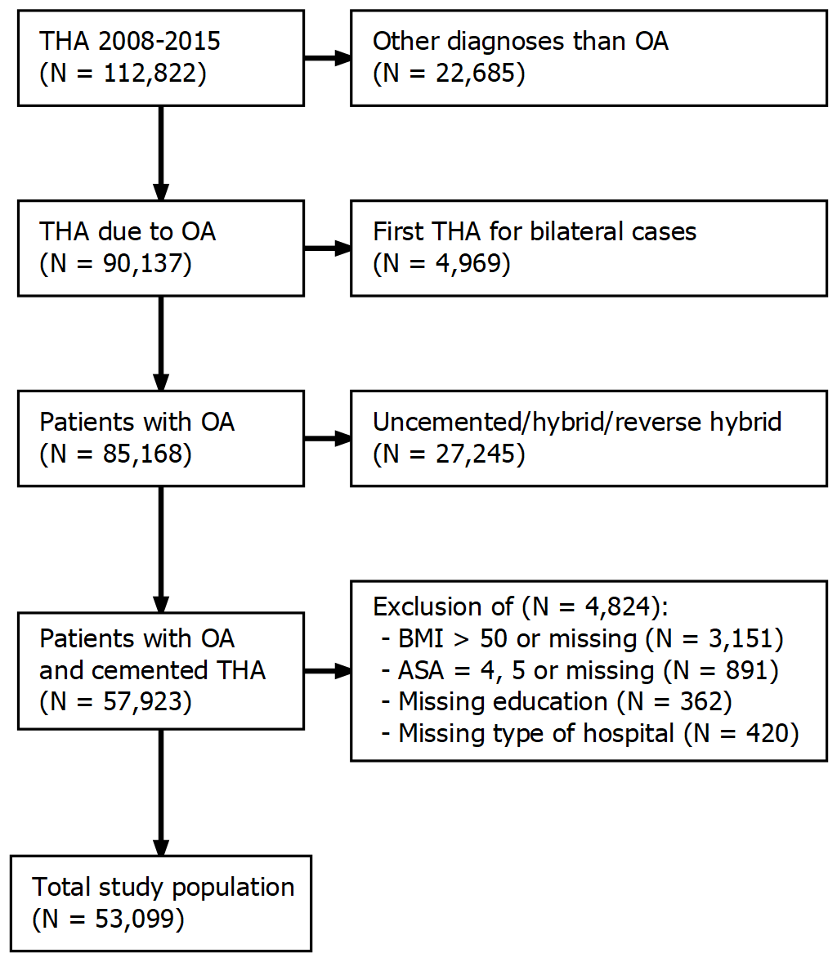
Figure 1: Flowchart depicting inclusion criteria and number of patients included in the development and internal validation phase of the model.

PAGE BREAK
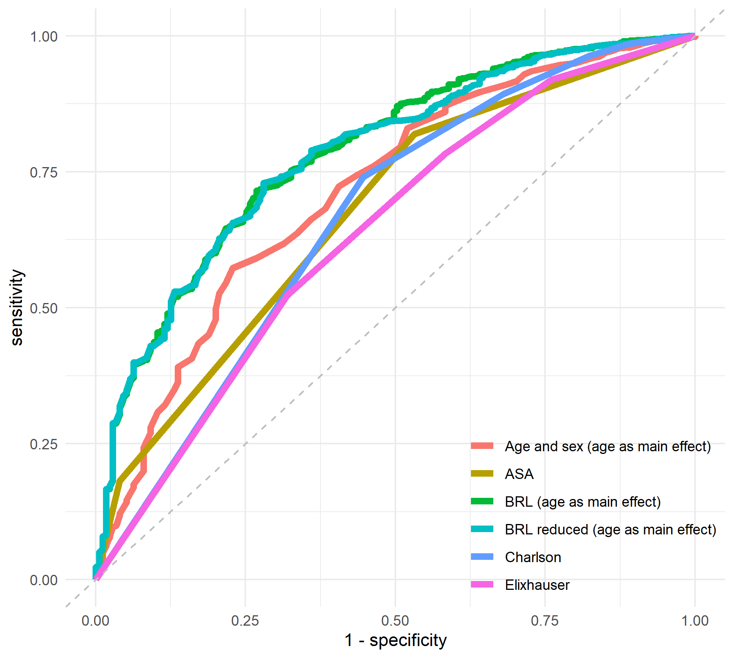
Figure 2: ROC curves for some of the models. The ‘BRL’ models are superior but the reduced version works equally well as the more complex version.

PAGE BREAK
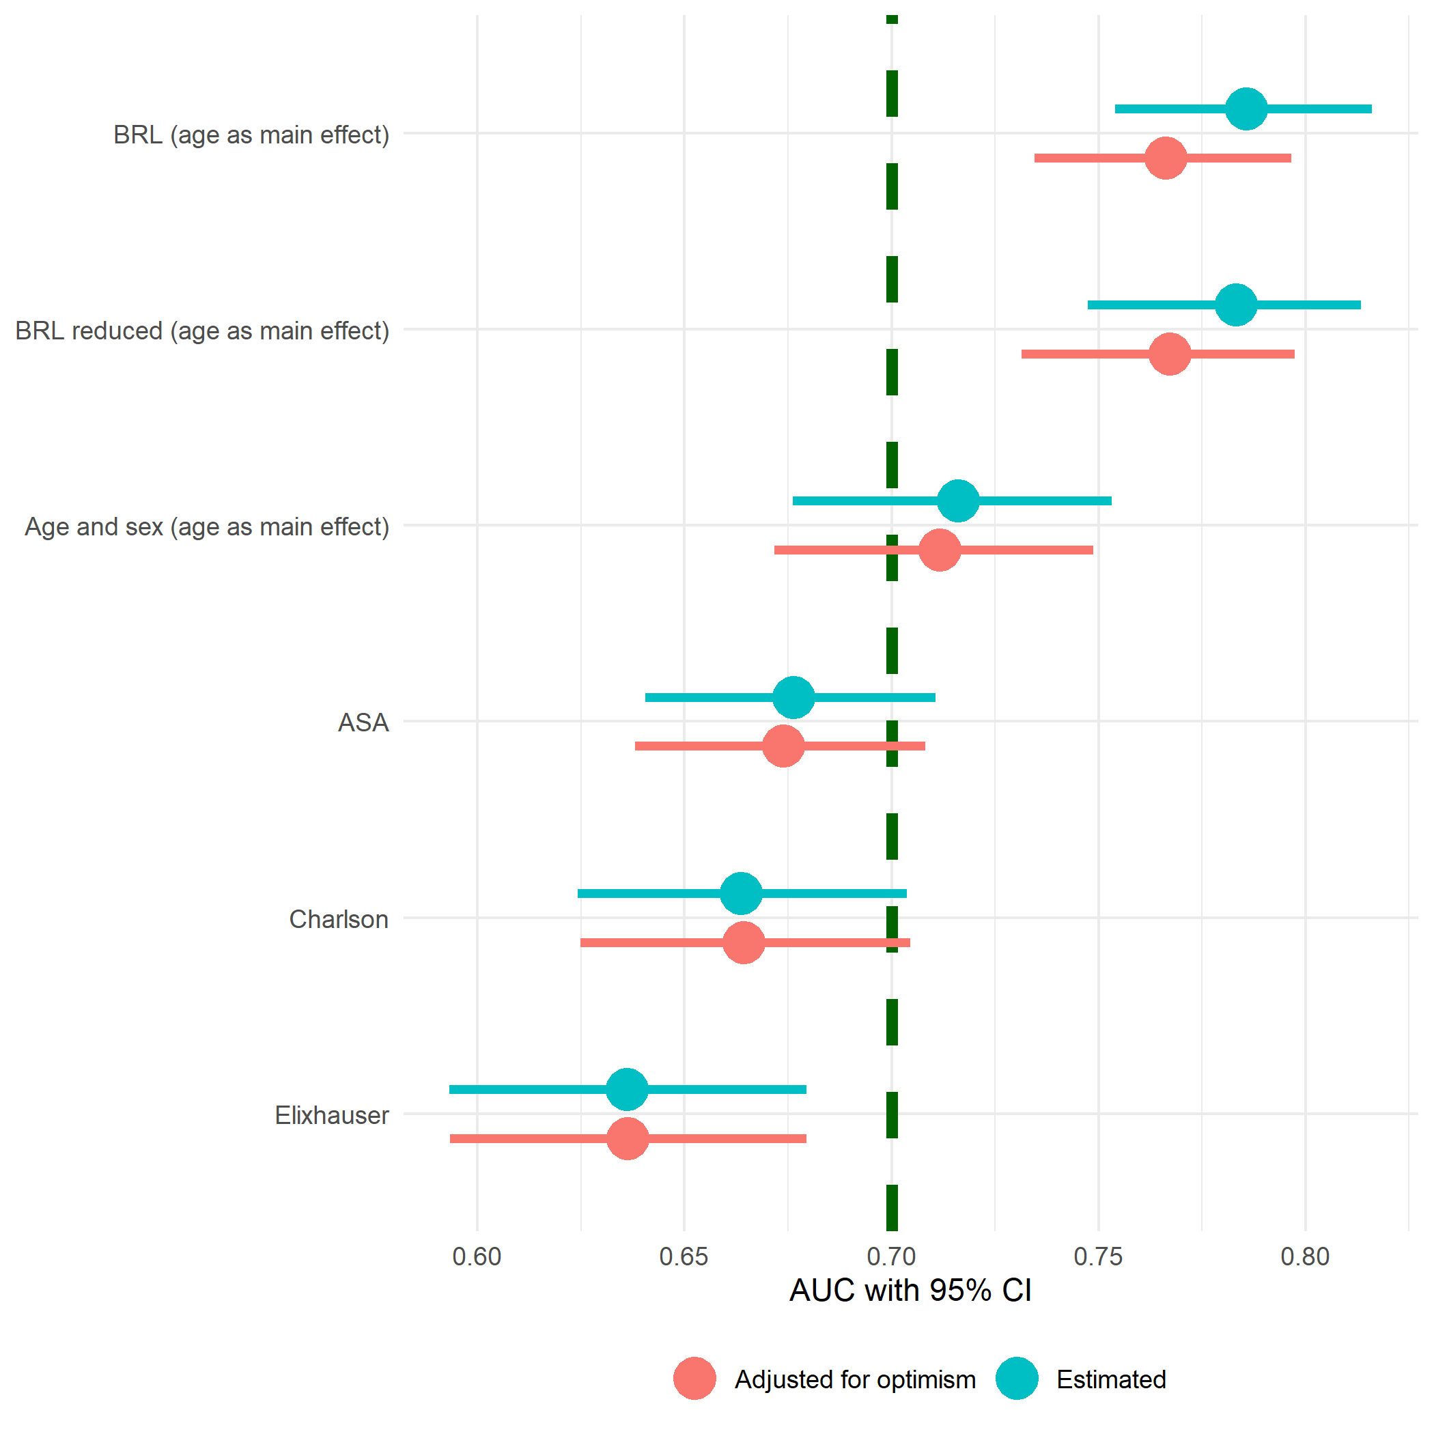
Figure 3: Area Under the Curve (AUC) as a measure of predictive accuracy. Only the BRL models have AUC statistically significantly above 0.7. The reduced version works as well as the more complex model. To adjust for optimism does not effect the result.

PAGE BREAK
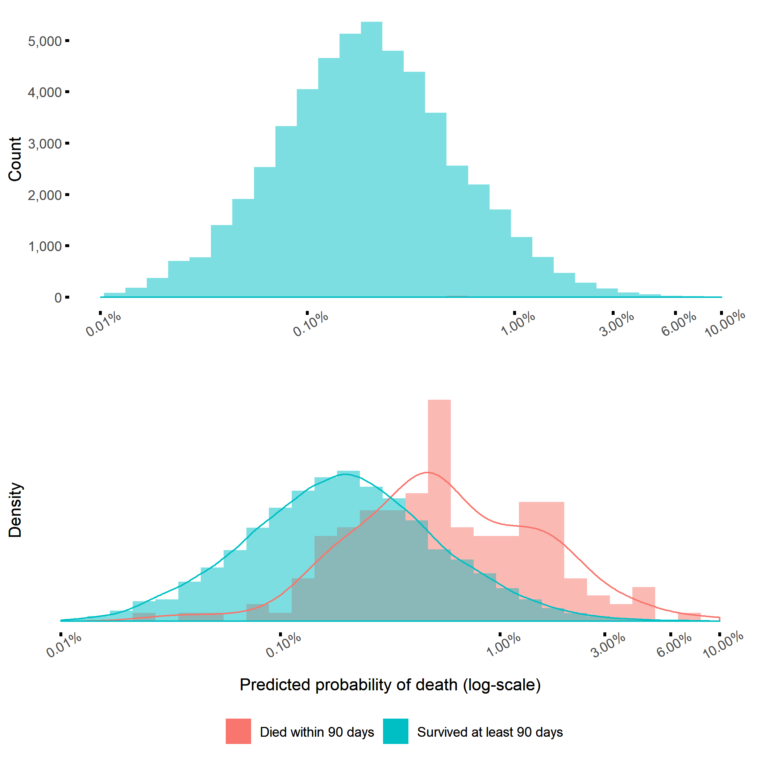
Figure 4: Most patients survived more than 90 days after THA, wherefore the blue bars totally dominate the histogram (upper panel). A standardized density plot however reveals that patients who died within 90 days (pink) were, on average, estimated to have a higher probability to do so (lower panel). There were very few observations with covariate patterns resultnig in death probabilities higher than 3%.

PAGE BREAK
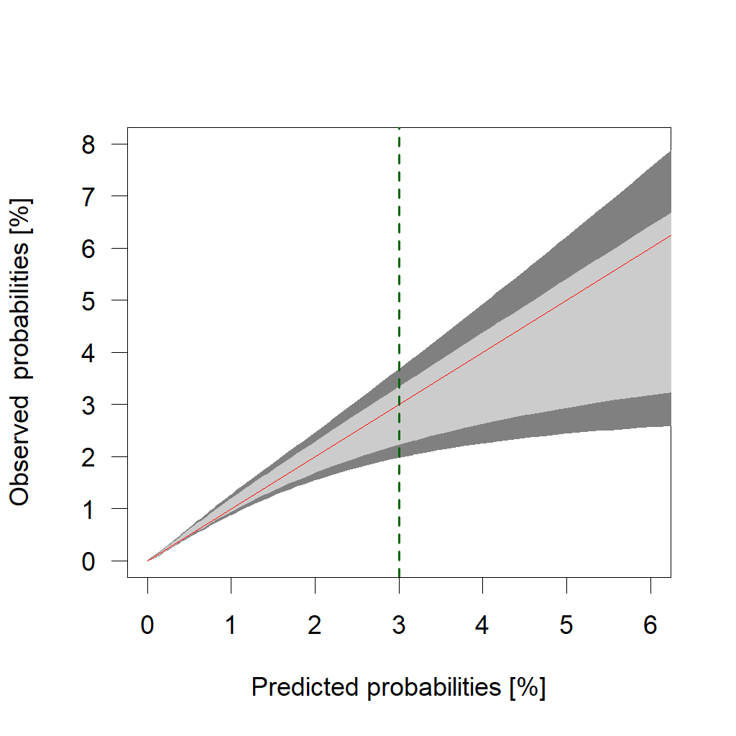
Figure 5: Calibration belts at 80% and 95% (light and dark grey). The predicted probabilities do not deviate from the observed ones by any statistical significance. The risk of over-estimation is however clear above 3%.

PAGE BREAK - TABLES
Table 1: Categorization of individual Charlson and Elixhauser comorbidities into broader comorbidities.
Comorbidities by groups | Charlson | Elixhauser
AIDS/HIV | Aids/hiv | Aids/hiv
Anemia |  | Blood loss anemia, Deficiency anemia
Arrhythmia |  | Cardiac arrhythmias
Arterial hypertension |  | Hypertension uncomplicated, Hypertension complicated
Cancer | Malignancy, Metastatic solid tumor | Lymphoma, Metastatic cancer, Solid tumor
CNS disease | Dementia, Hemiplegia or paraplegia | Depression, Paralysis, Other neurological disorders, Psychoses
Coagulopathy |  | Coagulopathy
Diabetes | Diabetes without complication, Diabetes complication | Diabetes uncomplicated, Diabetes complicated
Drug alcohol abuse |  | Alcohol abuse, Drug abuse
Fluid electrolyte disorders |  | Fluid electrolyte disorders
Heart condition | Congestive heart failure | Congestive heart failure, Valvular disease
Heart infarct | Myocardial infarction
Hypothyroidism |  | Hypothyroidism
Kidney disease | Renal disease | Renal failure
Liver disease | Mild liver disease, Moderate or severe liver disease | Liver disease
Lung airways disease | Chronic pulmonary disease | Chronic pulmonary disease, Pulmonary circulation disorder
Obesity |  | Obesity
Peptic ulcer | Peptic ulcer disease | Peptic ulcer disease
Rheumatic disease | Rheumatic disease | Rheumatoid arthritis
Vascular disease | Peripheral vascular disease, Cerebrovascular disease | Peripheral vascular disorder
Weight loss |  | Weight loss

PAGE BREAK
Table 2: Characteristics of the study population. Comorbidities recorded for at least one patient who survived 90 days, and one who did not, were modeled as potential predictors.
what | level | Died within 90 days | Survived at least 90 days
n |  | 175 | 52924
Age (mean (SD)) |  | 77.99 (7.89) | 72.66 (7.76)
Sex = Female (%) |  | 77 (44.0) | 32363 (61.1)
BMI (mean (SD)) |  | 26.81 (5.18) | 27.19 (4.39)
ASA grade (%)
 | 1 | 7 ( 4.0) | 9582 (18.1)
 | 2 | 86 (49.1) | 33795 (63.9)
 | 3 | 82 (46.9) | 9547 (18.0)
Hospital (%)
 | University | 74 (42.3) | 24386 (46.1)
 | County | 66 (37.7) | 16441 (31.1)
 | Rural | 19 (10.9) | 9921 (18.7)
 | Private | 16 ( 9.1) | 2176 ( 4.1)
Education (%)
 | Low | 30 (17.1) | 11615 (21.9)
 | Middle | 82 (46.9) | 20522 (38.8)
 | High | 63 (36.0) | 20787 (39.3)
Civil status (%)
 | Married | 83 (47.4) | 29353 (55.5)
 | Single | 38 (21.7) | 12850 (24.3)
 | Widow/widower | 54 (30.9) | 10721 (20.3)
Charlson (%)
 | 0 | 78 (44.6) | 39178 (74.0)
 | 1 | 41 (23.4) | 8076 (15.3)
 | 2 | 25 (14.3) | 3737 ( 7.1)
 | 3 | 12 ( 6.9) | 1164 ( 2.2)
 | 4+ | 19 (10.9) | 769 ( 1.5)
Elixhauser (%)
 | 0 | 56 (32.0) | 27717 (52.4)
 | 1 | 46 (26.3) | 13720 (25.9)
 | 2 | 31 (17.7) | 7208 (13.6)
 | 3+ | 42 (24.0) | 4279 ( 8.1)
AIDS/HIV (%) |  | 0 | 5 ( <0.1)
Anemia (%) |  | 4 ( 2.3) | 412 ( 0.8)
Arrhythmia (%) |  | 32 (18.3) | 4473 ( 8.5)
Arterial hypertension (%) |  | 70 (4<0.1) | 16607 (31.4)
Cancer (%) |  | 26 (14.9) | 2689 ( 5.1)
CNS disease (%) |  | 14 ( 8.0) | 1668 ( 3.2)
Coagulopathy (%) |  | 0 | 192 ( 0.4)
Diabetes (%) |  | 26 (14.9) | 4051 ( 7.7)
Drug alcohol abuse (%) |  | 1 ( 0.6) | 222 ( 0.4)
Fluid electrolyte disorders (%) |  | 0 | 304 ( 0.6)
Heart condition (%) |  | 31 (17.7) | 2608 ( 4.9)
Heart infarct (%) |  | 23 (13.1) | 2163 ( 4.1)
Hypothyroidism (%) |  | 7 ( 4.0) | 1784 ( 3.4)
Kidney disease (%) |  | 14 ( 8.0) | 537 ( 1.0)
Liver disease (%) |  | 0 | 207 ( 0.4)
Lung airways disease (%) |  | 18 (10.3) | 2860 ( 5.4)
Obesity (%) |  | 7 ( 4.0) | 993 ( 1.9)
Peptiulcer (%) |  | 2 ( 1.1) | 339 ( 0.6)
Rheumatidisease (%) |  | 10 ( 5.7) | 1912 ( 3.6)
Vascular disease (%) |  | 15 ( 8.6) | 1671 ( 3.2)
Weight loss (%) |  | 0 | 35 ( 0.1)

PAGE BREAK
Table 3: Variables selected by the bootstrap ranking procedure, and therefore kept in the ‘BRL’ model. Variables chosen at least 33 times out of 100 were kept in the ‘BRL reduced’ model as well. ASA grade 2 and 3 were kept in both models, since those are usually distinguished anyway. It would however be possible to use a model lumping grade 1 and 2 together.
variable | n
Cancer | 100
CNS disease | 100
Kidney disease | 100
ASA grade = 3 | 100
Age | 50
Obesity | 49
Male sex | 38
Heart condition | 20
Anemia | 9
ASA grade = 2 | 8
Heart infarct | 6

PAGE BREAK
Table 4: Area Under the Curve (AUC) as a measure of predictive accuracy for the ‘BRL’ model, the ‘BRL reduced’, a model with age and sex, as well as univariable models with ASA grade and the Charlson or Elixhauser comorbidity indices. Age was included as either a main effect, or in the form of restricted cubic splines (RCS) with three knots. ‘BRL reduced’ was also used without cancer and performed equally well in terms of AUC. The correction for optimism slightly decreased the AUC values, but those changes were marginal.
Model | AUC | AUC corrected for optimism
BRL (age as RCS) | 0.79 (0.76-0.82) | 0.77 (0.73-0.80)
BRL reduced (age as RCS) | 0.79 (0.75-0.82) | 0.77 (0.73-0.79)
BRL (age as main effect) | 0.79 (0.75-0.82) | 0.77 (0.73-0.80)
BRL reduced (age as main effect) | 0.78 (0.75-0.82) | 0.77 (0.74-0.80)
BRL reduced without cancer (age as main effect) | 0.78 (0.74-0.81) | 0.76 (0.72-0.79)
Age and sex (age as RCS) | 0.72 (0.68-0.76) | 0.72 (0.68-0.76)
Age and sex (age as main effect) | 0.72 (0.68-0.76) | 0.71 (0.67-0.75)
ASA | 0.68 (0.64-0.71) | 0.67 (0.64-0.71)
Charlson | 0.66 (0.62-0.70) | 0.66 (0.62-0.70)
Elixhauser | 0.64 (0.59-0.68) | 0.63 (0.59-0.67)

PAGE BREAK
Table 5: Estimated coefficients and odds ratios with 95% confidence intervals for the “BRL reduced” model.
term | beta | OR | p
(intercept) | -13.28
Cancer | 0.71 | 2.04 (1.30-3.08) | 0.001
CNS disease | 0.90 | 2.45 (1.35-4.11) | 0.002
Kidney disease | 1.33 | 3.79 (2.04-6.52) | <0.001
ASA grade = 2 | 0.88 | 2.42 (1.20-5.78) | 0.026
ASA grade = 3 | 1.66 | 5.27 (2.56-12.77) | <0.001
Age | 0.08 | 1.08 (1.06-1.11) | <0.001
Obesity | 0.77 | 2.17 (0.91-4.36) | 0.050
Male sex | 0.61 | 1.85 (1.36-2.52) | <0.001

PAGE BREAK

Bibliography
1 Price A, Smith J, Dakin H et al. The Arthroplasty Candidacy Help Engine tool to select candidates for hip and knee replacement surgery: development and economic modelling. Health Technology Assessment 2019; 23: 1–216.
2 Hunt LP, Ben-Shlomo Y, Clark EM et al. 90-day mortality after 409 096 total hip replacements for osteoarthritis, from the National Joint Registry for England and Wales: a retrospective analysis. The Lancet 2013; 382: 1097–104.
3 Garland A, Gordon M, Garellick G, Kärrholm J, Sköldenberg O, Hailer NP. Risk of early mortality after cemented compared with cementless total hip arthroplasty. The Bone & Joint Journal 2017; 99-B: 37–43.
4 Bülow E, Rolfson O, Cnudde P, Rogmark C, Garellick G, Nemes S. Comorbidity does not predict long-term mortality after total hip arthroplasty. Acta Orthopaedica 2017; 88: 1–6.
5 Inacio MCS, Pratt NL, Roughead EE, Graves SE. Using Medications for Prediction of Revision after Total Joint Arthroplasty. The Journal of arthroplasty 2015; 30: 2061–70.
6 Brusselaers N, Lagergren J. The Charlson Comorbidity Index in Registry-based Research. Methods of Information in Medicine 2017; 56: 401–6.
7 Walraven CV, Austin PC, Jennings A et al. A Modification of the Elixhauser Comorbidity Measures into a Point System for Hospital Death Using Administrative Data. Med 2009; 47: 626–33.
8 Manning DW, Edelstein AI, Alvi HM. Risk Prediction Tools for Hip and Knee Arthroplasty. The Journal of the American Academy of Orthopaedic Surgeons 2016; 24: 19–27.
9 Bülow E. Second is better! Large similarities between unilateral and second two-stage bilateral total hip arthroplasty for 70,694 patients with osteoarthritis. In: 8th international congress of arthroplasty registries. Leiden, 2019: No 14.
10 Ludvigsson JF, Otterblad-Olausson P, Pettersson BU, Ekbom A. The Swedish personal identity number: Possibilities and pitfalls in healthcare and medical research. European Journal of Epidemiology 2009; 24: 659–67.
11 Cnudde P, Rolfson O, Nemes S et al. Linking Swedish health data registers to establish a research database and a shared decision-making tool in hip replacement. BMC Musculoskeletal Disorders 2016; 17: 414.
12 Kärrholm J, Rogmark C, Nauclér E, Vinblad J, Mohaddes M, Rolfson O. Svenska Höftprotesregistret Årsrapport 2018. 2019.
13 Ludvigsson JF, Svedberg P, Olén O, Bruze G, Neovius M. The longitudinal integrated database for health insurance and labour market studies (LISA) and its use in medical research. European Journal of Epidemiology 2019; 34: 423–37.
14 Ludvigsson JF, Andersson E, Ekbom A et al. External review and validation of the Swedish national inpatient register. BMC public health 2011; 11: 450.
15 Charlson ME, Pompei P, Ales KL, MacKenzie CR. A new method of classifying prognostic comorbidity in longitudinal studies: Development and validation. Journal of Chronic Diseases 1987; 40: 373–83.
16 Deyo RA, Cherkin DC, Ciol MA. Adapting a clinical comorbidity index for use with ICD-9-CM administrative databases. Journal of Clinical Epidemiology 1992; 45: 613–9.
17 Quan H, Sundararajan V, Halfon P et al. Coding algorithms for defining comorbidities in ICD-9-CM and ICD-10 administrative data. Medical care 2005; 43: 1130–9.
18 Elixhauser A, Steiner C, Harris DR, Coffey RM. Comorbidity Measures for Use with Administrative Data. Medical care 1998; 36: 8–27.
19 Guo P, Zeng F, Hu X et al. Improved Variable Selection Algorithm Using a LASSO-Type Penalty, with an Application to Assessing Hepatitis B Infection Relevant Factors in Community Residents. PLOS ONE 2015; 10: e0134151.
20 Austin PC, Tu JV. Bootstrap Methods for Developing Predictive Models. The American Statistician 2004; 58: 131–7.
21 Miller ME, Hui SL, Tierney WM. Validation techniques for logistic regression models. Statistics in Medicine 1991; 10: 1213–26.
22 Nattino G, Finazzi S, Bertolini G. A new test and graphical tool to assess the goodness of fit of logistic regression models. Statistics in Medicine 2016; 35: 709–20.
23 Venables WN, Ripley B. Modern applied statistics with S. Springer, New York, 2002.
24 Bozic KJ, Ong K, Lau E et al. Estimating Risk in Medicare Patients With THA: An Electronic Risk Calculator for Periprosthetic Joint Infection and Mortality. Clinical Orthopaedics and Related Research 2013; 471: 574–83.
25 Mood C. Logistic Regression: Why We Cannot Do What We Think We Can Do, and What We Can Do About It. European Sociological Review 2010; 26: 67–82.
26 Haynes SR, Lawler PG. An assessment of the consistency of ASA physical status classification allocation. Anaesthesia 1995; 50: 195–9.
27 Whitmore RG, Stephen JH, Vernick C et al. ASA grade and Charlson Comorbidity Index of spinal surgery patients: correlation with complications and societal costs. The spine journal : official journal of the North American Spine Society 2014; 14: 31–8.
28 Kork F, Balzer F, Krannich A, Weiss B, Wernecke K-D, Spies C. Association of comorbidities with postoperative in-hospital mortality: a retrospective cohort study. Medicine 2015; 94: e576.
29 Gordon M, Stark A, Sköldenberg OG, Kärrholm J, Garellick G. The influence of comorbidity scores on re-operations following primary total hip replacement: comparison and validation of three comorbidity measures. The bone & joint journal 2013; 95-B: 1184–91.
30 Hofstede SN, Gademan MGJ, Vliet Vlieland TPM, Nelissen RGHH, Marang-van de Mheen PJ. Preoperative predictors for outcomes after total hip replacement in patients with osteoarthritis: a systematic review. BMC musculoskeletal disorders 2016; 17: 212.
31 Gerdin M, Roy N, Khajanchi M et al. Validation of a novel prediction model for early mortality in adult trauma patients in three public university hospitals in urban India. BMC emergency medicine 2016; 16: 15.
32 Söderman P, Malchau H, Herberts P, Johnell O. Are the findings in the Swedish National Total Hip Arthroplasty Register valid? A comparison between the Swedish National Total Hip Arthroplasty Register, the National Discharge Register, and the National Death Register. The Journal of arthroplasty 2000; 15: 884–9.
33 Söderman P, Malchau H, Herberts P, Zügner R, Regnér H, Garellick G. Outcome after total hip arthroplasty: Part II. Disease-specific follow-up and the Swedish National Total Hip Arthroplasty Register. Acta orthopaedica Scandinavica 2001; 72: 113–9.

