Validation

Erik Bulow

2020-01-21

# Flowchart

Patients included from NJR. (Many excluded due to fixation.)

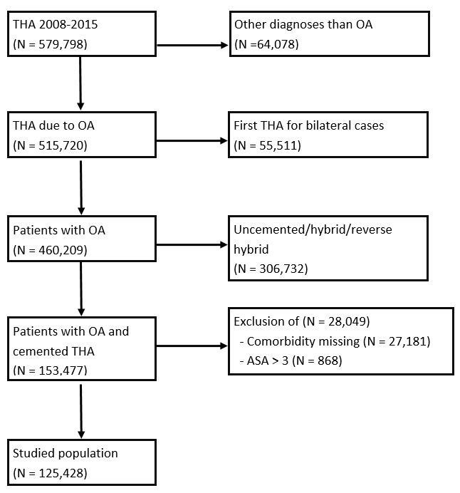

# Summary table

## NJR

|  |  |  |  |  |
| --- | --- | --- | --- | --- |
| What | level | Total (N=125,428) | Deceased (N=654) | Alive (N=124,774) |
| Age (mean, SD) |  | 73.5 (8.7) | 79.4 (7.7) | 73.5 (8.7) |
| Male (n, %) |  | 43,181 (34.4) | 311 (47.6) | 42,870 (34.4) |
| ASA | 1 | 10,890 (8.7) | 31 (4.7) | 10,859 (8.7) |
|  | 2 | 89,388 (71.3) | 312 (47.7) | 89,076 (71.4) |
|  | 3 | 25,150 (20.0) | 311 (47.6) | 24,839 (19.9) |
| Cancer disease (n, %) |  | 3,055 (2.4) | 52 (8.0) | 3,003 (2.4) |
| CNS disease (n, %) |  | 7,075 (5.6) | 77 (11.8) | 6,998 (5.6) |
| Kidney disease (n, %) |  | 7,370 (5.9) | 115 (17.6) | 7,255 (5.8) |

## To be compared with SHAR:

|  |  |  |  |  |
| --- | --- | --- | --- | --- |
| what | level | Died within 90 days | Survived at least 90 days | Total |
| n |  | 175 | 52924 | 53099 |
| Age (mean (SD)) |  | 77.99 (7.89) | 72.66 (7.76) | 72.68 (7.76) |
| Sex = Female (%) |  | 77 (44.0) | 32363 (61.1) | 32440 (61.1) |
| ASA grade (%) |  |  |  |  |
| ASA grade (%) | 1 | 7 ( 4.0) | 9582 (18.1) | 9589 (18.1) |
| ASA grade (%) | 2 | 86 (49.1) | 33795 (63.9) | 33881 (63.8) |
| ASA grade (%) | 3 | 82 (46.9) | 9547 (18.0) | 9629 (18.1) |
| Cancer (%) |  | 26 (14.9) | 2689 ( 5.1) | 2715 ( 5.1) |
| CNS disease (%) |  | 14 ( 8.0) | 1668 ( 3.2) | 1682 ( 3.2) |
| Kidney disease (%) |  | 14 ( 8.0) | 537 ( 1.0) | 551 ( 1.0) |

# ROC curve

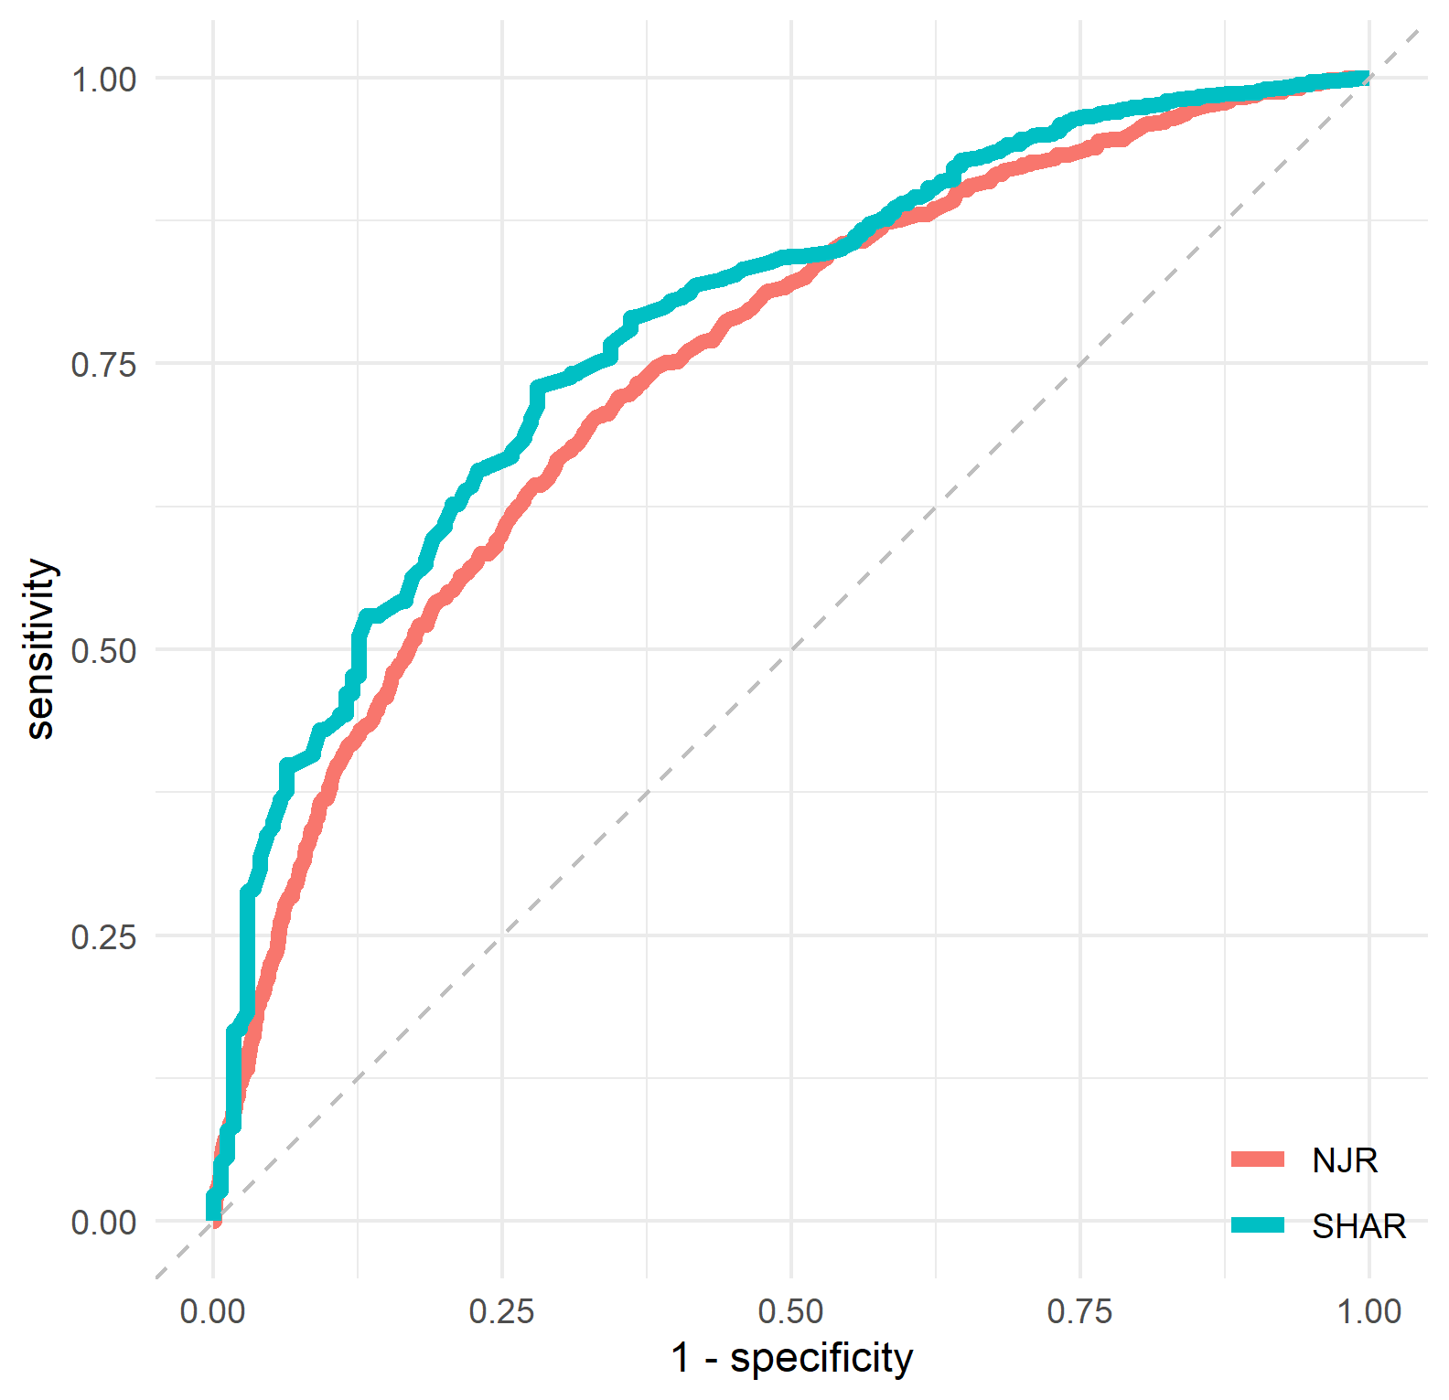

# AUC

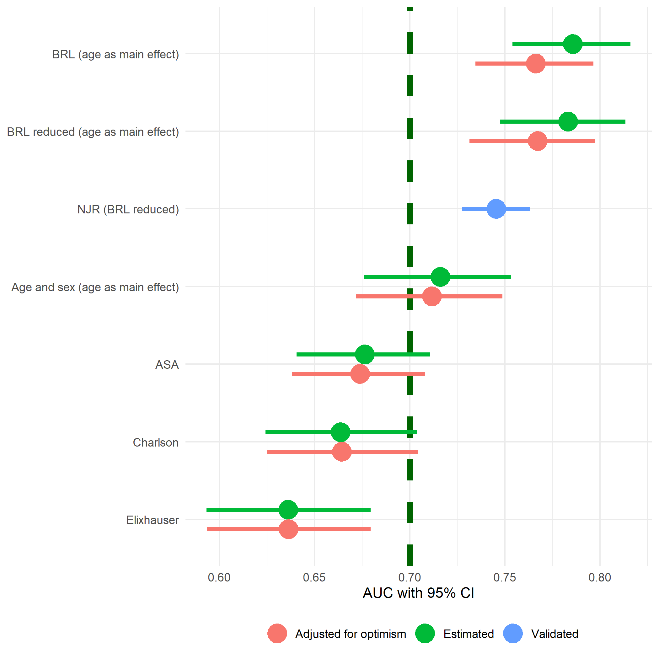

# Calibration

Model as-is overestimates probabilityies (as expected) but a re-calibrated version looks like this:

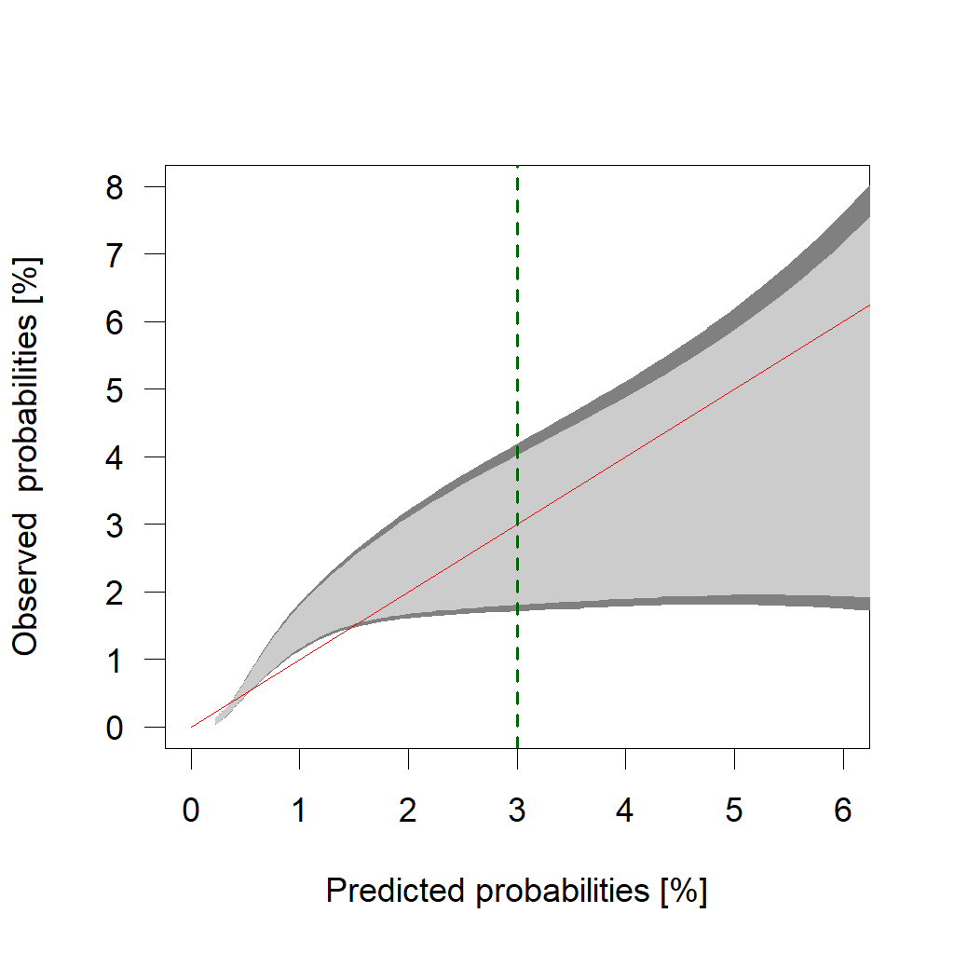

To compare with SHAR:

