Prediction of 90-day mortality after Total Hip Arthroplasty: a simplified and externally validated model based on Swedish and English and Wales registry data

Anne Garland1,2,3, Erik Bulow2,4, Erik Lenguerrand5, Ashley Blom6, Mark Wilkinson7, Adrian Sayers8, Szilard Nemes2,4, Ola Rolfson2,4, Nils P. Hailer1,2

2019-10-02

# Affiliation and contact

1. Department of Orthopaedics, Institute of Surgical Sciences, Uppsala University Hospital, Uppsala, Sweden
2. Swedish Hip Arthroplasty Register, Gothenburg, Sweden
3. Department of Orthopaedics, Visby Hospital, Visby, Sweden
4. Department of Orthopaedics, Institute of Clinical Sciences, The Sahlgrenska Academy, University of Gothenburg, Gothenburg, Sweden
5. Translational Health Sciences, Bristol Medical School, University of Bristol, England.
6. …
7. …
8. …

**Correspondence:** AG: [anne.garland@surgsci.uu.se](mailto:anne.garland@surgsci.uu.se), Phone: +46 498 26 80 00, Postal: Orthopedic Department, Visby Hospital, St Goransgatan 10, 621 84 Visby, Sweden  
EB: [erik.bulow@registercentrum.se](mailto:erik.bulow@registercentrum.se)  
SN: [szilard.nemes@registercentrum.se](mailto:szilard.nemes@registercentrum.se)  
NH: [nils.hailer@surgsci.uu.se](mailto:nils.hailer@surgsci.uu.se)

# Abstract

**OBJECTIVE:** Shared decision making is essential before total hip arthroplasty (THA) surgery. Comorbidities are associated with an increased risk of 90-day morbidity and -mortality, but diagnosis code-based instruments such as the Charlson or Elixhauser comorbidity indices are impossible to use in a clinical setting, and the American Society for Anesthesiologists (ASA) grade is imprecise. We searched for a simple model to predict early mortality after THA.

**PATIENTS AND METHODS:** We studied 53,099 Swedish patients operated with a cemented THA due to primary osteoarthritis and linked data from several national registries in order to collect information on demographics and comorbidities. Bootstrap ranking procedures were used together with logistic regression to develop prediction models for death within 90 days, and predictive power was assessed by the areas under the receiver operating characteristic curve (AUC). The final model was externally validated on a dataset from the National Joint Registry of England & Wales .

**RESLUTS:** The unadjusted cumulative 90-day survival was 99.7 % (95 % CI: 99.6 - 99.7). Best predictive performance for 90-day mortality was found for a model combining age, sex, ASA grade, the presence of CNS-, kidney- or heart diseases, cancer, obesity, or anemia (AUC = 0.78 (0.75-0.82)). This model was superior to the Charlson (AUC = 0.66 (0.62-0.70)) and Elixhauser comorbidity measures (AUC = 0.64 (0.59-0.68)). A web calculator to aid clinical usage was published at <https://erikbulow.shinyapps.io/thamortpred/>.

**CONCLUSION:** We found a relatively simple prediction model of 90 day mortality after total hip arthroplasty. This model requires less data and is easier to calculate compared to previously well-known comorbidity indices.

# Introduction

Shared decision making has evolved into an integral part of patient-physician interactions prior to surgical interventions, and the weighing of risks against benefits is central to this process. In terms of gained quality of life and cost-utility, total hip arthroplasty (THA) is an enormously successful procedure, but the risk of adverse events in the short and long term is an essential part of preoperative discussions and various risk prediction models have been developed.{Price A 2019}

90-day mortality after THA surgery performed due to osteoarthritis is low, ranging between 0.2 and 0.6% in large joint registry analyses where adjustment for comorbidities is possible.{Hunt LP 2013, Lancet}{Garland A 2017, BJJ} The presence of comorbidities is associated with poorer outcome after the insertion of THA, (Inacio et al. 2015) but the Charlson (CCI) and Elixhauser (ECI) Comorbidity Indices poorly predict mortality after THA and total knee arthroplasty{ref Inacio or other??}. Additionally, these complex comorbidity instruments are based on the availability of extensive datasets including in- and outpatient data on ICD-codes, and each of the comorbidity indices exists in numerous versions (Sundararajan et al. 2004; Deyo, Cherkin, and Ciol 1992; Quan et al. 2011; Cleves, Sanchez, and Draheim 1997; Walraven et al. 2009). Interpretation and comparison of different studies is therefore difficult.

Comorbidity data are used to construct universal or arthroplasty-specific risk prediction tools, but no model has so far been broadly accepted to predict mortality after elective THA (Manning, Edelstein, and Alvi 2016; Bülow et al. 2017). In order to propel arthroplasty surgery into the age of precision medicine, easily applicable tools to predict short- and long-term complications are urgently needed. We aimed to define a model that accurately predicts the risk of 90-day postoperative mortality after THA performed due to osteoarthritis .

# Patients and Methods

Patients recorded in the Swedish Hip Arthroplasty Register (SHAR) with cemented primary hip osteoarthritis 2008 - 2015 were included in the development phase of the study (Figure 1). Only the last operated hip was accounted for in patients with bilateral THA (Bülow 2019).

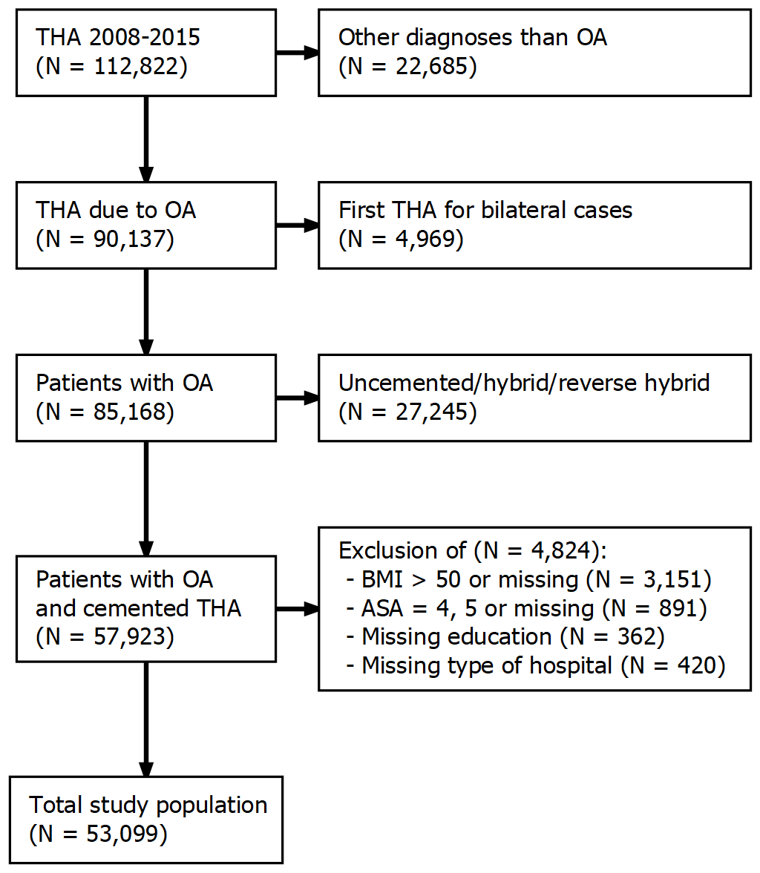

Figure 1: Flowchart depicting inclusion criteria and number of patients included in the development phase of the model.

Data linkage, based on the 10-digit identity numbers assigned to all Swedish residents (Ludvigsson et al. 2009), were used to collect data from a variety of sources, as previously described by Cnudde et al. (2016).

Age, sex, body mass index (BMI), ASA grade, type of hospital (university/county/rural/private) and year of surgery were collected from the SHAR which has a completeness of 96-98 % (Kärrholm et al. 2019). Data on education level (low/middle/high) and civil status (married/un-married/divorced/widow[er]), were collected from the longitudinal integration database for health insurance and labor market studies from Statistics Sweden (Ludvigsson et al. 2019). The Swedish National Patient Register was used to assess comorbidities during the year preceding index surgery. This register contains all relevant diagnoses coded by ICD-10, as well as dates of admission and discharge for in- and outpatient episodes in all private and public hospitals (Ludvigsson et al. 2011). Death dates were linked from the national population register.

Comorbidity was defined by individual ICD-10 codes grouped into 17 categories according to CCI (Charlson et al. 1987; Deyo, Cherkin, and Ciol 1992; Quan et al. 2005) and 31 categories according to ECI (Elixhauser et al. 1998; Quan et al. 2005). Patients with no recorded hospital visits during one year before surgery, were assumed to have no comorbidity.

Table 1: Categorization of individual Charlson (CCI) and Elixhauser (ECI) comorbidities into broader comorbidities.

|  |  |  |
| --- | --- | --- |
| Comorbidities by groups | CCI | ECI |
| AIDS/HIV | AIDS/HIV | AIDS/HIV |
| Anemia |  | blood loss anemia, deficiency anemia |
| Arrhythmia |  | cardiac arrhythmias |
| Cancer | malignancy, metastatic solid tumor | lymphoma, metastatic cancer, solid tumor |
| CNS | dementia, hemiplegia or paraplegia | depression, paralysis, other neurological disorders, psychoses |
| Diabetes | diabetes without complication, diabetes complication | diabetes uncomplicated, diabetes complicated |
| Drug alcohol abuse |  | alcohol abuse, drug abuse |
| Heart condition | congestive heart failure | congestive heart failure, valvular disease |
| Heart infarct | myocardial infarction |  |
| Hypertoni |  | hypertension uncomplicated, hypertension complicated |
| Kidney disease | renal disease | renal failure |
| Liver disease | mild liver disease, moderate or severe liver disease | liver disease |
| Lung airways disease | chronic pulmonary disease | chronic pulmonary disease, pulmonary circulation disorder |
| Peptic ulcer | peptic ulcer disease | peptic ulcer disease |
| Reuma | rheumatic disease | rheumatoid arthritis |
| Vascular disease | peripheral vascular disease, cerebrovascular disease | peripheral vascular disorder |

Some comorbidities were identified by both CCI and ECI, and some distinct comorbidities were closely related (such as hypertension with and without complications, or abuse of either drugs or alcohol). We used those categories to establish 16 broader categories (Table 1) in addition to 5 standalone ECI classes that were kept unchanged (hypothyroidism, coagulopathy, obesity, weight loss and fluid electrolyte disorders). Groups were merged according to clinical relevance as to be recognized in a patient-doctor meeting without access to external register data. Comorbidities recorded for at least one patient who died within 90 days, and one who did not, were included in the modelling process described below. The final model was also altered to not include cancer as a predictor. Patients with cancer are sometimes treated differently in the clinical setting, introducing difficulties in interpretation of this variable.

## Statistics

We used the Kaplan-Meier estimator to assess unadjusted cumulative survival.

Further analyses were based on logistic regression since no censoring occurred within the 90 day study period. We used a modelling procedure described by Guo et al. (2015) as a bootstrap ranking procedure with a logistic least absolute shrinkage and selection operator (LASSO) model. Numeric variables (age and BMI) were normalized before modelling to have mean = 0 and standard deviation = 1. 1,000 bootstrap samples were drawn from the initial data set (Austin and Tu 2004). We used 10-fold cross validation for every bootstrap sample with a broad range of potential penalty values ($λ$:s) in a logistic LASSO model. We then only kept $λ$:s minimizing the mean cross-validated deviances in each sample. Those $λ$:s were used to estimate model coefficients for each potential predictor. Absolute values from those estimates were used as a measure of variable importance. Piece-wise linear regression was then used to detect a break point where a significant drop in variable importance were observed. Potential predictors with variable importance above this break point were considered important and kept as model candidates. The whole process was repeated ten times.

Covariates that were selected each of the ten times were used in a main effects model of multivariable logistic regression without penalty, and without pre-normalization of numeric variables. We will call this model “BRL all”, where BRL stands for bootstrap ranking LASSO. A similar model, including any variable selected at least one out of ten times will be called “BRL any”. Univariable models with the ASA score, CCI and ECI were used for comparison, as well as a multivariable model with age and sex. Each model including age was fitted three times, once with age as a main effect and twice with restricted cubic splines, either by two or three knots.

Each of those models were used to predict the probability of death within 90 days for each patient. Sensitivity and specificity were estimated to form receiver operating characteristic (ROC) curves and the area under those curves (AUC) were used as a measure of predicitve power. Models with a lower 95 % confidence limit (Delong and Carolina 1988) above 0.7, were considered good. Odds ratios for the model with highest AUC were estimated with 95 % confidence intervals based on interpolations of profile traces (Venables and Ripley 2002).

t

We used R version 3.6.1 (R Foundation for Statistical Computing, Vienna, Austria) with significant packages tidyverse, tidymodels, furrr and pROC. All R-scripts and necessary software (but no personal data) is available as a live Binder environment (<https://mybinder.org/v2/gh/eribul/thamortpred/master?urlpath=rstudio>). A static archived version is also available at zenodo.org/XXX. **Prepared but non-public until paper is accepted/published!**

## Ethical approval

Ethical approval for this study was obtained from the Regional Ethical Review Board in Gothenburg (271-14 and 360-13).

# Results

After application of exclusion criteria, 53, 099 patients (age 35 - 99, 61% females) were included in the analysis (Figure 1). 175 (0.33 %) patients died within 90 days and no one was censored before that. The unadjusted cumulative 90-day survival was 99.7 % (95 % CI: 99.6 - 99.7).

Characteristics of the study population are presented in Table 2. 26 % of all patients had at least one pre-surgery comorbidity according to CCI, and 48 % according to ECI. The proportion of patients with ASA class 3 was 18 %. Most individual comorbidities were more common among patients who died.

Table 2: Baseline demographics. CCI/ECI = Charlson/Elixhauser comorbidity indices. Comorbidities prefixed with ECI are defined by the Elixhauser classification. Remaining comorbidities are based on the previously described combination of CCI and ECI. Comorbidities recorded for at least one patient who survived 90 days, and one who did not, were modeled as potential predictors.

|  |  |  |  |
| --- | --- | --- | --- |
| what | level | alive | dead |
| n |  | 52924 | 175 |
| Age (mean (SD)) |  | 72.66 (7.76) | 77.99 (7.89) |
| Sex = Female (%) |  | 32363 (61.1) | 77 (44.0) |
| BMI (mean (SD)) |  | 27.19 (4.39) | 26.81 (5.18) |
| ASA grade (%) |  |  |  |
|  | 1 | 9582 (18.1) | 7 ( 4.0) |
|  | 2 | 33795 (63.9) | 86 (49.1) |
|  | 3 | 9547 (18.0) | 82 (46.9) |
| Hospital (%) |  |  |  |
|  | University | 24386 (46.1) | 74 (42.3) |
|  | County | 16441 (31.1) | 66 (37.7) |
|  | Rural | 9921 (18.7) | 19 (10.9) |
|  | Private | 2176 ( 4.1) | 16 ( 9.1) |
| education (%) |  |  |  |
|  | low | 11615 (21.9) | 30 (17.1) |
|  | middle | 20522 (38.8) | 82 (46.9) |
|  | high | 20787 (39.3) | 63 (36.0) |
| civil status (%) |  |  |  |
|  | married | 29353 (55.5) | 83 (47.4) |
|  | single | 12850 (24.3) | 38 (21.7) |
|  | widow/widower | 10721 (20.3) | 54 (30.9) |
| CCI (%) |  |  |  |
|  | 0 | 39178 (74.0) | 78 (44.6) |
|  | 1 | 8076 (15.3) | 41 (23.4) |
|  | 2 | 3737 ( 7.1) | 25 (14.3) |
|  | 3 | 1164 ( 2.2) | 12 ( 6.9) |
|  | 4+ | 769 ( 1.5) | 19 (10.9) |
| ECI (%) |  |  |  |
|  | 0 | 27717 (52.4) | 56 (32.0) |
|  | 1 | 13720 (25.9) | 46 (26.3) |
|  | 2 | 7208 (13.6) | 31 (17.7) |
|  | 3+ | 4279 ( 8.1) | 42 (24.0) |
| heart condition (%) |  | 2608 ( 4.9) | 31 (17.7) |
| heart infarct (%) |  | 2163 ( 4.1) | 23 (13.1) |
| arrythmia (%) |  | 4473 ( 8.5) | 32 (18.3) |
| arterial hypertension (%) |  | 16607 (31.4) | 70 (40.0) |
| kidney disease (%) |  | 537 ( 1.0) | 14 ( 8.0) |
| diabetes (%) |  | 4051 ( 7.7) | 26 (14.9) |
| vascular disease (%) |  | 1671 ( 3.2) | 15 ( 8.6) |
| cancer (%) |  | 2689 ( 5.1) | 26 (14.9) |
| aids hiv (%) |  | 5 ( 0.0) | 0 ( 0.0) |
| liver disease (%) |  | 207 ( 0.4) | 0 ( 0.0) |
| lung airways disease (%) |  | 2860 ( 5.4) | 18 (10.3) |
| drug alcohol abuse (%) |  | 222 ( 0.4) | 1 ( 0.6) |
| cns disease (%) |  | 1668 ( 3.2) | 14 ( 8.0) |
| Rheumatic disease (%) |  | 1912 ( 3.6) | 10 ( 5.7) |
| anemia (%) |  | 412 ( 0.8) | 4 ( 2.3) |
| Peptic ulcer (%) |  | 339 ( 0.6) | 2 ( 1.1) |
| ECI hypothyroidism (%) |  | 1784 ( 3.4) | 7 ( 4.0) |
| ECI coagulopathy (%) |  | 192 ( 0.4) | 0 ( 0.0) |
| ECI obesity (%) |  | 993 ( 1.9) | 7 ( 4.0) |
| ECI weight loss (%) |  | 35 ( 0.1) | 0 ( 0.0) |
| ECI fluid electrolyte disorders (%) |  | 304 ( 0.6) | 0 ( 0.0) |

There were 5 comorbidities that were not recorded for any patient who died: AIDS/HIV, liver disease, ECI coagulopathy, ECI weight loss and ECI fluid electrolyte disorders, and these variables were thus excluded from the modelling process.

The “BRL any” model included age, sex, ASA, cancer, CNS, kidney disease, obesity, anemia and heart condition. The "BRL all model only included ASA, cancer, CNS, and kidney disease.

We observed no relevant differences between models based on age described by restricted cubic splines with two versus three knots and therefore only present results for models based on three knots. The use of splines did however not improve the accuracy of the models when compared to simpler main effect models. The “BRL any” model had an estimated AUC of 0.78 (CI: 0.75-0.82). The altered version without cancer performed equally good. The “BRL any” model was significantly better than the “BRL all” model with AUC 0.70 (CI: 0.66-0.74). Univariable models with ASA, CCI or ECI performed poorly with an that was AUC lower than 0.7. A model based on only age and sex performed slightly better than models using the comorbidity measures above, but with an AUC not statistically significantly above 0.7 (Table 3).

Table 3: Area Under the Curve (AUC) as a measure of predictive power for the ‘BRL any’ model compared to ‘BRL all’, a simpler model with age and sex, as well as univariable models with ASA score and the Charlson (CCI) or Elixhauser (ECI) comorbidity indices. Age was included as either a main effect, or in the form of restricted cubic splines (RCS) with three knots.

|  |  |
| --- | --- |
| Model | AUC |
| BRL any (age as RCS) | 0.79 (0.76-0.82) |
| BRL any (age as main effect) | 0.78 (0.75-0.82) |
| BRL any without cancer | 0.78 (0.74-0.81) |
| Age and sex (age as RCS) | 0.72 (0.68-0.76) |
| Age and sex(age as main effect) | 0.72 (0.68-0.76) |
| BRL all | 0.70 (0.66-0.74) |
| ASA | 0.68 (0.64-0.71) |
| CCI | 0.66 (0.62-0.70) |
| ECI | 0.64 (0.59-0.68) |

ROC curves for some of the models are displayed in Figure 2. The “BRL any” model is superior to all other models.

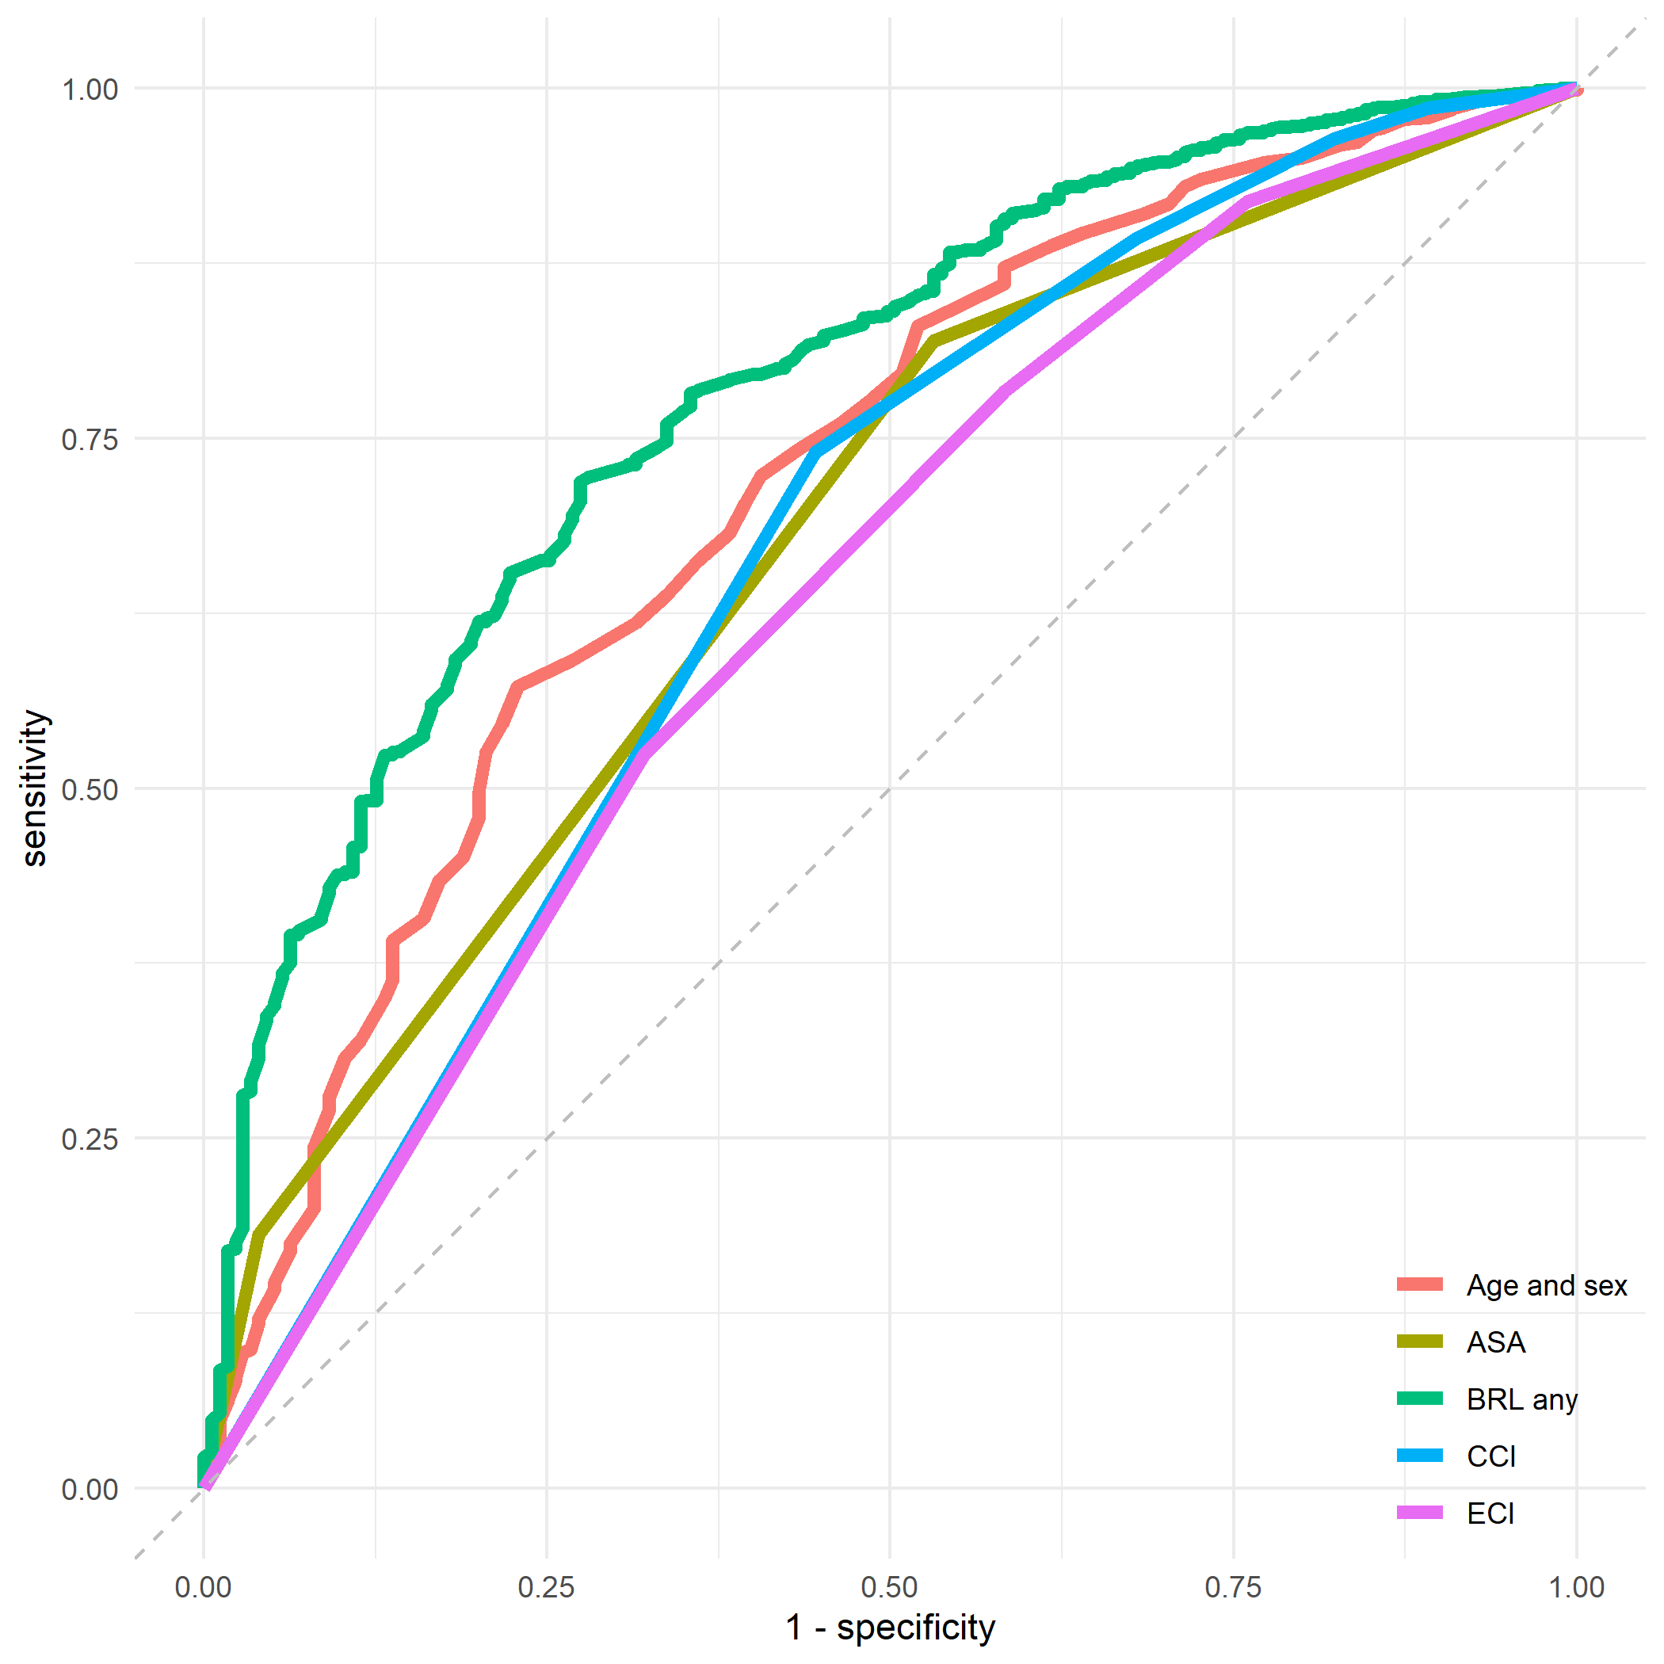

Figure 2: ROC curves for some of the models. The ‘BRL any’ model is distinguished from other models, which are partially over-lapping.

AUCs and 95 % confidence intervals are illustrated for the same models in Figure 3).

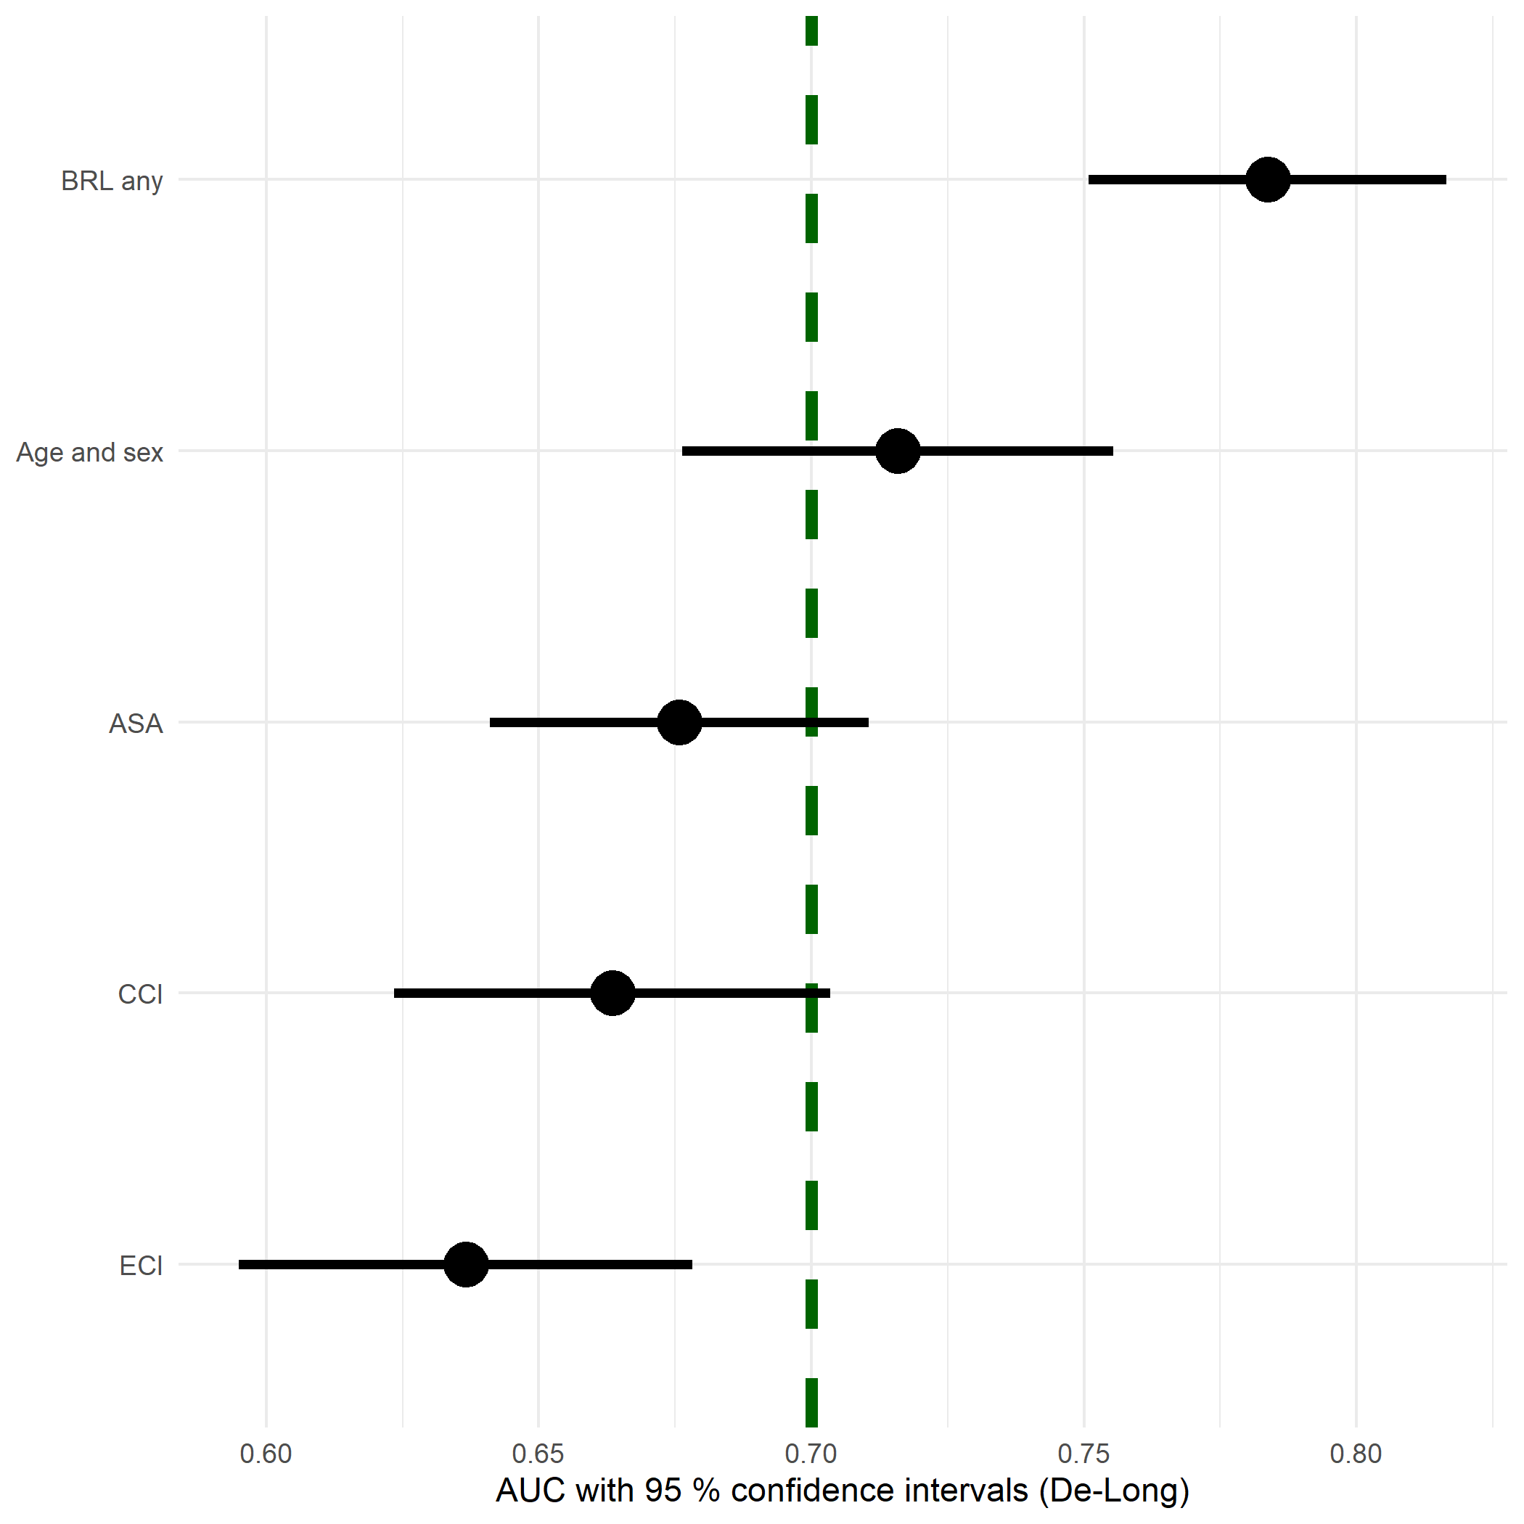

Figure 3: Area Under the Curve (AUC) as a measure of predictive power for the ‘BRL any’ model compared to a simpler model with age and sex, as well as univariable models with ASA score and the Charlson (CCI) or Elixhauser (ECI) comorbidity indices.

The ability of model “BRL any” to estimate probabilities of death within 90 days is illustrated in Figure 4. Patients who died had, on average, higher predicted probabilities to do so.

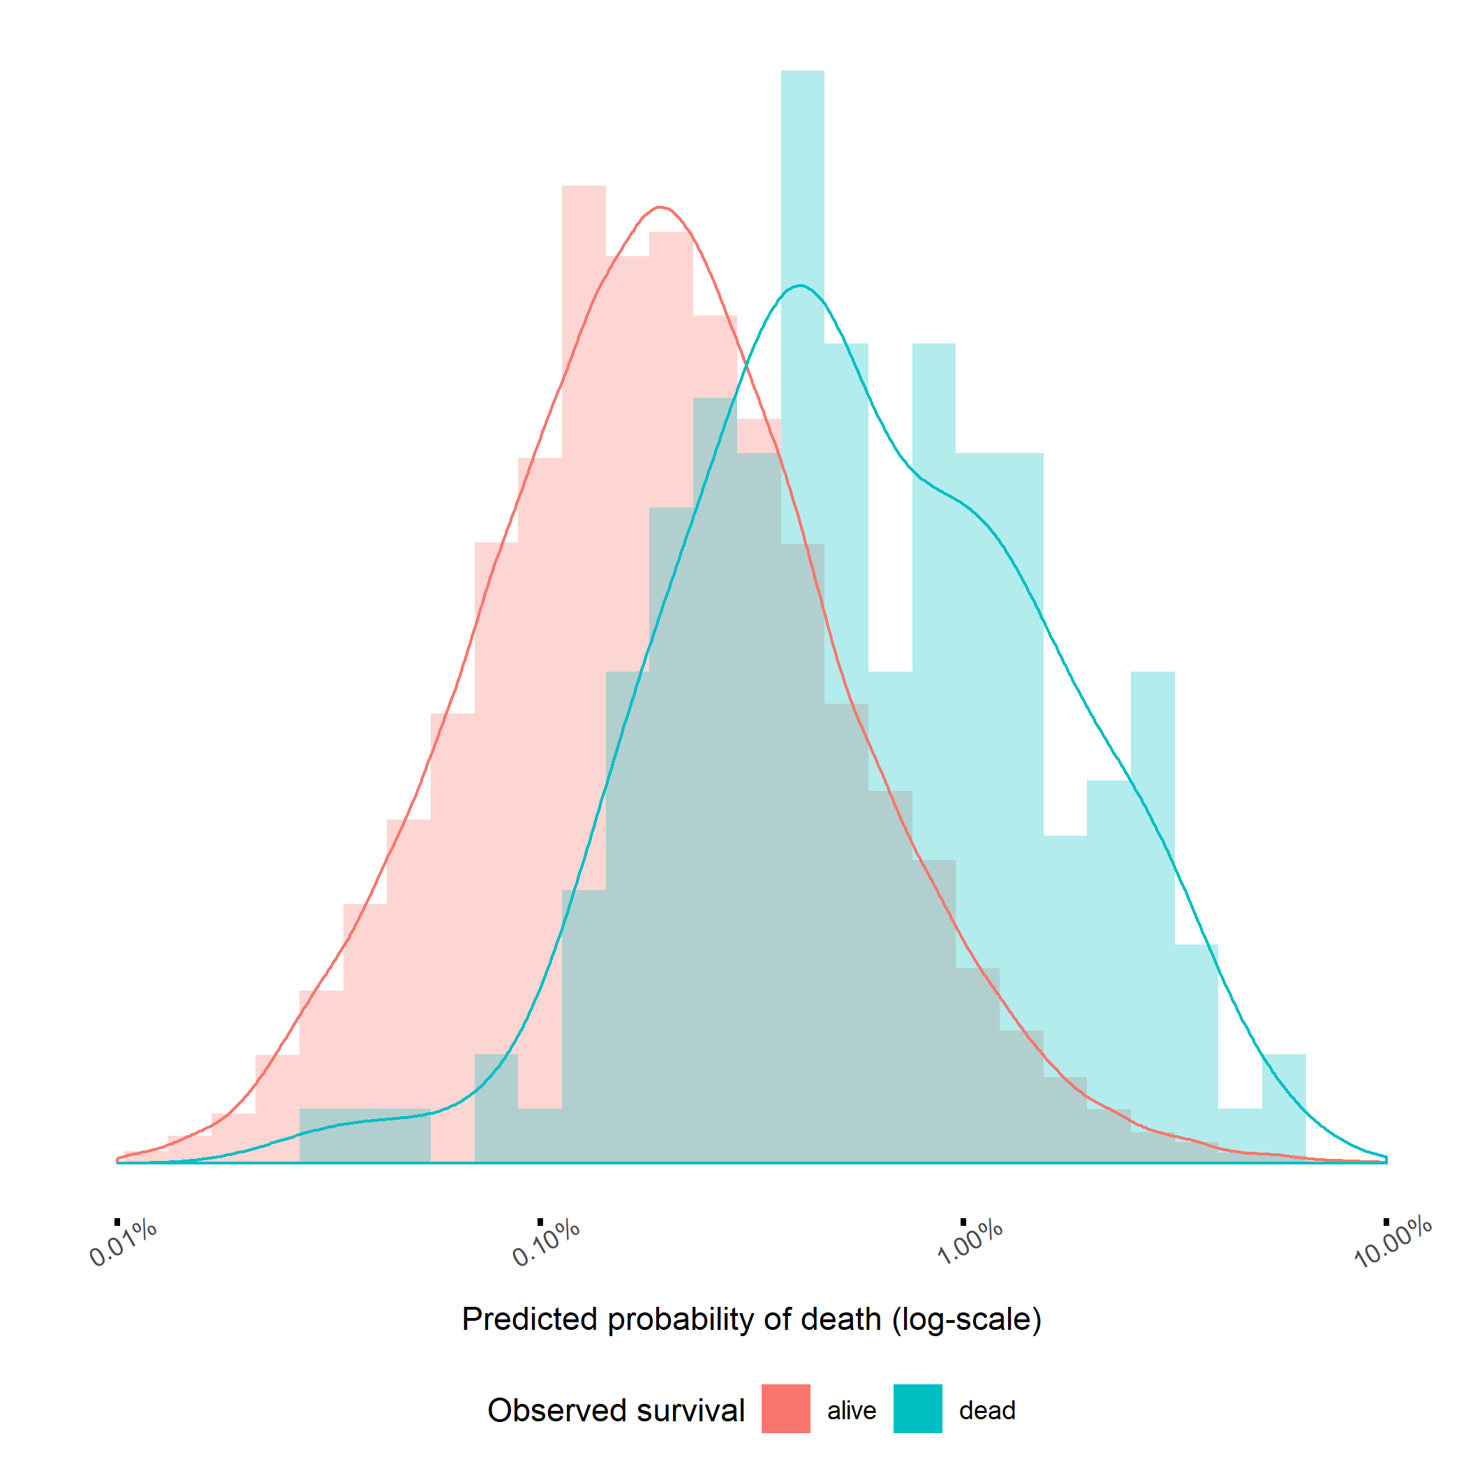

Figure 4: Patients who died within 90 days (blue) were, on average, estimated to have a higher probability to do so.

Estimated coefficients and corresponding odds ratios for the “BRL any” model is presented in Table 4.

Table 4: Estimated coefficients and odds ratios with 95 % confidence intervals for the “BRL any” model. Notations from the X-column is used in the formula in the disussion section.

|  |  |  |  |  |
| --- | --- | --- | --- | --- |
| term | X | beta | OR | p |
| (Intercept) |  | -13 |  |  |
| cancer | $$X_{1}$$ | 1 | 2.05 (1.31-3.11) | 0.001 |
| cns | $$X_{2}$$ | 1 | 2.46 (1.35-4.13) | 0.001 |
| kidney disease | $$X_{3}$$ | 1 | 3.46 (1.86-5.98) | <0.001 |
| ASA2 | $$X_{4}$$ | 1 | 2.37 (1.17-5.67) | 0.029 |
| ASA3 | $$X_{5}$$ | 2 | 4.73 (2.28-11.51) | <0.001 |
| ECI obesity | $$X_{6}$$ | 1 | 2.09 (0.87-4.21) | 0.063 |
| GenderMan | $$X_{7}$$ | 1 | 1.83 (1.34-2.49) | <0.001 |
| Age | $$X_{8}$$ | 0 | 1.08 (1.06-1.10) | <0.001 |
| anemia | $$X_{9}$$ | 1 | 1.83 (0.56-4.42) | 0.238 |
| heart condition | $$X_{10}$$ | 1 | 1.73 (1.12-2.59) | 0.010 |

We have provided a web calculator to aid clinical model usage in practice (<https://erikbulow.shinyapps.io/thamortpred/>).

# Discussion

In this nationwide cohort study we intended to compare the performance of a set of easily accessible data that are routinely collected in daily clinical practice with the complex comorbidity coding algorithms suggested by Charlson and Elixhauser. We found that a multivariable main effects logistic regression model with age, sex, ASA, cancer, CNS, kidney disease, obesity, anemia and heart condition was able to make better predictions than either CCI or ECI.

The resulting “BRL any” model can predict the probability of death ($p$) within 90 days for new patients as:

$$p=1/(1+exp(-13+0.72⋅X_{1}+0.90⋅X_{2}+1.24⋅X_{3}+0.86⋅X_{4}+1.55⋅X_{5}+0.74⋅X_{6}+0.60⋅X_{7}+0.08⋅X_{8}+0.61⋅X_{9}+0.55⋅X_{10}))$$

where $X_{i}$ indicate independent variables as notated in table 4. This formula is valid for patients within the observed age range (35 - 99 years).

For example a 35 yer old woman with ASA = 1 and none of the important comorbidities would only have a 0.0032 % risk to die within 90 days after elective THA surgery. Another woman, 67 years old (the first age quantile), have a higher risk of 0.038 %. A man, 78 years old (the third age quantile) with ASA = 3 and a previous heart condition would have a risk of 1.3 % risk. The perhaps unrealistic case of a 99 year old man with ASA = 3 and all listed comorbidities would have a theoretical risk as high as 82 %. Note however that this extreme case relies on extrapolation which is highly unreliable, since no such person was actually observed.

Some covariates in the “BRL any” model were not statistically significant by themselves but were still relevant due to unobserved heterogeneity (Mood 2010). Obesity for example is known to be associated with a higher risk of morbidity and all-cause mortality (Must and McKeown 2000). However, previous studies on primary THA cohorts have not indicated a higher risk of mortality in obese patients (Wallace et al. 2014). An explanation could be that obese patients selected for THA are comparably healthy and often younger.

Cancer could also be dropped as a predictor without any loss of predictive power. It was also encouraging that socio-demographic factors such as education and civil status, or organizational factors such as type of hospital, did not have a strong enough influence to be included in the final model.

It is known that male sex is associated with earlier deaths and that the remaining life span will decrease with increased age. It is less obvious that this relation must be linear. We used restricted cubic splines to allow a more flexible relation, but found that a linear relationship was equally good. Our model includes ASA class which is routinely assessed pre-operatively in most developed countries. It is however known to have a high degree of internal variability (Haynes and Lawler 1995). It has previously been compared to the CCI, but not with respect to mortality after THA (Whitmore et al. 2014; Kork et al. 2015). Patients with ASA 4-6 were excluded since those categories describe severe disease, moribund and brain-dead individuals. It can be questioned whether such classification is correct for our cohort. Comorbidities are also known to influence the outcome after THA (Inacio et al. 2015; Gordon et al. 2013; Hofstede et al. 2016). Coding algorithms on the other hand are complex and not used in clinical settings since the administrative burden is too high. CCI comprise 1,178 ICD-10 codes and ECI 1,516. Therefore, such indices are only used by researchers.

Risk prediction may be useful in the process of patient selection prior to surgery, in the preoperative risk management including a review of current medications, and in perioperative anesthesia management. A number of risk prediction tools of various complexity for adverse outcomes after total joint replacements have been introduced but none has been broadly accepted (Manning, Edelstein, and Alvi 2016). In the context of trauma surgery outcome prediction tools are common, and it seems possible to reduce the number of items without losing predictive power (Gerdin et al. 2016). Our results indicate that the risk of early postoperative mortality after THA could be assessed by a relatively simple prediction model.

A strength of this study is the nationwide design with a large cohort of primary THA patients. We were able to use exact data linkage by the Swedish unique identity numbers and had no censoring. Our data sources are valid with low proportions of missing data (Söderman et al. 2000, 2001; Kärrholm et al. 2019; Ludvigsson et al. 2011).

The risk of coding errors might be a limitation to the study, especially so if coding routines would change over time. It should also be remembered that the risk model does not study THA as an observed intervention. We merely followed the cohort who did already have THA. Hence, deaths within 90 days might occur for the patients regardless if THA is inserted or not. The proximity in dates however, the maximum of 90 days from THA to death, is an indication that the operation might have influenced the deaths observed. The insertion of an elective THA is always preceded by a clinical judgement. Hence, no patient with a foreseen death near-by is given THA to begin with. We therefore believe that at least a non-significant proportion of deaths within 90 days are related to the THA surgery, or with complications thereafter.

We hope that the supplied web calculator and the transparent reporting of this model might lead to clinical usage that can be part of a pre-surgery discussion between doctors and patients in need of THA.

# Contribution of authors

AG and NH initiated the study and managed the ethical review board application. EB, EL and SN performed the statistical analyses. AG and EB drafted the manuscript. All authors edited and finalized the manuscript.

# Bibliography

Austin, Peter C, and Jack V Tu. 2004. “Bootstrap Methods for Developing Predictive Models.” *The American Statistician* 58 (2): 131–37. <https://doi.org/10.1198/0003130043277>.

Bozic, Kevin J, Ravi K Bashyal, Shawn G Anthony, Vanessa Chiu, Brandon Shulman, and Harry E Rubash. 2013. “Is administratively coded comorbidity and complication data in total joint arthroplasty valid?” *Clinical Orthopaedics and Related Research* 471 (1): 201–5. <https://doi.org/10.1007/s11999-012-2352-1>.

Bülow, Erik. 2019. “Second is better! Large similarities between unilateral and second two-stage bilateral total hip arthroplasty for 70,694 patients with osteoarthritis.” In *8th International Congress of Arthroplasty Registries*, No 14. Leiden.

Bülow, Erik, Ola Rolfson, Peter Cnudde, Cecilia Rogmark, Göran Garellick, and Szilárd Nemes. 2017. “Comorbidity does not predict long-term mortality after total hip arthroplasty.” *Acta Orthopaedica* 88 (July): 1–6. <https://doi.org/10.1080/17453674.2017.1341243>.

Charlson, Mary E., Peter Pompei, Kathy L. Ales, and C. Ronald MacKenzie. 1987. “A new method of classifying prognostic comorbidity in longitudinal studies: Development and validation.” *Journal of Chronic Diseases* 40 (5): 373–83. <https://doi.org/10.1016/0021-9681(87)90171-8>.

Cleves, M A, N Sanchez, and M Draheim. 1997. “Evaluation of two competing methods for calculating Charlson’s comorbidity index when analyzing short-term mortality using administrative data.” *Journal of Clinical Epidemiology* 50 (8): 903–8. <http://www.ncbi.nlm.nih.gov/pubmed/9291875>.

Cnudde, Peter, Ola Rolfson, Szilard Nemes, Johan Kärrholm, Clas Rehnberg, Cecilia Rogmark, John Timperley, and Göran Garellick. 2016. “Linking Swedish health data registers to establish a research database and a shared decision-making tool in hip replacement.” *BMC Musculoskeletal Disorders* 17 (1): 414. <https://doi.org/10.1186/s12891-016-1262-x>.

Delong, Elizabeth R, and North Carolina. 1988. “Comparing the Areas under Two or More Correlated Receiver Operating Characteristic Curves : A Nonparametric Approach Author ( s ): Elizabeth R . DeLong , David M . DeLong and Daniel L . Clarke-Pearson Published by : International Biometric Society Stable.” *Biometrics* 44 (3): 837–45.

Deyo, Richard A., Daniel C. Cherkin, and Marcia A. Ciol. 1992. “Adapting a clinical comorbidity index for use with ICD-9-CM administrative databases.” *Journal of Clinical Epidemiology* 45 (6): 613–19. <https://doi.org/10.1016/0895-4356(92)90133-8>.

Elixhauser, Anne, Claudia Steiner, D Robert Harris, and Rosanna M Coffey. 1998. “Comorbidity Measures for Use with Administrative Data.” *Medical Care* 36 (1): 8–27.

Gerdin, Martin, Nobhojit Roy, Monty Khajanchi, Vineet Kumar, Li Felländer-Tsai, Max Petzold, Göran Tomson, Johan von Schreeb, and Towards Improved Trauma Care Outcomes in India (TITCO). 2016. “Validation of a novel prediction model for early mortality in adult trauma patients in three public university hospitals in urban India.” *BMC Emergency Medicine* 16 (February): 15. <https://doi.org/10.1186/s12873-016-0079-0>.

Gordon, M, A Stark, O G Sköldenberg, J Kärrholm, and G Garellick. 2013. “The influence of comorbidity scores on re-operations following primary total hip replacement: comparison and validation of three comorbidity measures.” *The Bone & Joint Journal* 95-B (9): 1184–91. <https://doi.org/10.1302/0301-620X.95B9.31006>.

Guo, Pi, Fangfang Zeng, Xiaomin Hu, Dingmei Zhang, Shuming Zhu, Yu Deng, and Yuantao Hao. 2015. “Improved Variable Selection Algorithm Using a LASSO-Type Penalty, with an Application to Assessing Hepatitis B Infection Relevant Factors in Community Residents.” Edited by Frank Emmert-Streib. *PLOS ONE* 10 (7): e0134151. <https://doi.org/10.1371/journal.pone.0134151>.

Haynes, S R, and P G Lawler. 1995. “An assessment of the consistency of ASA physical status classification allocation.” *Anaesthesia* 50 (3): 195–9. <http://www.ncbi.nlm.nih.gov/pubmed/7717481>.

Hofstede, Stefanie N, Maaike G J Gademan, Thea P M Vliet Vlieland, Rob G H H Nelissen, and Perla J Marang-van de Mheen. 2016. “Preoperative predictors for outcomes after total hip replacement in patients with osteoarthritis: a systematic review.” *BMC Musculoskeletal Disorders* 17: 212. <https://doi.org/10.1186/s12891-016-1070-3>.

Inacio, Maria C S, Nicole L Pratt, Elizabeth E Roughead, and Stephen E Graves. 2015. “Using Medications for Prediction of Revision after Total Joint Arthroplasty.” *The Journal of Arthroplasty* 30 (12): 2061–70. <https://doi.org/10.1016/j.arth.2015.06.009>.

Inacio, M.C.S. C S, N.L. L Pratt, E.E. E Roughead, and S.E. E Graves. 2016. “Evaluation of three co-morbidity measures to predict mortality in patients undergoing total joint arthroplasty.” *Osteoarthritis and Cartilage* 24 (10): 1718–26. <https://doi.org/10.1016/j.joca.2016.05.006>.

Kärrholm, Johan, Cecilia Rogmark, Emma Nauclér, Johanna Vinblad, Maziar Mohaddes, and Ola Rolfson. 2019. “Svenska Höftprotesregistret Årsrapport 2018.”

Kork, Felix, Felix Balzer, Alexander Krannich, Björn Weiss, Klaus-Dieter Wernecke, and Claudia Spies. 2015. “Association of comorbidities with postoperative in-hospital mortality: a retrospective cohort study.” *Medicine* 94 (8): e576. <https://doi.org/10.1097/MD.0000000000000576>.

Ludvigsson, Jonas F, Eva Andersson, Anders Ekbom, Maria Feychting, Jeong-Lim Kim, Christina Reuterwall, Mona Heurgren, and Petra Otterblad Olausson. 2011. “External review and validation of the Swedish national inpatient register.” *BMC Public Health* 11 (1): 450. <https://doi.org/10.1186/1471-2458-11-450>.

Ludvigsson, Jonas F., Petra Otterblad-Olausson, Birgitta U. Pettersson, and Anders Ekbom. 2009. “The Swedish personal identity number: Possibilities and pitfalls in healthcare and medical research.” *European Journal of Epidemiology* 24 (11): 659–67. <https://doi.org/10.1007/s10654-009-9350-y>.

Ludvigsson, Jonas F., Pia Svedberg, Ola Olén, Gustaf Bruze, and Martin Neovius. 2019. “The longitudinal integrated database for health insurance and labour market studies (LISA) and its use in medical research.” *European Journal of Epidemiology* 34 (4): 423–37. <https://doi.org/10.1007/s10654-019-00511-8>.

Manning, David W, Adam I Edelstein, and Hasham M Alvi. 2016. “Risk Prediction Tools for Hip and Knee Arthroplasty.” *The Journal of the American Academy of Orthopaedic Surgeons* 24 (1): 19–27. <https://doi.org/10.5435/JAAOS-D-15-00072>.

Mood, C. 2010. “Logistic Regression: Why We Cannot Do What We Think We Can Do, and What We Can Do About It.” *European Sociological Review* 26 (1): 67–82. <https://doi.org/10.1093/esr/jcp006>.

Must, Aviva, and Nicola M McKeown. 2000. *The Disease Burden Associated with Overweight and Obesity*. <http://www.ncbi.nlm.nih.gov/pubmed/25905320>.

Quan, Hude, Bing Li, Chantal M. Couris, Kiyohide Fushimi, Patrick Graham, Phil Hider, Jean Marie Januel, and Vijaya Sundararajan. 2011. “Updating and validating the charlson comorbidity index and score for risk adjustment in hospital discharge abstracts using data from 6 countries.” *American Journal of Epidemiology* 173 (6): 676–82. <https://doi.org/10.1093/aje/kwq433>.

Quan, Hude, Vijaya Sundararajan, Patricia Halfon, Andrew Fong, Bernard Burnand, Jean-Christophe Luthi, L Duncan Saunders, Cynthia a Beck, Thomas E Feasby, and William a Ghali. 2005. “Coding algorithms for defining comorbidities in ICD-9-CM and ICD-10 administrative data.” *Medical Care* 43 (11): 1130–9. <https://doi.org/10.1097/01.mlr.0000182534.19832.83>.

Söderman, P, H Malchau, P Herberts, and O Johnell. 2000. “Are the findings in the Swedish National Total Hip Arthroplasty Register valid? A comparison between the Swedish National Total Hip Arthroplasty Register, the National Discharge Register, and the National Death Register.” *The Journal of Arthroplasty* 15 (7): 884–9. <http://www.ncbi.nlm.nih.gov/pubmed/11061449>.

Söderman, P, H Malchau, P Herberts, R Zügner, H Regnér, and G Garellick. 2001. “Outcome after total hip arthroplasty: Part II. Disease-specific follow-up and the Swedish National Total Hip Arthroplasty Register.” *Acta Orthopaedica Scandinavica* 72 (2): 113–9. <https://doi.org/10.1080/000164701317323345>.

Sundararajan, Vijaya, Toni Henderson, Catherine Perry, Amanda Muggivan, Hude Quan, and William A Ghali. 2004. “New ICD-10 version of the Charlson comorbidity index predicted in-hospital mortality.” *Journal of Clinical Epidemiology* 57 (12): 1288–94. <https://doi.org/10.1016/j.jclinepi.2004.03.012>.

Venables, W N, and B Ripley. 2002. *Modern applied statistics with S*. Springer, New York.

Wallace, G, A Judge, D Prieto-Alhambra, F de Vries, N K Arden, and C Cooper. 2014. “The effect of body mass index on the risk of post-operative complications during the 6 months following total hip replacement or total knee replacement surgery.” *Osteoarthritis and Cartilage* 22 (7): 918–27. <https://doi.org/10.1016/j.joca.2014.04.013>.

Walraven, Carl Van, Peter C Austin, Alison Jennings, Hude Quan, J Forster Alan, Carl Van Walraven, Peter C Austin, and Alison Jennings. 2009. “A Modification of the Elixhauser Comorbidity Measures into a Point System for Hospital Death Using Administrative Data.” *Med* 47 (6): 626–33.

Whitmore, Robert G, James H Stephen, Coleen Vernick, Peter G Campbell, Sanjay Yadla, George M Ghobrial, Mitchell G Maltenfort, and John K Ratliff. 2014. “ASA grade and Charlson Comorbidity Index of spinal surgery patients: correlation with complications and societal costs.” *The Spine Journal : Official Journal of the North American Spine Society* 14 (1): 31–38. <https://doi.org/10.1016/j.spinee.2013.03.011>.