1)

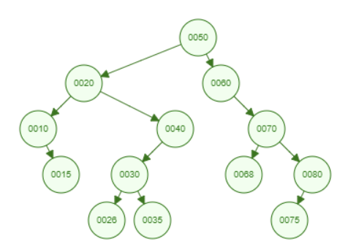



Inorder: 10, 15, 20, 26, 30, 35, 40, 50, 60, 68, 70, 75, 80

Preorder: 50, 20, 10, 15, 40, 30, 26, 35, 60, 70, 68, 80, 75

Postorder: 15, 10, 26, 35, 30, 40, 20, 68, 75, 80, 70, 60, 50

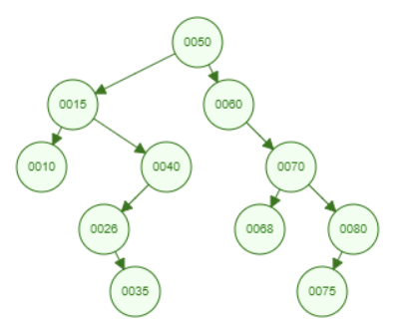

2)

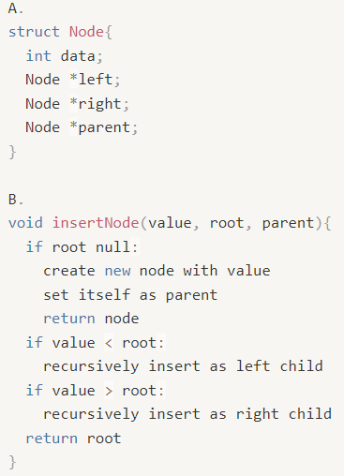

3)



| 7 | 5 | 6 | 1 | 0 | 3 |
| --- | --- | --- | --- | --- | --- |



| 6 | 5 | 3 | 1 | 0 |
| --- | --- | --- | --- | --- |

4)

1. O(C + logS)
2. O(logC + S)
3. O(logC + logS)
4. O(logS)
5. O(1)
6. O(logC + S)
7. O(S logS)
8. O(C logS)