I'm looking for a private chrome extension that interacts with twitch.tv (or if you can make a popout window for the GUI, that would be preferred. GUI doesn’t have to look too nice. I would need a “pin to top” option in a windowed gui)

Here's what I need it to do (in no particular order):

* Detect when a channel goes live and prompt a notification through chrome.
  + I should be able to input which channels I want notifications for.
* Detect when a channel prediction is run on a stream.
* Read the following:
  + the amount of channel points I have in a channel



* + the time left before a prediction closes

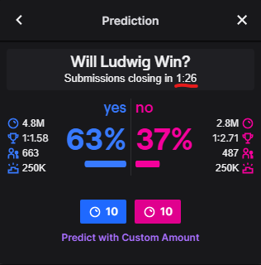

* + which option wins after the prediction closes (blue/pink)

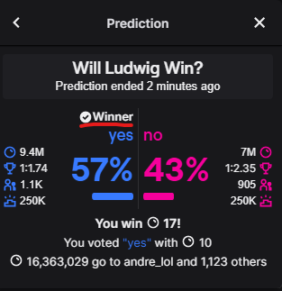

* + what percentage each option is

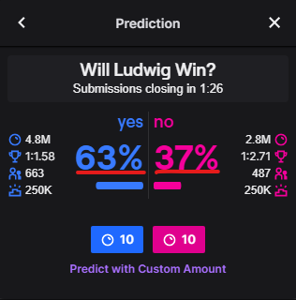

* + what game they are playing



* Bet a portion of my channel points.
  + It should save some channel points.
    - If I have 128 points, it should always save 100 points.
    - If I have 4,382 points, it should always save 4000 points.
    - If I have 82,777 points, it should always save 80000 points.
  + There is a cap on betting of 250000 points, so when I have greater than 1,500,000 points or higher, it should bet 250,000.
* The amount bet should be half of the excess points.
  + If I have 128 points, it should enter 14 points.
  + If I have 4,382 points, it should enter 191 points.
  + If I have 82,777 points, it should enter 388 points.
  + If I have 20,000 where the number ends in all zeros, it should enter nothing.

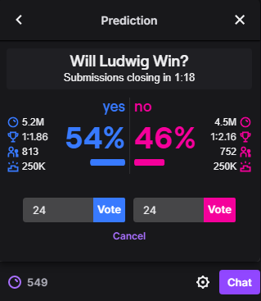

* It should enter this number into both entry fields. Once for blue and once for pink. It should then wait.
* There needs to be an abort button in the GUI.
* If I do not abort when time is less than or equal to 0:10 seconds, vote for:
  + (Listed in descending order of importance; top bullets overrule all else.)
  + If playing chess, always bet on blue.
  + If the (%) is between 52-48%, do not bet.
  + If either (%) is above 80%, bet on that one.
  + Whichever option has a higher (%)

Additionally, I want it to track the results between win rate for blue at each odds’ percentile into google sheets, and graph it.