Overview:
This week one challenge was to test our ability to pivot tables and charts to analyze and then visualize data. We were also tested on our ability to use several functions such as the sum, average and percentage function.
Analysis and Challenges:
The first analysis I was asked to make was outcomes by launched date. As you can see in the chart below, the theatre category’s success increased from Sept-Oct but so did the failures. There was a spike in the cancellations as well so just a big month for launches in general for theatre. Some challenges I ran into were repasting certain formulas an incorporating the correct cell changes as well.

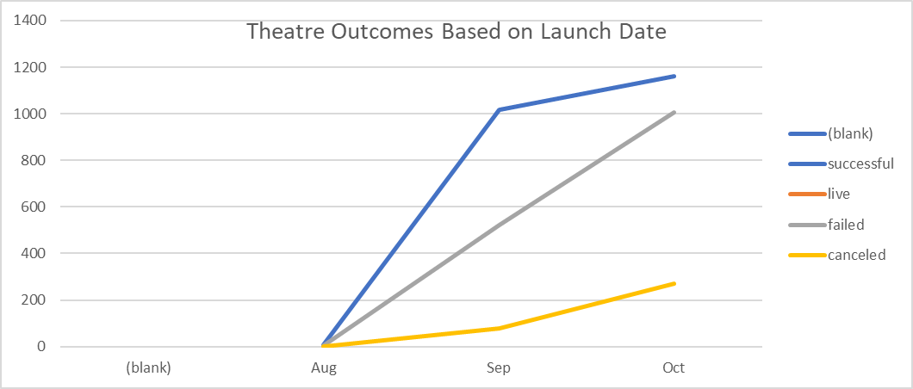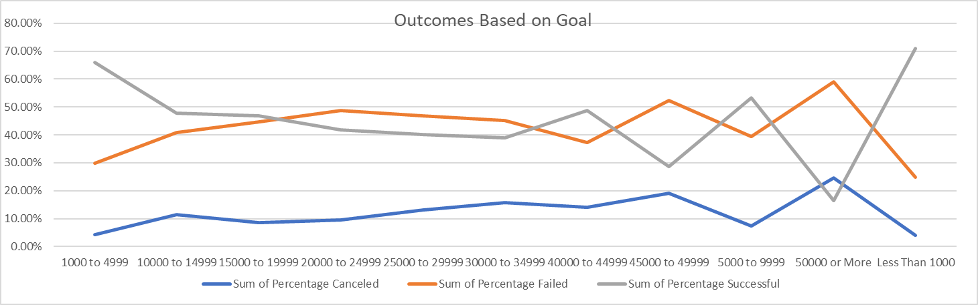

Results:
Two conclusions I can draw from theatre outcomes by launch date are that we had more successes overall, but our failures are growing as well. Based on the outcomes based on goals chart I can see those goals of less than 1000 have the highest success rate, which makes sense seeing that the amount asked for is so low. I would say this data is limited by the small window of time we are looking at. We could also make a combo chart with the total for each category in bars and a line showing their success or fail percentage. This give us an even closer more detailed description of our overall data set.

