Eric Dinh

April 21, 2017

ECE465-001

Socket-based Remote Controller for Drones

**Hardware and Software Settings**

Development PC

CPU Intel i5-3570K

RAM 16 GB

OS Windows 8.1 Professional

Software VMWare Workstation Pro 12.0.0

Programming Language C

Server/Client Virtual Machines

CPU 1 Processor/2 Cores

RAM 4 GB

OS Ubuntu 16.04.02 LTS

Required Packages git, build-essential, autoconf, libtool, libavahi-

client-dev, mplayer, libavcodec-dev, libavformat-dev,

libswscale-dev, libncurses5-dev, unzip

**Transport Protocol Between Client and Server**

UDP was used as the transport protocol between the server and client. This protocol was chosen since using a controller does not require 100% packet transmission. When using a controller, inputs are sent often enough that a lost packet would not make much of a difference. The smaller amount of overhead also makes UDP faster. An example of where UDP may be a better choice than TCP is in the event of an emergency power off. If a TCP connection does not receive the emergency power off command, there is a wait between until it can be sent again and no commands would be able to be sent. With UDP if this packet is lost, it can be immediately be sent again until it is received by the drone.

**Console Screenshots**

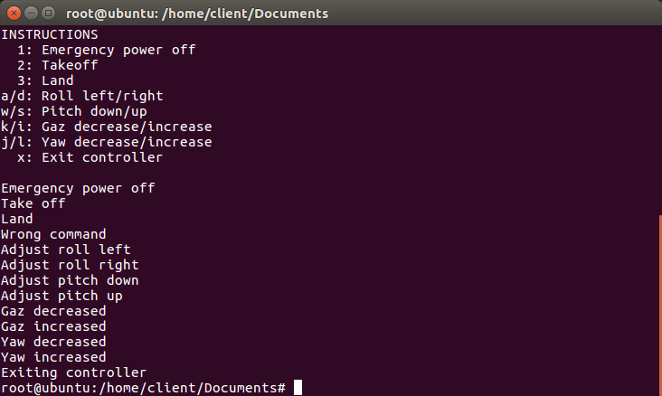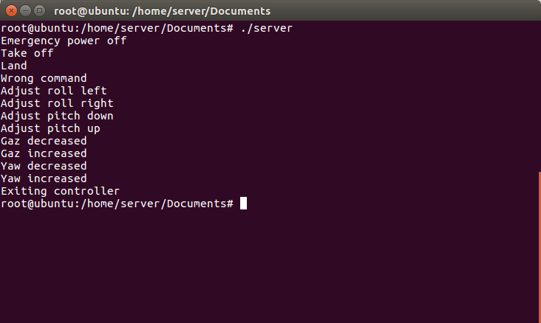*Server console Client console*

**Wireshark Screenshots**

*Emergency power off Takeoff*

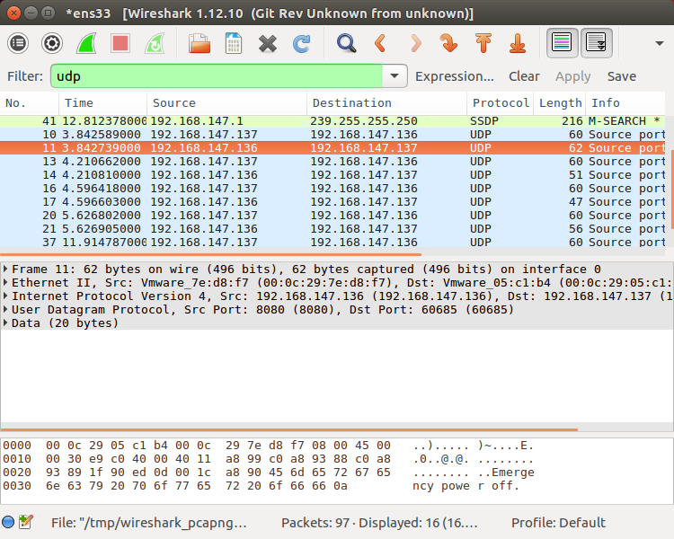 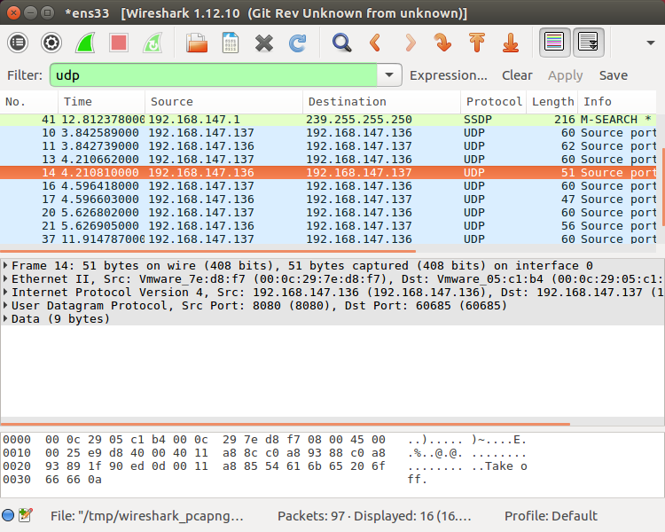

*Land*

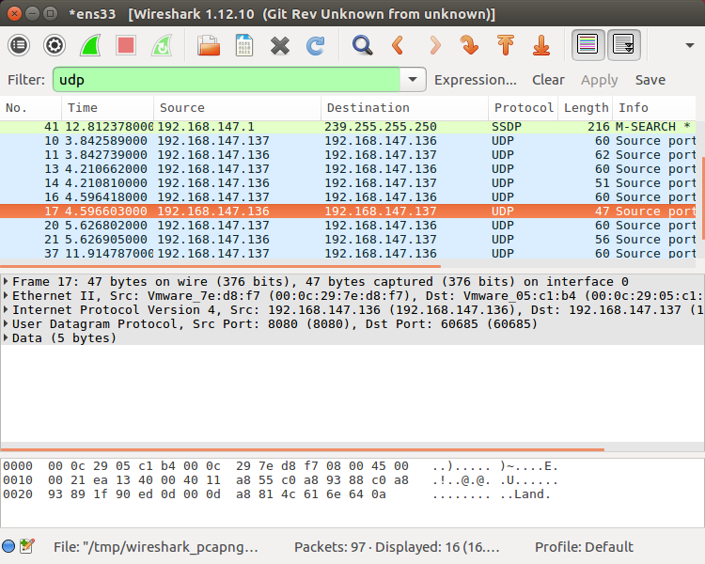

**Transport Protocol Between Server and Drone**

UDP was also used as the transport protocol between the server and drone for the same reasons it was used between the client and server.

**Code Installation Instructions**

- Install dependencies listed above in “Required Packages” on server machine

- Move server folder to server machine, client folder to client machine

- Navigate to server folder and run: unzip out.zip -d /path/to/server/folder then make

- Navigate to client folder and run: make

- Start server by running: ./server

- Start client by running: ./client

*\*Tested on Ubuntu 16.04.02*