A2

Prob 1

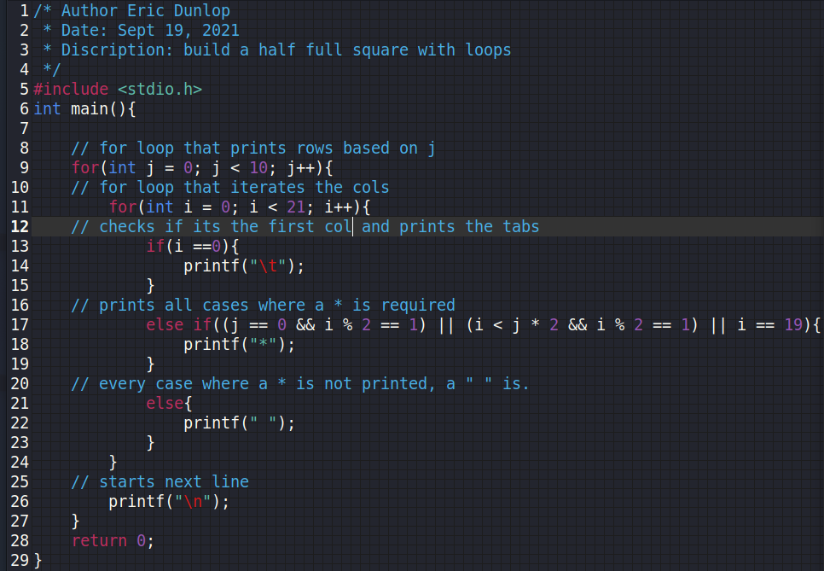

Prob2

Prob3

Prob4

|  |  |  |  |
| --- | --- | --- | --- |
| Variable name | & of variable | Content of variable | Number of bytes used by variable |
| aval | 0x7ffd44af76fe | 100 | 2 |
| bval | 0x7ffd44af76f8 | 100 | 4 |
| cval | 0x7ffd44af76f4 | 100.00 | 4 |
| dval | 0x7ffd44af76e8 | 100.00 | 8 |
| eval | 0x7ffd44af76e7 | d | 1 |
| fval | 0x7ffd44af76e6 | 100 | 1 |

Prob5

