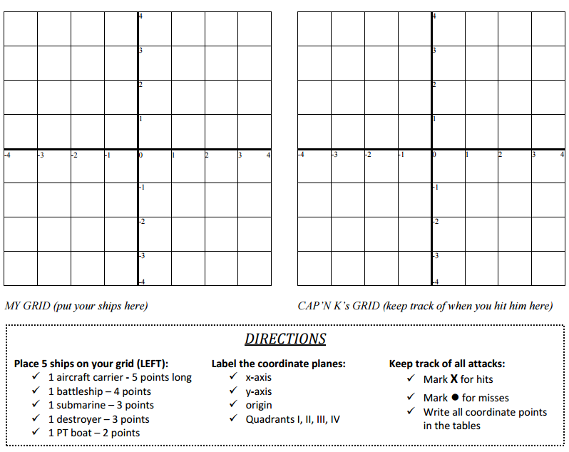

Your Grid (keep track of your ships here) Captain Eric’s Grid (keep track of his ships and hits here)