Instructions for Editing KStars Code on OS X using QT Creator.

<INSERT EXISTING INSTRUCTIONS FROM WEBSITE>

1. Install KStars using cmake with ./build-kstars.sh -3aci
2. Open QT Creator
3. Click “new Project”
4. Select Import Existing Project

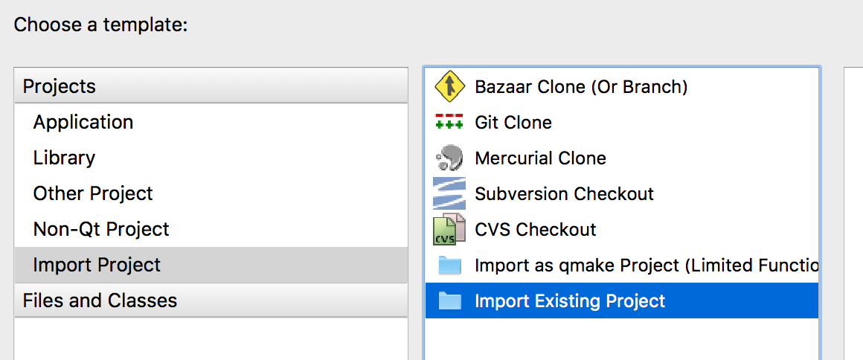

1. Enter the Project name “kstars” and Select the location of the cmake directory ~/IndiRoot/kstars-cmake/kstars. Click Continue.

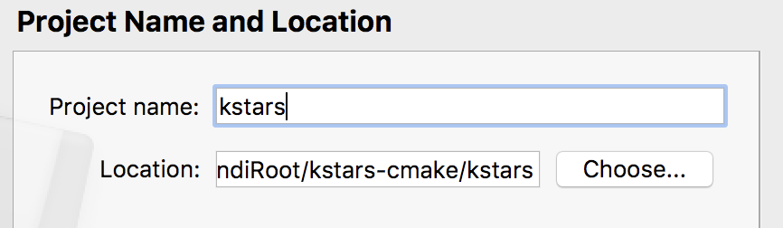

1. Select the files you want to include. I make sure the kstars directory has all files checked. Click Continue
2. Check that in “Add to version control,” Git is selected so that you can interact with the GIT repository and do not have to re-run the script everytime you want to update to the latest version of kstars.



1. Then click Done
2. Now click Projects 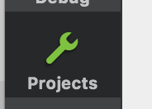
3. For the build directory, make sure to select the kstars-build directory, which is in a subfolder of the kstars-cmake directory.

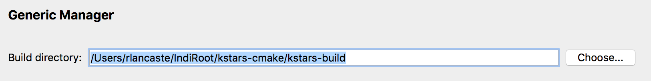

1. You will probably want to edit/set two environment variables. When KStars is built through emerge/craft, these variables get set correctly, but with cmake, you will need to set them yourself.

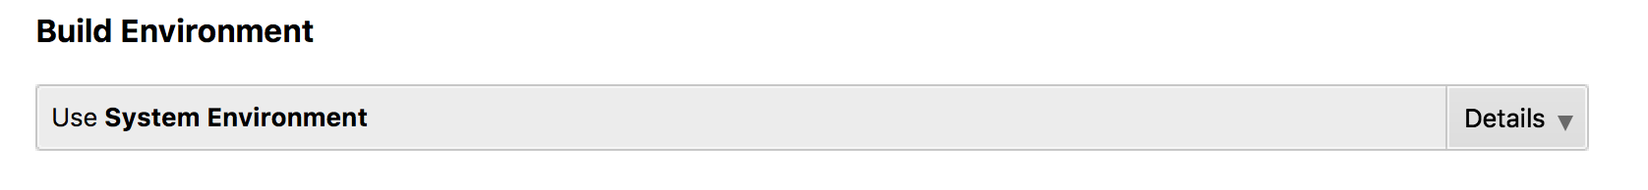

* 1. The PATH variable will already be there. But it almost certainly does not have /usr/local/bin in it. Make sure you add it. Here is what mine looks like:

/Users/rlancaste/Qt/5.7/clang_64/bin:/usr/local/bin:/usr/bin:/bin:/usr/sbin:/sbin

* 1. The QT_PLUGIN_PATH variable is probably absent from the list. In order to use the kstars plugins, you will need to click “Add” and then type in the path to your plugins folder in the app bundle. Here is what mine looks like:

/Users/rlancaste/IndiRoot/kstars-cmake/kstars-build/kstars/kstars.app/Contents/PlugIns

1. On the left hand side, click on “Run”

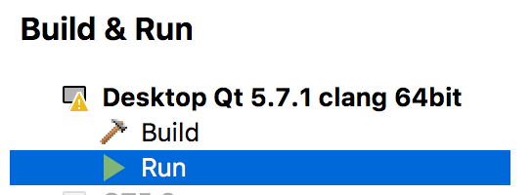

1. In the “Executable Path” box, you will want to click the choose button to select the application in the build directory for testing purposes. It is located in kstars-cmake/kstars-build/kstars/KStars.app. QtCreator will fill in the rest to get to the unix executable.



1. You should now be ready to edit and run code! To run it, click the big green arrow to the left. Happy Coding!

