Calculating trends in flow variability of Puget Sound rivers

Eric Ward, [eric.ward@noaa.gov](mailto:eric.ward@noaa.gov)

December 9, 2015

library(waterData)

Next we'll create a vector of gauge IDs we want to use

df = data.frame("river" = c("Sammamish","Cedar", "Dungeness", "Elwha", "Upper Sauk",   
"SF Stillaguamish", "SF Nooksack", "NF Stillaguamish", "Skokomish", "Cascade",   
"NF Nooksack", "Lower Skagit", "Lower Sauk", "White", "Puyallup", "Skykomish",   
"Snoqualmie", "Duwamish", "Upper Skagit", "Nisqually"), "gauge" = c(12125200,   
12119000, 12048000, 12045500, 12186000, 12161000, 12209000, 12167000,   
12061500, 12182500, 12205000, 12200500, 12189500, 12098500, 12093500,   
12134500, 12149000, 12113000, 12181000, 12089500))  
  
nRivers = dim(df)[1]

## Retrieving data from USGS

We'll use the $waterData$ package to grab the data from each gauge.

waterList = list()  
  
for(r in 1:nRivers) {  
dat = importDVs(staid = paste(df$gauge[r]))  
datesList = strsplit(as.character(dat$dates), "-")  
dat$year = as.numeric(lapply(datesList, getElement, 1))  
dat$month = as.numeric(lapply(datesList, getElement, 2))  
dat$day = as.numeric(lapply(datesList, getElement, 3))  
  
# calculate water month and year  
dat$waterMonth = NA  
dat$waterMonth[dat$month %in%c(10,11,12)] = dat$month[dat$month %in%c(10,11,12)] - 9  
dat$waterMonth[dat$month %in%seq(1,9)] = dat$month[dat$month %in%seq(1,9)] + 3  
  
dat$waterYear = dat$year  
# months Jan - Sept become part of water year starting last Oct 1  
dat$waterYear[dat$month %in%seq(1,9)] = dat$waterYear[dat$month %in%seq(1,9)] - 1  
  
waterList[[r]] = dat  
}

## Winter Flow Patterns

We can do the analysis on the full water year of data, but we can also focus on seasons. For example, for Puget Sound winter flows, we might want to focus on October - February (water months 1-5).

### Summary plots of winter discharge and variability

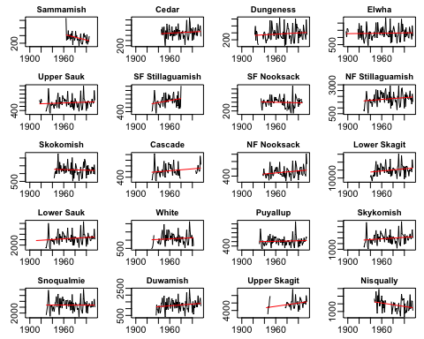

par(mfrow = c(5,4), mgp = c(2,0.5,0), mai = c(0.25,0.3,0.2, 0.1))  
# filter out years with no observations  
start = which((apply(summary.variability, 1, sum, na.rm=T))!=0)[1]  
for(i in 1:nRivers) {  
  
 ys = exp(summary.variability[-c(1:(start-1)),i])  
 xs = all.years[-c(1:(start-1))]  
 min(xs[is.na(ys)])  
  
 pred = predict.lm(lm(ys ~ xs), newdata=list(xs))  
 plot(xs, ys, type="l", main = df$river[i], cex.main=0.9, ylab = "")  
 indx = which(xs %in% seq(min(xs[is.na(ys)==F]), max(xs[is.na(ys)==F])))   
 lines(xs[indx], pred[indx], col="red")  
}

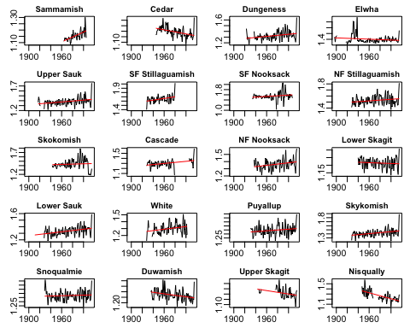

## Summer Flow Patterns

We can do the analysis on the full water year of data, but we can also focus on seasons. For example, for Puget Sound summer flows, we might want to focus on May - August (water months 8-11).

### Summary plots of summer discharge and variability

