Pollock Effort

This uses data from J. Gasper at AFSC. These data are observed and unobserved effort from the AI, BS and GOA groundfish fleets.

The goal here is to summarize fishery effort into boat days for observed and non-observed effort. Data were grouped by year, month, region (NMFS Stat Area), length category (Small [which is less than 125ft before 2013, greater than 60 feet after 2013] or Large) and processing sector (Catcher Processer and Shoreside).

I grouped data into Target: Pollock or non-Pollock, the below data are filtered to the Pollock target only. These data are also GOA only, but can expand that pretty easily if we are interested in AI or BS.

Data start in 2006 (not 2003 like we thought) based on how the codes that tell us if a trip was observed or not, I need to check-in with Jordan and ask what is going on with that and if there is other info I should look for from 2003-2006.

Looks like there is effort data within all of the seasons, april and may tend to have little to no effort, but with the seasonal grouping there will be effort in each box.

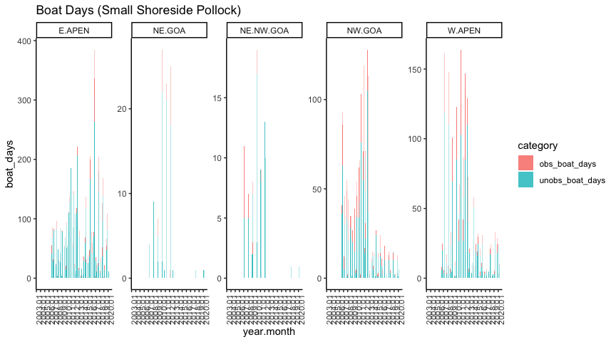 The way the length categories are grouped is kind of funky because some effort clearly switches over between small and large in 2013. We may not need to group based on lengths because we have the actual data and don’t have to get unobserved data based on the chart that groups observer rates based on boat lengths…? 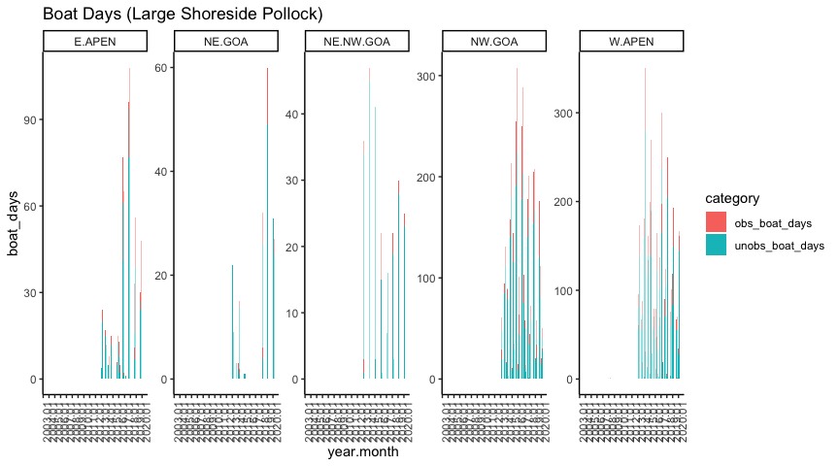

Heatmap Key: Black = No effort This heatmap has log(boat days) for all effort (observed and unobserved) for all sectors and all boat length categories 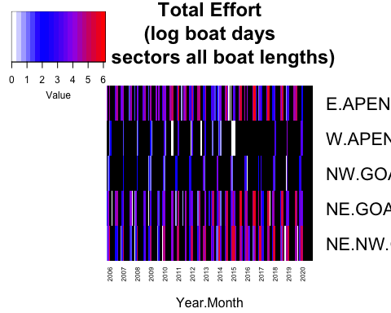

This heatmap has log(boat days) for all effort (observed and unobserved) for small shoreside boats - again can see disparity between 2013 length categories. (these categories make more sense for BS and AI, but in GOA there arent any shoreside boats > 125 feet). 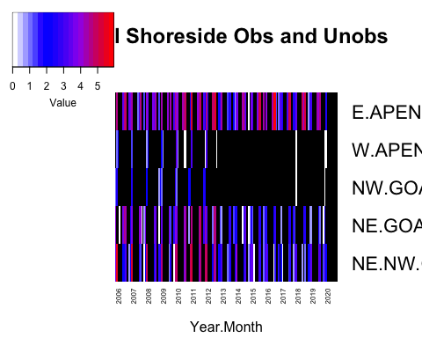

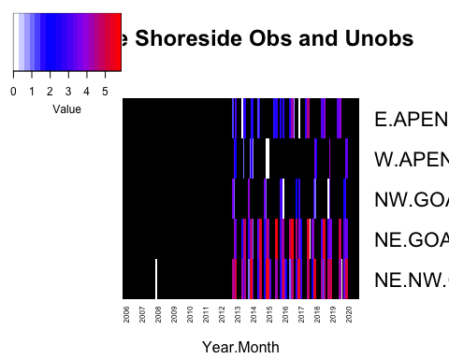

Catcher Processor Effort

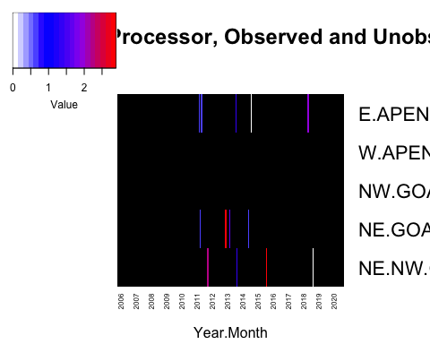

Fraction of Boat Days with an observer onboard. Black = no effort, white = no observed effort 