Final Project

I confirm that I will keep the content of this project confidential. I confirm that I have not received any unauthorized assistance in preparing for or writing this project. I acknowledge that a mark of 0 may be assigned for copied/plagiarized work.

Joseph Varacalli #104818664

Matt Prieur #104804850

Eric Yeung #104392784

This project consists of creating a program that translates logical addresses to physical addresses for a virtual address space of 216 bytes. The program will read from a text file with logical addresses and output the physical addresses.

The program has a TLB and a page table, which are used to help translate logical addresses to physical addresses. We also consider the fact that the physical memory size is smaller than the virtual address space. Since that is the case, we implemented a page replacement policy using the FIFO principle.

Our number of page faults and TLB hits all follow the correct answers provided.

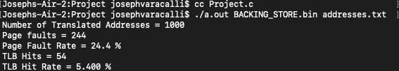When you do run the program, you must run it with the arguments BACKING_STORE.bin first and addresses.txt second, as shown in Fig. 1.

Figure