**EXPERIMENTS**

-**dataset_size** ~170

-**code**:

–(cleaning images)

–extracting components + generate_time_series

–clustering

-**cleaning signals**:

–signal clean

—removing confounds via glm, standardize

— high pass 0.01 Hz

–nilearn approach

– high pass 0.01 Hz, standardize

– remove confounds when generating timeseries of extracted components

-**components extracted from only 20 images**

- 10 images from each group, due to memory reasons

– 8gb ram + ~10gb swap

– code could get stuck on bigger number of components (communicate issue to nilearn)

**-clustering:**

–matrices:

— correlation, partial correlation, tangent space

– stratified cross validation

— n_splits = 15

— test_size = 15

**RISULTATI STOPSIGNAL**

##**SIGNAL CLEAN**

##accuracy

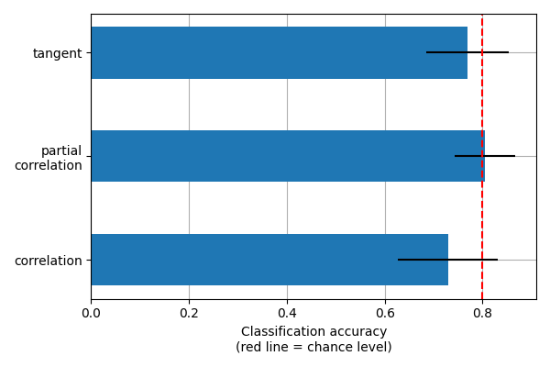

##**NILEARN**

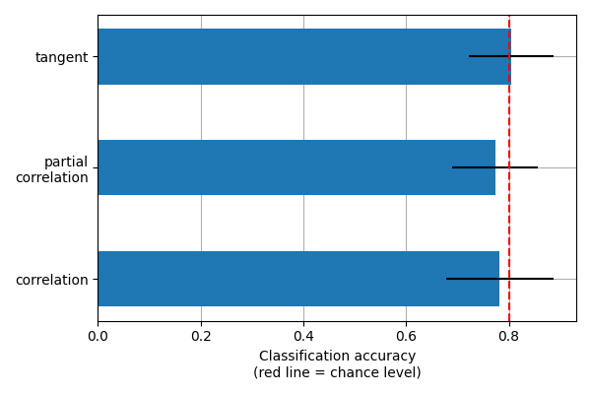

**RISULTATI BART**

##**SIGNAL.CLEAN**

##accuracy

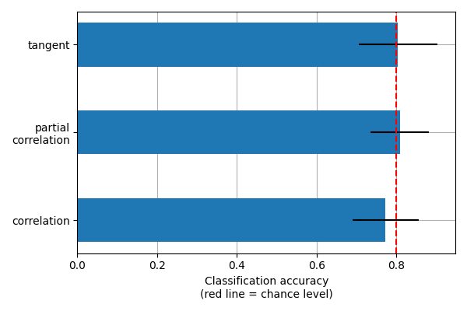

##**NILEARN**

##accuracy

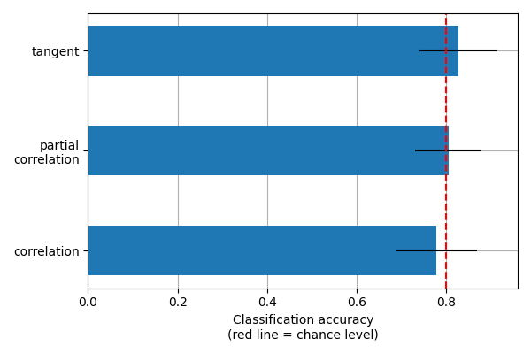

**TIME - STOPSIGNAL**

## **SIGNAL.CLEAN**

## time – **2h 33 mins**

#images_cleaner: (~110 mins usato bart come referenza)

#generate_ica_time_series: 43 mins

#clustering: 31 secs

## **NILEARN**

## time - **28 mins**

#generate_ica_time_series: 26 mins

#clustering: 59 secs

**TIME - BART**

## **SIGNAL.CLEAN**

## time – 2h 32 mins

#images_cleaner: 110 mins

#generate_ica_time_series: 41 mins

#clustering: 31 secs

## **NILEARN**

## time - 43 mins

#generate_ica_time_series: 42 mins

#clustering: 34 secs