**Parallel Programming Exercise 8 – 10**

|  |  |
| --- | --- |
| **Author:** | 蕭彧 ([r11922138@ntu.edu.tw](mailto:r11922138@ntu.edu.tw)) |
| **Student ID** | R11922138 |
| **Department** | Computer Science |

# Problem and Proposed Approach

This programming exercise is to write the matrix vector multiplication using checkboard approach described in the textbook.

# Theoretical Analysis Model

χ is time needed to do single element-wise multiplication

Suppose p is a square number

λ is the message latency

β is network bandwidth

Sequential execution time: n*n

Redistribute b: λ + 8 ⎡*n*/√*p*⎤ / β + log √*p (* λ + 8 ⎡*n*/√*p*⎤ / β)

Reduction time: log √*p (* λ + 8 ⎡*n*/√*p*⎤ / β)

Expected execution time: χ ⎡*n*/√*p*⎤ ⎡*n*/√*p*⎤ + λ + 8 ⎡*n*/√*p*⎤ / β + log √*p (* λ + 8 ⎡*n*/√*p*⎤ / β) + log √*p (* λ + 8 ⎡*n*/√*p*⎤ / β)

# Performance Benchmark

The message latency is λ = 0.001521 sec, and the network bandwidth is β = 1658 MB/sec

The matrix size is 4096x4096, and the vector size is 4096.

Table 1. The execution time

|  |  |  |  |  |  |  |  |  |
| --- | --- | --- | --- | --- | --- | --- | --- | --- |
| Processors | 1 | 2 | 4 | 8 | 16 | 32 | 64 | 128 |
| Real execution time | 0.07642 | 0.03960 | 0.02452 | 0.01236 | 0.00786 | 0.00587 | 0.00625 | 0.00652 |
| Estimate execution time | 0.07614 | 0.03807 | 0.02351 | 0.01205 | 0.00698 | 0.00511 | 0.00591 | 0.00621 |
| Speedup | 1 | 1.93 | 3.12 | 6.18 | 9.72 | 13 | 12.23 | 11.72 |
| Karp-flatt metrics | - | 0.036 | 0.094 | 0.042 | 0.043 | 0.047 | 0.067 | 0.078 |

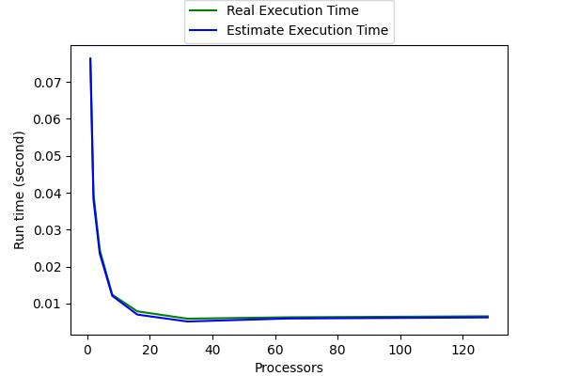

Figure 1. The performance of diagram

# Conclusion and Discussion

This program extensively practices the use of each Openmp functions. The core part, matrix times vector, only need few lines of codes, but the communication part needs hundreds of codes. I think the most difficult part is also the communication part. Since this program require communicator creating and splitting, which make the case more complicated, I need to make sure the program is using right rank and right communicator. Most of my effort is spent on checking communication issues, too.