Parallel Programming Exercise 4 – 7

Author: | 蕭彧 (r11922138@ntu.edu.tw)
Student ID | R11922138
Department | Computer Science

Problem and Proposed Approach
This programming exercise is to practice how to do sum reduction. Each processor needs to assign a value base in its rank, and processor 0 do a sum reduction of these values.

Theoretical Analysis Model
Let’s say we have p processors, and λ is the message latency. We need to do one sum reduction on p numbers. The computation time is logp (processor 0’s sum reduction time), and the necessary communication time is λlogp. The overall time complexity will be O((1 + λ)logp).

Performance Benchmark
I pick process 0’s execution time, since it need to do the reduction. Since we don’t know the actual message latency, the estimate execution time assume message latency be 0.
This program doesn’t really have a base execution time, since the problem is based on the number of processors, so we can’t calculate speedup or other metrics in this program.
Table 1. The execution time
Processors | 1 | 2 | 4 | 8 | 16 | 32 | 64 | 128
Real execution time | 0.000236 | 0.000164 | 0.000278 | 0.000136 | 0.000124 | 0.005024 | 0.005159 | 0.036127
Estimate execution  time | 0.000236 | 0.000236 | 0.000472 | 0.000708 | 0.000944 | 0.00118 | 0.001416 | 0.001651
Speedup | - | - | - | - | - | - | - | -
Karp-flatt metrics | - | - | - | - | - | - | - | -

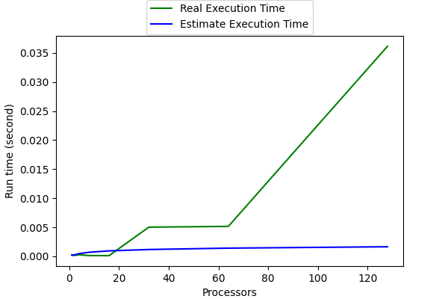
Figure 1. The performance of diagram

Conclusion and Discussion
The real runtime is dominated by the network latency. In estimate runtime, I ignore network latency, so that we can see how the network latency can affect our program speed. As the professor said, the network latency can be 1000 times longer than execution time. Next program 6-8. We will estimate the network latency, and we can see how scary it is.

