Parallel Programming Exercise 4 – 9

Author: | 蕭彧 (r11922138@ntu.edu.tw)
Student ID | R11922138
Department | Computer Science

Problem and Proposed Approach
This programming exercise is a variation of Sieve of Eratosthenes. After we mark all the prime numbers, we need to find the max gap of two consecutive prime numbers. N is set to 1,000,000 in this case.
The Sieve of Eratosthenes method I used is the final optimized version in the class, i.e. delete even integers, each process finds its own primes, and reorganize loops.
The block size in reorganize loops is set to 16384, since the L1 cache size of the processor is 32K, I set block size to half of the cache size to increase locality.
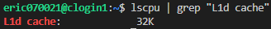
My approach is to traverse the local prime list to find the max gap of two consecutive prime numbers in local. We also need to check the primes between two processor, i.e. the gap between last prime of a previous processor and the first prime of the current processor. To collect these two primes, I use MPI_Gather to gather these primes to processors 0. Processor 0 will calculate the gap between these two primes and find the max gap. Finally, I use MPI_Reduce and set the reduce behavior to MPI_MAX to determine the max gap throughout all processors.
The max gap of two consecutive prime numbers I calculated for n = 1000000 is 114.

Theoretical Analysis Model
χ is time needed to mark a cell
λ is the message latency
Sequential execution time: (χn ln ln n) / 2 (exclude even numbers) + χn^{1/2} ln ln n^{1/2} (precompute table time) + n (traverse prime array to find max gap)
Reduction time: λ ⎡log p⎤
Gather time: 2λ ⎡log p⎤
Expected execution time: χn^{1/2} ln ln n^{1/2} + (χn ln ln n) / 2p + n/p + 3λ ⎡log p⎤

Performance Benchmark
I pick process 0’s execution time, since it need to do the reduction. The message latency is λ = 0.001521 sec, and the network bandwidth is β = 1658 MB/sec
Table 1. The execution time
Processors | 1 | 2 | 4 | 8 | 16 | 32 | 64 | 128
Real execution time | 0.010213 | 0.005318 | 0.003681 | 0.001581 | 0.001265 | 0.000590 | 0.000862 | 0.000855
Estimate execution  time | 0.010157 | 0.005128 | 0.003578 | 0.001514 | 0.000852 | 0.000495 | 0.000582 | 0.000621
Speedup | 1 | 1.92 | 2.77 | 6.46 | 8.07 | 17.31 | 11.84 | 11.94
Karp-flatt metrics | - | 0.04166 | 0.148014 | 0.034055 | 0.06551 | 0.02737 | 0.069927 | 0.07653

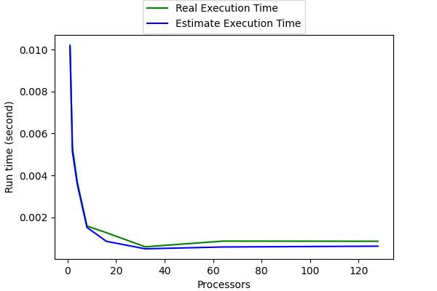
Figure 1. The performance of diagram

Conclusion and Discussion
Same as 4-8, the increase of processors indeed speedup the execution time at first, but too much processors will let the time be dominated by network latency. Especially we have 2 gathers operation this time, the network latency will play more important role when n is not large. By karp-flatt metric, we can see that the processor counts 32 is still the best amounts of processors to use in this case.

