Parallel Programming Exercise 4 – 6

Author: | 蕭彧 (r11922138@ntu.edu.tw)
Student ID | R11922138
Department | Computer Science

Problem and Proposed Approach
(Brief your problem, and give your idea or concept of how you design your program.)

Theoretical Analysis Model
(Try to give the time complexity of the algorithm, and analyze your program with iso-efficiency metrics)

Performance Benchmark
(Give your idea or concept of how you design your program.)

Table 1. The execution time
Processors | 1 | 2 | 3 | 4 | 5 | 6 | 7 | 8
Real execution time | 0.021632 | 0.010839 | 0.007264 | 0.005458 | 0.004388 | 0.003685 | 0.003166 | 0.002783
Estimate execution  time | 0.021632 | 0.010816 | 0.007211 | 0.005408 | 0.004326 | 0.003605 | 0.00309 | 0.002704
Speedup
Karp-flatt metrics

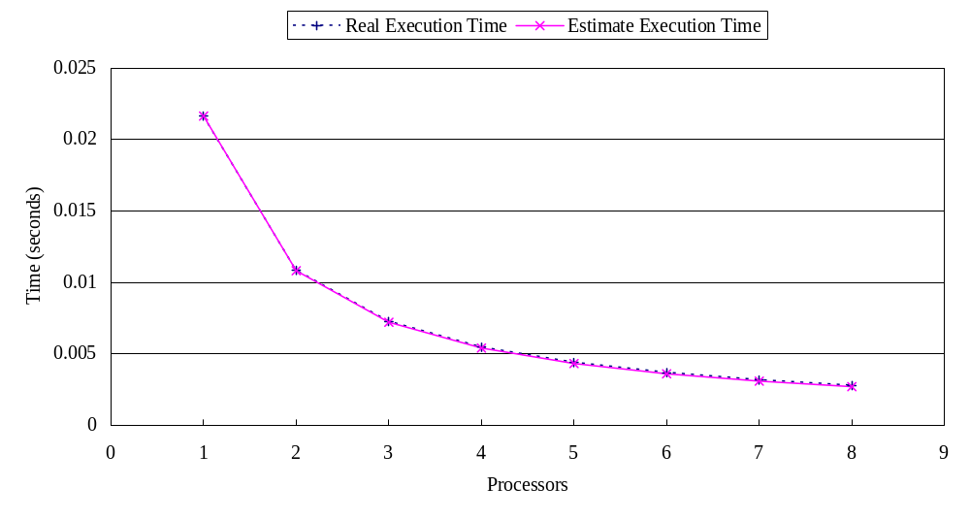
Figure 1. The performance of diagram

Conclusion and Discussion
(Discuss the following issues of your program
- What is the speedup respect to the number of processors used?
- How can you improve your program further more
- How does the communication and cache affect the performance of your program?
- How does the Karp-Flatt metrics and Iso-efficiency metrics reveal?
)

Appendix(optional):
(If something else you want to append in this file, like picture of life game)

