Parallel Programming Exercise 4 – 6

Author: | 蕭彧 (r11922138@ntu.edu.tw)
Student ID | R11922138
Department | Computer Science

Problem and Proposed Approach
This programming exercise is to do the classic Kernighan and Ritchie's classic "hello, world" program, but a parallel variant. My approach is simple and straightforward, just let each processor print out its rank.

Theoretical Analysis Model
Theoretically, the program can perfectly parallelize. Let’s say we have p processors, so we need to print p “Hello world”. The time complexity will be O(1).

Performance Benchmark
Since the execution time of each processor varies, I choose the longest execution time.
This program doesn’t really have a base execution time, since the problem is based on the number of processors, so we can’t calculate speedup or other metrics in this program.
Table 1. The execution time
Processors | 1 | 2 | 4 | 8 | 16 | 32 | 64 | 128
Real execution time | 0.000235 | 0.000250 | 0.000275 | 0.000314 | 0.000331 | 0.000281 | 0.000342 | 0.000332
Estimate execution  time | 0.000235 | 0.000235 | 0.000235 | 0.000235 | 0.000235 | 0.000235 | 0.000235 | 0.000235
Speedup | - | - | - | - | - | - | - | -
Karp-flatt metrics | - | - | - | - | - | - | - | -

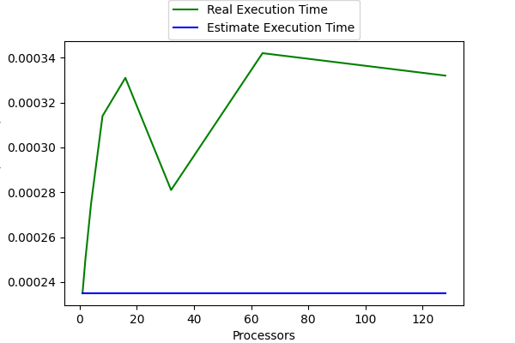
Figure 1. The performance of diagram

Conclusion and Discussion
In the performance benchmark we can see that there isn’t speedup but speed down when the number of processors increase. This is because this program is essentially a O(1) time complexity program, the speed down is contributed by the overhead of mpi. Since this program doesn’t need communication, it won’t affect our program speed. Karp-Flatt metrics reveals that when the number of processors increase, the parallelization is still the same cause the metrics does not increase.

