Parallel Programming Exercise 4 – 12

Author: | 蕭彧 (r11922138@ntu.edu.tw)
Student ID | R11922138
Department | Computer Science

Problem and Proposed Approach
This programming exercise is to calculate pi using Simpson’s Rule to approximate.
Simpson’s rule has a main for loop from 1 to n/2. My approach is to use cyclic allocation to allocate processors. Each processor will add up a partial sum of pi, and after all processors calculated, use a reduction to sum these partial sums. Finally, add some postprocess to the sum and then we can get our approximation of pi. The following figure is the core of the code.
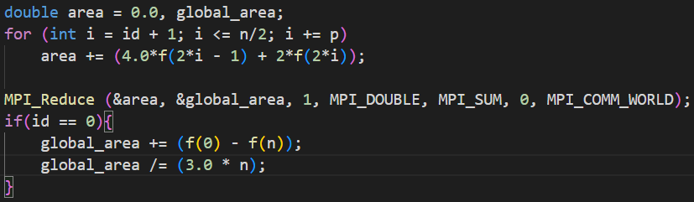

Theoretical Analysis Model
χ is time needed to calculate f function
λ is the message latency
Sequential execution time: (n + 2)χ
Reduction time: λ ⎡log p⎤
Expected execution time: (n / p)χ + 2χ + λ ⎡log p⎤

Performance Benchmark
I pick process 0’s execution time, since it need to do the reduction. The message latency is λ = 0.001521 sec, and the network bandwidth is β = 1658 MB/sec
Table 1. The execution time
Processors | 1 | 2 | 4 | 8 | 16 | 32 | 64 | 128
Real execution time | 0.000006 | 0.000007 | 0.000019 | 0.00002 | 0.000038 | 0.000051 | 0.000157 | 0.000829
Estimate execution  time | 0.000006 | 0.000008 | 0.000017 | 0.000018 | 0.000032 | 0.000048 | 0.000125 | 0.000521
Speedup | 1 | 0.85 | 0.31 | 0.3 | 0.157 | 0.117 | 0.038 | 0.007
Karp-flatt metrics | - | 1.3529 | 3.9677 | 3.666 | 6.7273 | 8.79046 | 26.717 | 143.974

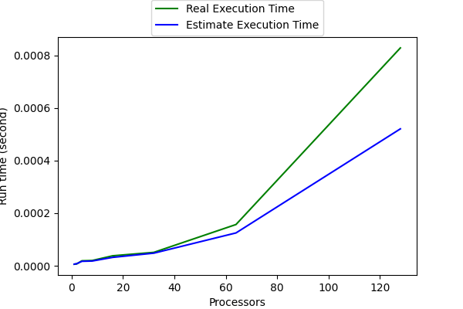
Figure 1. The performance of diagram

Conclusion and Discussion
We can see that when the processor counts arise, the execution arise too. This is mainly because the n in this case is too small, n is only 50. The network latency dominates when n is small like this. Especially when using 128 processors, half of the processors are not even working.
I have tested larger n like 100000. In this case, The execution time is nearly perfectly parallelized. But the n is this question is restricted to 50, so the power of multiple processors can not show in this question.

