Parallel Programming Exercise 4 – 8

Author: | 蕭彧 (r11922138@ntu.edu.tw)
Student ID | R11922138
Department | Computer Science

Problem and Proposed Approach
This programming exercise is a variation of Sieve of Eratosthenes. After we mark all the prime numbers, we need to check the number of two consecutive odd prime numbers. N is set to 1,000,000 in this case.
The Sieve of Eratosthenes method I used is the final optimized version in the class, i.e. delete even integers, each process finds its own primes, and reorganize loops.
The block size in reorganize loops is set to 16384, since the L1 cache size of the processor is 32K, I set block size to half of the cache size to increase locality.
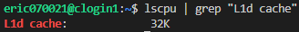
My approach is to traverse the local prime list to check the number of two consecutive odd prime numbers. We also need to check the last element of previous processor, i.e. id-1 processor. If the last element of the previous processor is prime, and so does the first element of current processor, the number of two consecutive odd prime numbers need to plus 1. This part I use MPI_Send and MPI_Recv to concurrently passing message among processors.
The number of two consecutive odd prime numbers I calculated for n = 1000000 is 8170.

Theoretical Analysis Model
χ is time needed to mark a cell
λ is the message latency
Sequential execution time: (χn ln ln n) / 2 (exclude even numbers) + χn^{1/2} ln ln n^{1/2} (precompute table time)
Reduction time: λ ⎡log p⎤
Send and receive time: λ (concurrently send and receive)
Expected execution time: χn^{1/2} ln ln n^{1/2} + (χn ln ln n) / 2p + λ ( ⎡log p⎤ + 1)

Performance Benchmark
I pick process 0’s execution time, since it need to do the reduction. The message latency is λ = 0.001521 sec, and the network bandwidth is β = 1658 MB/sec
Table 1. The execution time
Processors | 1 | 2 | 4 | 8 | 16 | 32 | 64 | 128
Real execution time | 0.006882 | 0.003465 | 0.00189 | 0.001079 | 0.001095 | 0.000366 | 0.000845 | 0.000503
Estimate execution  time | 0.006362 | 0.003420 | 0.00179 | 0.000955 | 0.000477 | 0.000292 | 0.000488 | 0.000501
Speedup | 1 | 1.986 | 3.641 | 6.378 | 6.285 | 18.8 | 8.14 | 13.68
Karp-flatt metrics | - | 0.007049 | 0.03286 | 0.03633 | 0.103049 | 0.022649 | 0.108927 | 0.0658

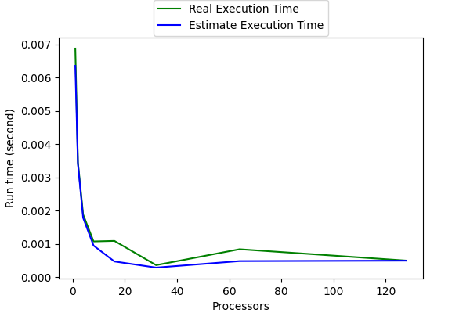
Figure 1. The performance of diagram

Conclusion and Discussion
The increase of processors indeed speedup the execution time at first, but too much processors will let the time be dominated by network latency. We can see in the Figure1 when the processor count reach 32, the speedup is almost stop, and even increase after we keep adding more processors. We can then find the best amount of processor to use base on this figure. When n=1000000, 32 processors can get the best result. But, if n is large enough, theoretically we can gain almost 128x speedup when using 128 processors.

