Advanced Mathematics for Engineers,
Laboratory Problems

Eric Saier
Mat-Nr: 28224

Problem 1.1
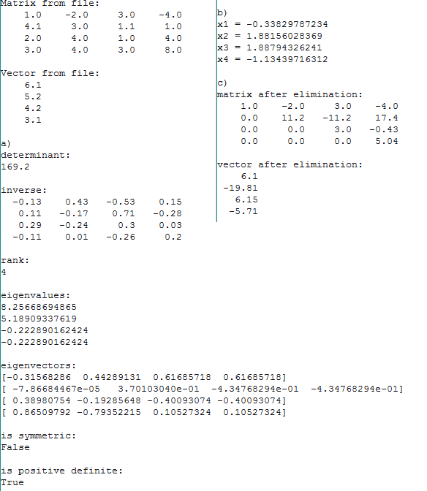

Problem 1.2

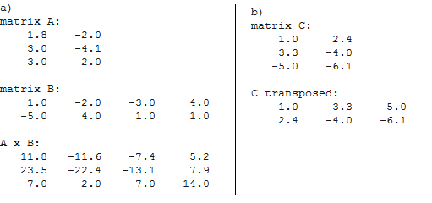

Problem 2.3

a + b + c) (next page)

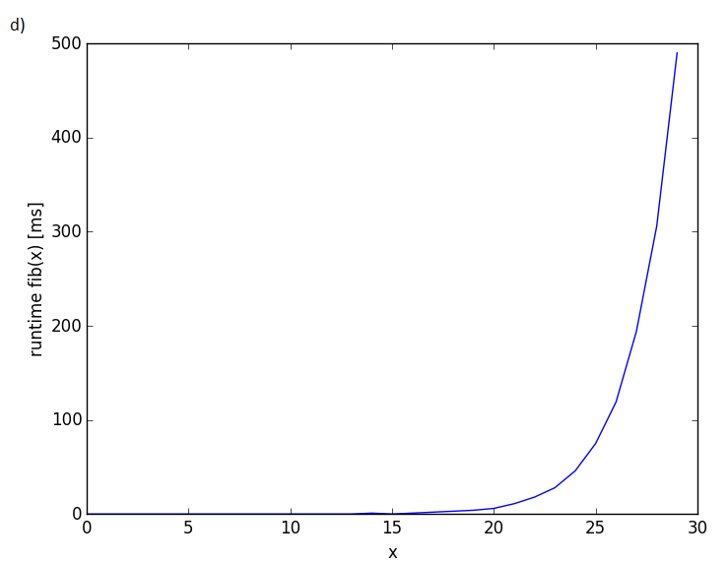

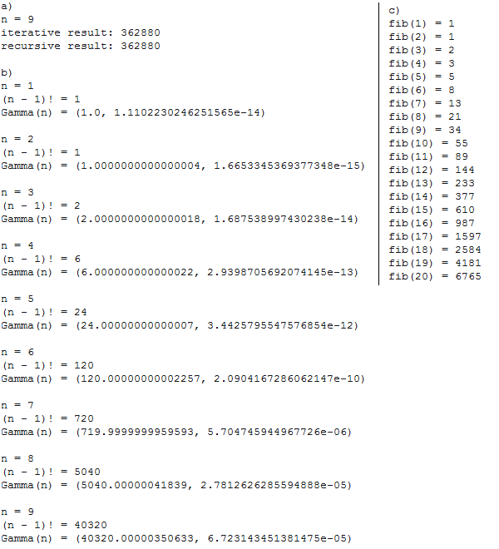

Problem 2.4

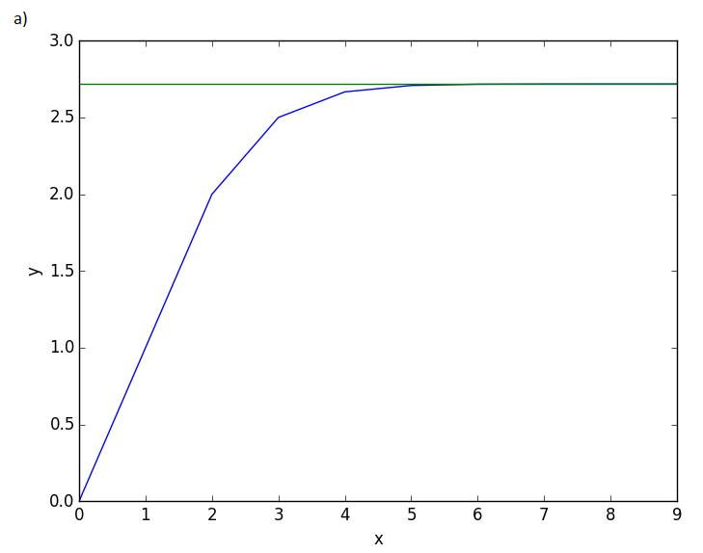
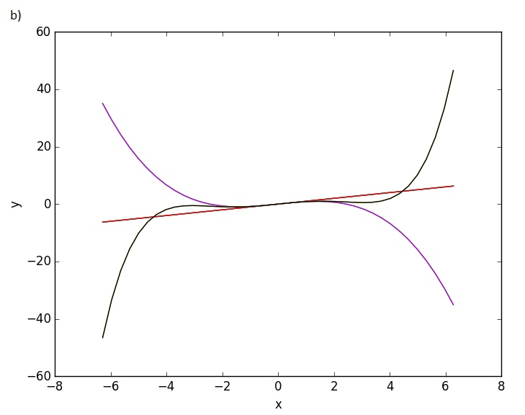

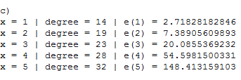

Problem 2.5
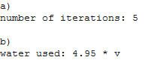

c)
No it can't, the optimal β is the closest value to 1 – α.

d)

(n = number of iterations)

e)
It can be minimized by increasing the value of β.

