Advanced Mathematics for Engineers,
Laboratory Problems

Eric Saier
eric.saier@hs-weingarten.de
Mat-Nr: 28224

Problem 5.9

b)
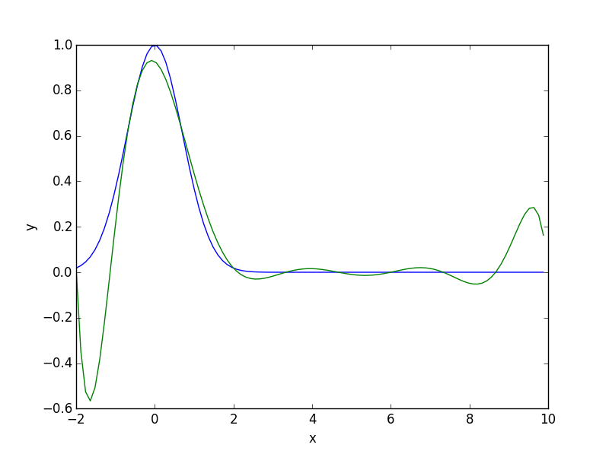
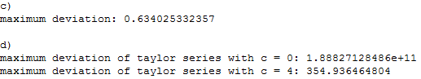

Problem 5.10
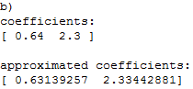

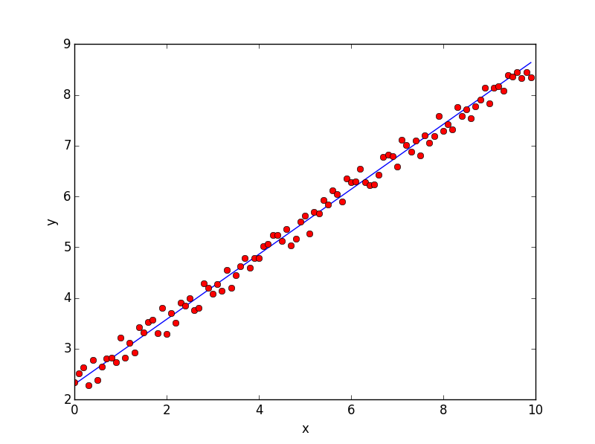

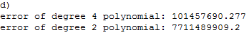

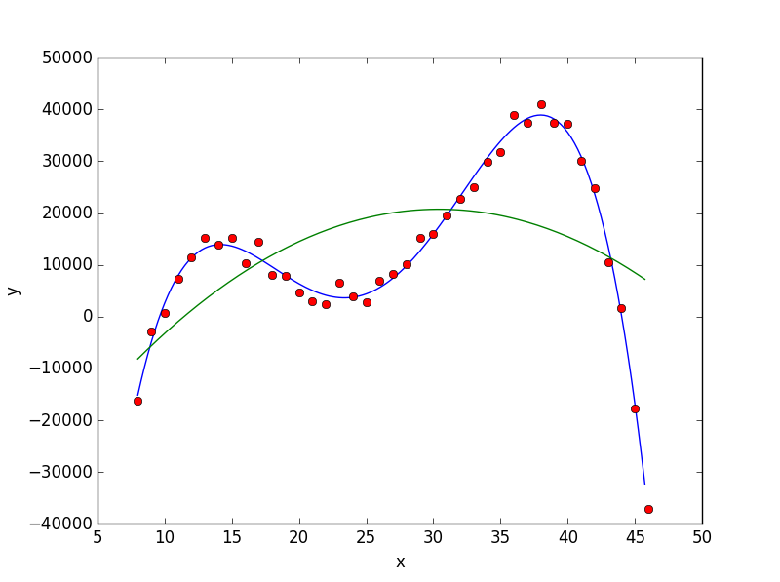
Problem 5.11

c)
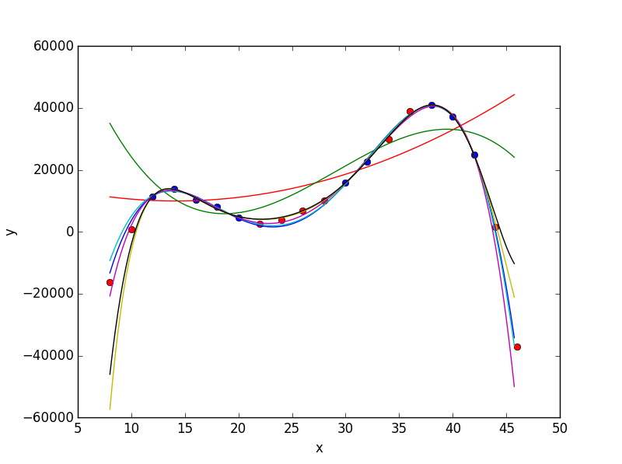

d)
