Advanced Mathematics for Engineers,
Laboratory Problems

Eric Saier
eric.saier@hs-weingarten.de
Mat-Nr: 28224

Problem 3.6
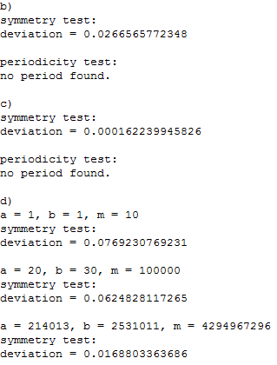

Problem 3.7

a)
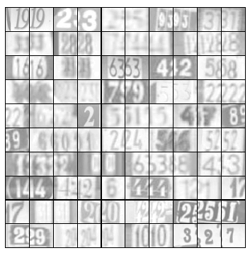

b)

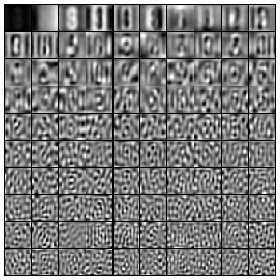

c)
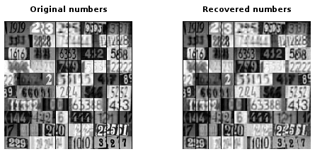

d)

50 principal components:
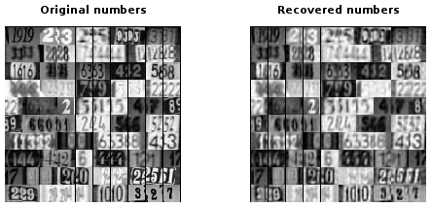

10 principal components:

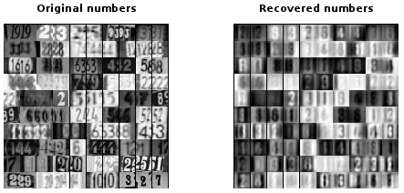

e)
Like the JPEG compression detail gets lost, especially between two area where the color contrast is high.

Problem 4.8

a)
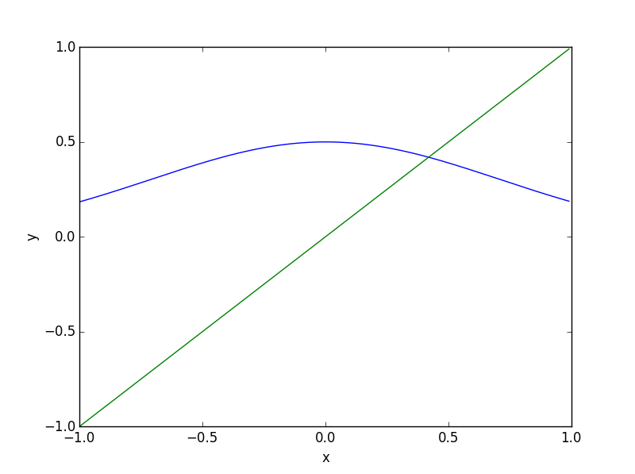
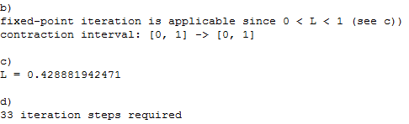

e)
Newton's method is the fastest because it also utilizes the first derivative of the function.

Interval bisection is the slowest because by always using the middle of the interval as a bound, it reaches the root the slowest.

f)
27 steps were needed instead of the estimated 33 steps. It took less steps because the a priori estimation always asumes the worst case scenario.

